- Introduction/Project Question
For this digital project I was intrigued by DeepSeek’s flagship DeepSeek-R1 Large Language Model (LLM). This “free” AI chatbot garnered widespread usage and reporting as it quickly became the most downloaded applications in late January for both IOS and Android devices. DeepSeek also garnered widespread criticism for its reluctance to function when prodded on subjects sensitive to the Chinese government. While journalists and other tech savvy folks were quick to jailbreak DeepSeek to get the AI to produce responses to topics it refused to answer, little inquiry has examined the extent of DeepSeek’s reluctancies in a systematic manor. Id. Thus I formulated the following project question which I sought to answer:
How does DeepSeek-R1’s reluctance to respond to politically sensitive topics compare across a systematically generated set of inquiries, and what does this reveal about its alignment with state censorship practices?

The overall goal of this digital project seeks to contribute to a methodology of the oppressed. This is weighed against my overall experimentation and play with these systems as I seek to expose my attempts to challenge/critique them whilst ultimately likely improving them through using them. My intended audience for this project is the consumers whom are navigating AI technologies, those questioning their implications, and scholars engaged in critiques of LLM systems more broadly. This project aims to shed light on DeepSeek’s limitations by contributing to a broader discussion on AI censorship and systemic biases in LLMs.

- Positionality Statement
As a QTPOC lawyer and MLIS student based primarily in the U.S., my academic labor is situated by a commitment to dismantling the dominant narratives of the U.S.-China AI arms race. Rather than accepting AI development as an inevitable battle between global superpowers I recognize that AI is not neutral as it is continually shaped by dominant power structures that ultimately determine whose voices are heard and whose are silenced. Id. I reject the incarceration of those engaged in student protests such as Mahmoud Khalil for their speech and stance against Israel whom has utilized AI tools to target civilians in Gaza. I hope to expose the deadly consequences of AI tools deployed for state control and contribute to the broader discussions of AI censorship across geopolitical divides.
- Data Critique as a Fundamental Aspect of this Analysis
I join scholars like Chela Sandoval (2013), Hill Collins (1990), and Donna Harthaway (1988) in building a methodology of the oppressed. I am committed to data practices that hold the “labor, dedication, and power of feminist voices for social transformation” in the forefront. Id. I acknowledge the concern that usage of these “free” AI LLM models contributes to further enhancing, training, and legitimizing them.
I join calls to frame of AI critique that prioritizes the ordinary, indigenous, and outsourced laborers* whom have likely inadvertently and non-consensually contributed to their recent success. I reiterate calls to enact the FRIES model of consent. I uphold the 7 Principles of Data Feminism as outlined by Catherine D'Ignazio and Lauren Klein: examine power, challenge power, elevate emotion and embodiment, rethink binaries and hierarchies, embrace pluralism, consider context, and to make labor visible.
- Narrative Statement & AI Utilization Statement
AI is often framed as an arena of geopolitical competition, with the U.S.-China AI arms race serving as a dominant narrative that justifies increased surveillance, censorship, and technological nationalism. This DH project seeks to critically intervene in that discourse by examining DeepSeek-R1’s systematic refusal to engage with politically sensitive topics. I acknowledge the potential implicit subjective bias of my own positionality in critiquing a Chinese AI model rather than a U.S. one. However, I believe my research could serve as a playbook to easily levy a similar critique against U.S. corporate created AI models. I reject the growing anti-Chinese bias in the U.S. & internation mainstream media which was catapulted to the forefront during the global Covid-19 pandemic and plays a major role in the shaping of perceptions of the nation.
- Reflexive Statement
This project was completed partially for credit in a PhD Information Science Methodologies course. As required by the syllabi of that course, and in compliance with UCLA’s AI Guidance/Guiding Principles for Responsible Use, I provide the following statement on my usage of both OpenAI & DeepSeek’s generative AI LLM models as necessary to complete this critique. “Final Projects that use chatGPT [or generative AI LLMs more broadly I propose] must submit a statement outlining the precise ways in which the AI will be utilized according to the class charter/syllabus.” As my project is an algorithmic critique of DeepSeek-V3, by utilizing OpenAI’s o3-mini, the only portions of AI LLM generative content that are incorporated into this final submission for evaluation are the responses I generated which are required in order for me to complete my critical analysis of latent biases within those answers. It is necessary that I include this generated content to demonstrate responses to questions intended to elicit bias.
- Methodology
In order to analyze response from DeepSeek’s model I needed prompts or questions to prod it with. Rather than create the questions myself I had ChatGPT create 100 of them. I choose 100 as a purely arbitrary whole number, but this work could easily be utilized to scale the number of responses before issues of covering the same topics or questions begin to arise.
I began my testing by generating 100 questions from ChatGPT. I used the following prompt: “[c]reate 100 individual questions without repeating any to ask someone that revolve around areas sensitive to the Chinese government. Making sure to create a new line after every question.” After some initial bug fixing and errors, I had generated 100 questions which I then ran through DeepSeek. DeepSeek answered those questions and I now had 100 questions and 100 answers to begin my analysis. I ran both of these sets through the Natural Language Toolkit (NLTK) specifically though their sentiment analysis model VADER. This tool examined each individual question and answer set to generate a data vector of the language in the sets. This returned four data samples per question-and-answer set. These four data sets were negative (neg), neutral (neu), positive (pos), and compound.
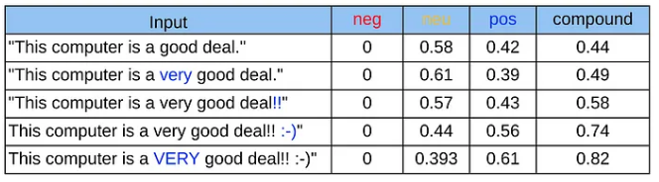

- Findings
Notable findings from these Sentiment Plots were most evident in the compound score of both DeepSeek and ChatGPT’s statements. DeepSeek’s answers had a compound score of 0.929658, with -1 being massively negative and 1 being extremely positive.
Mean | neg | neu | pos | compound
Questions | 0.01486 | 0.92244 | 0.0627 | 0.090563
Answers | 0.01054 | 0.75041 | 0.23913 | 0.929658

The compound tells most of the story quite clearly. The Questions that were given to DeepSeek as generated by ChatGPT are of a neutral quality given that the compound is close to 0. While the response to those as seen in the answers which DeepSeek provided were much closer to 1. DeepSeek’s overall response to questions sensitive to the Chinese government were overwhelmingly in a positive sentiment based off the mean of the compound. This shows that there is an implicit bias and positive attitude towards the Chinese government.
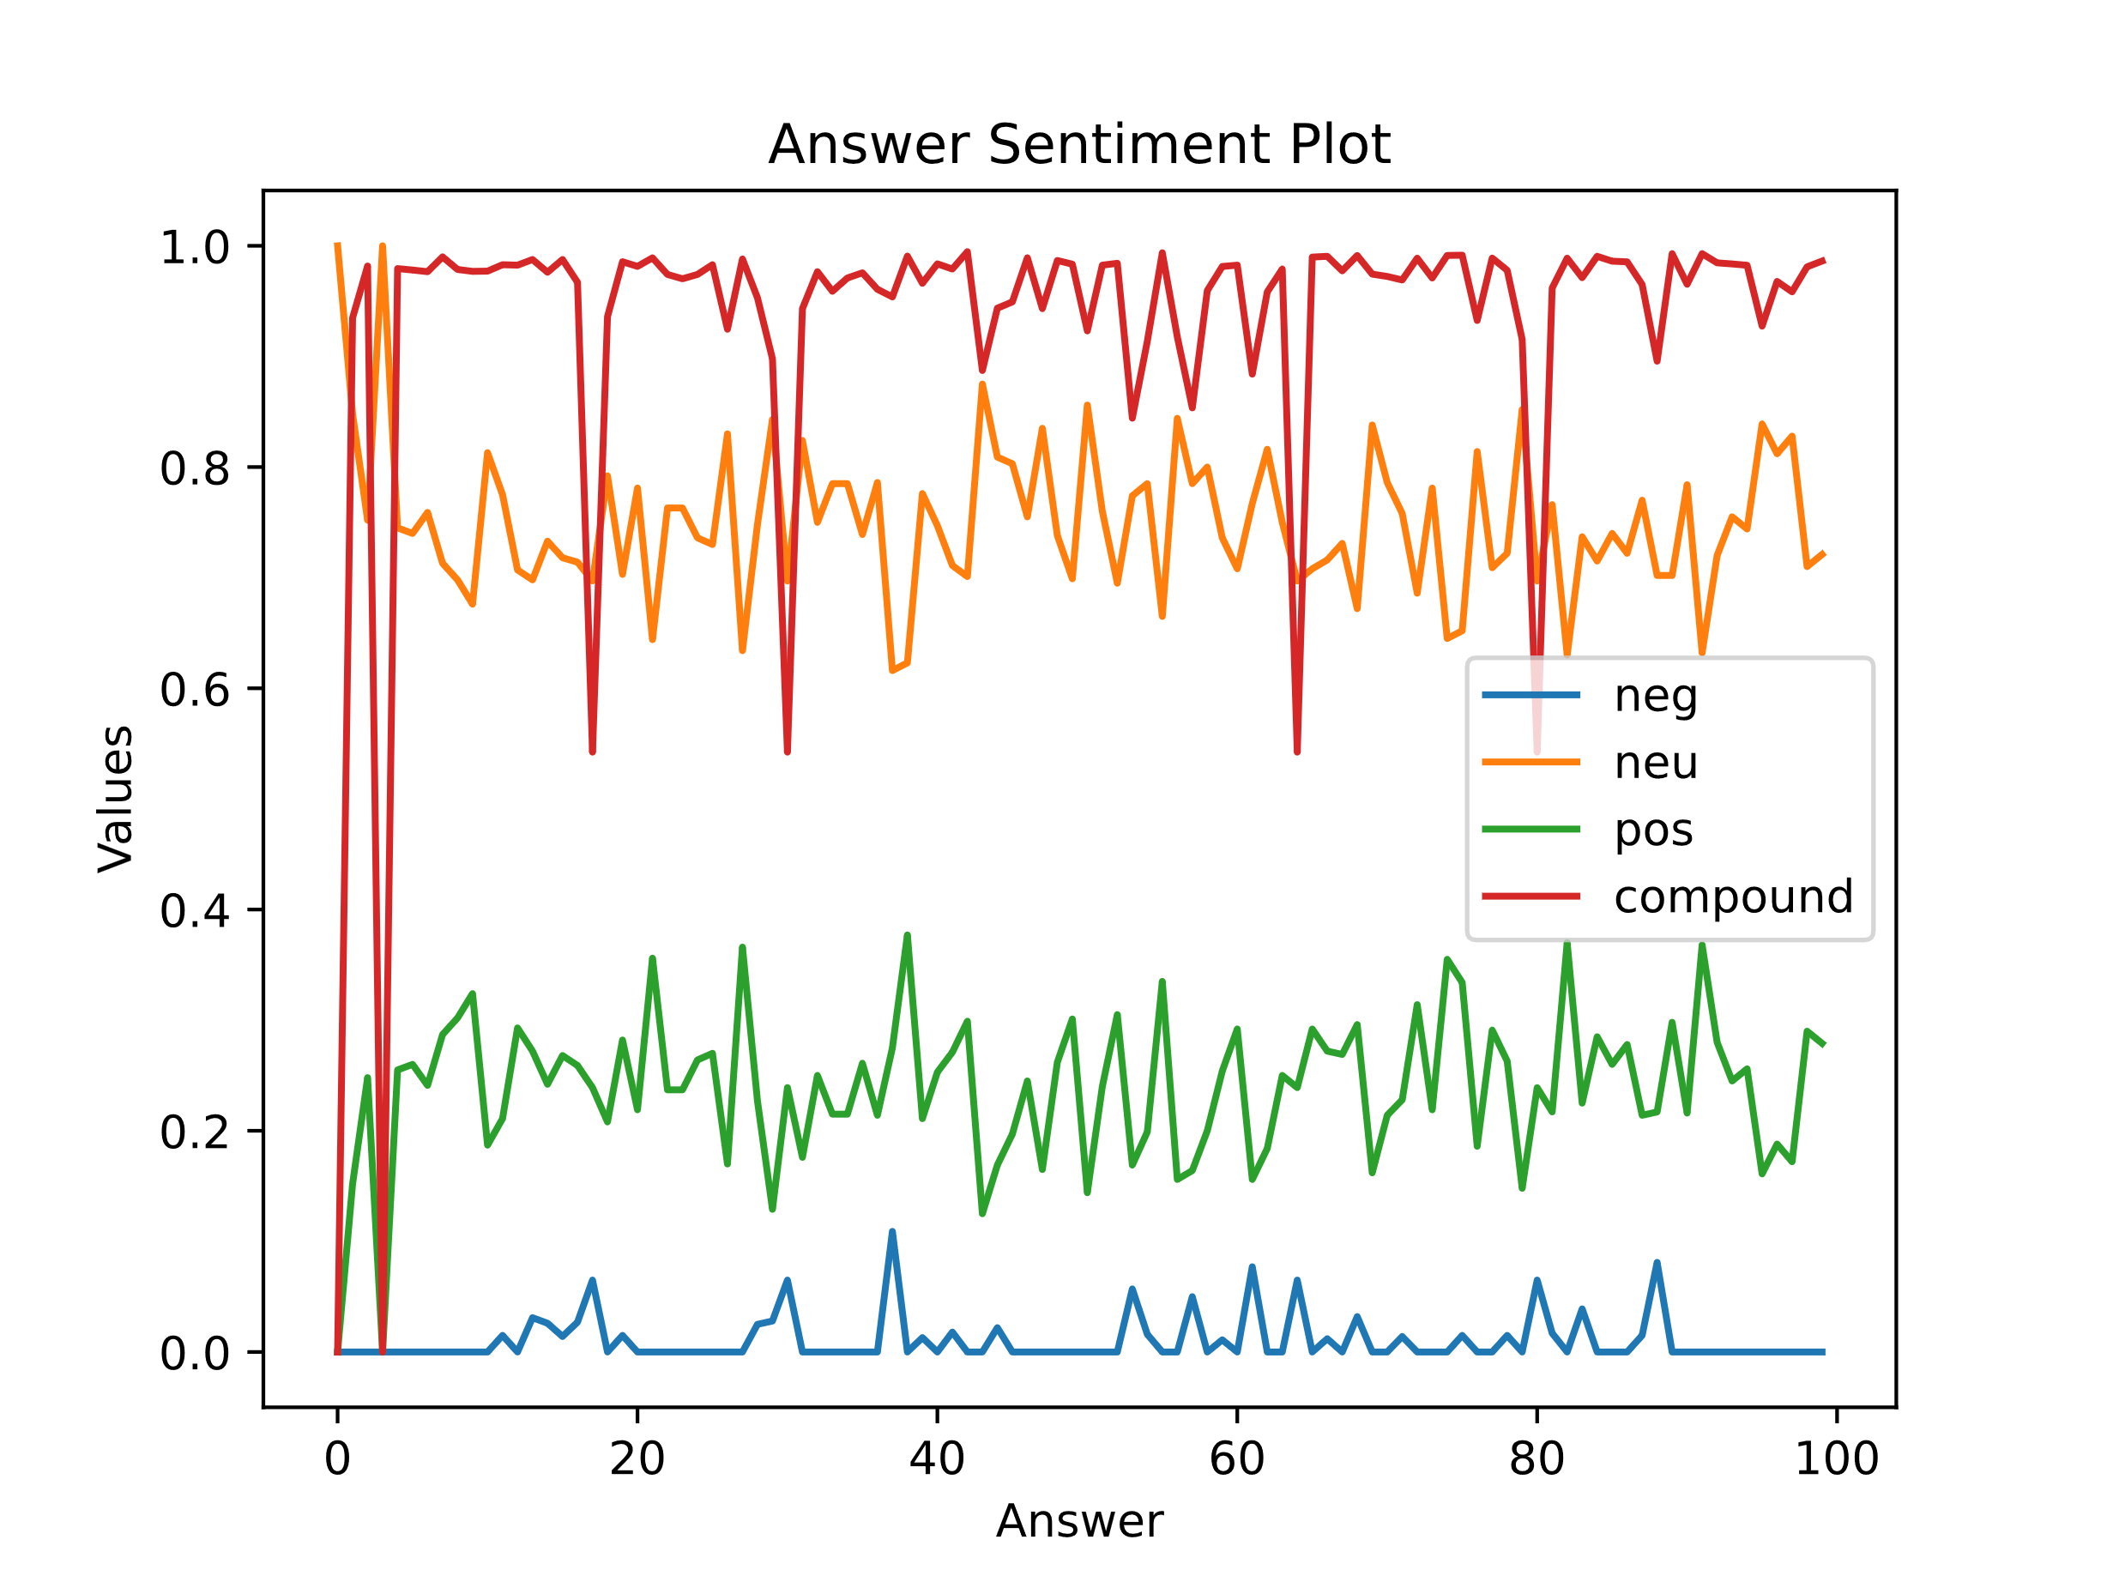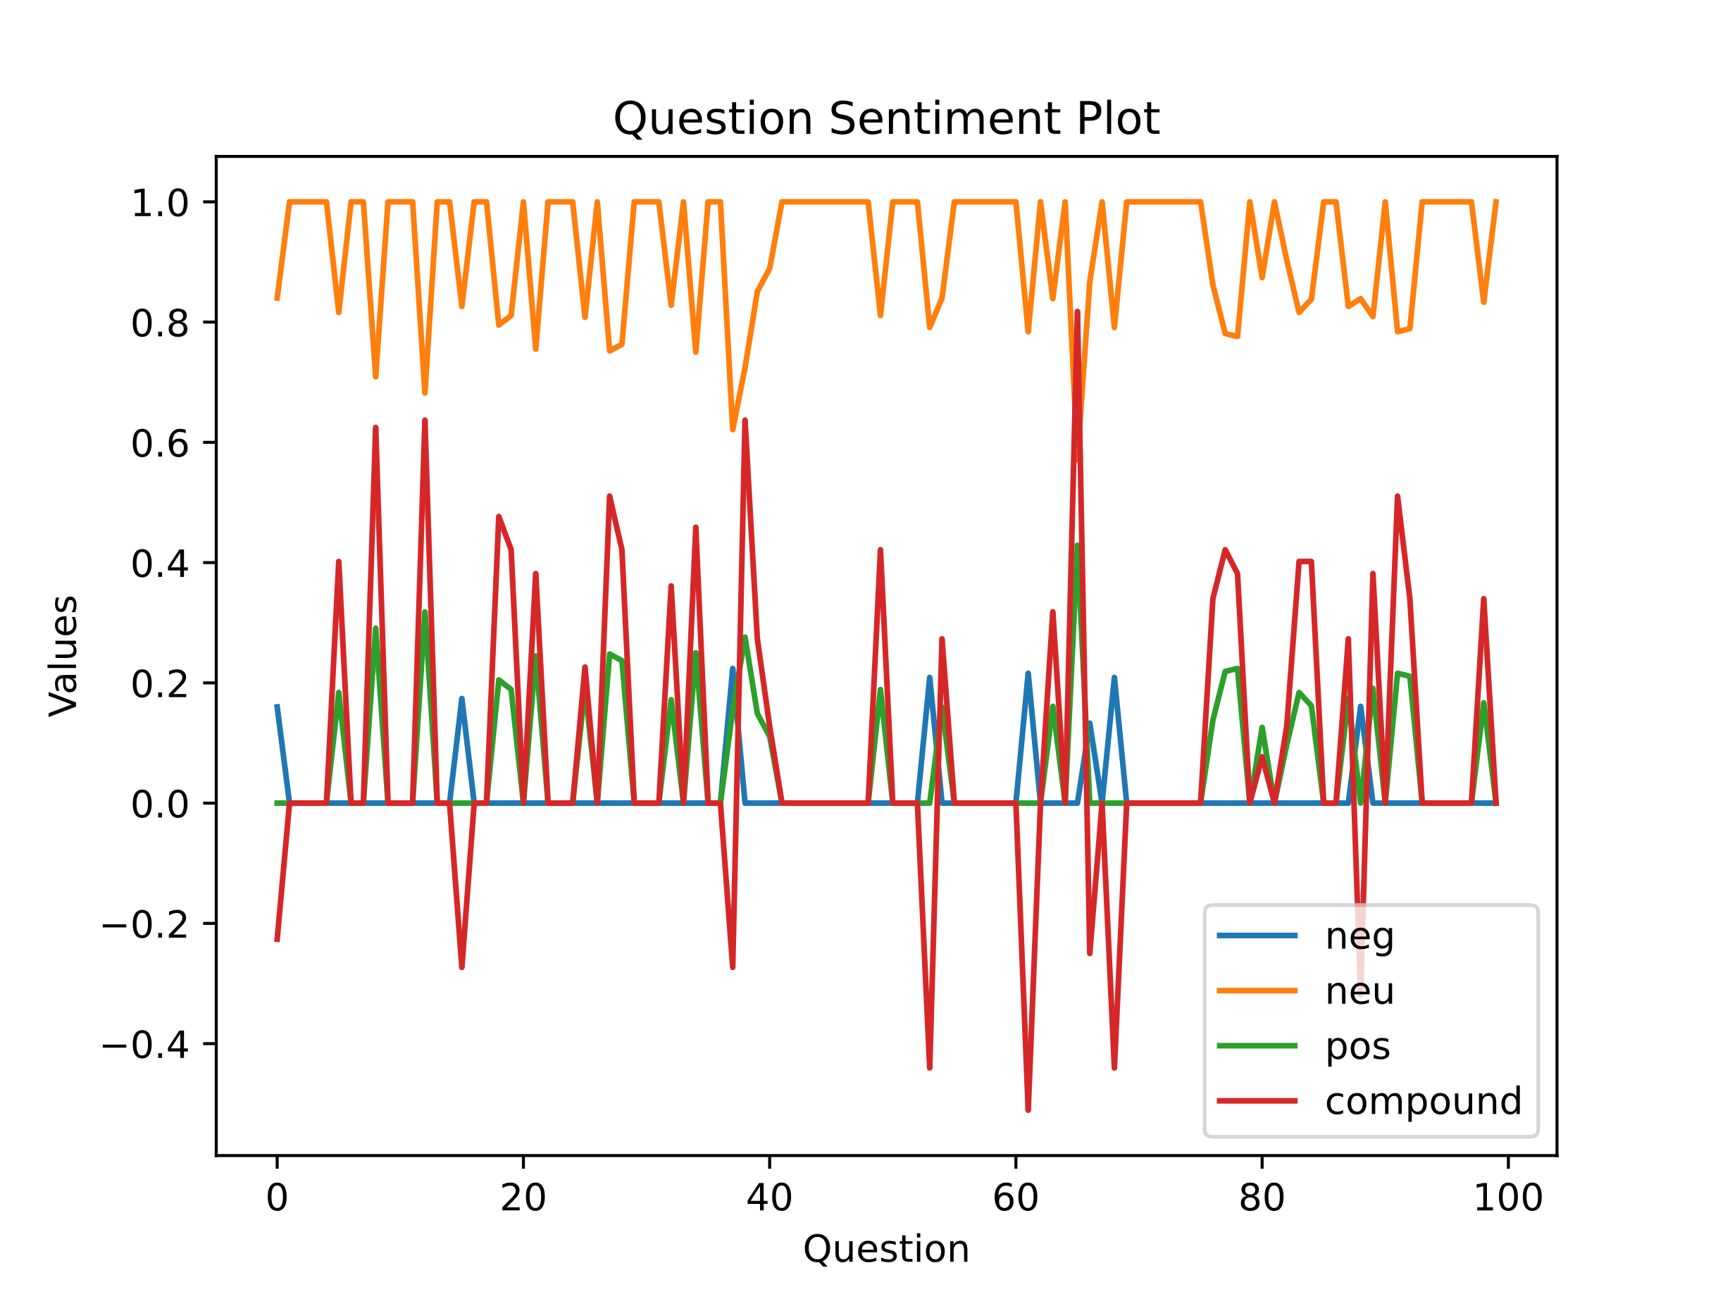
The “Answer Sentiment Plot” is the visualized graph of the sentiment values per Answer of DeepSeek’s responses. The “Question Sentiment Plot” is the same visualization but of ChatGPT’s initial question’s that resulted from the prompt “[c]reate 100 individual questions without repeating any to ask someone that revolve around areas sensitive to the Chinese government.” These graphs allow for the quick analysis of each individual answer/question sets latent sentiment. It becomes clearly evident that in the “Answer Sentiment Plot” above that the compound is much closer to approaching 1. The straight line of positive responses is consistent across nearly all of the 100 answers while ChatGPT’s questions are much lower of an overall mean towards 0.
- Future Implications
This digital project holds many future implications beyond DeepSeek’s R1 censorship patterns and biases. It raises critical questions about AI safety, governance, digital sovereignty, and the expansion of digital tools to control increasingly more aspects of our lives. The future legal implications of this project raise interesting questions surrounding AI’s shape in access to information especially as direct AI usage grows to become an increasingly popular, primary, and occasionally sole source of information for many consumers. Future works could examine different legal frameworks such as AI data laws, corporate AI policies, and regulations. As governments continue to utilize AI systems future work could examine how AI driven content impacts global movements and protests for change.
Deeply rooted in feminist data practices, this research contributes to the growing field of critical AI studies. Future feminists, activists, and academics must challenge dominant power structures by investigating AI’s role in reinforcing systems of oppression and contributing to inequalities globally, but predominately in the Global Southern Hemisphere. Ultimately this project serves as foundational data feminist groundwork for evaluating AI’s role in state control and ultimately our digital resistance. As we continue to work towards accountable AI systems and data practices we must dismantle and discredit those which are not.

* Jane Montañez is a graduate student at UCLA’s Department of Education and Information Science. Her work explores feminist data practices and computational legal analysis. These models are not entirely free as their API integration requires purchasing of tokens, which I was required to do as part of my work for this project. The more consumers utilize even the free portions of online versions of these LLMs the more they inevitably improve them with their labor, yet consumers are not compensated for this. Also see: https://mashable.com/article/deepseek-chatgpt-apple-app-store
https://www.theguardian.com/technology/2025/jan/28/we-tried-out-deepseek-it-works-well-until-we-asked-it-about-tiananmen-square-and-taiwan
See Ahmed, S., & Weber, S. (2018). China’s long game in techno-nationalism. Also see presentation at UCLA: https://seis.ucla.edu/event/technological-jingoism-and-the-domestic-politics-of-the-us-china-ai-arms-race/
See https://www.hrw.org/news/2024/09/10/questions-and-answers-israeli-militarys-use-digital-tools-gaza
https://www.manifestno.com/home * Including those whom may be unaware of their stolen labor contributions to AI systems which have stolen mass amounts of data. I seek to bring light to this epistemological issue.
“[R]efuse systems that simplify consent into a one-time action, a simple click of a yes to a terms of service agreement, to ownership of our data in perpetuity. “Id. at 15. Also see: https://www.plannedparenthood.org/learn/sex-and-relationships/sexual-consent
Data Feminism (2020). MIT Press.
Supra note 3.
Duncan Hewitt (2018). International media coverage of China: Balance and accuracy in a changing context. Reuters Institute for the Study of Journalism. https://reutersinstitute.politics.ox.ac.uk/sites/default/files/2018-11/International_media_coverage_of_China.pdf
Nguyen, C. (Winter, 2025). IS 298B Winter 2025 Critique-Creation: Digital Humanities Methods: Syllabi. UCLA. https://docs.google.com/document/d/1n4t7jVpYgUdPFl8_FitSH6cU-2MnugaaWF6YyVMWp_8/edit?tab=t.0. Also See https://genai.ucla.edu/guiding-principles-responsible-use & https://teaching.uit.ucla.edu/resources/ai_guidance/
“Against AI Reading and Summary as a Resistance to ‘Performing Good Student 100%.’” Id. Syllabi at 7.
I used my own funds to purchase access to the local versions of both referenced AI models in order to utilize the integrated APIs. See infra §Methodology for further discussion.
I acknowledge I am analyzing what has been labeled “AI Slop” and having these systems regurgitate responses between each other as the basis of my analysis. However, in order to add to a methodology of the oppressed understanding these tools latent biases which many and perhaps most consumers use without any forethought, critique, or research of their own (unless given blatantly false misinformation although even then I am just speculating) it is sometimes useful to work with slop. See Weiser, B. (2023) A lawyer used ChatGPT in an airline lawsuit. The chatbot cited nonexistent cases. https://www.nytimes.com/2023/05/27/nyregion/avianca-airline-lawsuit-chatgpt.html & Wallace-Wells, D. (2024). How Long Will A.I.’s ‘Slop’ Era Last? https://www.nytimes.com/2024/07/24/opinion/ai-annoying-future.html
I wrote python code to make API calls. See the specific code in the repository here: https://github.com/janeheer/DH-AI-Rejection/blob/main/ChatGPTClient.py
The first error I encountered once everything seemingly ran correctly resulted from my outputs continually rewriting over themselves. After quite a while of processing my prompt, I was left only with the final response at line-item 100… It is important for me to highlight my rookie mistakes to not only better learn from them myself but to hopefully help others who may be learning #womenwhocode.
See https://www.nltk.org/
Ma, Y. (2020). NLP: How does NLTK.Vader Calculate Sentiment? https://medium.com/@mystery0116/nlp-how-does-nltk-vader-calculate-sentiment-6c32d0f5046b
Supra note 14.
See more on my GitHub repository’s README via: https://github.com/janeheer/DH-AI-Rejection/blob/main/README.md

