**An Investigative Report on Uruguay’s National RealTime Suicide Attempt Surveillance System for Suicide Attempts: Implementation, Legal Context, FirstYear Findings, and a Synthetic Supervised RiskModel Prototype**

**Abstract**

Uruguay launched a realtime national registry of suicide attempts in 2022 to equip services with timely, standardized information for prevention and follow up. I have summarized the first year of operation (2023), during which the system recorded an age standardized attempt rate of 140.44 per 100,000 and a marked predominance among women and adolescents/young adults, with self poisoning as the leading method. To illustrate how surveillance data could support proactive care, I have develop an synthetic supervised learning prototype that estimates the probability of same year repetition at the index presentation. Pipelines include a regularized logistic regression and a calibrated histogram based gradient boosting model, evaluated with a time aware split and probability calibration. Because all data and model outputs are synthetic, results are for workflow demonstration only. I also outline a governance pathway, prospective validation on real data, fairness and calibration monitoring, and human control, that must be required before any operational adoption.

**1. Introduction**

Suicide remains a major public health concern, with an estimated 700,000 deaths annually worldwide (World Health Organization [WHO], 2021). While global mortality has generally declined since 2000, trends in the Americas have been less favorable (Pan American Health Organization [PAHO], 2022). Uruguay has historically reported among the region’s highest suicide mortality rates, prompting the creation of the National Honorary Commission on Suicide Prevention (2011) and a National Suicide Prevention Strategy (2021–2025). An important development within this strategy was the transition, in 2022, from a partially fulfilled paper system to a digital real time registry of suicide attempts, with mandatory reporting across emergency departments and expected submission within 24 hours (Ministerio de Salud Pública [MSP], 2017, 2020, 2024; PAHO, 2018; WHO, 2016).

The registry’s primary aims are to estimate the incidence and repetition of suicide attempts, identify incidence groups, and provide timely information that can guide any care and service allocation. These aims align with international guidance on suicide surveillance and public health ethics (WHO, 2016, 2017). Uruguay’s legal and policy environment, like the Mental Health Law (2017), the National Mental Health Plan (2020–2027), and national clinical guidelines, provides an enabling framework for the registry’s sustainability and quality improvement.

**2. Legal and Policy Context**

Uruguay’s registry is embedded in a multilayered legal architecture. Registration of suicide attempts is mandatory, access to the system is role based and audited, and post attempt care is governed by national clinical protocols (MSP, 2017, 2020, 2024). Complementary policies include expanded access to psychological treatments and a national 24/7 helpline. In this context, the registry functions not as a siloed database but as a tool for ongoing clinical governance and public health action (PAHO, 2018; WHO, 2017).

**3. System Implementation**

Operational definition and coverage. A suicide attempt is recorded when the act is oriented toward ending one’s life, as declared by the person and/or diagnosed by a clinician. All 97 emergency departments report into the system within 24 hours.

Inclusion/exclusion. Nonfatal attempts with confirmed suicidal intent are included; ideation without attempt, accidental injury, and fatal cases (captured via mortality registries) are excluded (PAHO, 2018; WHO, 2016).

Core variables and quality assurance. The registry captures anonymized ID, country of origin, sex, date of birth, method, attempt date, previous attempts, treatment status, referral, healthcare institution, ED of record, and registration timestamp. A central team conducts daily quality checks for completeness and internal consistency.

Ethics and data protection. The registry adheres to WHO surveillance ethics and Uruguay’s data protection regulations; access is limited to authorized staff and fully audited (WHO, 2017).

**3.6 Synthetic Supervised RiskModel Prototype**

Rationale. Follow up after a suicide attempt is time sensitive; the risk of near term repetition is elevated, and structured outreach can improve outcomes (Hawton et al., 2016). Risk scores used with clinician judgment, can help prioritize contact when resources are constrained. To demonstrate this concept without touching personal data, a synthetic prototype that outputs calibrated probabilities of same year repetition at the index presentation, has been created.

I have simulated multiyear records that mirror the registry’s schema and reproduce key 2023 margins: a predominance of women (~71.6%), an age distribution centered around young people, self poisoning as the leading method, modest Monday/Sunday elevation and an October peak, ~50.6% with prior attempts, and ~8.17% with same year repetition (median 54 days). Generation used pandas and NumPy for data structures and sampling (Harris et al., 2020; McKinney, 2010).

Prediction target and features. The binary label was “same year repetition” (present vs. absent Second_Attempt_Date_Same_Year). Candidate predictors were limited to variables observable at or before the index presentation: sex; age; method; month and day of week; previous attempts (yes/no); treatment status (yes/no); healthcare institution; country of origin; and ED of record.

Modeling and validation. I trained two scikitlearn pipelines (Pedregosa et al., 2011): (1) logistic regression with class weighting for interpretability and stable calibration; and (2) histogrambased gradient boosting (nonlinear interactions), followed by CalibratedClassifierCV with isotonic regression to improve probability accuracy (NiculescuMizil & Caruana, 2005; Zadrozny & Elkan, 2002). Preprocessing consisted of imputation, one hot encoding for categoricals, and scaling for numerics within each pipeline. To mimic prospective use and avoid leakage, we used a time based split (earlier years for training; the last year as a holdout). Discrimination was summarized with ROCAUC and PRAUC, and calibration was assessed with reliability curves. Given class imbalance (~8% positive), modest PRAUC is expected; calibration is critical for actionable thresholds.

Output: I persisted trained artifacts with joblib and implemented two action formats: (a) TopK daily triage lists, which are robust when capacity is fixed, and (b) thresholded flags, where the cutoff is selected on the holdout to meet a target precision or recall. For sandbox demonstration, a minimal FastAPI endpoint (served by Uvicorn) provides batched scoring. All artifacts are synthetic only and **nonclinical.**

**4. FirstYear Findings (2023)**

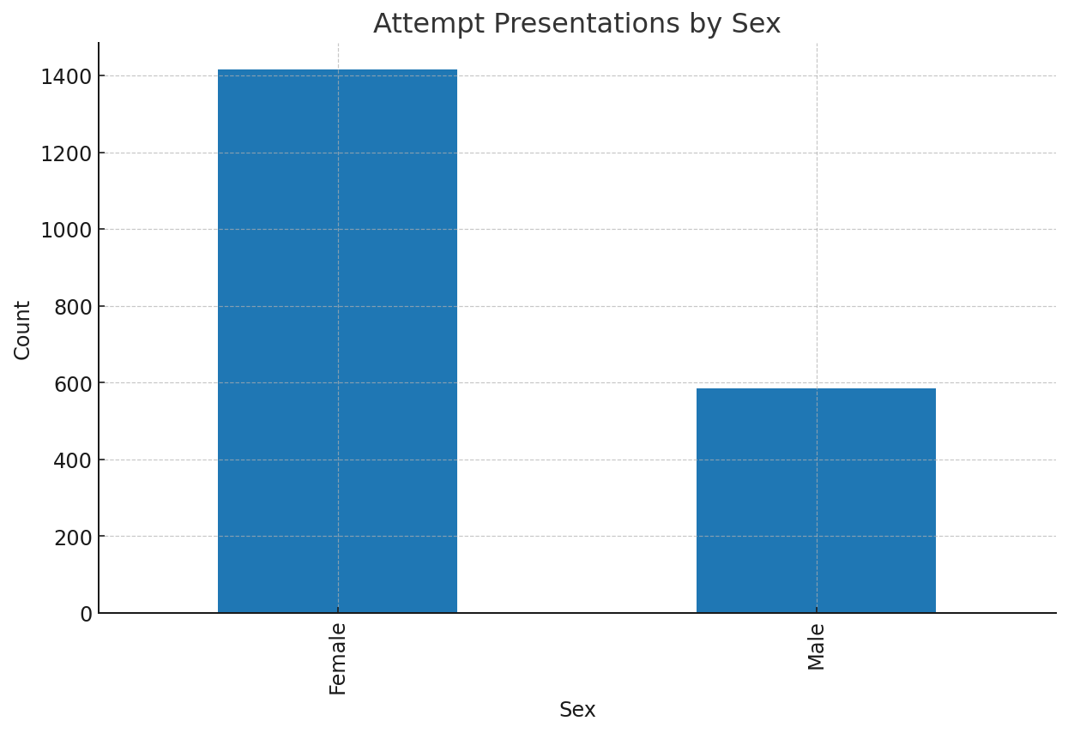

*Figure 1. Attempt presentations by sex.*

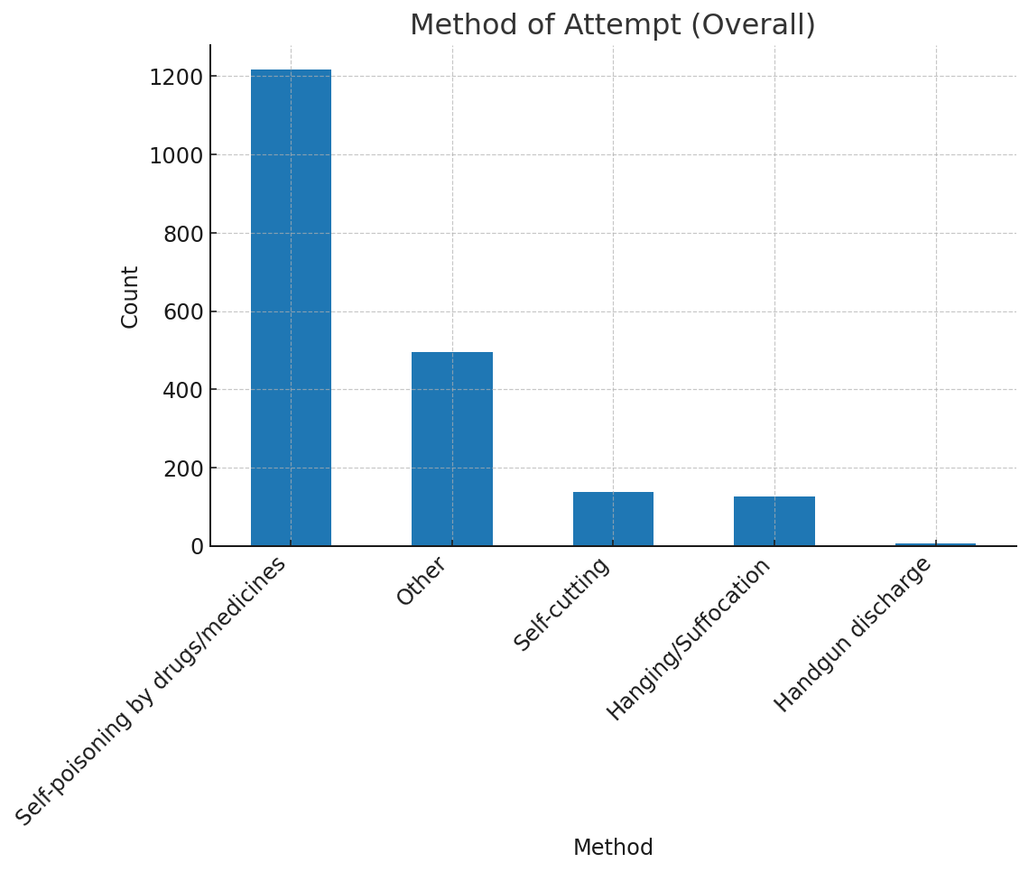

*Figure 2. Method of attempt (overall).*

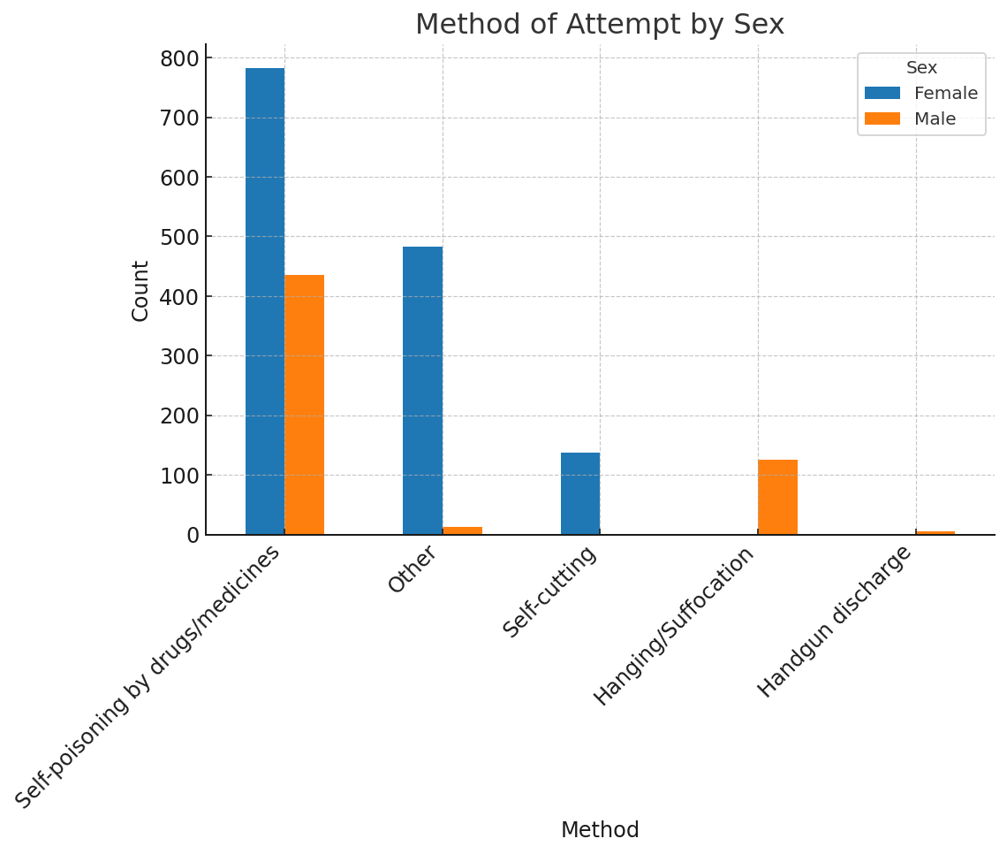

*Figure 3. Method of attempt by sex.*

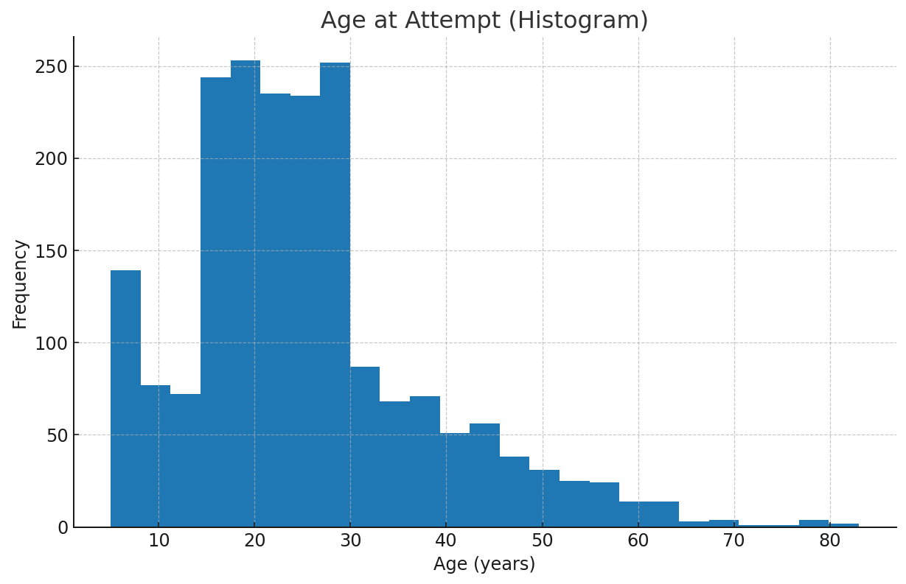

*Figure 4. Age at attempt (histogram).*

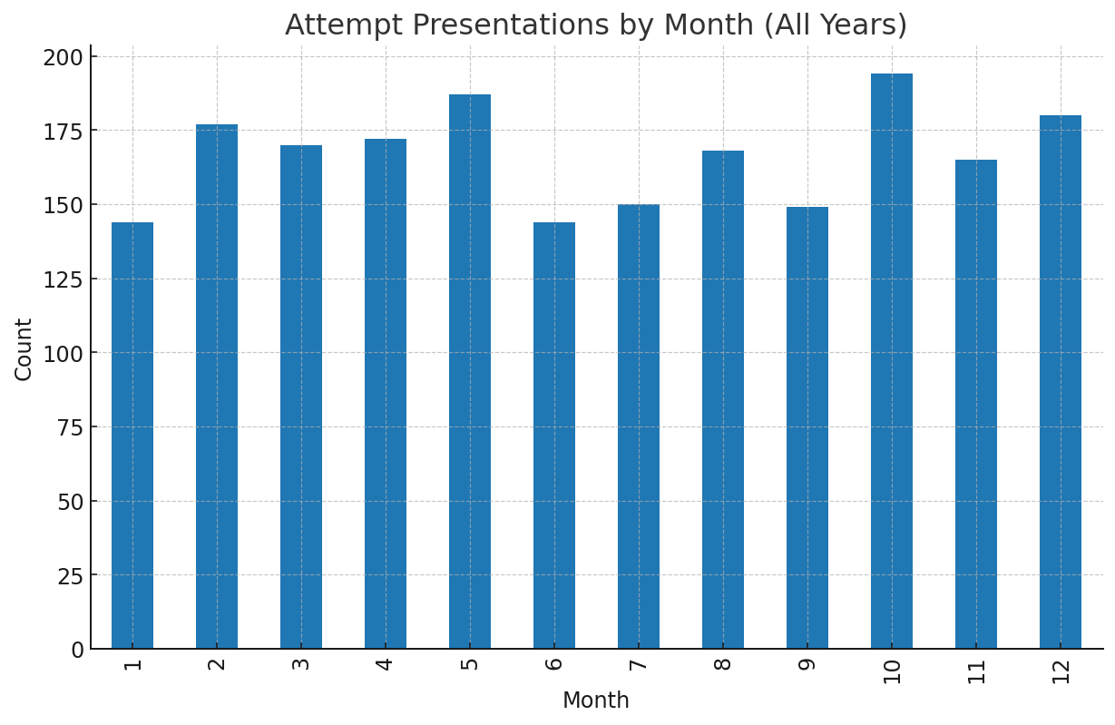

*Figure 5. Attempt presentations by month (all years).*

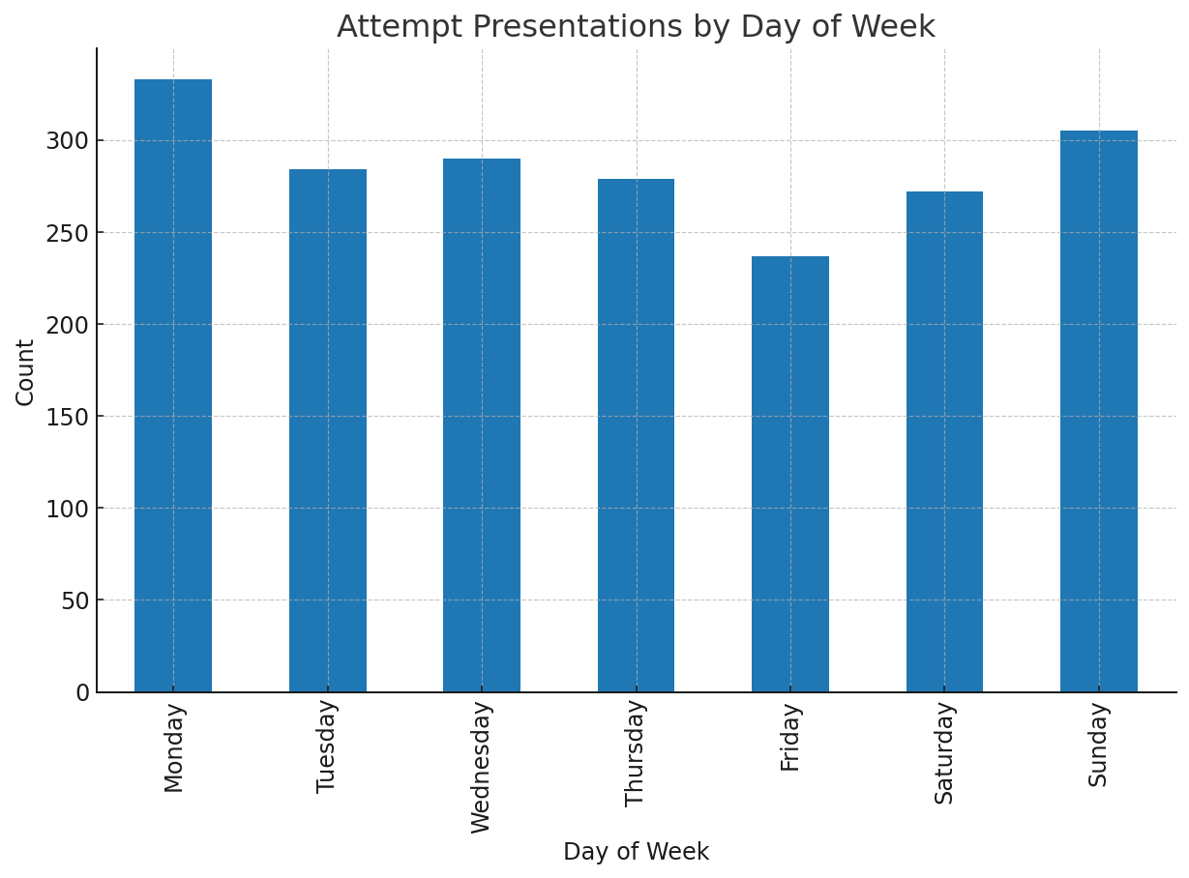

*Figure 6. Attempt presentations by day of week.*

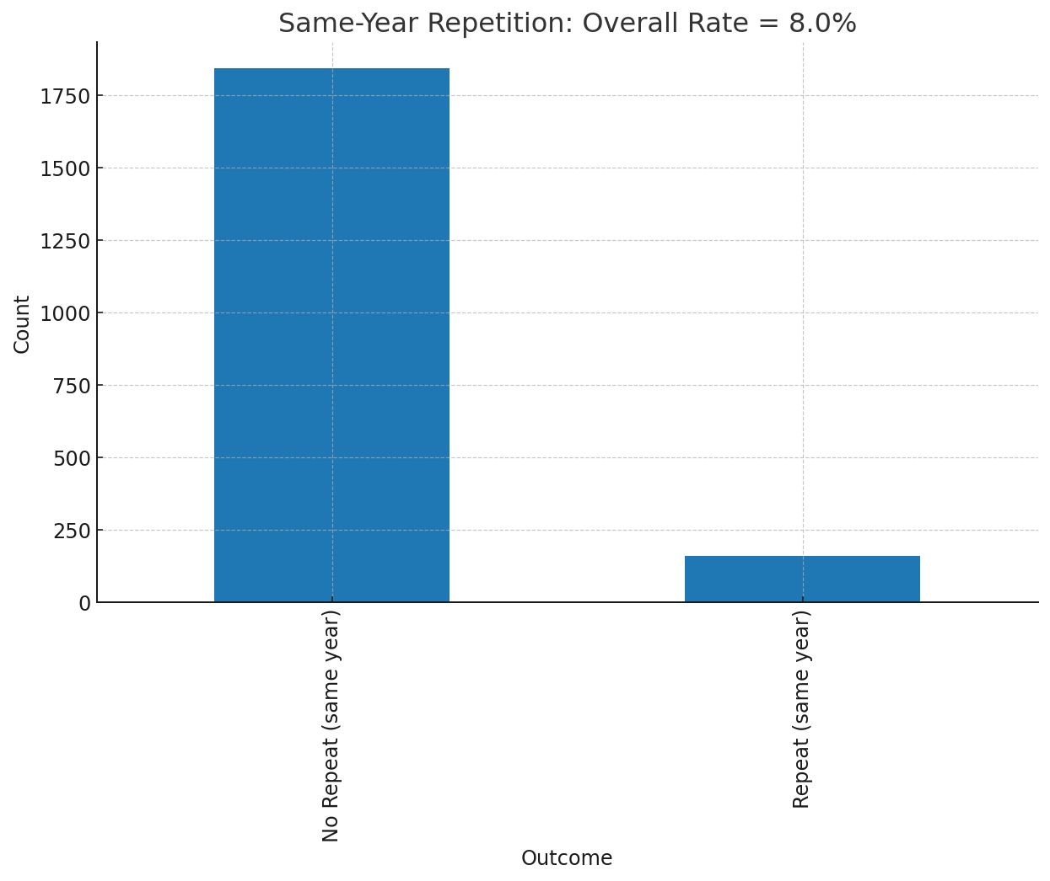

*Figure 7. Same-year repetition (overall).*

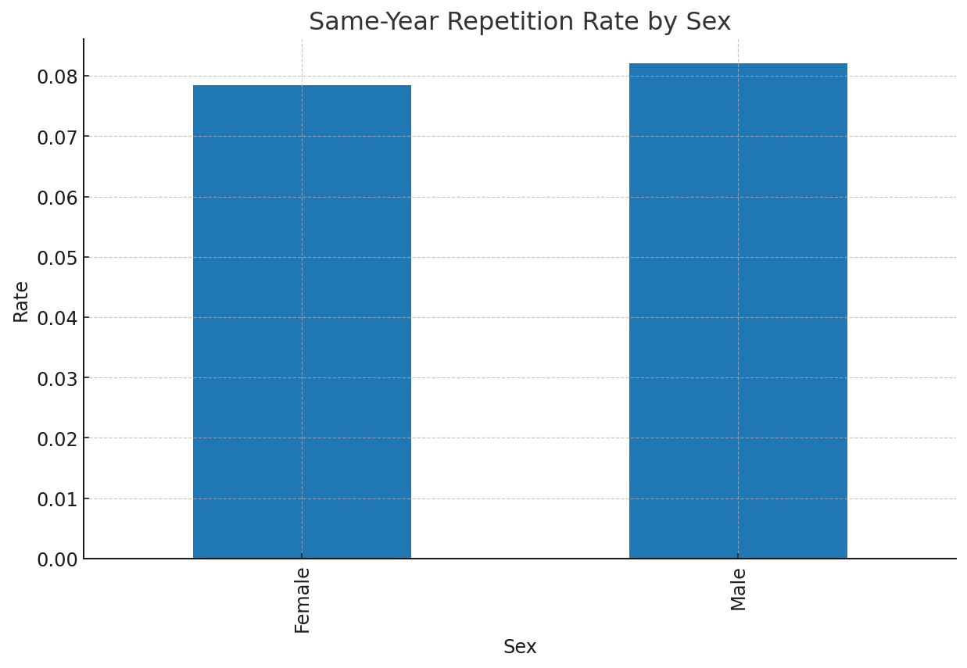

*Figure 8. Same-year repetition rate by sex.*

The registry recorded 4,723 presentations to emergency departments made by 4,274 individuals. The age standardized rate of suicide attempts was 140.44 per 100,000. Women accounted for roughly 71.6% of attempts; more than half of presentations involved individuals under 30 years of age, with a concentration among those aged 15–29. Self poisoning with medicines predominated for both sexes; hanging/suffocation was the second most common method among men, and self cutting among women. Temporally, Mondays and Sundays showed slightly higher counts, October was the peak month, and a small dip was observed during winter school holiday weeks. Approximately half of individuals had a history of previous attempts; 8.17% repeated within the same year (median 54 days). These patterns align with international literature on methods, repetition risk, and seasonality, while underscoring the need for multiple years of observation to confirm cyclical effects and to refine resource planning (Hawton et al., 2016; PAHO, 2018; Valtonen et al., 2006; WHO, 2014, 2016, 2021).

**4.6 Synthetic Demonstration Results (NonClinical)**

On the synthetic holdout, both pipelines produced calibrated probabilities that could be converted to TopK queues or thresholded flags. Reliability plots after isotonic calibration approached the diagonal, indicating improved alignment between predicted and observed risk in the synthetic setting. Because all data are simulated, these figures are illustrative; they validate workflow mechanics (feature contract, calibration, threshold selection, and reporting) rather than clinical accuracy (NiculescuMizil & Caruana, 2005; Pedregosa et al., 2011).

**5. Discussion**

Concept of operations. Used carefully, probability scores can help target limited follow up capacity where the chance of near term repetition is highest, complementing, and thus never replacing clinical assessment. Two pragmatic patterns are common: (1) TopK daily triage lists sized to staff capacity; and (2) calibrated thresholds tuned to achieve service goals (e.g., target precision to limit false positives or target recall to capture most representers). Thresholds should be re estimated periodically as coverage and prevalence shift.

Governance and safety. Any application to real persons requires (i) prospective validation on registry data with time aware splits; (ii) calibration monitoring and periodic recalibration; (iii) fairness review across sex and age strata and by attempt method; (iv) transparent model documentation and immutable audit logs; and (v) explicit articulation of the tradeoffs between false negatives (missed representations) and false positives (additional outreach) (NiculescuMizil & Caruana, 2005; WHO, 2017; Zadrozny & Elkan, 2002). Decisions remain with licensed clinicians under national law and guidelines (MSP, 2017, 2020, 2024).

Limitations. The demonstration uses synthetic data; no claims are made about realworld performance. The outcome, same year repetition, is a proxy; operational deployments may prefer 30 or 90day endpoints or time to event models. Early under ascertainment in a new registry can bias both the estimated prevalence and the label distribution; calibration and thresholds must be reestablished when coverage stabilizes. Finally, no diagnoses, clinical severity, or medication detail are included, as adding these requires a lawful basis and careful privacy design.

**6. Conclusions**

Uruguay’s real time registry has strengthened the ability to monitor suicide attempts, understand repetition, and inform policy in near real time. The synthetic supervised prototype demonstrates a feasible path to calibrated, auditable risk informed follow up, provided that any real data deployment is preceded by rigorous validation, fairness and calibration monitoring, and human controlled safeguards. With these guardrails, the registry can underpin a continuous improvement cycle linking surveillance, prioritized follow up, and evaluation.

**References (APA)**

Benson, R., Rigby, J., Brunsdon, C., Cully, G., Too, L., & Arensman, E. (2022). Quantitative methods to detect suicide and selfharm clusters: A systematic review. International Journal of Environmental Research and Public Health, 19(9), 5313.

Bostwick, J. M., Pabbati, C., Geske, J. R., & McKean, A. R. (2016). Suicide attempt as a risk factor for completed suicide: Even more lethal than we knew. American Journal of Psychiatry, 173(11), 1094–1100.

Harris, C. R., Millman, K. J., van der Walt, S. J., Gommers, R., Virtanen, P., Cournapeau, D., … Oliphant, T. E. (2020). Array programming with NumPy. Nature, 585(7825), 357–362.

Hawton, K., Witt, K. G., Salisbury, T. L., Arensman, E., Gunnell, D., Hazell, P., Townsend, E., & van Heeringen, K. (2016). Psychosocial interventions following selfharm in adults: A systematic review and metaanalysis. The Lancet Psychiatry, 3(8), 740–750.

McKinney, W. (2010). Data structures for statistical computing in Python. In Proceedings of the 9th Python in Science Conference (SciPy 2010) (pp. 51–56).

Ministerio de Salud Pública. (2017). Protocolo de atención y seguimiento a las personas con intento de autoeliminación en el SNIS.

Ministerio de Salud Pública. (2020). Plan Nacional de Salud Mental 2020–2027.

Ministerio de Salud Pública. (2024). Guía de práctica clínica: Abordaje de la conducta suicida (SNIS).

NiculescuMizil, A., & Caruana, R. (2005). Predicting good probabilities with supervised learning. In Proceedings of the 22nd International Conference on Machine Learning (pp. 625–632).

Pan American Health Organization. (2018). Manual de prácticas para el establecimiento y mantenimiento de sistemas de vigilancia de intentos de suicidio y autoagresiones.

Pan American Health Organization. (2022). Mortalidad por suicidio en la Región de las Américas: Informe regional 2015–2019.

Pedregosa, F., Varoquaux, G., Gramfort, A., Michel, V., Thirion, B., Grisel, O., … Duchesnay, É. (2011). Scikitlearn: Machine learning in Python. Journal of Machine Learning Research, 12, 2825–2830.

World Health Organization. (2014). Preventing suicide: A global imperative.

World Health Organization. (2016). Practice manual for establishing and maintaining surveillance systems for suicide attempts and selfharm.

World Health Organization. (2017). Guidelines on ethical issues in public health surveillance.

World Health Organization. (2021). Suicide worldwide in 2019: Global estimates.