SOA Automatic running of SoapUI Testsuits over MAC

Table of Contents
#1 Download and Install SOAP UI Free Tool on Mac PC 2
#2 Import .zip SOA Soap Project file: 3
#3 SoapUI Tool Terminologies 4
#4 Setting SoapUI Auto Job, which runs during weekdays @10 am. 5

#1 Download and Install SOAP UI Free Tool on Mac PC
http://sourceforge.net/projects/soapui/files/soapui-intellij-plugin/4.0.1/

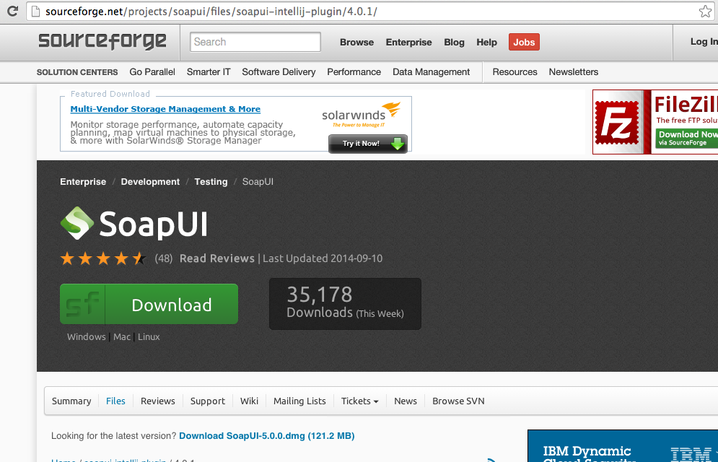

#2 Import .zip SOA Soap Project file:
Create New Folder “SOAPUI” in you home folder, then creates “Reports” folder inside it . Directory structure should looks like ‘/Users/vthakur/SOAPUI/Reports’
File is attached in email to be imported using “Import Packed Project” Option, and follow the process unzip in “SOAPUI” folder.

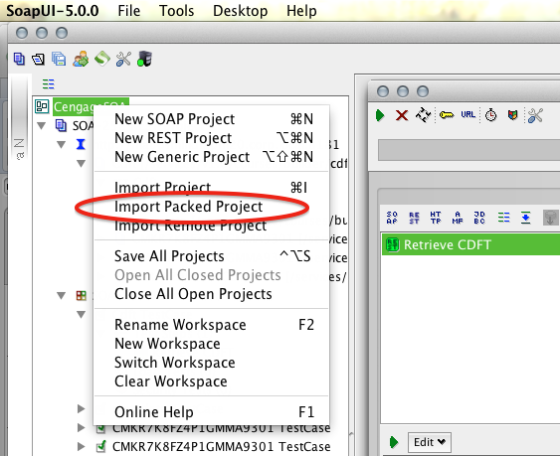

#3 SoapUI Tool Terminologies
a. REST Services Endpoint (Representational state transfer )
http://mabosmindtapm20.corp.local/services/v1.0/courses/builder/cdft/metadata
b. Workspace > Project (SOAP or REST)
c. Generate Testsuite
d. Method: GET, PUT, POST, DELETE, HEAD
c. Payload Example:
{"title": "new title", "displayName": "new desc", "startDate": 1111, "endDate":9999}
d. Response: XML, JSON, HTML, RAW

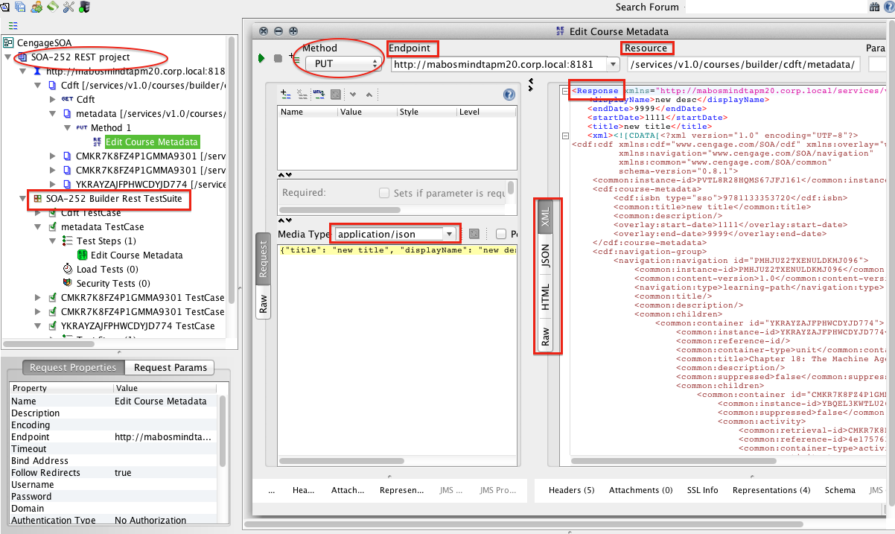

#4 Setting SoapUI Auto Job, which runs during weekdays @10 am.
Used Crontab Job > Run on Weekday @ 10AM and Store reports Results in Local directory /Users/vthakur/SOAPUI/ and Send reports to Group.

// A. Create a Shell file “soapAutomator.sh” lives SOAPUI folder
- cd /Applications/SoapUI-5.0.0.app/Contents/java/app/bin
- sh testrunner.sh -s"SOA-252 Builder Rest TestSuite" -r -a -f/Users/vthakur/SOAPUI/Reports /Users/vthakur/SOAPUI/REST-Project-1-soapui-project.xml

// B. Setting Crontab Job in Terminal
sudo -u
crontab -u vthakur -e
00 10 * * 1,3,5 sh /Users/vthakur/SOAPUI/soapAutomator.sh

