INEURON

**INSURANCE PREMIUM PREDICTION**

WIREFRAME

**Homepage:**

*The user is entered in to the homepage as shown below. He/she can view the homepage to predict the person’s health insurance.*

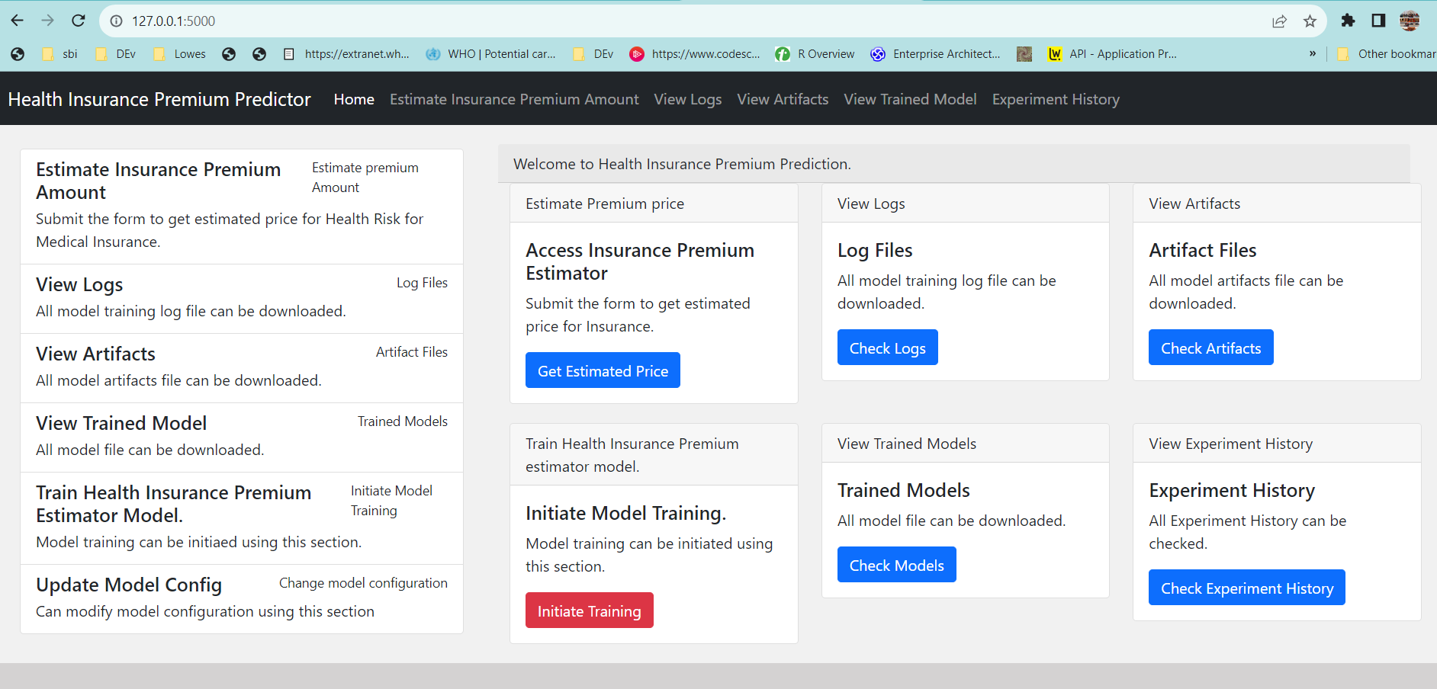

**Details page:**

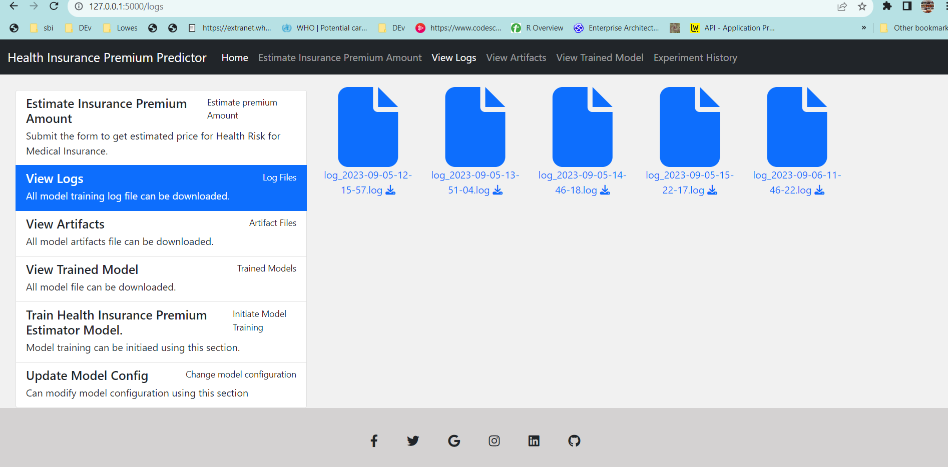

**Results Page:**

*After enter the details of the person in the form the user can view the results in the result page.*

