

OCTO-DE Benefit Tools Crew | Accredited Representation Management
April, 2026 | Find a Representative
Version 3.0

Revision History
Date | Version | Description | Author
12/5/2023 | 1.0 | MVP: Minimum Viable Product | Lindsay Li-Smith
2/26/2024 | 2.0 | Adjustments and enhancements based on UX research findings | Lindsay Li-Smith
4/26/2024 | 2.1 | Corrected links to reflect the most up-to-date URLs | Lindsay Li-Smith
6/14/2024 | 2.2 | Removed the “Other” input field for the Report Outdated Information feature | Lindsay Li-Smith
7/25/2024 | 2.3 | Removed the Report Outdated Information feature | Lindsay Li-Smith
9/6/2024 | 2.4 | Added in a FAQ #10 and resource #4 below | Lindsay Li-Smith
7/31/2025 | 2.5 | Added guidance on how representatives can update their contact information to the Major Issues and Error Messages section | Lindsay Li-Smith
2/2026 | 2.6 | Added mention of address approximation, updated team contact emails | Jennifer Seipel
3/20/2026 | 3.0 | Added in the Veterans Service Organization (VSO) combo search box | Mia Bottcher

Table of Contents
1. Product Overview 4
2. User Access 4
3. Navigation 4
4. Functionality 5
5. Major Issues and Error Messages 8
6. Frequently Asked Questions 11
7. Table of Figures 12

1. Product Overview
The Find a Representative product is a user-friendly, accessible tool for Veterans to search for an accredited representative on VA.gov, intended to mirror the representative search functionality of older tools: OGC and eBenefits.
Users will be able to search for representatives based on:
- Type of accredited representative (*Required)
  - Veteran Service Officer (VSO), attorney, claims agent
- Location (*Required)
  - Address, city, state, or postal code
  - “Use my location”
- Search area
  - Defaults to 50 miles
  - Other options: 5 miles, 10 miles, 25 miles, 100 miles, 200 miles, Show all
- Name of accredited representative
  - Open text input field
- Veterans Service Organization
  - Combo box input field

2. User Access
All users will have access to the Find a Representative product; authentication is not required for this experience.

3. Navigation
Accredited Representative Landing Page
Most of the benefits pages on VA.gov will have a link that points to our landing page “Get help from a VA accredited representative”, often in the “What if I need help?” (or similar) section towards the bottom of the page.

The URL for this landing page will be https://va.gov/get-help-from-accredited-representative.

Find a Representative Product Page
The landing page mentioned above will link to our Find a Representative product page, which will have a URL of https://va.gov/get-help-from-accredited-representative/find-rep.

Search
Users will also be able to find our Find a Representative tool through the VA.gov search in the “Our top recommendations for you” section.

The landing page and product page will appear in this section of search results, for any searches on VA.gov that match key words in the page title or description.

4. Functionality
Search for an Accredited Representative
Users will be able to search for accredited representatives based on the following parameters:
- Type of accredited representative (*Required)
  - Veteran Service Officer (VSO), attorney, claims agent
- Location (*Required)
  - Address, city, state, or postal code
  - “Use my location”
- Search area
  - Defaults to 50 miles
  - Other options: 5 miles, 10 miles, 25 miles, 100 miles, 200 miles, Show all
- Name of accredited representative
  - Open text input field
- Veterans Service Organization (VSO)
  - Combo box input field
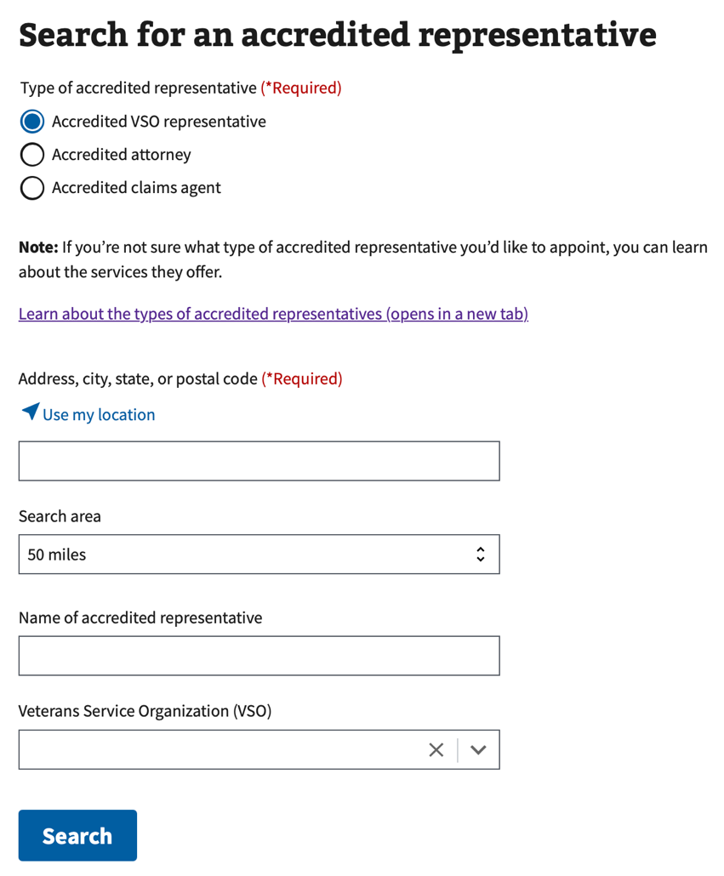

Figure 1. Search criteria for Find a Representative.
Search Results
A list of representatives matching the user’s search parameters will be displayed, with 10 results per page.
The search results will include the following representative details:
- Distance in miles
  - If no valid street address is found for the representative, an estimated distance will be displayed based on
- Full name
- Associated organization(s)
- Address (clickable, opens Google Maps in a new tab)
- Phone number (clickable, initiates a phone application)
- Email (clickable, initiates an email application)
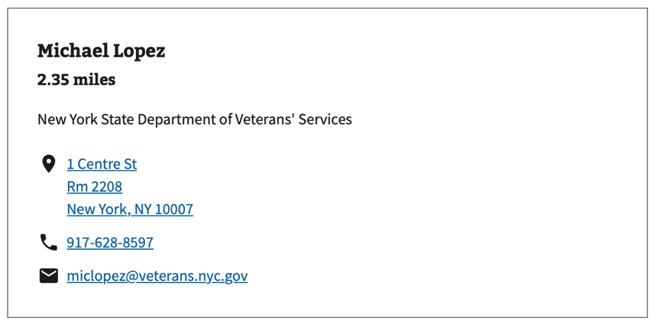
Figure 2: Example of a representative in search results with exact location.
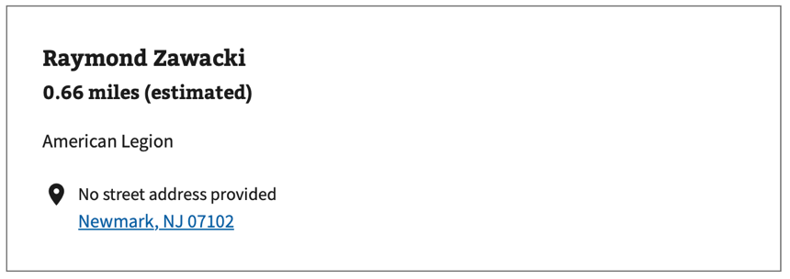
Figure 3: Example of a representative in search results with estimated location.

The search results allow the following “Sort by” options:
- Distance (closest to farthest) - default
- First name (A - Z)
- First name (Z - A)
- Last name (A - Z)
- Last name (Z - A)
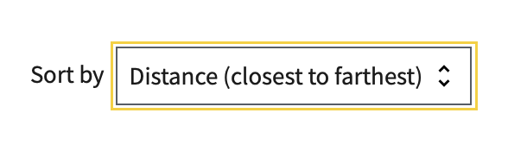
Figure 4. Default sort.
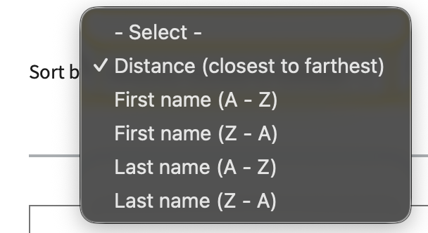
Figure 5. All sort options.

5. Major Issues and Error Messages
If the Find a Representative page is not loading for users, please ensure they are using the most updated version of their browser and/or operating system.

If a user tries to search without entering a location, the location input field will become highlighted in red with an error message “Please enter a valid location.”:
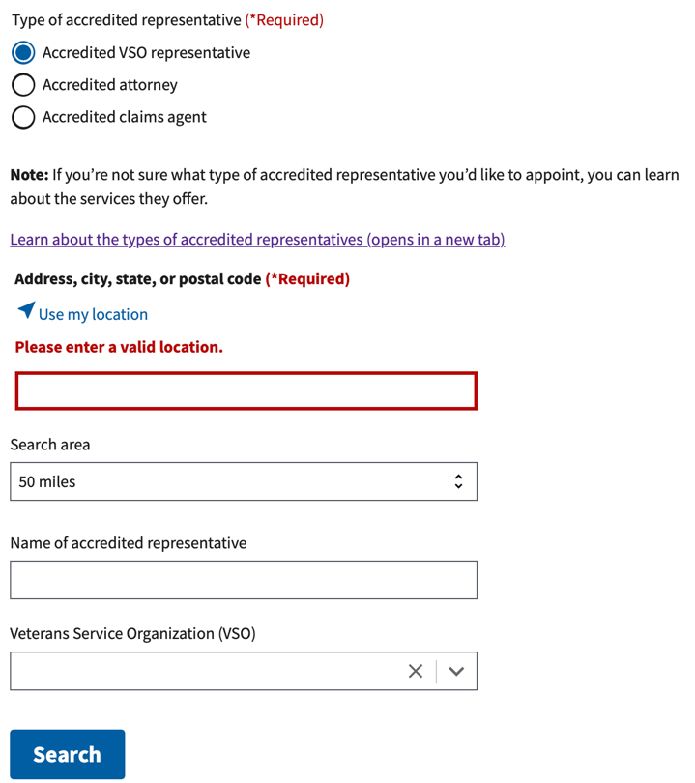
Figure 6. Error message when a location has not been specified.
If a user has not enabled location sharing in their browser and tries to “Use my location”, a “We need to use your location. Please enable location sharing in your browser to use this feature.” alert will appear:
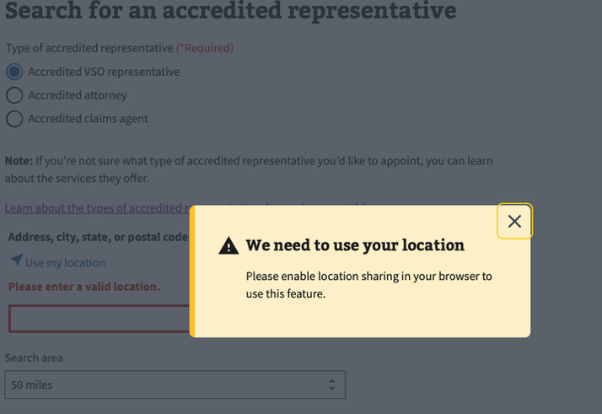
Figure 7. Alert when location sharing is disabled.
If there is an issue retrieving search results, whether that’s with the VA network or our connected location service (Mapbox), a general “We’re sorry, something went wrong. Please try again soon.” alert will appear below the Search button:
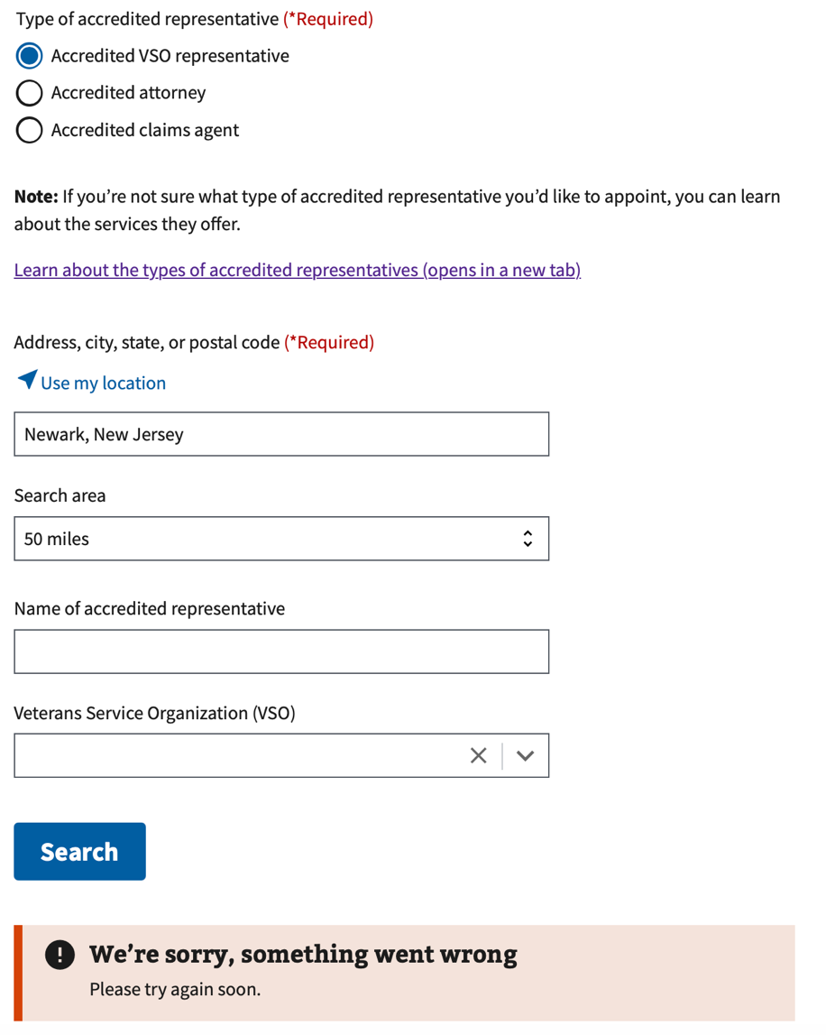
Figure 8. General alert when there is an issue with retrieving search results.
If a representative notices that their contact information is incorrect and requests an update, they will need to send their update request to the Office of General Council. Please see instructions here for messaging that can be copy and pasted into email responses: https://github.com/department-of-veterans-affairs/va.gov-team/blob/master/products/accredited-representation-management/product-documentation/find-a-representative/how-to-update-representative-contact-information.md

6. Frequently Asked Questions
Users may have the following questions, when using this product:
- What's the differences between accredited representatives (VSOs, attorneys, claims agents)?
- What makes a representative accredited?
- Do accredited representatives charge fees?
- How do I appoint an accredited representative?
- How can an accredited representative help me?
- Does an accredited representative have to help me?
- Can I work with more than one accredited representative at a time?
- Can I work with an accredited representative online or over the phone?
- How do I cancel my representation?
- What if the representative contact information is incorrect?

Answers to these questions, and additional information about accredited representatives can be found on:
- The top of the “Find a Representative” product page includes definitions of each type of accredited representative: https://va.gov/get-help-from-accredited-representative/find-rep
- The “Get help from an accredited representative” landing page includes information on how to find and appoint an accredited representative: https://va.gov/get-help-from-accredited-representative
- The “FAQ” page includes additional information about accredited representatives: https://www.va.gov/resources/va-accredited-representative-faqs/
- Guidance for updating representative contact information: https://github.com/department-of-veterans-affairs/va.gov-team/blob/master/products/accredited-representation-management/product-documentation/find-a-representative/how-to-update-representative-contact-information.md

7. Table of Figures
Figure 1. Search criteria for Find a Representative. 5
Figure 2: Example of a representative in search results with exact location. 6
Figure 3: Example of a representative in search results with estimated location. 6
Figure 4. Default sort. 6
Figure 5. All sort options. 7
Figure 6. Error message when a location has not been specified. 8
Figure 7. Alert when location sharing is disabled. 8
Figure 8. General alert when there is an issue with retrieving search results. 9

