CentOS Multi VM Web Infrastructure Lab
Portfolio case study | 2026
Prepared by Adetoun Janet Adewusi
Project overview
I documented a virtualized CentOS lab with one front-end load balancer and three web-server virtual machines. The work covered VM networking, host resolution, Apache web services, firewall and SELinux configuration, NGINX load-balancing configuration, and service checks. The screenshots and lab notes provide evidence of the environment and browser responses.
This is a portfolio record of a VM-based lab. The original VM disks and configuration files are not part of this document, so it is not presented as a ready-to-run software repository.

Lab environment
Component | Role in the lab
CentOS_HA | Front-end host for NGINX load balancing
CentOS_WS1 | Apache web server with its own test page
CentOS_WS2 | Apache web server with its own test page
CentOS_WS3 | Additional Apache backend in the lab topology
Oracle VirtualBox | Virtual machine environment; the notes show bridged networking

Architecture
A browser request is directed to the NGINX host, which can distribute requests across the Apache web servers. The lab notes cover least-connections and round-robin configurations, including a test with one server unavailable.
Request path | Host | Service
Browser | CentOS_HA | NGINX front end
Forwarded request | CentOS_WS1 / WS2 / WS3 | Apache backends

Configuration and validation
The lab record follows the work from virtual-machine setup through service checks. The stages below summarize the documented steps without reproducing machine-specific account names or local network details.

1. Build the VM environment
Cloned and named the load-balancer VM and three web-server VMs in VirtualBox, then configured bridged networking.

2. Configure networking
Checked interface addresses, set hostnames, added host entries, and tested connectivity between the VMs.

3. Prepare the web servers
Installed and started Apache on the backend hosts, opened the required firewall service, and created distinct pages for the servers.

4. Configure the front end
Prepared the NGINX host, opened its firewall access, enabled the SELinux network setting noted in the lab, and backed up the NGINX configuration before changes.

5. Exercise load-balancing options
The notes document a least-connections configuration and test, plus a round-robin configuration with one backend unavailable.

6. Check services and logs
Reviewed service status and logs and opened the hosted pages in a browser to check the web-server responses.

Skills shown
- CentOS Linux administration and command-line work
- VirtualBox VM setup and bridged networking
- Hostnames, /etc/hosts, interface checks, and connectivity testing
- Apache web-server setup and firewall configuration
- NGINX configuration and load-balancing concepts
- SELinux awareness, service status checks, and log review

Evidence and project status
The VM inventory screenshot shows the lab machines. Browser screenshots show distinct pages from two web-server hosts through the lab network address. The accompanying lab notes record the networking, service, firewall, NGINX, and logging steps. The VM disks and original configuration files are not included; this document preserves the available evidence after the computer change.

Selected lab evidence
The screenshots below are selected from the lab record. They show the VM inventory and the distinct web pages served by two backend machines.
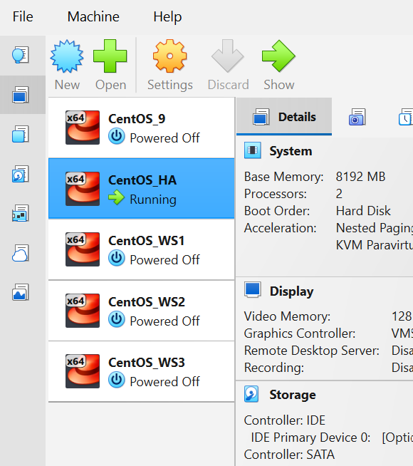
VirtualBox inventory showing the load-balancer and web-server VMs
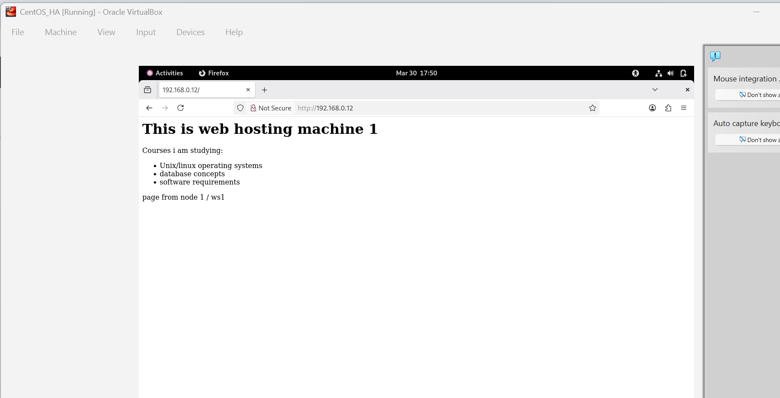 | 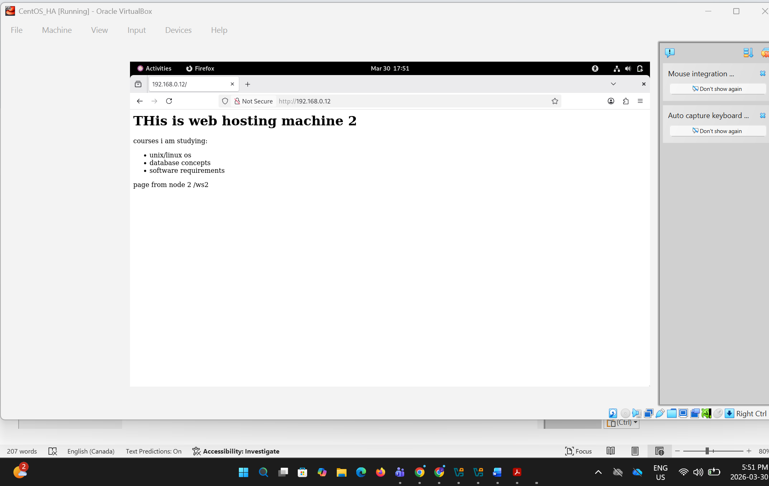
Backend response: web hosting machine 1 | Backend response: web hosting machine 2

