Name: Janet Adetoun Adewusi
Date: 2026-02-27

Questions [20 marks]
1
Create 2 tables based on the ER diagram shown below. Include necessary constraints in the CREATE TABLE statements. Name all constraints except NOT NULL properly
YHLI.GUEST TABLE
CREATE TABLE YHLIGUEST (
GUEST_ID NUMBER(8) NOT NULL,
FIRSTNAME VARCHAR2(50) NOT NULL,
LASTNAME VARCHAR2(50) NOT NULL,
CONTACT_NO NUMBER(10) NOT NULL,
EMAIL VARCHAR2(50) NOT NULL,
ADDRESS VARCHAR2(100) NOT NULL,
LOYALTY_PROGRAM VARCHAR2(8) NOT NULL,
CONSTRAINT GUEST_GUEST_ID_PK PRIMARY KEY (GUEST_ID)
);
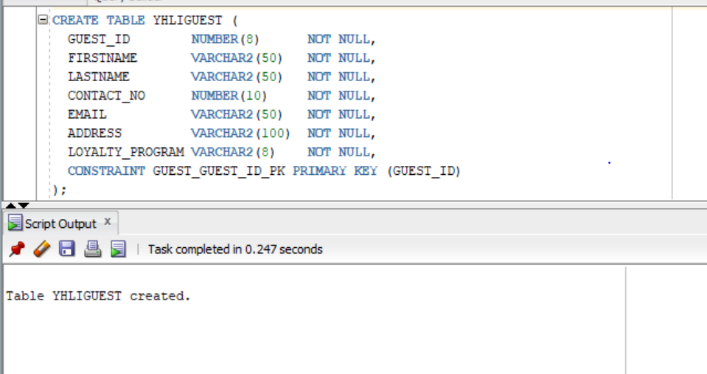
ROOM RESERVATION TABLE
CREATE TABLE YHLROOMRESERVATION (
RESERVATIONID VARCHAR2(10) NOT NULL,
GUEST_ID NUMBER(8) NOT NULL,
ROOMTYPE VARCHAR2(10) NOT NULL,
CHECKINDATE DATE NOT NULL,
CHECKOUTDATE DATE NOT NULL,
NUMOFGUESTS NUMBER(1) NOT NULL,
SPECIALREQUESTS VARCHAR2(250),
STATUS VARCHAR2(15) NOT NULL,
CONSTRAINT ROOMRESERVATION_PK
PRIMARY KEY (RESERVATIONID),

CONSTRAINT ROOMRESERVATION_GUEST_ID_FK
FOREIGN KEY (GUEST_ID)
REFERENCES YHLIGUEST (GUEST_ID)
);
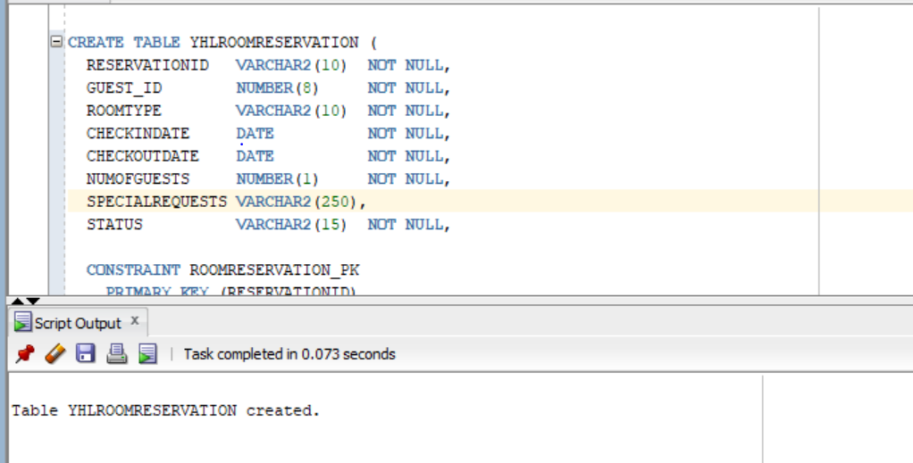
2.
ALTER TABLE YHLIGUEST
ADD CONSTRAINT GUEST_LOYALTYPROGRAM_CK
CHECK (LOYALTY_PROGRAM IN ('LEVEL_0','LEVEL_1','LEVEL_2','LEVEL_3'));
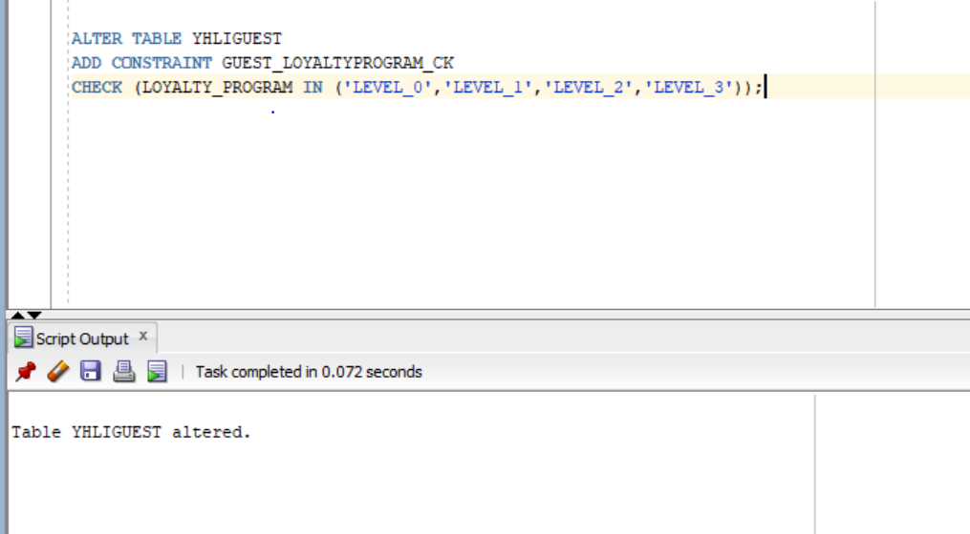
3
A
ALTER TABLE YHLROOMRESERVATION
ADD CONSTRAINT ROOMRESERVATION_ROOMTYPE_CK
CHECK (ROOMTYPE IN ('Queen','King','Twin','Hollywood Twin','Double-Double','Studio'));
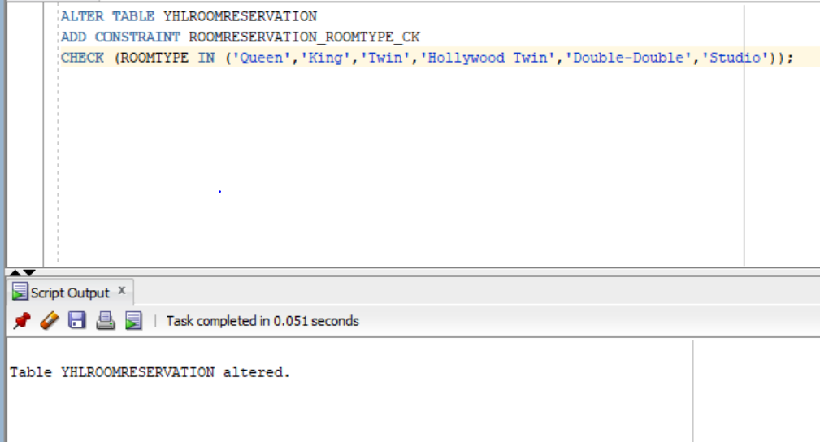
B
ALTER TABLE YHLROOMRESERVATION
ADD CONSTRAINT ROOMRESERVATION_DATE_CK
CHECK (CHECKOUTDATE >= CHECKINDATE);
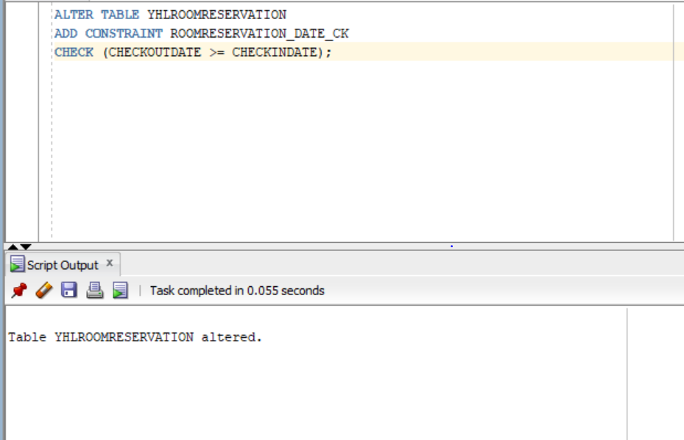
C
ALTER TABLE YHLROOMRESERVATION
ADD CONSTRAINT ROOMRESERVATION_STATUS_CK
CHECK (STATUS IN ('Confirmed','Cancelled'));
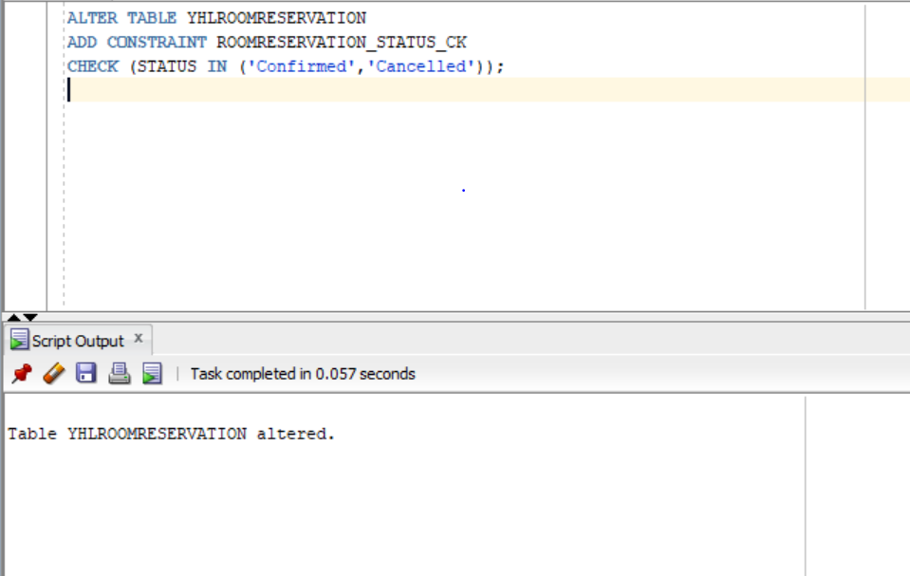
4
INSERT ALL
INTO YHLIGUEST (GUEST_ID, FIRSTNAME, LASTNAME, CONTACT_NO, EMAIL, ADDRESS, LOYALTY_PROGRAM)
VALUES (1, 'John', 'Doe', 1234567890, 'john.doe@email.com', '123 Maple St', 'LEVEL_2')
INTO YHLIGUEST (GUEST_ID, FIRSTNAME, LASTNAME, CONTACT_NO, EMAIL, ADDRESS, LOYALTY_PROGRAM)
VALUES (2, 'Jane', 'Smith', 987654321, 'jane.smith@email.com', '456 Oak Ave', 'LEVEL_1')
INTO YHLIGUEST (GUEST_ID, FIRSTNAME, LASTNAME, CONTACT_NO, EMAIL, ADDRESS, LOYALTY_PROGRAM)
VALUES (3, 'Adetoun', 'Adewusi', 4374290979, 'adewusiadetounjjj3@gmail.com', '32 Castor Crescent', 'LEVEL_0')
SELECT * FROM DUAL;

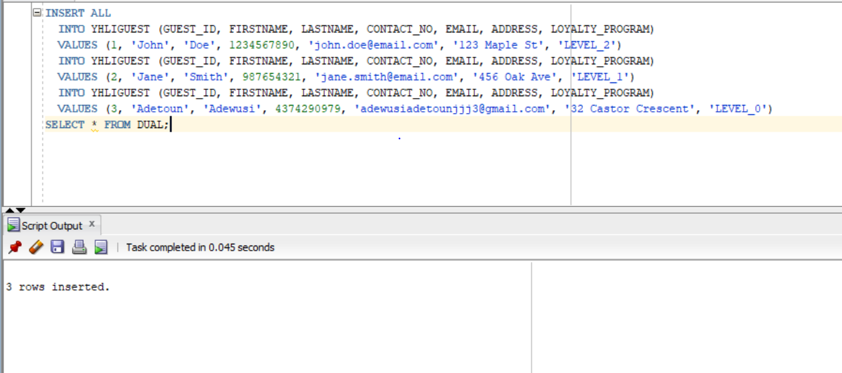
5.
INSERT ALL
INTO YHLROOMRESERVATION
(RESERVATIONID, GUEST_ID, ROOMTYPE, CHECKINDATE, CHECKOUTDATE, NUMOFGUESTS, SPECIALREQUESTS, STATUS)
VALUES
('RES-001', 1, 'King',
TO_DATE('2026-03-01','YYYY-MM-DD'),
TO_DATE('2026-03-05','YYYY-MM-DD'),
2, NULL, 'Confirmed')

INTO YHLROOMRESERVATION
(RESERVATIONID, GUEST_ID, ROOMTYPE, CHECKINDATE, CHECKOUTDATE, NUMOFGUESTS, SPECIALREQUESTS, STATUS)
VALUES
('RES-002', 3, 'Queen',
TO_DATE('2026-04-10','YYYY-MM-DD'),
TO_DATE('2026-04-12','YYYY-MM-DD'),
1, 'Late check-in', 'Confirmed')

SELECT * FROM DUAL;
SELECT * FROM YHLROOMRESERVATION;
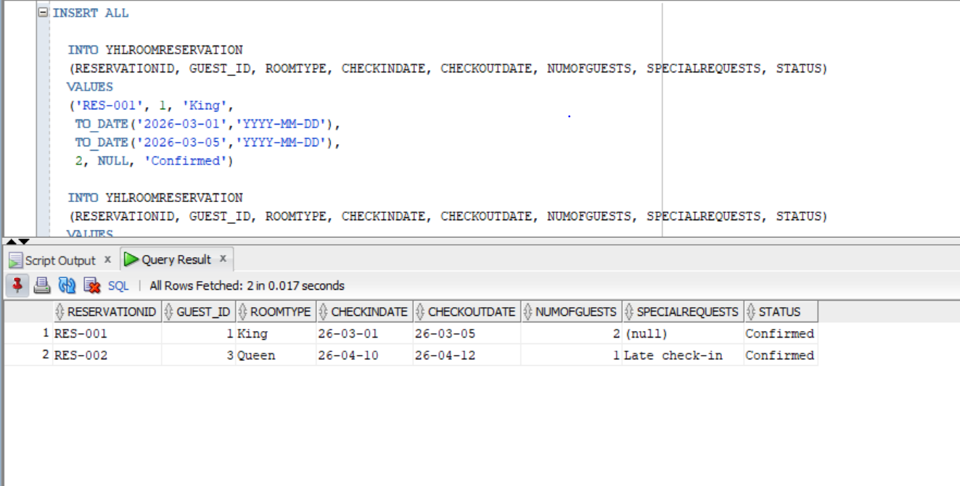
6
UPDATE YHLROOMRESERVATION
SET CHECKINDATE = TO_DATE('2026-04-12','YYYY-MM-DD'),
CHECKOUTDATE = TO_DATE('2026-04-15','YYYY-MM-DD')
WHERE RESERVATIONID = 'RES-002';
SELECT *
FROM YHLROOMRESERVATION
WHERE RESERVATIONID = 'RES-002';
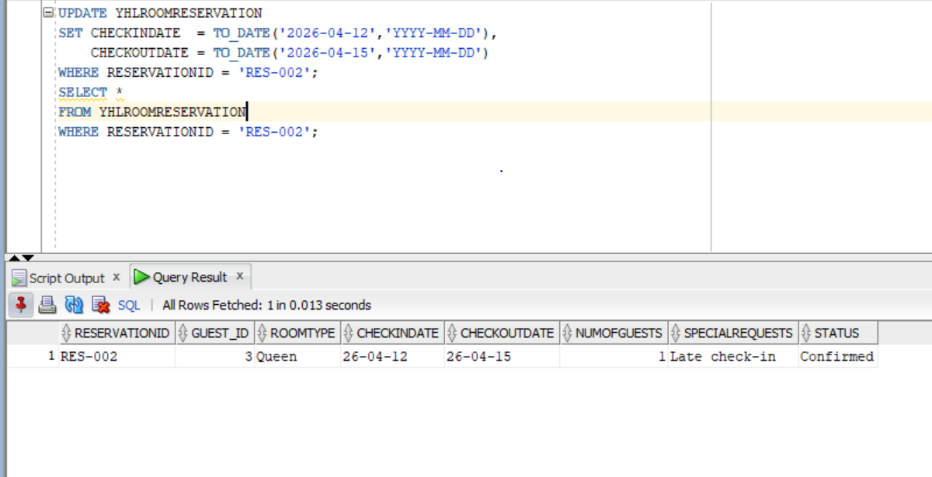
7
UPDATE YHLROOMRESERVATION
SET SPECIALREQUESTS = 'Pets allowed',
CHECKOUTDATE = TO_DATE('2026-03-08','YYYY-MM-DD')
WHERE RESERVATIONID = 'RES-001';
SELECT *
FROM YHLROOMRESERVATION
WHERE RESERVATIONID = 'RES-001';
8
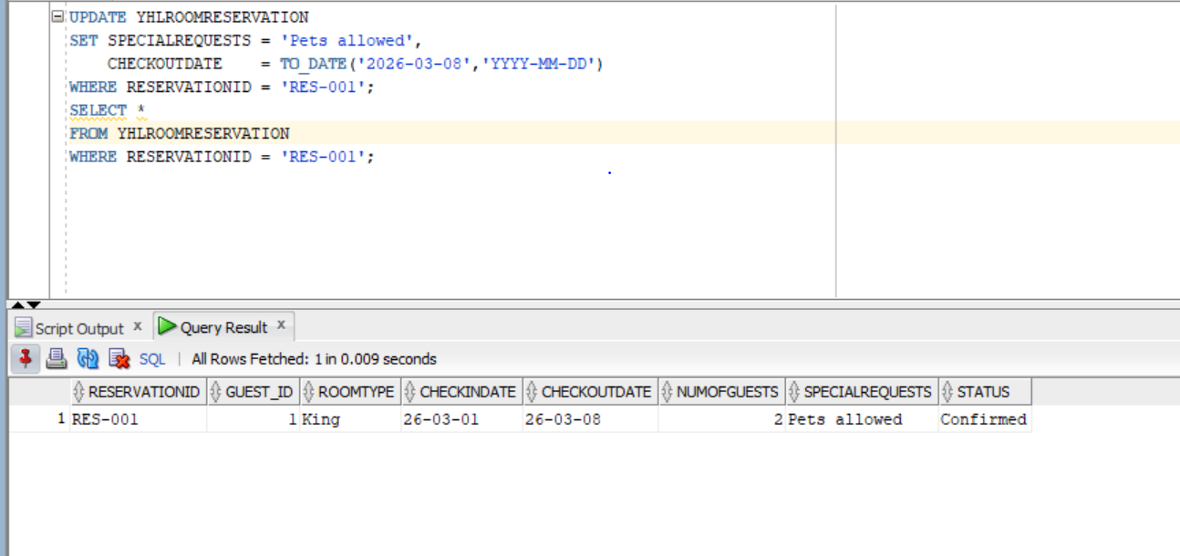
8
The deletion fails because the guest has child records in the RoomReservation table. The foreign key constraint prevents deleting a parent row when related child rows exist.


