**POWER BI ASSIGNMENT 1**

2) You're working with sales data from multiple regions. How would you create a report that displays total sales, average sales, and a trend analysis?

The steps to create a report that displays total sales, average sales, and a trend analysis:

1.**Import and Clean Data**:

Go to Home > Get Data to import your dataset.

In PowerQuery Editor, filter out any empty values to ensure clean data, then click Close & Apply to load it.

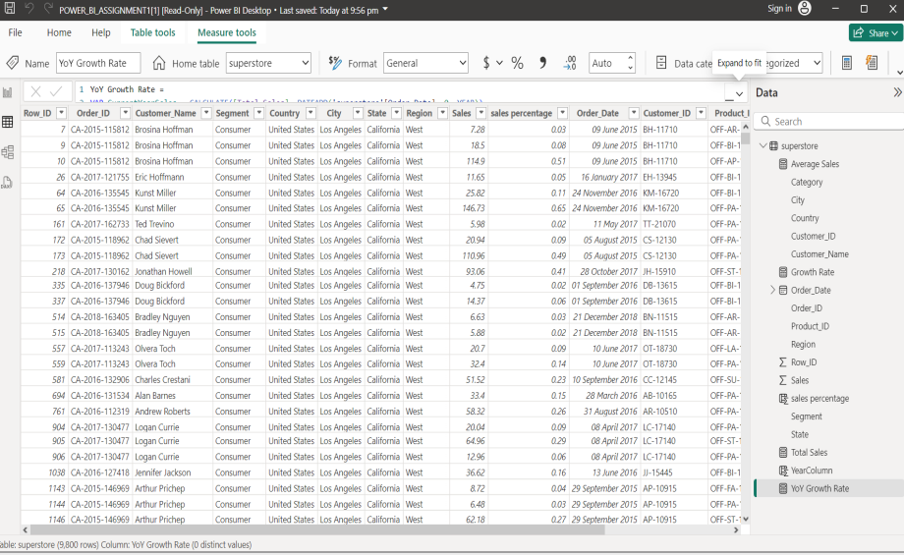

2. **Extract Year from Date**:

In Data View, create a new column by selecting Modeling > New Column.

Formula to extract the year:

**Year = YEAR('superstore'[Order_Date])**

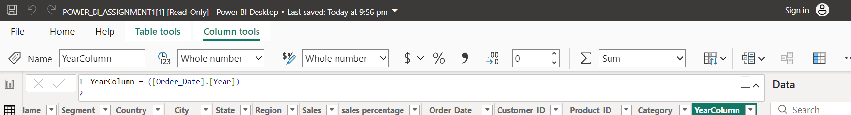

3. **Calculate Total Sales**:

Go to **Modeling > New Measure**.

Formula for total sales:

**Total Sales = SUM('superstore'[Sales Percentage])**

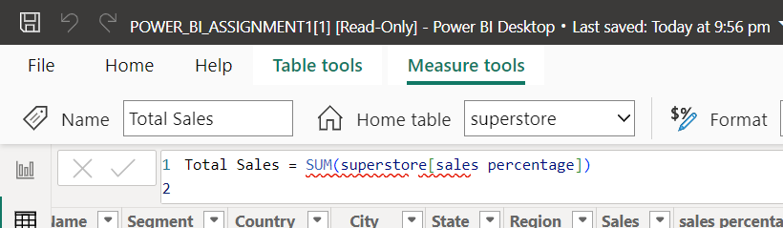

**4. Calculate Average Sales**:

Create another **New Measure** for average sales:

**Average Sales = AVERAGE('superstore'[Sales Percentage])**

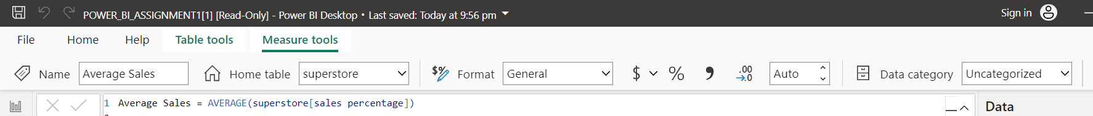

**5. Calculate Year-over-Year (YoY) Growth Rate**:

Create a New Measure for growth rate:

**Growth Rate =**

VAR CurrentYearSales = CALCULATE([Total Sales], DATEADD('superstore'[Order_Date], 0, YEAR))

VAR PreviousYearSales = CALCULATE([Total Sales], DATEADD('superstore'[Order_Date], -1, YEAR))

RETURN IF(NOT(ISBLANK(PreviousYearSales)), DIVIDE(CurrentYearSales - PreviousYearSales, PreviousYearSales, 0), BLANK())

**6. Create Visuals**:

Insert **Card Visuals** in **Report View** to display **Total Sales**, **Average Sales**,

Use a **Line Chart** to show Average sales over time by adding **Year** to the X-axis and **Average Sales** to the Y-axis.

Use a **Bar Chart** to show Total sales by Region .Taking **Region** to the X-axis and **Total Sales** to the Y-axis

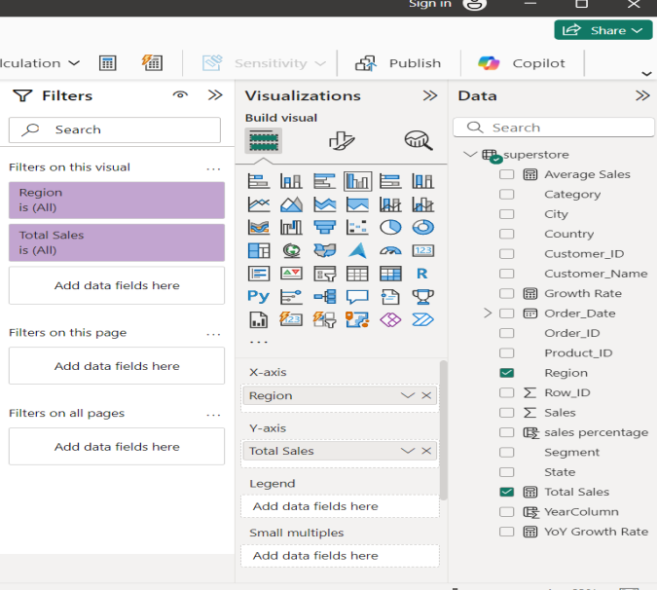

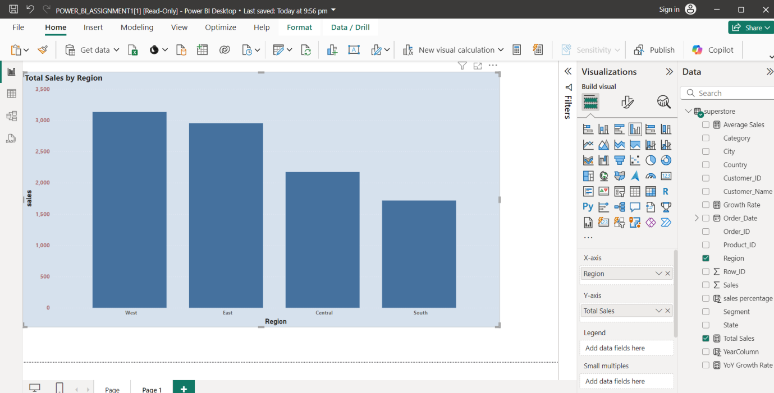

**7.** **Save the report:**

Save the report with required name with .pbix format. This is used make an analytical study on sales data from multiple regions.

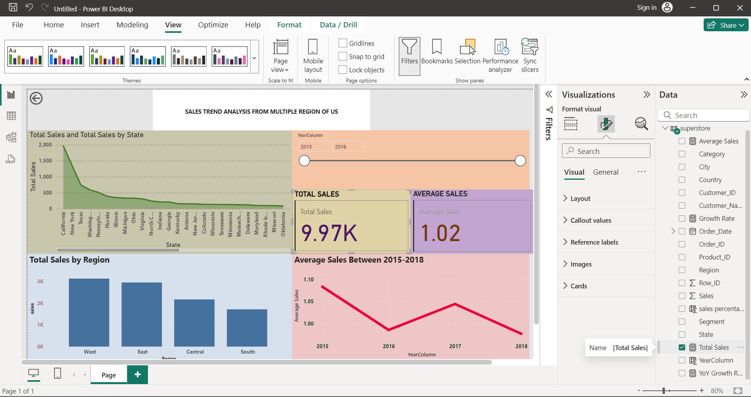

Top of Form