Janet L. Allbee
Statistical Analyst III, Colorado State Patrol

8601 W. 89th Avenue
Westminster, Colorado 80021
303.489.3795
allbeejanet@gmail.com

September 16, 2016

Re: Lara Reeder

I had the pleasure of working with Lara at the Colorado State Patrol in my role as the Patrol’s statistical analyst – we partnered on a number of data-related projects and I found her both well-versed on the requirements for data projects generally, as well as dedicated to the data quality assurance and attention to detail that allows these projects to succeed at the highest level.

In her role managing the Patrol’s SafetyNet commercial vehicle reporting program, Lara developed data systems and management processes that elevated Colorado’s version of this federally required program to one of the best (if not the best) in the country. This required both a breadth of subject matter expertise in her program area as well as an in-depth understanding of data and data management techniques. Some of the elements of this program that I witnessed her managing incredibly well include:

- Collecting data from crash reports and evaluating thousands of individual cases to determine whether they met the business definition of federally countable crashes by applying the appropriate business rules to each case;
- Accurately entering data regarding each reportable crash into the SafetyNet database as required by federal mandate for the program;
- Creating reports and documents regarding the SafetyNet program;
- Disseminating data, documents, and reports throughout the Patrol regarding the status of commercial vehicle crashes in Colorado;
- Maintaining extremely high levels of data quality by auditing data to determining the cause of discrepancies between disparate data sources; and
- Designing business process improvements to minimize any potential discrepancies between separate data sources measuring the same data points.

Lara is highly capable as an analyst, with experience using Excel and Access to work with data. Her experience also includes more administrative duties that incorporate contracts and purchasing through the state system. Unfortunately for the Patrol, the creation of the Crime Analysis Unit and its planned expansion were too late to keep Lara at the Patrol, because she would have been an excellent addition to the department, with her combination of subject matter expertise in law enforcement, her analytic capabilities, and her skillset with data tools such as Microsoft Excel and Access. She’s a resource that’s missed. Should she ever decide to return to the Patrol, I would absolutely recommend her for an analysis position.
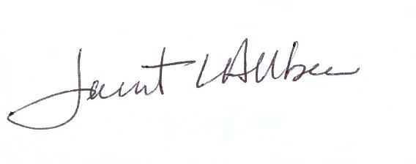
Thank you for your attention,

Janet L. Allbee

