THE MWALIMU NYERERE MEMORIAL ACADEMY

THE DEPARTMENT OF INFORMATION COMMUNICATION AND TECHNOLOGY(ICT)

A SECURE SELF HOSTED PRIVATE CLOUD STORAGE FOR ACADEMIC INSTITUTIONS.

PROGRAMME NAME: RESEARCH PROPOSAL.
MODULE CODE: ITT 06105
FULL NAME: JANETH MASHAKA JAMES.
REGISTRATION NUMBER: MNMA/OD9.ICT/0603/24
SUPERVISOR NAME: JULIUS MAUNGO.
ACADEMIC YEAR: 2025/2026.

LIST OF ABBREVIATIONS.

API - Application Programming Interface
DBMS - Database Management System
DFD - Data Flow Diagram
ERD - Entity Relationship Diagram
ICT - Information and Communication Technology
LAN – Local Area Network
RBAC – Role Based Access Control
SSL – Secure Socket Layer
TLS – Transport Layer Security
UI - User Interface
WAN – Wide Area Network

LIST OF TABLES

Figure 4.1: Hardware Requirements for the Proposed system…………….
Figure 4.2: Software Requirements for the Proposed System………………….
Figure 4.3: Functional Requirements of the system………………………
Figure 4.4: Nonfunctional Requirements of the system……………………
Figure 5.1: Project Budget and Cost Estimation………………………….........

LIST OF FIGURES

Figure 3.1: Use case Diagram for Secure Self Hosted Private Cloud storage system
Figure 3.2: Data Flow Diagram (DFD level 0) of the proposed system
Figure 3.3: Data Flow Diagram (DFD level1) of the proposed system
Figure 3.4: Entity Relationship Diagram(ERD) for the Database Design
Figure 5.1: Gantt Chart for the project timeline

TABLE OF CONTENTS

CHAPTER ONE: INTRODUCTION
  - Background of the project.
In recent years, academic institutions such as universities and college generated and store large amount of digital information. These include academic documents, research materials, student records, lecture notices and administrative files. Managing and storing this information securely has become an important challenge for many institutions.

Many institutions still store files on personal computers, flash drivers or send them through email and messaging applications. These methods can lead to problems such as data loss, poor organization of files and unauthorized access to important information.

Cloud storage technology has become a solution for storing digital data. However, using public cloud services may raise concerns about data privacy and security because institutions do not have full control over their data.

Therefore, a secure self-hosted private cloud storage system can help academic institutions store and manage their files within their own servers while ensuring better security and control of information.

  - Problem 0f Statement.
Academic institutions face challenges in securely storing and managing digital documents. Files are often stored in different devices or shared through insecure platforms, which increase the risk of data loss, unauthorized access, and poor file management.
In additional, using third party cloud services may limit the institutions control over its data and may exposed sensitive academic information to security risks.

Therefore, there is need for a secure system that allows academic institutions to store, manage and access their files safely within their own environment.

  - Project Objectives.
    - Main objective
To develop a secure self-hosted private cloud storage system for academic institutions.

    - Specific objectives
- To develop a system that allow users to upload, download and manage files securely.

- To improve the security and organizational of digital academic documents.

- To design a secure cloud storage system for academic institutions.

- To analyze the current methods used for storing academic files.

- To test and evaluate system performance and security.

  - Significance of project.
This project will help academic institutions store their files in a secure and organized system. It will reduce the risk of data loss and authorizes access to important academic documents.
The system will also allow users such as students, lectures, and administrators to easily access and manage files in one centralized platform.

  - Scope of the project.
This project focuses on designing and developing a secure hosted private cloud storage system for academic institutions. The system will allow users to upload, store, download, and manage files through a secure platform.

The project will mainly focus on system design, development, and testing within a limited academic environment.

CHAPTER TWO: LITERATURE REVIEW.
2.1 Overview
This chapter reviews existing studies, technologies, and systems related to cloud storage and data management in academic institutions. The purpose of this literature review is to understand how digital storage systems are currently used and to identify their strengths and limitations.
The review focuses on concepts such as cloud storage technology, private cloud systems, and data security in academic environments. It also examines previous systems developed to manage and store digital information in educational institutions.

2.2 Review of related works.
Many researchers and organizations have developed systems to improve digital storage and data management. Cloud storage systems have become popular because they allow users to store, manage, and access files through the internet.
According to previous studies, cloud storage provides advantages such as easy access to data, efficient storage management, and improved collaboration between users. Systems such as online cloud storage platforms allow users to upload, download, and share files from different locations.
However, some studies show that public cloud services may raise concerns related to data security, privacy, and lack of control over stored information. Academic institutions often deal with sensitive data such as student records, research documents, and examination results, which require a high level of protection.
Other researchers have suggested the use of private cloud storage systems as a better alternative. A private cloud allows an organization to host its own storage system within its own

infrastructure. This approach improves security, gives the institution full control over its data, and reduces dependency on external cloud providers.
Several projects have also proposed secure file management systems that allow authorized users to upload, download, and manage files within a controlled environment. These systems help improve document organization and reduce the risk of data loss.

2.3 Research Gap/Existing gap.
Although many cloud storage systems already exist, most academic institutions still depend on public cloud services or traditional storage methods. These solutions may not fully address issues related to data privacy, security, and institutional control.
In addition, some existing systems do not provide sufficient security mechanisms or flexible access control for different users within an institution.
Therefore, there is a need to design and implement a secure self-hosted private cloud storage system that allows academic institutions to store and manage their data within their own environment while ensuring proper security and controlled access.

CHAPTER THREE: METHODOLOGY.
3.1 Project Design
Project design explains the general structure of the proposed system and how different parts of the system interact with each other. The proposed system will be a secure self-hosted private cloud storage designed to help academic institutions store, manage and share academic files safely.
The system will allow users such as students, lecturers and administrators to upload, download and manage files through a secure platform. The system will also include authentication features to ensure that only authorized users can access the stored information.
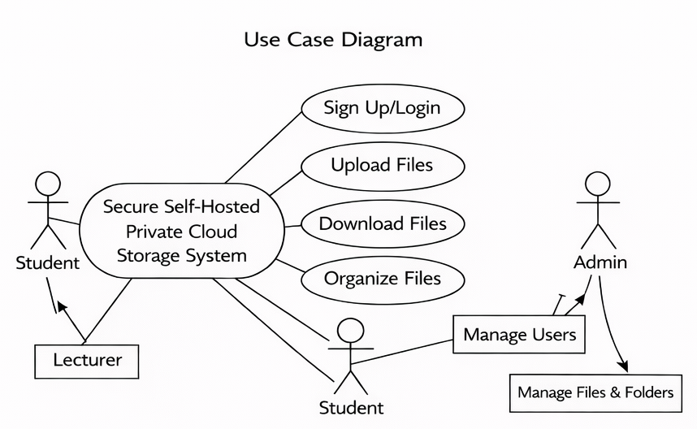

Figure 3.1: Use Case Diagram for the Proposed System

Actors:
- Student
- Lecturer
- System Administrator
Main use cases:
- Login
- Upload files
- Download files
- Manage users
- Manage storage
The use case diagram illustrates the interaction between users and the cloud storage system. It shows the main functions that each user can perform within the system.
3.2 System development methodology.
This project will use the Waterfall Model as the system development methodology. The Waterfall model is a structured development approach where each stage of system development is completed before moving to the next stage.
- Requirement Analysis – Identifying system requirements and understanding user needs.
- System Design – Designing system architecture, database structure, and system interactions.
- System Development – Writing program code and building the cloud storage system.
- System Testing – Testing the system to ensure that it works correctly and securely.
- System Implementation – Deploying the system for actual use
3.3 System Design Approach
System design describes how the system will be structured and how information will flow within the system. In this project, different design diagrams will be used to explain the structure and operation of the system.
These diagrams include:
- Data Flow Diagram (DFD)
- Entity Relationship Diagram (ERD)
These diagrams help in understanding how data moves within the system and how the database will be structured.

3.3.1 Data Flow Diagram (DFD Level 0)
The DFD Level 0 shows the general overview of how data flows between users and the system.

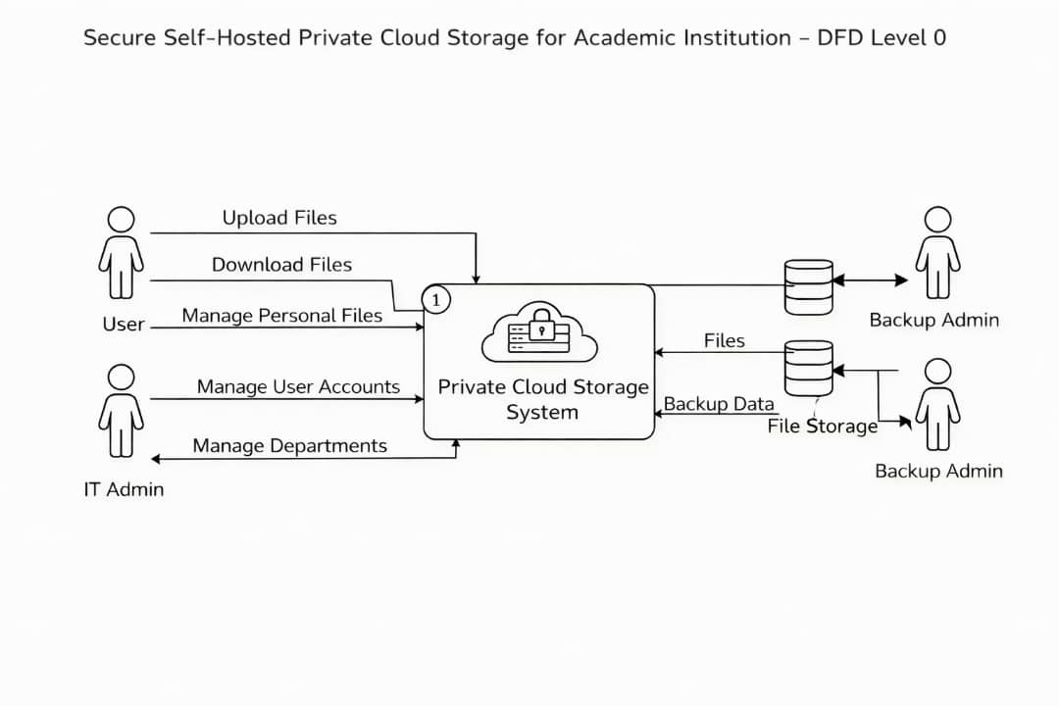
Figure 3.2: Data Flow Diagram (Level 0)

The DFD Level 0 presents a high-level overview of how users interact with the cloud storage system.

Entities:
- Student
- Lecturer
- Administrator
Process:
- Cloud Storage System
Data flows:
- Upload files
- Download files
- User authentication

3.3.2 Data Flow Diagram (DFD Level 1)
DFD Level 1 provides a more detailed explanation of the processes involved in the system.

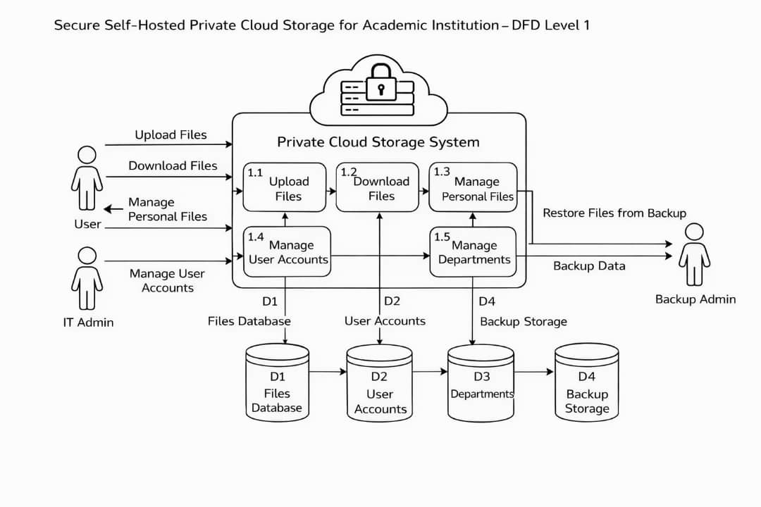
Figure 3.3: Data Flow Diagram (Level 1)
Processes may include:
- User authentication
- File upload
- File download
- File storage management
This diagram shows detailed processes that occur inside the system when users interact with the cloud storage platform.

3.3.3 Entity Relationship Diagram(ERD)
The Entity Relationship Diagram (ERD) shows how data will be organized in the database.
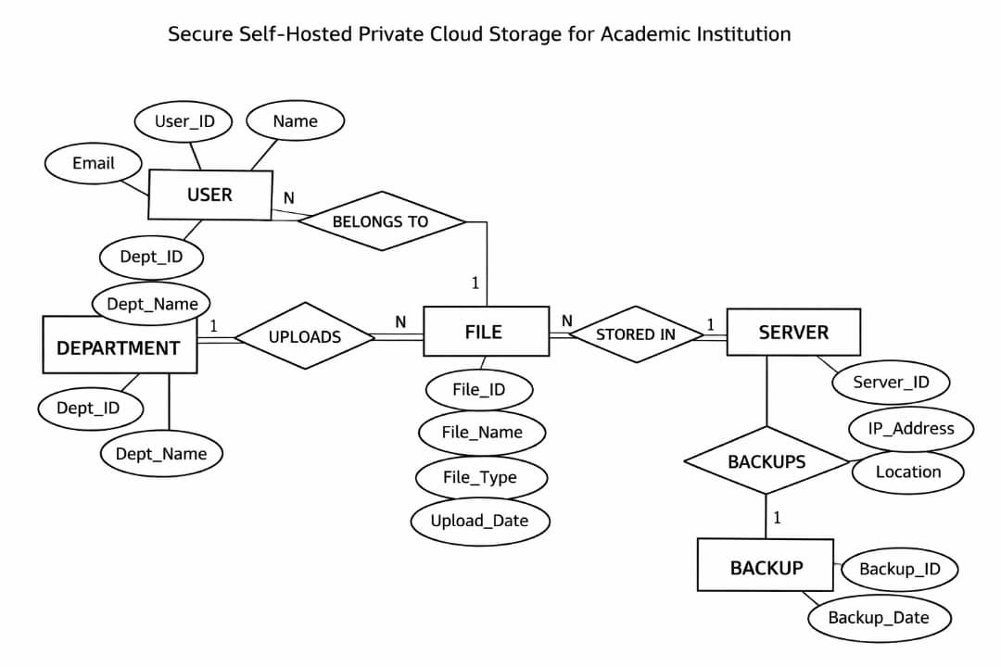
Figure 3.4: Entity Relationship Diagram (ERD)
The ERD describes the structure of the database and the relationships between different entities in the cloud storage system.

3.4 Data collection methods.
The project will use the following data collection methods:
Interviews – To gather information from students and lecture about file management challenges.
Observation – To study how academic files are currently stored and shared.
Desk Research – To review books, journals, and online sources related to cloud computing.
3.5 Tools and technologies used
The following tools will be used:
TOOLS | PURPOSE
Python (Django Framework) | Backend development & web framework for building secure cloud storage
HTML/CSS | User interface
PostgreSQL | Database
JavaScript | Interactive features
Django Development Server | Local server for testing
Vs Code | Code editor
3.6 Ethical Considerations
The project will ensure that user data is handled responsibly. User information will remain confidential and only authorized users will access the system. Participants involved in interviews will be informed about the purpose of the study before providing information.

CHAPTER FOUR: SYSTEM REQUIREMENTS.

4.1 Hardware Requirements.

To implement a secure self-hosted private cloud storage system, the following hardware is required:
HARDWARE COMPONENT | DESCRIPTION
Server computer | A dedicated server to host the application and database, supporting multiple users simultaneously.
Client computers | Laptops or desktops used by students, lectures and administrators access the system.
Storage devices | SSD or HDD to store uploaded files and maintain backups.
Network equipment | Routers, switches, and cabling to ensure reliable LAN and internet connectivity.
Backup devices | External storage drives or Network Attached Storage(NAS)for disaster recovery.
Note: The server should have sufficient CPU, RAM, and storage capacity to handle concurrent uploads, downloads, and database operations.

4.2 Software Requirements
SOFTWARE | PURPOSE
Operating system | Windows server or Linux to host the cloud system.
Web framework | Django (Python)
Database | PostgreSQL
Development tools | VS Code
Web browser | Google chrome, Mozilla Firefox, or Microsoft Edge to access the system.

4.3 Functional Requirements
The system must:
- User Registration & Login: Secure authentication for students, lecturers, and administrators.
- File Upload: Ability to upload documents such as assignments, lecturers notes, and research materials.
- File download: Users can download files stored in the system.
- File management: Admins can manage files, monitors storage usage, and delete unwanted files.
- Search and filter: Search files by name, type, or upload date.
- Role based access control: Users have access according to their role (student, lecturer, admin)

4.4 Non-Functional Requirements
REQUIREMENT | DESCRIPTION
Security | Password encryption and secure file storage to prevent unauthorized access.
Performance | System must handle at least 50 concurrent users without significant delay.
Reliability | Backup and recovery mechanisms to prevent data loss.
Usability | Simple and intuitive interface for students and lectures.
Availability | Accessible 24/7 during academic periods with minimal downtime.

4.5 User Requirements.
Students:
- Access lecture notes and course materials.
- Upload assignments.
- Download required documents.

Lecturers:
- Upload lecture notes and resources.
- Monitor student submissions.
- Download student assignments.
Administrator:
- Manage user accounts and roles.
- Monitor storage usage and file management.
- Generate reports for storage and access logs.

4.6 Operational Environment
- Network: LAN or reliable internet connection.
- Power Supply: Continuous power with UPS to prevent system downtime.
- Physical Environment: Server placed in a secure, ventilated location.
- Scalability: Ability to expand storage or user base in the future without redesigning the system.

CHAPTER FIVE: SYSTEM OUTCOMES
5.1. Achievement of Objectives
This project will aim to achieve several objectives related to improving secure data storage for academic institutions. The system will provide a secure platform where students, lecturers, and administrators will be able to upload, download, and manage academic files safely.
The proposed system will implement authentication and authorization mechanisms to ensure that only authorized users will access stored files. The system will also include encryption and access control features to enhance the security of academic data.
Furthermore, the system will allow users to store and retrieve files easily, which will improve accessibility of academic resources within the institution. Students will be able to submit assignments, lecturers will upload learning materials, and administrators will manage user accounts and system resources.
At the end of the implementation, the system will demonstrate improved data security, better file organization, and efficient storage management for academic institutions.
Expected outcomes will include:
- Secure file storage for academic documents
- Controlled user access through authentication
- Efficient file uploading and downloading
- Centralized storage for institutional academic resources
- Improved management of digital learning materials
These outcomes will support academic institutions in managing their digital resources more effectively and securely.
5.2. System Performance EvaluationThe performance of the proposed system will be evaluated based on several factors including efficiency, accuracy, speed, and system security.
- Efficiency
The system will efficiently manage file storage and retrieval by organizing files in a structured cloud environment. Users will be able to upload and access files quickly, reducing time spent searching for documents.

- Accuracy
The system will ensure accurate file storage and retrieval through database management and user authentication mechanisms. Files will be stored correctly and retrieved without data loss.
- Speed
The system will provide fast file upload and download speeds, depending on the network connection and server capacity. The system architecture will be designed to minimize delays when accessing stored files.
- Security
Security will be one of the main evaluation criteria. The system will use authentication mechanisms, user roles, and secure access protocols to protect sensitive academic data from unauthorized access.
- Reliability
The system will be designed to operate reliably, ensuring that users will be able to access their files whenever needed without interruptions.
Overall, the system will improve data storage reliability, security, and accessibility within academic institutions.

CHAPTER SIX: PROJECT PLAN
  - Introduction
This chapter describes how the project will be implemented and manage during the development process. It ensures that the project is executed within time, budget, and resources constraints. The plan includes phases, timeline, budget, and risk management.

  - Project Phases
The project will be divided into several phases to ensure proper development and organization.
Phase 1: Requirement analysis
In this phase, system requirements will be identified and analyzed. The needs of students, lecturers, and administrators will be studied in order to determine the required system features.
Phase 2: System design
During this phase, the system architecture will be designed. Diagrams such as Use Case Diagrams, ER Diagrams, and System Architecture Diagrams will be created to illustrate how the system will operate.
Phase 3: System development
In this phase, the actual system will be developed using appropriate programming technologies such as Python, HTML, CSS, and PostgreSQL.
Phase 4: System testing
The developed system will be tested to ensure it will function correctly and securely. Any errors or issues will be identified and corrected.

Phase 5: Implementation
After successful testing, the system will be deployed and made available to users within the academic institution.

  - Project Timeline representation
The project will follow a specific timeline to ensure all activities will be completed within the required period.
Phase | Activity | Duration
Phase 1 | Requirement Analysis | 2 weeks
Phase 2 | System Design | 2 weeks
Phase 3 | System Development | 4 weeks
Phase 4 | System testing | 2 weeks
Phase 5 | Implementation | 1 weeks

Figure 6.3. chart project Timeline
Total project duration will be approximately 11 weeks.

  - Source of Fund and Budgets
The development of the system will require certain resources and financial support. The main costs will include software tools, Hardware resources, internet connectivity, and system hosting infrastructure.

Item | Estimated cost
Computer/Laptop | Available
Internet Connectivity | Moderate
Software Tools | Open-Source (Free)
Server Setup | Minimal Cost

Most development tools will be Open-source, which will reduce the overall project cost.

6.5 Risk management
Several risks may affect the successful completion of the project, and strategies will be planned to minimize these risks.
- Time constraints
Limited project time may affect development progress. Proper scheduling will be implemented to ensure tasks will be completed on time.
- Technical Challenges
Technical issues may occur during development. These challenges will be addressed through research and testing.
- Budget Limitations
Limited financial resources may affect system deployment. The project will rely on open-source technologies to reduce costs.
- Data security risks
Security threats may affect stored academic data. The system will implement encryption, authentication, and access control mechanisms to reduce these risks.
By managing these risks effectively, the project will achieve its objectives successfully.

REFERENCES

Buyya, Rajkumar, Broberg, James, & Goscinski, Andrzej. (2011). Cloud Computing: Principles and Paradigms. Wiley.
Erl, Thomas, Puttini, Ricardo, & Mahmood, Zaigham. (2013). Cloud Computing: Concepts, Technology & Architecture. Prentice Hall.
Mather, Tim, Kumaraswamy, Subra, & Latif, Shahed. (2009). Cloud Security and Privacy. O’Reilly Media.
Rhoton, Jason. (2010). Cloud Computing Explained: Implementation Handbook for Enterprises. Recursive Press.
Sosinsky, Barrie. (2011). Cloud Computing Bible. Wiley Publishing.
Velte, Anthony T., Velte, Toby J., & Elsenpeter, Robert. (2010). Cloud Computing: A Practical Approach. McGraw-Hill.
Winkler, Vic (J.R.). (2011). Securing the Cloud: Cloud Computer Security Techniques and Tactics. Elsevier.

