A children's guide to
Python programming



Printing text and creating variables




Open the Python app and tap .

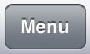
Press and start a program.

Type a name for your program and select a folder to save it in.

Type these commands into the 'script' window:

print("Hello world.") print("\n") print("I am learning Python.")

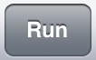
Press and watch the 'interpreter' window.

Program - A sequence of commands that are followed in order to carry out a task. Run - Carrying out the commands in a program. Also known as execute.

Press and start a program.

What does the
print
command do?

What does printing
\n
do?

What happens if you make a mistake in
your commands?

Type a name for your program and select a folder to save it in.

Variable – A value that can be stored and used in a program.
Type these commands in and then them:
What does the
input

command do?

Does it matter if you type
in text other than your
name?

forename = input("What is your forename? ") print ("Hello",forename)

Edit and improve:
• Add a variable to store a surname. Then change the print command so it prints their full name.

Calculations and random numbers

Open the Python app and tap .

Press and start a program.

Type a name for your program and select a folder to save it in.

Type these commands in and then them:

print(100+10)

Is the calculation still solved if you use a negative number or
a decimal number?

Edit and improve:

- Change the commands to do a different calculation, such as a: take away -, multiplication * or division /.

Testing - Trying out a program to check if it works as expected. Debugging - Finding and correcting mistakes in a program's source code.

Press and start a program.

Type a name for your program and select a folder to save it in.

Type these commands in and then them:
What does the
.randrange

command do?

import random number = random.randrange(10,20,1) print(number)
Edit and improve:

print(number+10)
- Change the number 10 to a smaller number and the number 20 to a bigger number to see what effect this has on the program.
- Add some commands to do calculations with the random number. e.g.

Number variables and adding comments

Open the Python app and start a program.

Type these commands in and then them:

number = int(input("Type a whole number: ")) answer = number * 8 print(number,"multiplied by 8 is",answer)

What happens if you type in a decimal number instead of an integer (whole number)?

Edit and improve:

answer2 = number + 6
print(number,"add 6 is",answer2)
- Find out what changing int to float lets you do.
(Remember to change it back to int afterwards!) • Add commands so the answer to an addition is printed as well. You will need to use another variable called answer2:

- Change the program so you have to type in two numbers at the start to use in each calculation. You will need to use another variable called number2. Remember to print it on the screen before you show the answer!

Add these commands to your program:

# This is a comment.
Does text on a line starting with a hash then a space (# ) do anything when the program is run?

Comments - Notes in a program's code which explain what commands do to remind you. They are not run.
Edit and improve:
- Type some comments beside some commands to explain what they do.

If statements
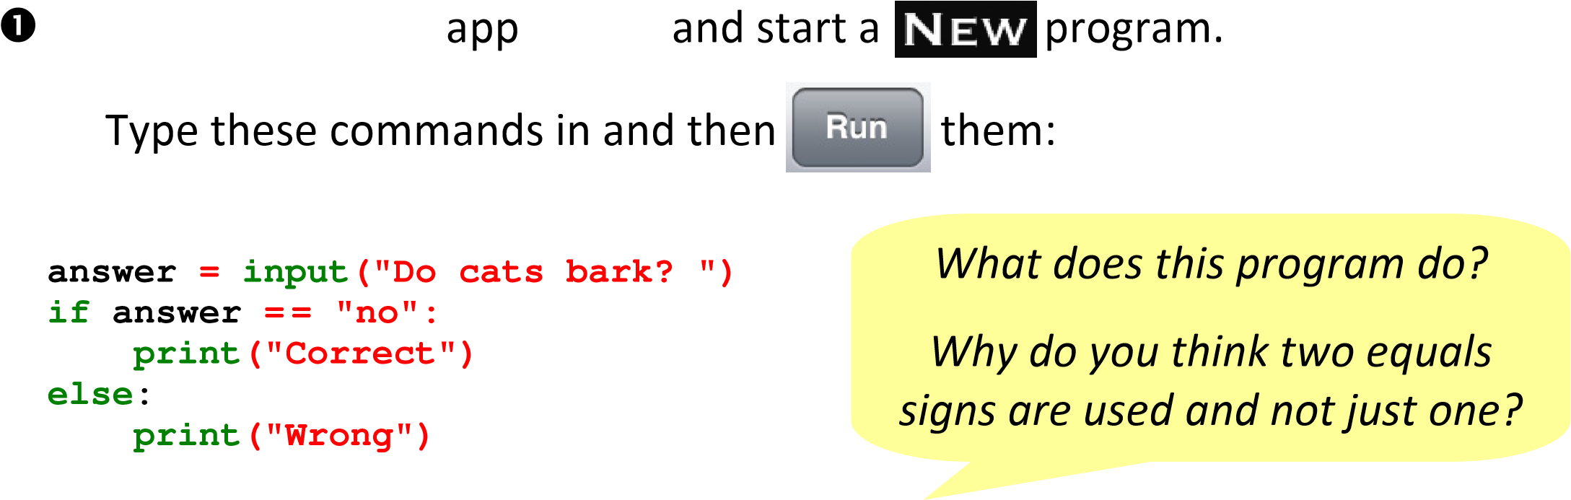

IF statement - Decides which commands to run depending on whether certain things (conditions) are true or false.

Programming challenge:
Create a program that asks a maths calculation and prints if the user answers it right or wrong. Can you change one of the numbers in it to a random number?

Edit and improve:
- Change the question being asked (and the answer too, if needed).

Start a program.

mark = int(input("Score: ")) if mark > 80: print("Outstanding") elif mark > 40: print("Great") else:
print("Good")
Type these commands in and then them:
What does this program do?

What does the
elif
command
let you do?

Edit and improve:
- Add another elif command in the middle so that a score of more than 60 is rated as "Super".

Arrays

app and start a program.
Type these commands in and then them:
Use copy and paste to help

you quickly copy this!
import random vegarray = ["broccoli","beans"] veg = random.choice(vegarray)
print("Mashed",veg," on the ceiling.") What does this program do?

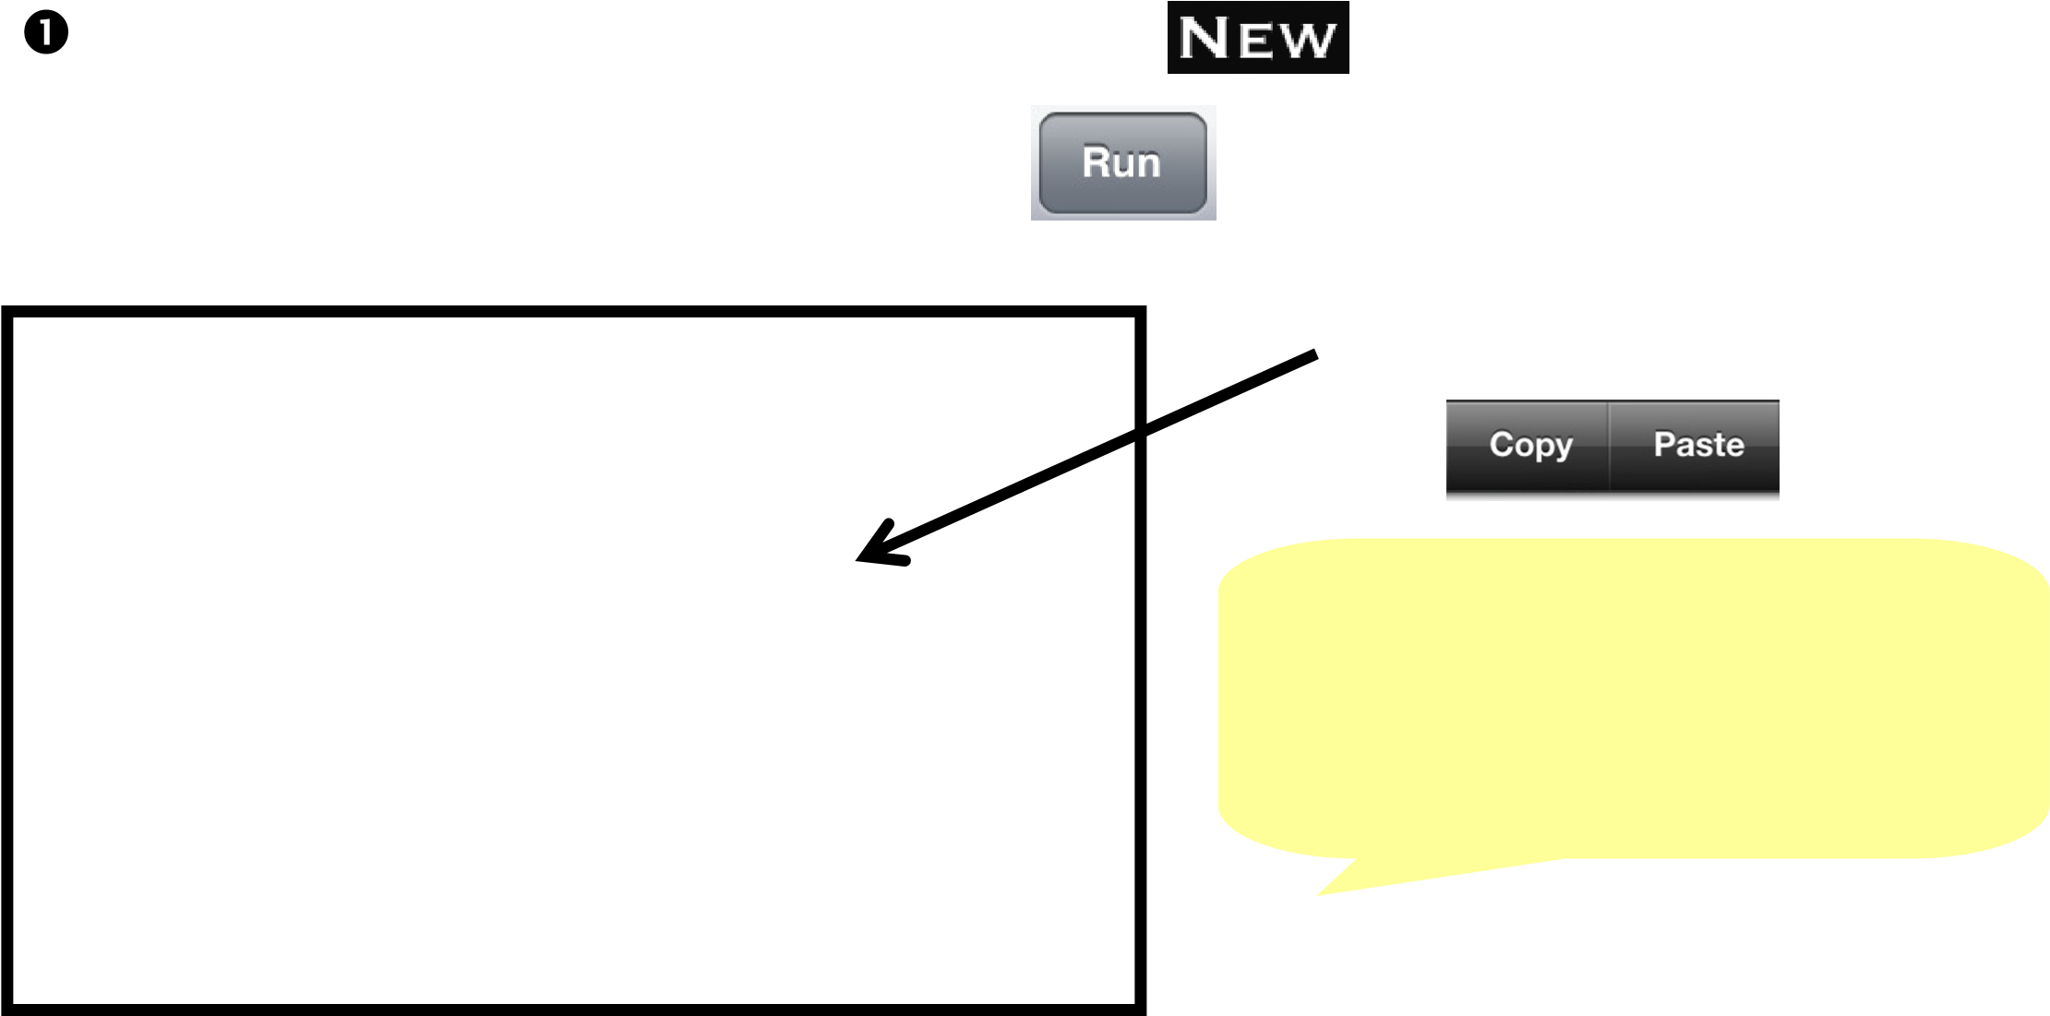
veg = random.choice(vegarray) What is the purpose of the print("Boiled",veg," on the floor.") veg = random.choice(vegarray) vegarray? print("Stewed",veg," in the corner.")
veg = random.choice(vegarray)
Programming challenge:
Create an array to store a list of names. Add commands to: .append, .pop, .insert and .remove names. Find out what the .sort() command does.
print(veg," upon the door.")
Array - A list of values.
Edit and improve:

• Put more items in the array to make the poem more interesting.

Start a program, type these commands in and then them:

vehicles = ["bus","car","train"]

print(vehicles[0]) print(vehicles[1]) print(vehicles[2])

vehicles.append("plane") print(vehicles)

vehicles.pop(2) vehicles.insert(2,"boat") print(vehicles)

vehicles.remove("car") print(vehicles)

Can you see what the:
.append, .pop,
.insert and .remove commands do?

Functions

app and start a program.
Type these commands in and then them:
Function - A sub-program which is placed at the start of a bigger program and can be called (run) later using its name.

import random

def options cointoss():= ["heads","tails"]
result = random.choice(options) print(result)
cointoss() cointoss() cointoss() cointoss() cointoss()
What does this program do?

Why is better to call the function five times than to copy all of its commands five
times?

Edit and improve:
• Change the program so it shows the results of rolling a six-sided dice instead. You don't need to put "" around the options because they are numbers.

Programming challenge:
Create a program that tells a user's fortune by calling (running) a function two times which randomly picks a prediction from an array:

e.g. You will be given money.
You will become famous.
You will see an alien.
You will find a lost item.
You will score well in a test.

Can you ask the user to input their name so that it is included in the predictions (e.g. Tom will be given money)?

Iteration (looping)
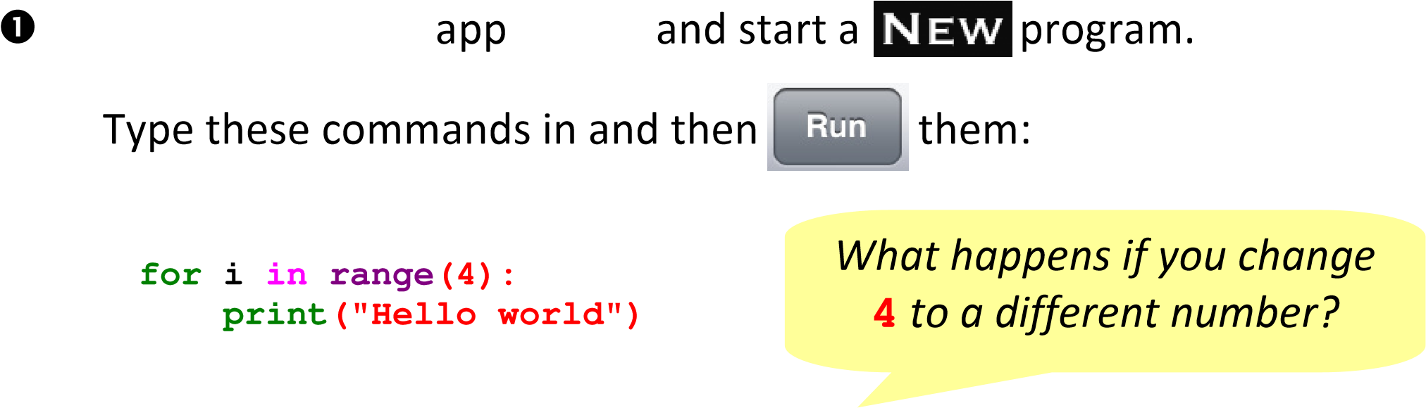

Iteration - A way of repeating or looping commands multiple times.
Start a program, type these commands in and then them:

for i in range(1,10):
print(i*10)
What happens if you change 4 and 10 to different numbers?

Start a program, type these commands in and then them:

 | If  =  =  means 'equal to',  what does  !=  mean?  What does a  while  loop do?
  password = "fish" guess = ""
  while (password != guess"):
  guess = input("Enter password: ")
  if password == guess: print("Correct" ) else:
  print("Try again")

Programming challenge:
Create a program in which the computer sets the password as a random
integer from 1 to 100 and user has to correctly guess it.

Can you use: if, elif and else commands to give the user clues (e.g. "Too

high" or "Too low" )? Can you add a variable which counts the number of guesses (count = count + 1)?

Parameters and validation

Open the Python app and start a program.

Type these commands in and then them:

  def timestable(multiple): for i in range(1,11):
  print(i,"* ",multiple," =",i*multiple)
  multiple = int(input("Type a number: "))
  print("\n") timestable(multiple)
  Parameter - A way of passing a value from the main program to a function when it is called (run).

Programming challenge:
Create a function that prints the biggest of two values.
In the main program below it, the user will input two integers and they will be passed to the function as parameters.

Start a program, type these commands in and then them:
def validation():

number = 0 while True:
try :
number = int(input("Type a whole number: ")) except ValueError:
print ("Not a whole number!) else:
return (number)

x = validation()

What is the purpose of this function?

How could it be useful?

Validation - Automatic checking by a computer to ensure that an entered value is sensible.

Programming challenge:
if side1 == side2 == side3:
print("Equilateral") elif side1 == side2: print("Isosceles") elif side2 == side3: print("Isosceles") elif side1 == side3: print("Isosceles") else:
print("Scalene")
Create a function which prints whether a triangle is: equilateral, scalene or isosceles.
In the main program below it, the user will input the triangle's three side lengths as integers (checked with the validation
function above) and they will be passed to the function as parameters.

Algorithms

Algorithm - An explanation of a the processes or instructions a program carries

Create a
simple
version of a Snakes and Ladders game:

•

Can you add more
print
commands to display what is happening on screen?
•

Can you make the game print the player's name at the end?
•

Can you add another player to the game whose positi
on is stored in a variable
called
position2
?
You will need to make the game let each player mov
e in
turns. You could create a variable called
finished
which is set to 0 at the
start and changes to 1 when a player wins, forcing the game to stop.

Programming challenge:

out, usually described in a flowchart.
Set

position = 0

Is

position
> 100
?

Run
move
function

Print a "Well
done" message

Start

Stop

yes

no

Press the
keyboard to roll

Start

no

Set
dicenumber
as a
random number
between 1 and 6.

position =
position +
dicenumber

Is
position

on a snake or
ladder number?

Stop

Change the
position
so
it is more or less (use:
if,
elif
and
else
)

yes

move

function

Main program

Many thanks to Phil Bagge for the inspiration to learn Python and write this guide!
www.code-it.co.uk/philbagge.html

