Title: Foot and Ankle Kinematic and Morphology Differences in Pediatric Populations

Abstract (~ 6 sentences)
Pes planovalgus, or flatfoot (FF), secondary to cerebral palsy is one of the most common foot deformities that negatively impacts motor function, causes symptoms of pain, and is widely variable amongst populations, including children. Accurate identification of the involved segments, planes, and joint excursions during ambulation that occur in FF is crucial for clinical interventions. Significant variability in this multiplanar deformity can lead to inconsistent clinical management strategies among children with FF. The purpose of this study was to identify subgroups of typically developing children using multi-segment foot and ankle kinematics during gait and their respective bone morphology as inputs for principal component analysis, canonical correlation analysis and various clustering methods to correlate their bone morphology with their kinematic gait characteristics. 4 distinct subgroups were identified amongst typically developing children, with unique gait and bone morphology characteristics. The identification of these subgroups has the potential to provide better understanding of form and function in pediatric foot deformities.

Clinical Problem
Cerebral palsy (CP) is the most common motor disability in children caused by a brain disorder that permanently impacts a child’s body movement and muscle coordination. Cases of CP can happen due to altered development of areas in the brain associated with muscle movement in the womb such as bleeding in the brain, white matter damage, or interruption in brain growth (Cerebral Palsy | National Institute of Neurological Disorders and Stroke, n.d.). Symptoms of CP vary widely between people, but typically impact movement and posture including lack of muscle coordination (ataxia), stiff or tight muscles (spasticity), tremor, or altered gait (walking).
Pes planovalgus/flatfoot (FF) secondary to cerebral palsy is one of the most common disorders among children and adolescents with a reported prevalence of 44% (Park et al., 2013; Pfeiffer et al., 2006). Unfortunately, early childhood flatfoot may be under-reported due to the asymptomatic nature of the deformity until later in adolescence/young adulthood when unresolved structural changes cause pain, dysfunction (Bresnahan & Juanto, 2020), and disability including unpredictable, progressive collapse of the medial longitudinal arch which occurs in 3-10% of the population from previously asymptomatic planus feet (Pita-Fernandez et al., 2017; Thomas et al., 2011).
Standard-of-care assessment for children with these 3-dimensional (3D) foot deformities is 2-dimensional (2D) radiographic imaging, which have questionable validity and reliability as it is difficult to determine the relative spatial positions of each 3D structure leading to over-estimation of deformity, missed diagnoses, and impaired surgical planning. Functional assessment of these foot deformities is performed by 3D gait analysis, the current gold standard for gait deviations that provides a comprehensive analysis on gait kinematics by calculating the biomechanical parameters from a marker-based motion capture system as seen in Figure 1 (Lan et al., 2024).
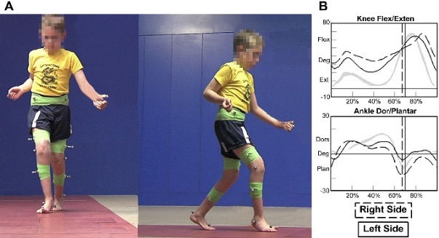
Fig. 1. Gait analysis setup for children with gait abnormalities (K. N. Dibbern et al., 2025).
However, static radiographic measures such as CT and MRI lack critical weightbearing diagnostic information and have shown poor correlation with foot kinematics during walking in studies of pediatric flexible flatfoot (Böhm et al., 2020). Thus, the relationship between joint form and function is not well understood in the foot.
Weightbearing CT (WBCT) is an emerging technology that captures the foot deformity in a loaded position with high resolution volumetric CT data at equivalent or less radiation exposure than the current standard-of-care foot and ankle radiograph series. Previous studies highlighted deviations in the subtalar joint of the hindfoot (i.e. the articulation between the talus and calcaneus) between WBCT scans of patients with and without progressive collapsing foot deformity (PCFD), formerly termed adult-acquired FF deformity, using 3D distance and coverage mapping with statistical shape models (SSMs).(K. Dibbern et al., 2023; K. N. Dibbern et al., 2021) While WBCT has been increasingly used in adult foot and ankle pathologies, particularly the complex 3D nature of PCFD, there is limited understanding of functional weightbearing on 3D deformity in pediatrics and how the mechanisms of arch collapse differ from adult-onset cases.
Current treatments for FF secondary to CP include physical, speech, and occupational therapy, drug treatments, surgery, or assistive devices (CDC, 2025). For children with increased symptoms, such as pain and difficulty walking due to severe spasticity and stiffness, surgical procedures to lengthen muscles and tendons may be performed to improve mobility and lesson pain. While these surgical procedures provide improved mobility and decreased pain, great consideration is required from the care team to prevent long-term consequences for developing children. With this, there is a need to identify clinical subgroups that differentiate FF secondary to CP in children to address inconsistent gait kinematics and increased variability in symptom presentation. These efforts will facilitate improved treatment planning and post-operative outcomes for similar patients within a subgroup.

Literature Review
For adult populations, the foot’s complex structure leads to morphological variability even among a healthy population. Root et al. (1971) described different foot types in healthy adult populations (L, 1977) including rectus, planus, and cavus. Previous studies have investigated kinematic foot types in adults, but results have been inconsistent and, in some cases, conflicting due to varied neutral referencing methods, whereby modeling segments for the hindfoot are not representative of the true orientation of the bones. Further, previous kinematic gait analyses limit primary variables of the interest to discrete variables, such as peak angles, rather than the whole gait cycle leading to potential loss of data.
Recently, studies examining FF in children, Kruger et al. (2019) and Krzak et al. (2014) defined 5 distinct, kinematic subgroups among samples of typically developing children and children with CP using Principal Component Analysis (PCA) to reduce the dimensionality of the kinematic variables, while ensuring maximum variance in their principal components. After reducing the dataset, cluster analysis with k-means was performed on the principal components to identify subgroups of similar individuals (Kruger et al., 2019; Krzak et al., 2015). These subgroups further defined an objective means to classify multi-segment and ankle kinematics of children with involvement of different planes and various ranges of motion to ultimately be used to analyze severity and track disease progression. However, these studies did not consider the morphology/bone shape of the hindfoot in their analysis.
Analyzing a multivariate dataset containing both gait and bone shape would help further identify potential clinical subgroups and provide a better understanding of how bone shape may impact functional gait for patients. A previous study done by Birdal & Sertbas (2023), looked at improving gait identification in 3D by utilizing multivariate data analysis in separate body halves using canonical covariates with the Canonical Correlation Analysis method (CCA) method (Birdal & Sertbas, 2023). CCA primarily aims to projection pairs for two sets of vectors such that the transformed vectors are maximally correlated in the dimensionality reduced space (Birdal & Sertbas, 2023). The authors found that CCA-based multi-feature fusion helped enhance gait assessment and identification to recognize a subject’s walking patterns.
The purpose of the current study was to identify clinically relevant subgroups among a sample of 10 typically developing children by using multi-segment foot kinematics and statistical shape models (SSMs) as inputs for PCA, CCA, and K-means cluster analysis. We anticipate that identified subgroups would present with unique kinematic and morphological characteristics.

Methods (make sure to include python tools)

Data Collection and Preprocessing
Ten typically developing children/adolescents were included. All participants were not diagnosed with foot deformities and were recruited for diagnostic gait analysis. Multi-segment 3D marker gait analysis was captured for each patient, consisting of static and walking trials. Kinematic gait variables of interest for this project included, sagittal ankle, coronal ankle, ankle rotation, sagittal midfoot, coronal midfoot, and midfoot rotation angles throughout the gait cycle.
$$X_{gait} ϵ R^{10 x \left(101 x 6=606\right)}$$
Individuals received a bilateral WBCT to collect bone morphology. WBCT of the calcaneus was segmented with DisiorBone Logic to form a 3D STL of the bone for each patient. From this, a statistical shape model (SSM) particle cloud was formed, where particles represented points on the surface morphology of the bone. Calcaneus particles of the left hindfoot were mirrored to match the right bone of each patient. Procrustes analysis in SciPy was performed on all the bones to apply the necessary translation, scaling, rotation, and reflection to minimize the sum of squared pointwise differences between them, using the mean shape as the reference.
$$X_{SSM} ϵ R^{10 x \left(4096 ∙3 ∙2=24576\right)}$$
$$X_{gait }+X_{SSM}= R^{10 x \left(606+ 24576=25182\right)}$$
Each variable was then normalized by removing the mean and scaling to unit variance with Scikitlearn – StandardScaler.

Data Dimensionality Reduction

Principal Component Analysis (PCA)
The PCs for gait and SSM were derived separately first utilizing the normalized respective datasets using Scikitlearn – PCA, which resulted in 10 initial PCs for both gait and SSM. Criteria for PC retention included: (1) explained variance ≥ 0.10, (2) components located to the left of an ‘elbow’ on the scree plot containing the eigenvalues across all PCs (Cattell, 1966), (3) retaining minimum number of components such that cumulative percent of variance accounted for was ≥ 80% (Jolliffe & Cadima, 2016). Gait and shape loadings on the PCs were examined for clinical interpretation.

Canonical Correlation Analysis (CCA)
CCA was performed on the PCs that were retained using Scikitlearn – CCA to find the canonical vectors such that they capture the maximum correlation between gait and SSM PCs. CCA canonical correlations were examined to determine appropriateness for clustering. Leave-One-Out Stability Analysis assessed the robustness of the relationships between gait and SSM by examining the weights, loadings, and rotations. PCs with the largest contributions were identified to highlight what dominates the gait-SSM relationship. CCA scores for both gait and SSM were concatenated for clustering analysis.

Cluster Analysis
Hierarchical clustering analysis with Ward’s method was initially performed on the gait-shape CCA scores for all participants. This established the number of prior clusters to be used in the cluster methods. K-means and Gaussian Mixture Modeling (GMM) clustering were both evaluated on the CCA scores for appropriate subgroup membership. For k-means, the optimal number of clusters was determined by the distance coefficients as they are merged into clusters, maximizing similarities within a subgroup and differences between subgroups. A scree plot and silhouette score plotted the most optimal number of clusters for the dataset. Unlike the hard clustering method of K-means, GMM performed soft clustering by assuming multiple Gaussian distributions belong to different clusters. GMM performance was evaluated with log-likelihood, which measures how well the model explains the data, and scoring methods including Akaike information criterion (AIC) and Bayesian information criterion (BIC). Cluster agreement across methods (ARI) and heatmap visualization were analyzed to compare clustering analysis between K-means and GMM. Once subgroup membership was assigned, main effect of membership of identified on CCA/PCA scores and original data space for analysis and clinical interpretation.

Results

Principal Component Analysis
Of the 6060 gait and 245760 SSM features, 10 PCs were formed with PCA. PC1 and PC2 for both gait and SSM explained 80% of the variance, for both datasets (Figure 1).
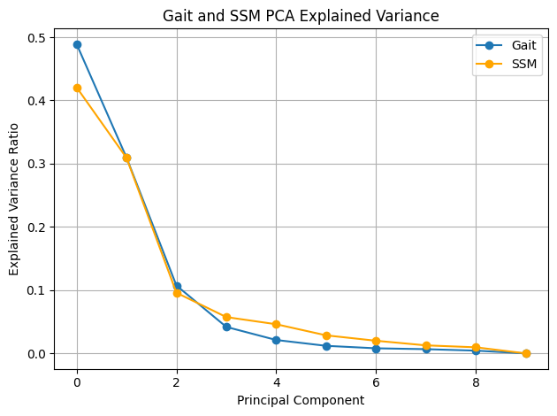
Figure 1. Explained variance of PCs for Gait and SSM
PCA weighting scores for each subject highlighted how strongly that subject expressed the particular mode of variation in gait or bone shape (Table 1, 2).
 | PC1 | PC2 | PC3 | PC4 | PC5 | PC6 | PC7 | PC8 | PC9 | PC10
0 | 29.32 | 7.54 | -15.26 | -0.72 | -4.34 | -1.52 | 0.28 | 0.26 | 0.98 | 0.00
1 | 5.51 | -4.49 | 8.49 | -2.51 | -1.97 | -4.06 | 1.83 | 1.46 | -3.10 | 0.00
2 | -6.50 | -30.88 | -3.60 | 1.34 | 0.59 | 1.82 | 0.73 | 3.14 | 1.11 | 0.00
3 | -15.11 | -9.45 | -9.19 | 4.38 | 3.11 | -2.00 | 1.12 | -3.93 | -0.89 | 0.00
4 | -30.59 | 16.38 | -0.04 | 5.66 | -2.83 | -1.75 | -2.38 | 1.82 | 0.56 | 0.00
5 | -13.54 | 5.62 | 7.42 | -6.49 | -2.20 | 0.51 | 3.33 | -1.55 | 2.52 | 0.00
6 | -8.59 | -0.66 | -4.02 | -8.63 | -1.20 | 3.73 | -3.12 | -0.88 | -1.87 | 0.00
7 | 17.76 | -6.84 | 9.69 | -0.96 | 3.39 | -2.64 | -3.80 | -1.02 | 1.71 | 0.00
8 | 16.30 | 2.72 | 8.80 | 8.70 | -2.51 | 4.48 | 0.52 | -1.23 | -0.72 | 0.00
9 | 5.42 | 20.05 | -2.29 | -0.76 | 7.96 | 1.43 | 1.50 | 1.94 | -0.31 | 0.00
Table 1: Individual weight scores for each PC for gait

 | PC1 | PC2 | PC3 | PC4 | PC5 | PC6 | PC7 | PC8 | PC9 | PC10
0 | -77.72 | 52.99 | -64.51 | 47.59 | 12.44 | -30.39 | -22.04 | 21.49 | 13.30 | 0.00
1 | -86.55 | -77.51 | -69.32 | 33.51 | -11.57 | 42.76 | 2.42 | -21.48 | -10.11 | 0.00
2 | -64.41 | 4.45 | 6.81 | -6.85 | 0.82 | -54.97 | 29.64 | -26.89 | -5.39 | 0.00
3 | 172.03 | -99.66 | 30.21 | 16.13 | 20.04 | -13.98 | -37.76 | -13.43 | -5.76 | 0.00
4 | -12.53 | 40.54 | 97.44 | 66.05 | 2.67 | 20.11 | 19.43 | 5.93 | 6.54 | 0.00
5 | -36.69 | 23.27 | -0.67 | -43.59 | 84.54 | 17.03 | 7.10 | 9.41 | -8.98 | 0.00
6 | 221.72 | 61.27 | -54.76 | -4.98 | -19.51 | 5.23 | 29.30 | 10.22 | -0.70 | 0.00
7 | -27.84 | -132.48 | 10.10 | -45.40 | -16.32 | 6.11 | 5.74 | 5.15 | 33.23 | 0.00
8 | -63.98 | -49.67 | 27.02 | -23.77 | -45.58 | -7.15 | -6.42 | 27.04 | -27.64 | 0.00
Table 2: Individual weight score for each PC for SSM
Constructs of the PCs were reviewed to provide clinically relevant interpretations of the data taking into which features within the gait cycle and of the bone shape were included. Specifically for gait, features with the most loading in PC1 were during swing phase in the coronal ankle (Figure 2) and PC2 during the transition between the first and second rocker of the sagittal ankle (Figure 3A) and preswing/terminal stance of the sagittal midfoot (Figure 3B).
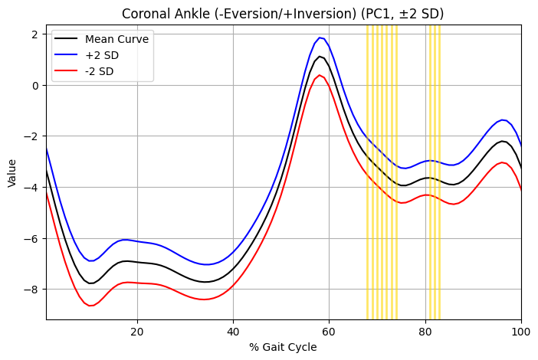

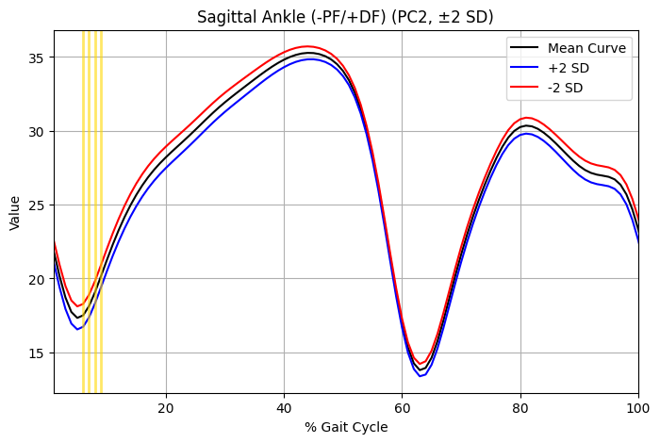
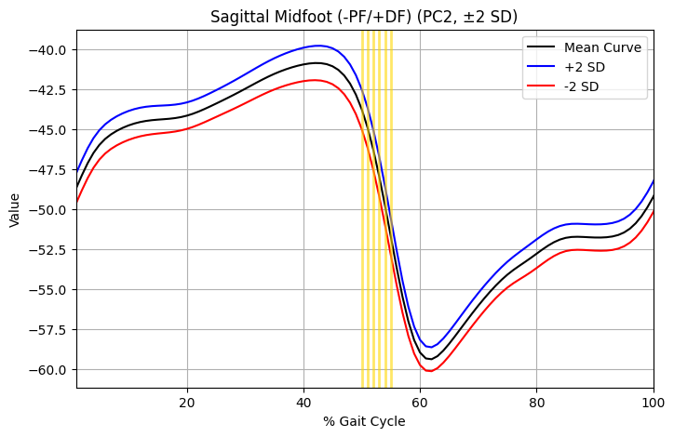

Figure 3. Top gait features in PC1 (A) and PC2 (B, C) highlighted in yellow throughout the gait cycle.
For the shape models, PC1 features with the most loading were located on the calcaneal tuberosity and the talar articular surface, where the calcaneus meets the talus on the subtalar joint. PC2 showed greater feature loading on the upper portion of the posterior calcaneus (Figure 4).
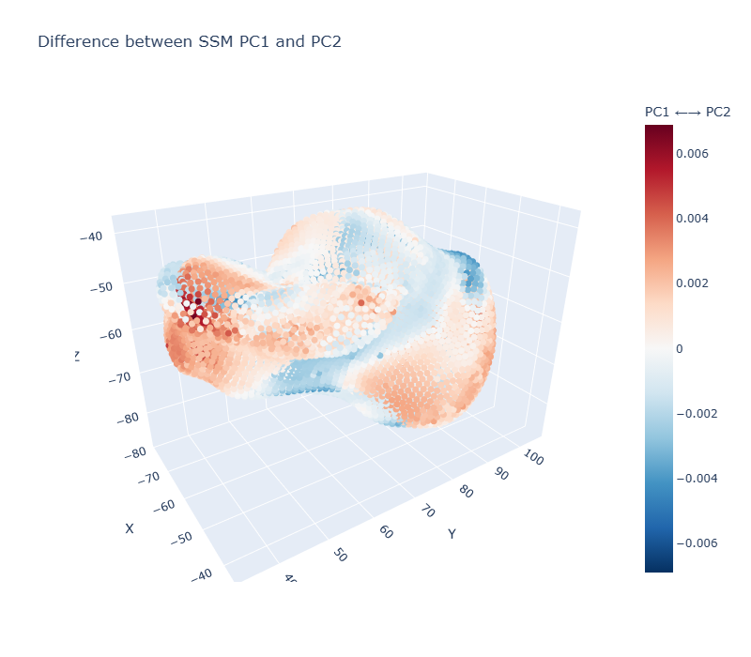
Figure 4. Difference between shape model PC1 (red) and PC2 (blue).

Canonical Correlation Analysis (CCA)
Using PC1 and PC2 from gait and SSM, canonical variates (CV) were found to represent the strongest shared biomechanical pattern for this population. Moderate correlations were found for canonical variate 1 (r = 0.567) and canonical variate 2 (r = 0.438) (Figure 5). CCA stability was assessed using leave-one-out correlations indicating a mean Pearson correlation of 0.6175 ± 0.12 with a range between 0.5 to 0.96 for subject-specific correlations. CCA weights for gait and shape indicated that for CV1, PC2 of both gait (0.96) and shape (0.99) dominate the CV. For CV1, PC1 of gait (0.96) and shape (-0.99) are the primary scores included in the CV.

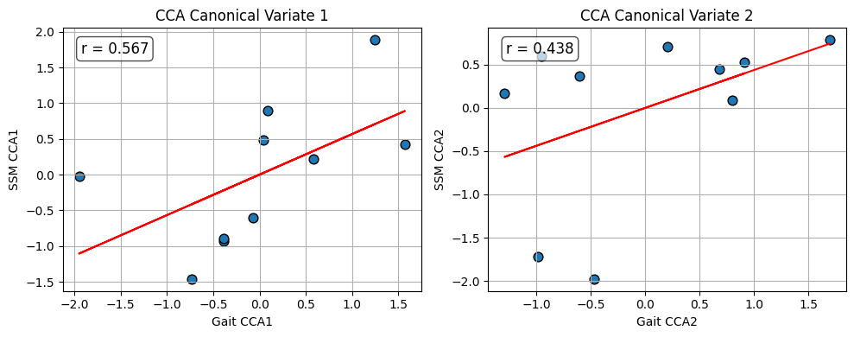
Figure 5. CCA for canonical variate 1 and 2 between gait and SSM.
 | Gait_CCA1 | Gait_CCA2 | SSM_CCA1 | SSM_CCA2
0 | 0.040458 | 1.697718 | 0.489664 | 0.786631
1 | -0.38458 | 0.202352 | -0.93073 | 0.705265
2 | -1.9479 | -0.952351 | -0.02096 | 0.602555
3 | -0.39017 | -0.984385 | -0.89311 | -1.71904
4 | 1.567717 | -1.292282 | 0.424877 | 0.166822
5 | 0.585423 | -0.604401 | 0.212274 | 0.369191
6 | 0.091195 | -0.466905 | 0.900011 | -1.97845
7 | -0.73301 | 0.803286 | -1.46216 | 0.092451
8 | -0.07503 | 0.914901 | -0.60553 | 0.530904
9 | 1.245887 | 0.682067 | 1.88566 | 0.44367
Table 3: Canonical scores for gait and SSM

Cluster Analysis
Hierarchical cluster analysis with Ward method identified 4 primary subgroups on the combined CCA scores of gait and SSM for K-means and GMM cluster analysis (Figure 6).
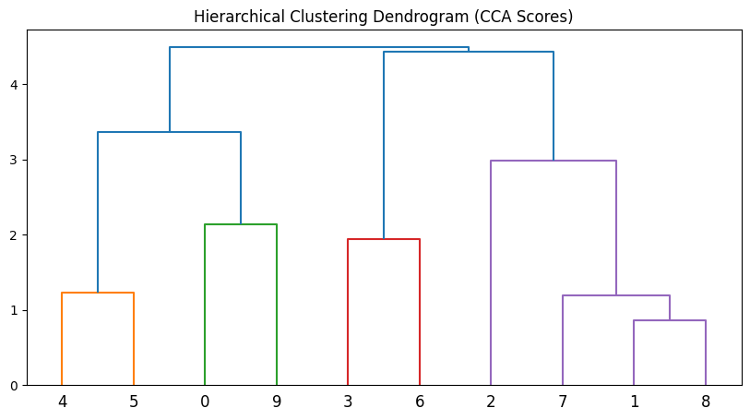
Figure 6. Hierarchical clustering dendrogram combined CCA scores of gait and SSM.
K-means and GMM performance were evaluated with silhouette score, Davies-Bouldin index, and BIC and AIC for GMM (2.3. Clustering, n.d.). From this, four clusters were chosen for best stability of the study dataset as clustering stability became unstable after 5 clusters and the dataset is small, containing only 10 subjects (Figure 7).
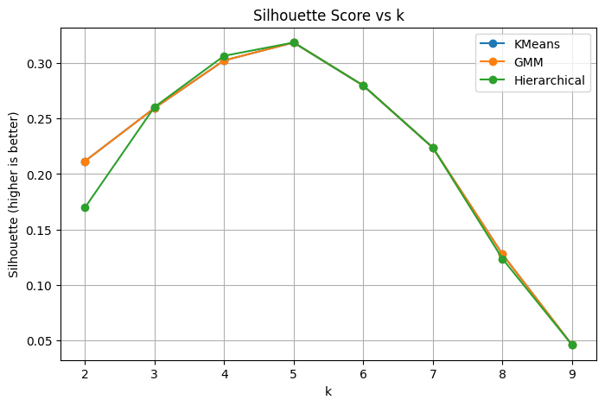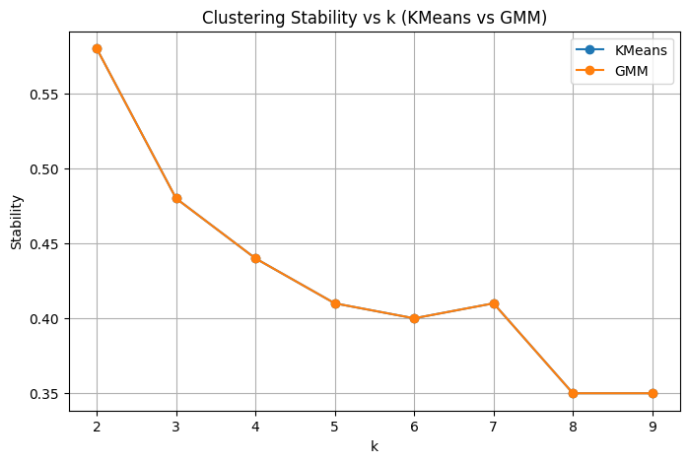
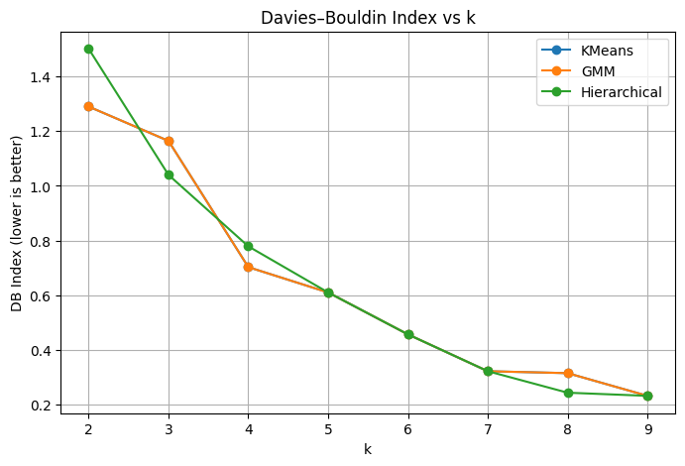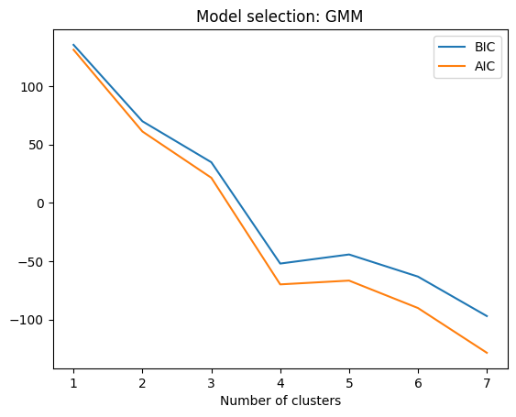
Figure 7. Clustering evaluation metrics to determine cluster amount: silhouette score, Davies-Bouldin index and stability.
K-means and GMM clusters were examined for subgroup membership with Adjusted Rand Index (ARI) and found a 1 to 1 relationship, indicating similar performance between both clustering methods in assigning participant subgroups (Figure 8).
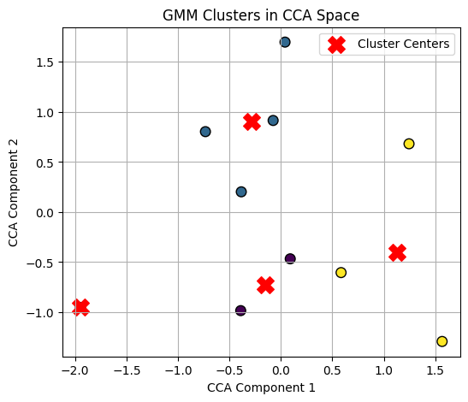
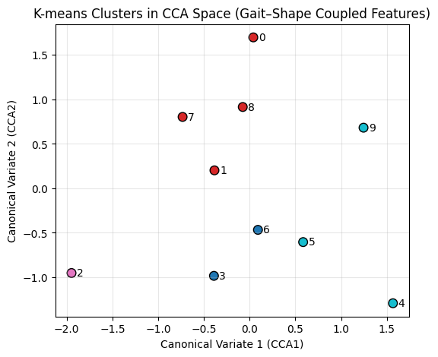
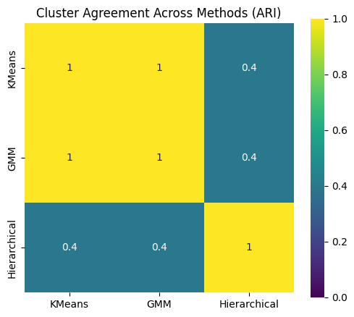
Figure 8. Cluster analysis between k-means and GMM. Evaluate agreement across methods with (ARI).
- Subgroup #1 (n = 2)
- Subgroup #2 (n = 4)
- Subgroup #3 (n = 1)
- Subgroup #4 (n= 4)
Amplitude shifts were present across all six kinematic gait variables, notably in midfoot rotation, indicating translation changes between clusters. Waveform slope variations in the sagittal ankle and ankle rotation across clusters indicate joint angle deformations due to joint interactions throughout the gait cycle (Figure 9).
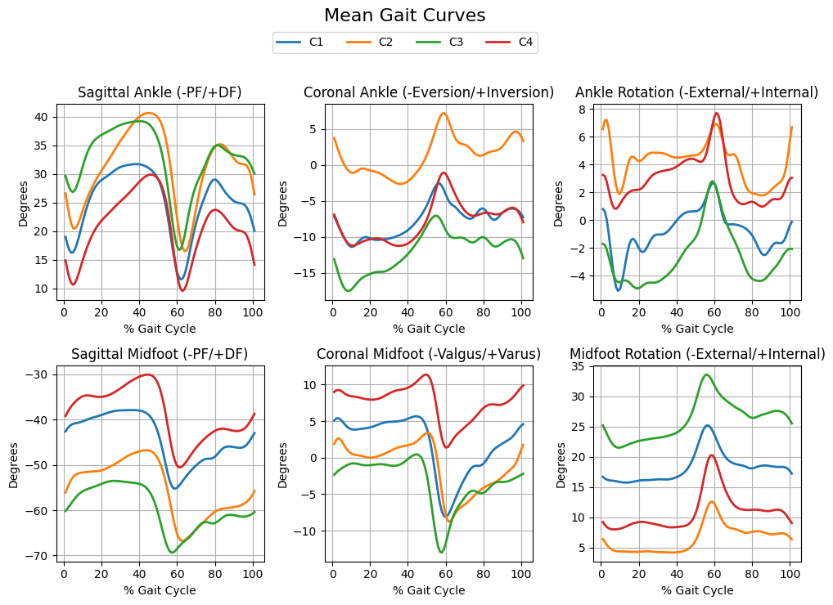
Figure 9. Mean gait curves for participants in subgroups.
SSM mean with ± 2 standard deviation 3D plots showed subgroup 1 with primary shifts in the subtalar joint (red) with potential increase in the posterior tuberosity. Subgroup 2 indicated translational changes in the subtalar joint. Subgroup 3 consisted of only one participant and thus did not have standard deviations within the group. Subgroup 4 visualized shifts in the medial process of the calcaneus, the primary location of initial load bearing during the first rocker of gait (Figure 10)

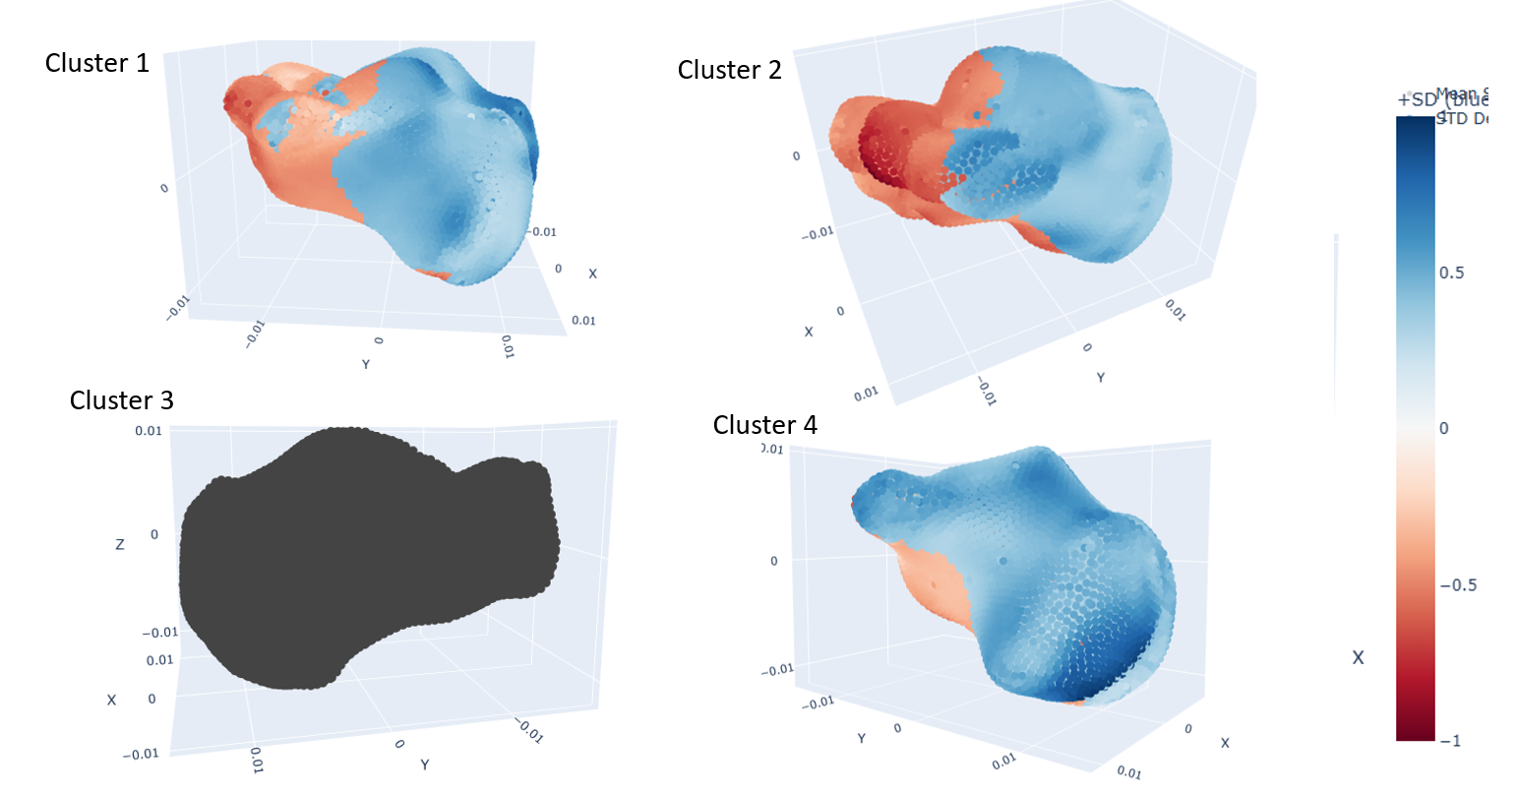

Figure 10. SSM mean and standard deviations for each subgroup.
Discussion
The current study identified four distinct kinematic and shape subgroups among a sample of TD children using 3D multisegment foot and ankle kinematics and bone morphology as inputs for PCA, CCA, K-means, and GMM cluster analysis. PCA reduced the initial gait and SSM dataset to clinically relevant scores and CCA was used to determine canonical variates with maximum correlation between PC scores. Cluster analysis on CVs was compared between k-means and GMM, where both methods performed similarly, identifying subgroups with varied gait profiles, alignment, and morphology.
For this population, primary shifts in gait and morphology occurred between the subtalar joint between the talus and the calcaneus of the hindfoot and the calcaneal tuberosity. Further work should be performed to indicate clinical interventions to address these shifts. Additionally, a greater study population with more clinically diverse participants, including those with diagnosed FF or CP, would help characterize patient symptom presentations for improved cluster analysis. Deep learning techniques may also be utilized on a larger dataset including synthetic data compared to the control population to understand the true effect of bone shape on gait performance for pediatric populations.

References
2.3. Clustering. (n.d.). Scikit-Learn. Retrieved April 30, 2026, from https://scikit-learn/stable/modules/clustering.html
Birdal, R. G., & Sertbas, A. (2023). 3-D Gait Identification Utilizing Latent Canonical Covariates Consisting of Gait Features. Computers, Materials and Continua, 76(3), 2727–2744. https://doi.org/10.32604/cmc.2023.032069
Böhm, H., Döderlein, L., Fujak, A., & Dussa, C. U. (2020). Is there a correlation between static radiographs and dynamic foot function in pediatric foot deformities? Foot and Ankle Surgery, 26(7), 801–809. https://doi.org/10.1016/j.fas.2019.10.006
Bresnahan, P. J., & Juanto, M. A. (2020). Pediatric Flatfeet—A Disease Entity That Demands Greater Attention and Treatment. Frontiers in Pediatrics, 8, 19. https://doi.org/10.3389/fped.2020.00019
Cattell, R. B. (1966). The Scree Test For The Number Of Factors. Multivariate Behavioral Research, 1(2), 245–276. https://doi.org/10.1207/s15327906mbr0102_10
CDC. (2025, July 23). About Cerebral Palsy. Cerebral Palsy (CP). https://www.cdc.gov/cerebral-palsy/about/index.html
Cerebral Palsy | National Institute of Neurological Disorders and Stroke. (n.d.). Retrieved December 1, 2025, from https://www.ninds.nih.gov/health-information/disorders/cerebral-palsy
Dibbern, K., Behrens, A., Talaski, G. M., Mansur, N. S. B., Carvalho, K. A. M., & de Cesar Netto, C. (2023). Evaluation of Automated Coverage and Distance Mapping Selections to Improve Reliability and Clinical Utility of 3D Weightbearing CT Assessments. Foot & Ankle Orthopaedics, 8(4), 2473011423S00153. https://doi.org/10.1177/2473011423S00153
Dibbern, K. N., Krzak, M. G., Olivas, A., Albert, M. V., Krzak, J. J., & Kruger, K. M. (2025). Scoping Review of Machine Learning Techniques in Marker-Based Clinical Gait Analysis. Bioengineering, 12(6), 591. https://doi.org/10.3390/bioengineering12060591
Dibbern, K. N., Li, S., Vivtcharenko, V., Auch, E., Lintz, F., Ellis, S. J., Femino, J. E., & de Cesar Netto, C. (2021). Three-Dimensional Distance and Coverage Maps in the Assessment of Peritalar Subluxation in Progressive Collapsing Foot Deformity. Foot & Ankle International, 42(6), 757–767. https://doi.org/10.1177/1071100720983227
Jolliffe, I. T., & Cadima, J. (2016). Principal component analysis: A review and recent developments. Philosophical Transactions of the Royal Society A: Mathematical, Physical and Engineering Sciences, 374(2065), 20150202. https://doi.org/10.1098/rsta.2015.0202
Kruger, K. M., Graf, A., Flanagan, A., McHenry, B. D., Altiok, H., Smith, P. A., Harris, G. F., & Krzak, J. J. (2019). Segmental foot and ankle kinematic differences between rectus, planus, and cavus foot types. Journal of Biomechanics, 94, 180–186. https://doi.org/10.1016/j.jbiomech.2019.07.032
Krzak, J. J., Corcos, D. M., Damiano, D. L., Graf, A., Hedeker, D., Smith, P. A., & Harris, G. F. (2015). Kinematic foot types in youth with equinovarus secondary to hemiplegia. Gait & Posture, 41(2), 402–408. https://doi.org/10.1016/j.gaitpost.2014.10.027
L, R. M. (1977). Normal and abnormal function of the foot. Clinical Biomechanics, 0, 457–459.
Lan, Z., Lempereur, M., Gueret, G., Houx, L., Cacioppo, M., Pons, C., Mensah, J., Rémy-Néris, O., Aïssa-El-Bey, A., Rousseau, F., & Brochard, S. (2024). Towards a diagnostic tool for neurological gait disorders in childhood combining 3D gait kinematics and deep learning. Computers in Biology and Medicine, 171, 108095. https://doi.org/10.1016/j.compbiomed.2024.108095
Park, M. S., Kwon, S.-S., Lee, S. Y., Lee, K. M., Kim, T. G., & Chung, C. Y. (2013). Spontaneous Improvement of Radiographic Indices for Idiopathic Planovalgus with Age. JBJS, 95(24), e193. https://doi.org/10.2106/JBJS.M.00301
Pfeiffer, M., Kotz, R., Ledl, T., Hauser, G., & Sluga, M. (2006). Prevalence of Flat Foot in Preschool-Aged Children. Pediatrics, 118(2), 634–639. https://doi.org/10.1542/peds.2005-2126
Pita-Fernandez, S., Gonzalez-Martin, C., Alonso-Tajes, F., Seoane-Pillado, T., Pertega-Diaz, S., Perez-Garcia, S., Seijo-Bestilleiro, R., & Balboa-Barreiro, V. (2017). Flat Foot in a Random Population and its Impact on Quality of Life and Functionality. Journal of Clinical and Diagnostic Research : JCDR, 11(4), LC22–LC27. https://doi.org/10.7860/JCDR/2017/24362.9697
Thomas, M. J., Roddy, E., Zhang, W., Menz, H. B., Hannan, M. T., & Peat, G. M. (2011). The population prevalence of foot and ankle pain in middle and old age: A systematic review. PAIN, 152(12). https://journals.lww.com/pain/fulltext/2011/12000/the_population_prevalence_of_foot_and_ankle_pain.28.aspx

