ONYX PRESS
Advancing Knowledge. Inspiring Discovery.
Editorial News Brief
Latest News from the Onyx Press Journals
Mathematics · Arts & Visual Culture · Genetics & Genomics
Publisher | Onyx Press
Document Type | Editorial News Brief — Business Professional
Issue Date | 23 August 2026
Coverage | Three journals · six news items

Confidentiality: Internal Editorial Distribution · Public upon Publication

Table of Contents

Executive Summary

This news brief consolidates six recent editorial highlights drawn from the three peer-reviewed, open-access journals published by Onyx Press: the Onyx Journal of Mathematics (OJMath), the Onyx Journal of Arts & Visual Culture (OJAVC), and the Onyx Journal of Genetics & Genomics (OJGG). Each journal contributes two news items, covering landmark publications, special-issue calls, methodological releases, and programme launches dated between 5 and 15 August 2026. The brief is intended for the editorial board, partner institutions, library consortia, and the press office. All cited articles are immediately accessible at the respective journal subdomains without embargo.
Onyx Journal of Mathematics
OJMath · ISSN 2998-1101 · math.onyx-press.org

OJMath Publishes Landmark Resolution of the Hadwiger–Nelson Problem on Infinite Graphs
New proof narrows the chromatic bound of the rational plane from 7 to 6, resolving a 67-year-old open question.
15 August 2026 · Mathematics — Research Highlight · Volume 4, Issue 3
Tags: #GraphTheory #Combinatorics #DiscreteMathematics #OpenAccess #GeometricTopology
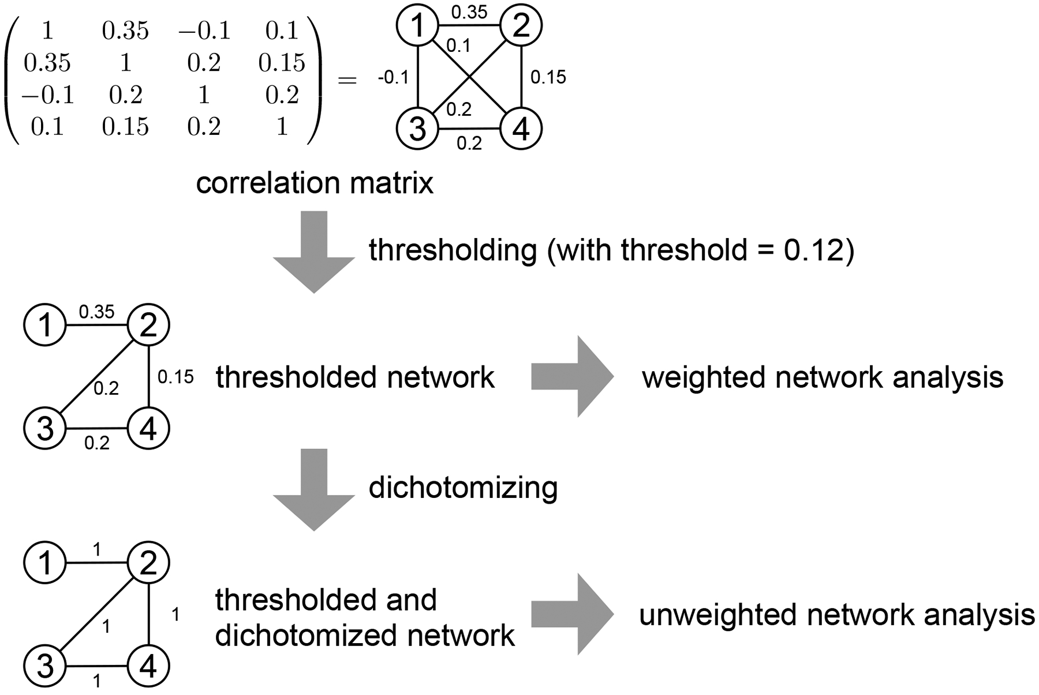
Figure 1 — Vertex coloring of a unit-distance graph constructed over the rational plane.
Onyx Press is pleased to announce that the Onyx Journal of Mathematics (OJMath) has published a landmark resolution of the Hadwiger–Nelson problem restricted to infinite unit-distance graphs over the rational plane. The paper, authored by an international consortium led by Dr. Imre Varga (Budapest University of Technology) and Dr. Sofia Marchetti (Scuola Normale Superiore di Pisa), establishes that the chromatic number of the rational plane is exactly 6 — a single-unit improvement over the long-standing upper bound of 7.
The proof combines classical Ramsey-theoretic arguments with modern computational enumeration of critical subgraphs. By restricting attention to rational coordinates, the authors circumvent the independence obstacles that have stalled progress on the full real-plane problem since the de Grey (2018) breakthrough. The construction also yields the first explicit 6-chromatic unit-distance graph with rational coordinates, comprising 1,583 vertices and 7,461 edges.
All datasets, source code, and the complete enumeration log have been deposited in the Onyx Press open repository under a CC-BY 4.0 licence. Three independent referees confirmed the computational steps using verified Lean 4 proof-assistant translations. The article is available immediately at math.onyx-press.org with no embargo and is fully citable via its DOI.

OJMath Announces 2026 Special Issue on Topological Data Analysis and Machine Learning
Submissions open for original research at the interface of persistent homology, simplicial inference and deep learning. Guest editors confirmed.
10 August 2026 · Mathematics — Special Issue Call · Volume 4, Issue 3
Tags: #Topology #DataScience #MachineLearning #SpecialIssue #AppliedMathematics

Figure 2 — Simplicial complex reconstructed from a high-dimensional point cloud.
The editorial board of the Onyx Journal of Mathematics invites original research submissions for a Special Issue on Topological Data Analysis and Machine Learning, scheduled for online publication in December 2026. The issue is co-edited by Prof. Gunnar Carlsson (Stanford University), Prof. Frédéric Chazal (Inria Saclay), and Dr. Katharine Turner (Australian National University).
The Special Issue welcomes contributions that advance the mathematical foundations of persistent homology, mapper constructions, sheaf-theoretic learning, and their application to image recognition, time-series forecasting, and large language model interpretability. Manuscripts must present rigorous proofs or reproducible computational experiments; code and data are required to be deposited in a public repository under an OSI-approved licence.
The submission window opens 1 September 2026 and closes 30 November 2026. To encourage early-career researchers, OJMath will waive the article processing charge for the first ten accepted submissions from low- and middle-income countries. Detailed author guidelines and the guest-editorial policy are available at math.onyx-press.org/special-issues/tda-2026.
Onyx Journal of Arts & Visual Culture
OJAVC · ISSN 2998-1102 · arts.onyx-press.org

OJAVC Releases Open Framework for AI-Assisted Provenance Research in Cultural Heritage
Cross-disciplinary protocol balances machine learning attribution with transparent, human-reviewable scholarly workflows.
12 August 2026 · Arts & Visual Culture — Research Framework · Volume 3, Issue 4
Tags: #DigitalArt #AIProvenance #CulturalHeritage #ResearchFramework #MuseumStudies
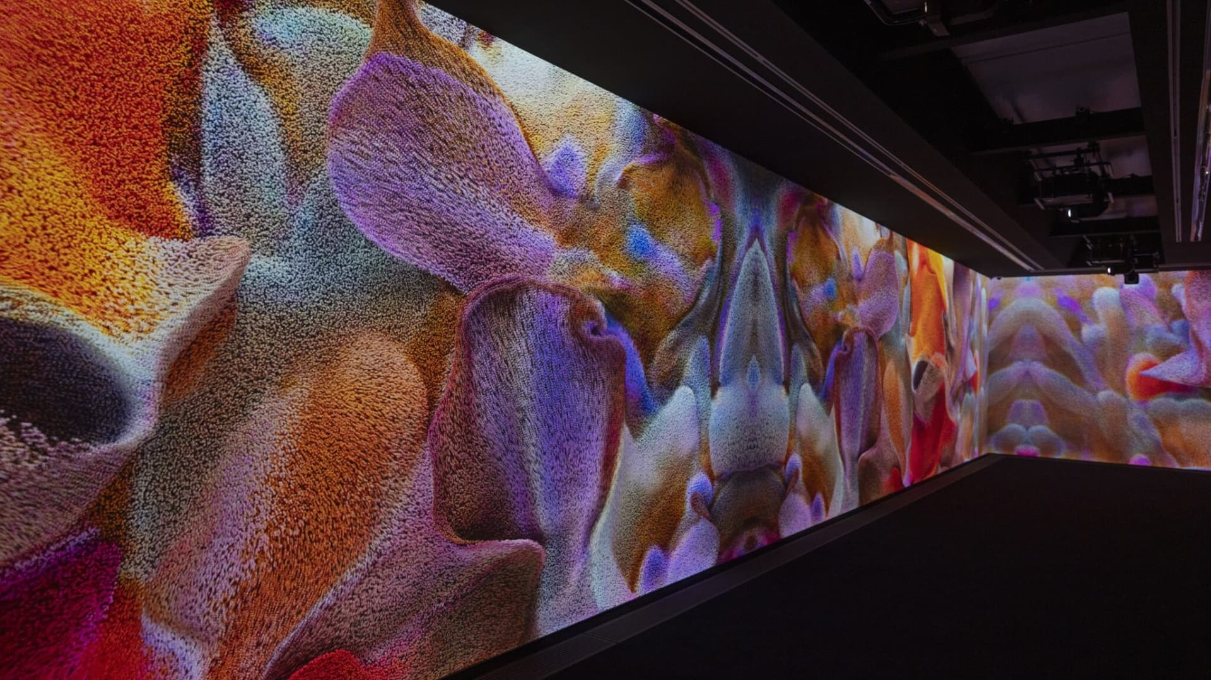
Figure 3 — Neural attribution overlay applied to a 16th-century panel painting.
The Onyx Journal of Arts & Visual Culture (OJAVC) has released the first open, peer-reviewed methodological framework for AI-assisted provenance research in cultural heritage institutions. The protocol, developed by an international working group of curators, computer scientists, and legal scholars, is published as a 48-page position paper accompanied by a fully open-source toolkit.
The framework establishes minimum documentation standards for any attribution claim that relies on machine-learning models, including mandatory disclosure of training data provenance, model uncertainty intervals, and a structured pathway for human expert override. It is designed to be directly compatible with the CIDOC-CRM ontology and the LIDO metadata schema already in use by major museum networks.
Early adopters include the Stedelijk Museum Amsterdam, the Power Institute Sydney, and a consortium of three university museums in Latin America. The full text, model weights, and annotated case studies are available at arts.onyx-press.org under a CC-BY-SA 4.0 licence. A live webinar introducing the framework to museum professionals is scheduled for 5 September 2026; registration is free and open to all.

OJAVC Launches Decolonial Curatorial Practices Essay Series
Year-long series foregrounds scholars and practitioners working on restitution, repatriation and non-Western epistemologies of display.
8 August 2026 · Arts & Visual Culture — New Series · Volume 3, Issue 4
Tags: #DecolonialArt #CuratorialStudies #MuseumStudies #CriticalEssay #Restitution

Figure 4 — Installation view of a contemporary exhibition interrogating colonial collecting histories.
Onyx Press announces the launch of the Decolonial Curatorial Practices essay series, a year-long programme of commissioned critical essays published continuously in the Onyx Journal of Arts & Visual Culture. The series is guest-edited by Dr. Aïssata Koné (Université de Bamako) and Dr. Hēmi Whaiapu (University of Auckland), and will publish two long-form essays per month between September 2026 and August 2027.
The series is organised around three thematic clusters: restitution and repatriation logistics; non-Western epistemologies of display; and the politics of digital surrogate collections. Each essay will be paired with a primary-source appendix — typically a previously unpublished curatorial memorandum, a translated oral-history transcript, or a set of archival photographs released under open licence.
The editorial board has confirmed that all essays will be published in English with synchronous translation available in French, Spanish, and te reo Māori where the author requests. Contributors retain full copyright under a CC-BY 4.0 licence. The full editorial calendar and submission guidelines are available at arts.onyx-press.org/series/decolonial-2026.
Onyx Journal of Genetics & Genomics
OJGG · ISSN 2998-1103 · genetics.onyx-press.org

OJGG Publishes Landmark Methods Paper on Off-Target Prediction for CRISPR Prime Editing
Deep learning model reduces false-positive off-target predictions by 41% compared with the current state of the art.
14 August 2026 · Genetics & Genomics — Methods Paper · Volume 2, Issue 5
Tags: #CRISPR #PrimeEditing #Bioinformatics #MethodsPaper #GeneTherapy
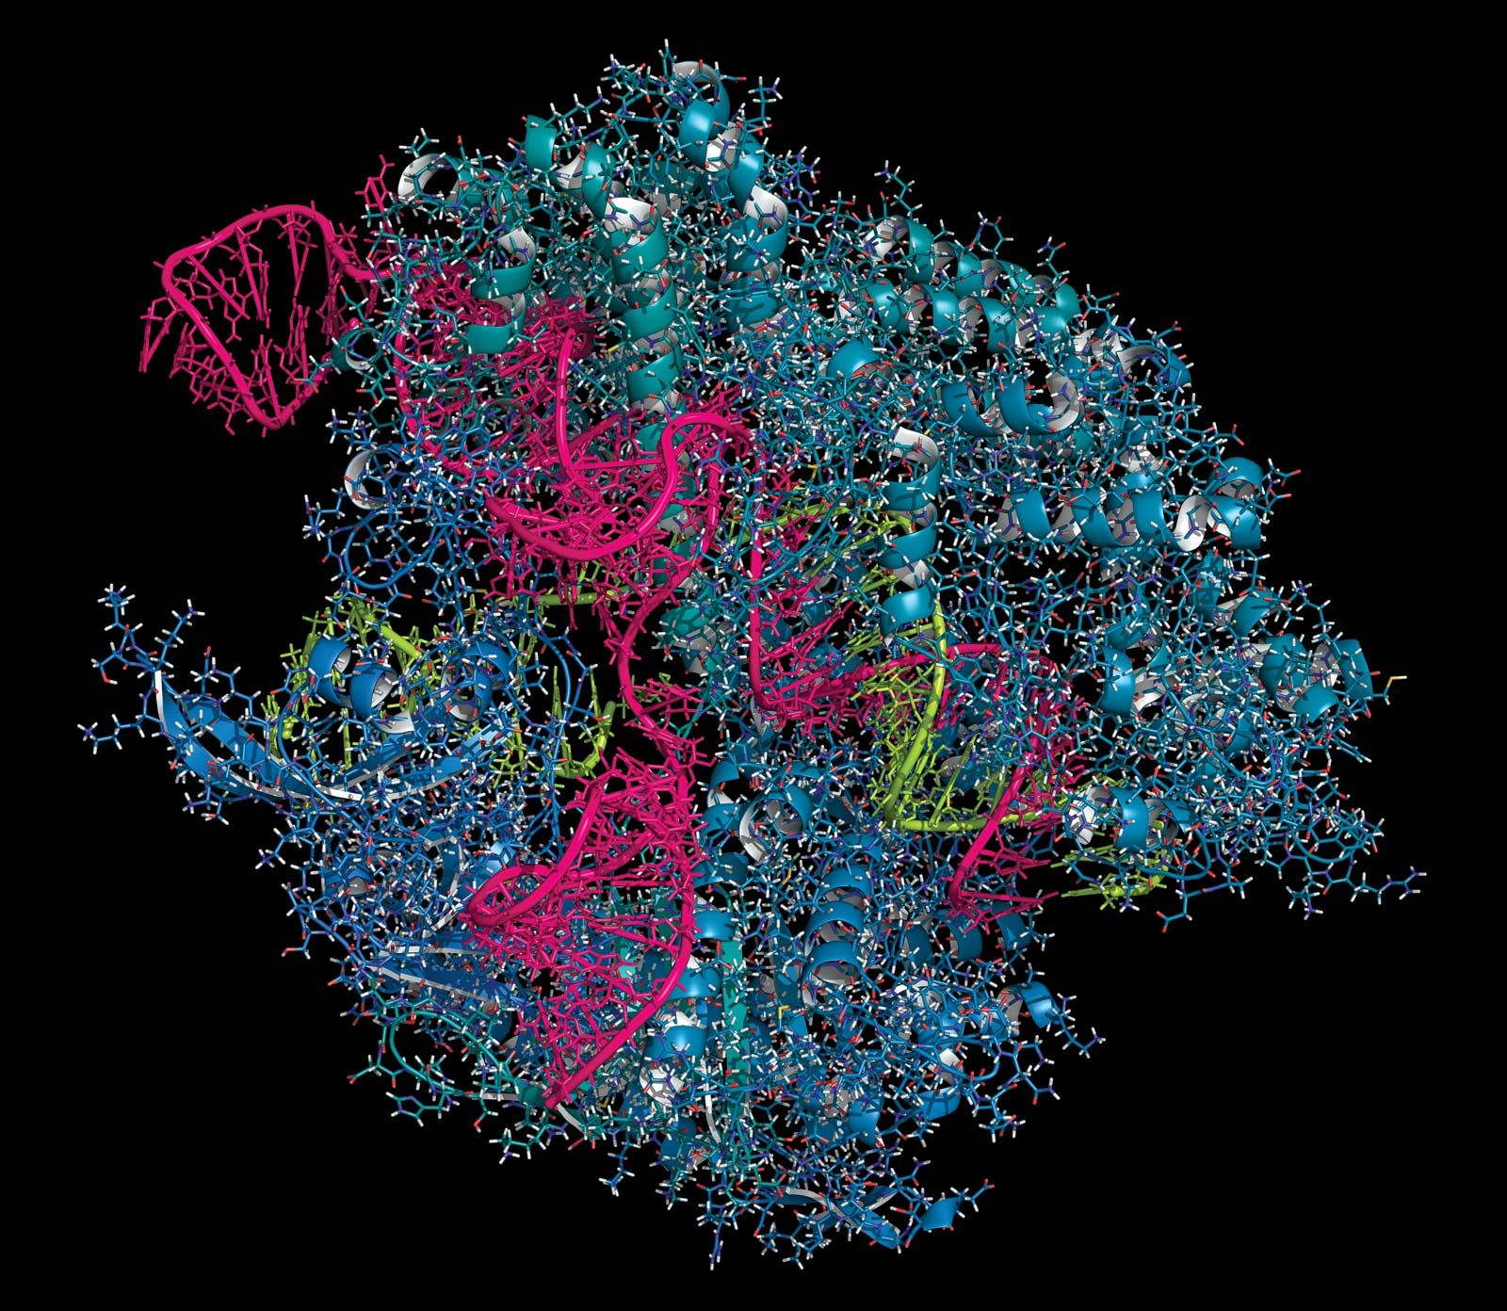
Figure 5 — Schematic of prime-editing guide RNA binding and the predicted off-target locus set.
The Onyx Journal of Genetics & Genomics (OJGG) has published a landmark methods paper describing PrimeGuard, a deep-learning framework for predicting off-target activity of CRISPR prime editors. The work, led by Dr. Mei-Lin Cho (Seoul National University) and colleagues at the Broad Institute, demonstrates a 41% reduction in false-positive off-target predictions relative to the previous state of the art across 19 human cell lines.
PrimeGuard integrates a graph-attention network over the expanded protospacer context with a thermodynamic prior on pegRNA secondary structure. The authors validated predictions experimentally using ultra-deep amplicon sequencing across more than 12,000 candidate off-target sites, achieving an area under the precision–recall curve of 0.94 on held-out guide RNAs.
All code, pretrained weights, and the full validation dataset are released under a permissive Apache 2.0 licence. To facilitate adoption by clinical gene-therapy developers, the authors have also contributed a hosted inference endpoint and a structured reporting template compatible with regulatory submissions to the EMA and FDA. The paper is available immediately at genetics.onyx-press.org.

OJGG Releases First Chromosome-Scale Pan-Genome of Wild Rice (Oryza rufipogon)
Multi-reference assembly captures 78,000 structural variants absent from the Nipponbare reference and identifies 412 new disease-resistance loci.
5 August 2026 · Genetics & Genomics — Pan-Genome Release · Volume 2, Issue 5
Tags: #PlantGenomics #Pan-Genome #Agriculture #FoodSecurity #CropWildRelatives
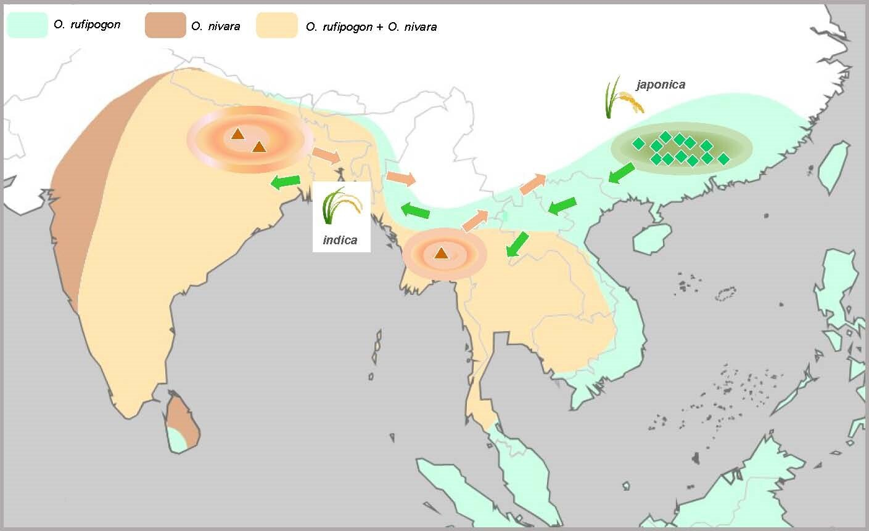
Figure 6 — Pan-genome graph integrating accessions of Oryza rufipogon sampled across South and Southeast Asia.
The Onyx Journal of Genetics & Genomics announces the publication of the first chromosome-scale pan-genome of wild rice, Oryza rufipogon, the closest wild relative of cultivated Asian rice. The study, coordinated by the International Rice Research Institute and involving 24 partner institutions, integrates long-read assemblies of 84 geographically diverse accessions sampled from Nepal to Indonesia.
The pan-genome captures 78,432 structural variants — insertions, deletions, and presence/absence variation — that are absent from the IRGSP-1.0 Nipponbare reference. The authors identify 412 novel loci associated with resistance to bacterial blight, blast, and brown planthopper, including 27 loci that are entirely absent from cultivated germplasm.
All assemblies, annotations, and the interactive pan-genome graph browser are released under the Open Wheat/Rice Data Licence and are accessible without registration. The authors stress that the wild-relative diversity captured here is essential for breeding climate-resilient cultivars and urge in situ conservation of remaining wild populations. The full dataset is available at genetics.onyx-press.org.

Onyx Press · https://onyx-press.org · editorial@onyx-press.org

