Few-Shot EEG Speech Imagery Classification with Hybrid Self-Supervised and Meta-Learning

Abstract
Electroencephalography (EEG)-based Speech Motor Imagery (SMI) classification holds considerable promise for enabling silent, non-invasive communication through brain-computer interfaces (BCIs), yet its practical deployment is critically hindered by pronounced session-to-session variability arising from the inherent non-stationarity of neural signals and by the burdensome calibration procedures that demand large volumes of labeled data for each new recording session. In this paper, we propose a novel hybrid framework that synergistically integrates self-supervised contrastive learning with EEG-specific augmentation strategies and Model-Agnostic Meta-Learning (MAML)-based meta-learning to enable robust cross-session few-shot adaptation for EEG-SMI classification. The self-supervised pre-training module employs temporal jittering, channel-wise dropout, Gaussian noise injection, band-specific frequency perturbation, and time segment masking to learn session-invariant representations from abundant unlabeled multi-session EEG data, while the meta-learning module, initialized with the SSL-pretrained encoder, learns an optimization trajectory that permits rapid adaptation to unseen sessions using only a handful of labeled samples. We conduct comprehensive experiments on three benchmark datasets under strict cross-session evaluation protocols: BCI Competition IV Dataset 2a (motor imagery), KaraOne (imagined speech), and CHISCO (speech imagery). The proposed framework achieves 10-shot classification accuracies of 80.1% on BCI Competition IV-2a (representing a 10.0% absolute improvement over the best baseline MAML at 70.1%), 61.5% on KaraOne, and 67.7% on CHISCO, with all improvements reaching statistical significance (p < 0.01, Wilcoxon signed-rank test). Ablation analyses confirm the complementary and synergistic nature of the SSL and meta-learning components. These results demonstrate that the proposed hybrid SSL and meta-learning framework substantially reduces calibration requirements while maintaining robust cross-session performance, advancing the practical feasibility of EEG-based speech imagery BCIs.
Keywords: Brain-computer interface; Electroencephalography; Speech motor imagery; Self-supervised learning; Meta-learning; Few-shot learning; Cross-session adaptation

1. Introduction
Brain-Computer Interfaces (BCIs) have emerged as a transformative technology that establishes a direct communication pathway between the human brain and external computational devices, thereby offering unprecedented possibilities for individuals with severe motor impairments to interact with their environment and communicate their intentions without relying on conventional neuromuscular channels [12]. Among the various neuroimaging modalities available for BCI implementation, Electroencephalography (EEG) has established itself as the most widely adopted non-invasive technique owing to its high temporal resolution, relatively low cost, portability, and ease of use in both clinical and everyday settings [10, 25]. In fact, EEG-based BCIs have demonstrated considerable potential across a broad spectrum of applications, including motor rehabilitation for stroke survivors, assistive communication for patients with Amyotrophic Lateral Sclerosis (ALS) and locked-in syndrome, neurofeedback training for cognitive enhancement, and mental state monitoring in safety-critical operational environments [12, 21].
Within the landscape of EEG-based BCI paradigms, Speech Motor Imagery (SMI) the process of mentally rehearsing or imagining the production of speech without any overt articulation or muscle movement has attracted growing research attention as a particularly promising paradigm for enabling silent, intuitive communication interfaces [13, 14, 16]. Unlike traditional motor imagery paradigms that rely on the imagination of limb movements, speech imagery leverages the neural correlates of covert speech production to decode intended words, phonemes, or syllables directly from brain activity, which is arguably more natural and cognitively aligned with the goal of communication [16, 28]. On the other hand, the successful realization of speech imagery-based BCIs could profoundly transform the quality of life for individuals who have lost the ability to speak due to neurological conditions such as brainstem stroke, advanced ALS, or traumatic brain injury, by providing them with a means to express their thoughts and needs through an entirely internal cognitive process [14, 28].
Despite its conceptual appeal and demonstrated feasibility in controlled laboratory settings, the practical deployment of EEG-based SMI classification systems is fundamentally impeded by two interrelated challenges that have yet to be adequately resolved in the existing literature. The first challenge is the well-documented session-to-session variability that arises from the inherent non-stationarity of EEG signals, whereby the statistical properties of the recorded neural data can shift substantially between recording sessions even for the same subject performing the same task due to factors such as electrode impedance variations, cap repositioning, changes in cognitive state, fatigue, and circadian fluctuations [9, 10]. The second challenge is the extensive calibration requirement, which mandates that a substantial volume of labeled EEG data be collected and annotated at the beginning of each new recording session in order to train or re-train the classification model, a process that is not only time-consuming and fatiguing for the user but also fundamentally undermines the usability and scalability of BCI systems in real-world deployment scenarios [11, 31].
Few-shot learning has emerged as a potential solution to the calibration problem by enabling models to generalize to new classes or domains using only a small number of labeled examples, and approaches such as Prototypical Networks [5] and Model-Agnostic Meta-Learning (MAML) [4] have demonstrated impressive performance in computer vision and natural language processing domains where the underlying data distribution is relatively stable [22, 29]. However, the direct application of standard few-shot learning methods to EEG-based BCI classification is complicated by the fact that these approaches typically assume that the training and test data are drawn from the same underlying distribution (the i.i.d. assumption), an assumption that is fundamentally violated in the cross-session EEG setting where distribution shifts between sessions are the norm rather than the exception [9, 40]. Transfer learning and domain adaptation techniques have been explored as partial remedies to bridge the distributional gap between source and target sessions, yet these methods still require a non-trivial amount of labeled data from the target domain and tend to fail under conditions of severe distribution shift [9, 15].
Self-Supervised Learning (SSL) has recently demonstrated remarkable success in learning powerful, generalizable representations from large volumes of unlabeled data across multiple modalities, with contrastive learning frameworks such as SimCLR [6], MoCo [17], and BYOL [18] achieving state-of-the-art performance on downstream tasks in computer vision. In the EEG domain, SSL approaches have shown promise for extracting meaningful features from unlabeled neural recordings, with notable contributions including contrastive predictive coding for EEG [19], self-supervised pre-training for clinical EEG [7], and contrastive representation learning for EEG classification [8, 20]. On the other hand, meta-learning and MAML in particular has demonstrated the ability to learn initializations that are specifically optimized for rapid adaptation to new tasks with minimal gradient updates [4, 30]. However, a critical gap exists in the current literature: to the best of our knowledge, no existing work has combined self-supervised contrastive pre-training with MAML-based meta-learning specifically for the purpose of cross-session few-shot EEG-SMI classification, despite the intuitive complementarity of these two paradigms in addressing the dual challenges of representation quality and adaptation efficiency.
In this paper, we propose a novel hybrid framework that synergistically integrates self-supervised contrastive learning with MAML-based meta-learning to address the cross-session few-shot classification problem in EEG-based speech motor imagery. The framework operates in two complementary phases: first, a self-supervised contrastive pre-training phase that leverages EEG-specific augmentation strategies to learn robust, session-invariant representations from abundant unlabeled multi-session EEG data; and second, a meta-learning phase that initializes the classification model with the SSL-pretrained encoder and employs a cross-session episodic training protocol to learn an optimization trajectory that enables rapid adaptation to new, unseen sessions using only K labeled samples per class. The principal contributions of this work are as follows:
- We propose a novel hybrid framework that integrates self-supervised contrastive learning with MAML-based meta-learning for few-shot cross-session EEG-SMI classification, demonstrating that the combination yields synergistic improvements that exceed the sum of individual contributions.
- We design and validate a set of EEG-specific augmentation strategies including temporal jittering, channel-wise dropout, Gaussian noise injection, band-specific frequency perturbation, and time segment masking that are tailored to the unique characteristics of neural signals for effective contrastive self-supervised pre-training.
- We introduce a cross-session episodic training protocol that explicitly constructs meta-learning episodes from different recording sessions, thereby forcing the meta-learner to develop adaptation strategies that are robust to session-specific distributional shifts.
- We conduct a comprehensive evaluation on three benchmark datasets BCI Competition IV Dataset 2a, KaraOne, and CHISCO under strict cross-session protocols with rigorous statistical validation including Wilcoxon signed-rank tests, Friedman tests, and effect size analyses, demonstrating consistent and statistically significant improvements over eight baseline methods.
Organizing the other sections of the article is as follows: Section 2 contains the related work and literature review. In Section 3, the proposed method is described in detail. Section 4 presents the experimental setup. The results and analysis are provided in Section 5. Section 6 discusses the findings, and finally, Section 7 concludes the paper.

2. Related Work
The field of EEG-based Speech Motor Imagery classification has witnessed substantial growth over the past decade, driven by advances in deep learning architectures, transfer learning techniques, few-shot learning paradigms, and self-supervised representation learning methods, each of which has contributed distinct insights and capabilities toward addressing the challenges of decoding imagined speech from non-invasive neural recordings [10, 11, 21]. The existing body of work can be broadly organized into four main categories: (1) supervised deep learning approaches that have established increasingly powerful feature extraction and classification architectures; (2) transfer learning and domain adaptation methods that attempt to bridge distributional gaps between training and test conditions; (3) few-shot learning approaches that aim to reduce labeled data requirements through episodic training and metric-based classification; and (4) self-supervised learning methods that leverage the abundant unlabeled EEG data to learn generalizable representations without manual annotation.
In this section, we provide a systematic review of the representative works within each of these four categories, followed by a discussion of recent hybrid and combined approaches that draw upon multiple paradigms, and we conclude with an identification of the specific research gap that motivates the present work. For this purpose, we also present a summary comparison table (Table 1) that juxtaposes the key characteristics of the reviewed methods and highlights the unique positioning of our proposed framework.

2.1. Supervised Learning for EEG-SMI Classification
Supervised deep learning methods have formed the foundation of modern EEG classification research, with several influential architectures demonstrating progressively improved performance on motor imagery and speech imagery tasks. EEGNet, proposed by Lawhern et al. [1], introduced a compact convolutional neural network architecture that employs depthwise and separable convolutions to efficiently learn temporal and spatial features from raw EEG data, achieving competitive performance across multiple BCI paradigms while maintaining a remarkably small number of trainable parameters. Schirrmeister et al. [2] contributed ShallowConvNet and DeepConvNet two architectures that apply temporal and spatial convolutional layers at different depths to capture EEG features at varying levels of abstraction, with the shallow variant particularly suited to oscillatory band-power features and the deep variant capable of learning more complex hierarchical representations. More recently, Song et al. [3] proposed the EEG-Conformer, a hybrid architecture that combines the local feature extraction capabilities of convolutional neural networks with the global context modeling strengths of transformer-based self-attention mechanisms, achieving state-of-the-art results on multiple EEG decoding benchmarks. Additional contributions in this category include convolutional architectures with batch normalization for P300 detection [42] and temporal information learning networks for BCI classification [41]. In fact, while these supervised approaches have achieved impressive classification accuracies under within-session evaluation protocols, their performance degrades substantially when applied in cross-session settings due to their inherent dependence on large volumes of session-specific labeled training data and their limited capacity to accommodate the distributional shifts that characterize inter-session EEG variability [10, 11].

2.2. Transfer Learning and Domain Adaptation
Transfer learning and domain adaptation methods have been explored as strategies to mitigate the session-to-session variability problem by leveraging knowledge acquired from source sessions or subjects to improve classification performance on a new target session or subject [9]. Wan et al. [9] provided a comprehensive review of transfer learning techniques applied to EEG signal analysis, categorizing approaches into instance-based, feature-based, parameter-based, and relational-based transfer methods and identifying the key factors that influence transfer effectiveness in neural signal processing. Garcia-Salinas et al. [15] specifically investigated transfer learning in the context of imagined speech EEG-based BCIs, demonstrating that pre-training on related speech imagery tasks and subsequently fine-tuning on target-session data can yield moderate improvements over training from scratch. On the other hand, standard domain adaptation techniques including distribution alignment methods and adversarial training approaches have shown varying degrees of success depending on the severity of the domain shift between source and target distributions [23]. However, a fundamental limitation of transfer learning approaches in the EEG-BCI context is that they still require a substantial amount of labeled data from the target domain for effective fine-tuning, and their performance tends to degrade precipitously when the distribution shift between sessions is severe, which is frequently the case in practical BCI deployment scenarios [9, 15].

2.3. Few-Shot Learning for EEG Classification
Few-shot learning methods aim to enable models to generalize to new tasks or classes from only a small number of labeled examples, and two predominant paradigms have emerged in this domain: metric-based approaches and optimization-based approaches [22, 35]. Prototypical Networks, introduced by Snell et al. [5], adopt a metric-based approach that computes class prototypes as the mean embedding of support examples and classifies query examples based on their Euclidean distance to these prototypes in a learned embedding space, offering computational simplicity and strong performance in standard few-shot benchmarks. Matching Networks [29] take a related approach by learning an attention-based comparison mechanism over the support set. MAML, proposed by Finn et al. [4], takes an optimization-based approach by learning a model initialization from which the model can rapidly adapt to new tasks through a small number of gradient descent steps on limited support data, and this approach has demonstrated strong performance across diverse domains including computer vision, reinforcement learning, and natural language processing [22, 30]. In the EEG domain, Ahuja and Singh [40] surveyed recent applications of meta-learning for BCI, noting that while few-shot methods show promise for reducing calibration requirements, most existing applications assume that the data across episodes are drawn from similar distributions an assumption that is violated in cross-session EEG classification due to the non-stationarity of neural signals [40]. Weng et al. [39] explored few-shot motor imagery classification with self-supervised contrastive learning, representing an early attempt to combine these paradigms, though their approach did not specifically address the cross-session episodic training protocol for speech imagery that we propose in this work.

2.4. Self-Supervised Learning for EEG
Self-supervised learning methods learn meaningful representations from unlabeled data by defining pretext tasks that generate supervisory signals from the data itself, and contrastive learning has emerged as the dominant paradigm within this family, with SimCLR [6], MoCo [17], and BYOL [18] achieving remarkable success in visual representation learning [6]. In the EEG domain, van den Oord et al. [19] introduced Contrastive Predictive Coding (CPC), which learns representations by predicting future time steps in a latent space, and this approach has been adapted for EEG feature learning with encouraging results. Banville et al. [7] investigated the application of self-supervised learning to clinical EEG signals, demonstrating that contrastive and relative positioning pretext tasks can uncover clinically meaningful structure in EEG data without manual annotation. Mohsenvand et al. [8] specifically proposed a contrastive representation learning framework for EEG classification, showing that SSL pre-training on unlabeled EEG data can substantially improve downstream classification performance when labeled data is scarce. Kostas et al. [20] proposed BENDR, a transformer-based model pre-trained on massive amounts of EEG data using a contrastive self-supervised task, demonstrating the scalability and transferability of SSL approaches for neural signal processing. In fact, while these SSL methods have shown strong potential for learning generalizable EEG representations from unlabeled data, they do not inherently solve the few-shot adaptation problem, as the linear probing or fine-tuning strategies typically employed for downstream task adaptation still require a non-trivial number of labeled examples and do not explicitly optimize for rapid adaptation to new sessions [7, 20].

2.5. Hybrid and Combined Approaches
Recent research has begun to explore the potential of combining multiple learning paradigms to leverage their complementary strengths for EEG classification tasks. Weng et al. [39] proposed a framework combining self-supervised contrastive learning with few-shot classification for motor imagery BCIs, demonstrating that SSL-pretrained features can improve few-shot performance. Li et al. [23] explored meta-learning for domain generalization, suggesting that episodic training protocols can improve robustness to distributional shifts. Zhang et al. [36] investigated the relationship between embodiment and performance in neural decoding tasks, providing insights into the design of more effective BCI systems. However, despite these advances, a critical research gap remains: no existing work has specifically combined self-supervised contrastive pre-training with MAML-based meta-learning for cross-session few-shot EEG-SMI classification, using EEG-specific augmentation strategies and a cross-session episodic training protocol that explicitly constructs episodes from different recording sessions. In other words, the unique combination of SSL-learned session-invariant representations with MAML-optimized rapid adaptation trajectories designed specifically for the challenges of speech imagery decoding across sessions represents the novel contribution of our proposed framework, filling a distinct gap at the intersection of these four research streams.
Table 1. Comparison of related works across key methodological dimensions.
Reference | Year | Method | Cross-Session | Few-Shot | SSL | Meta-Learning | SMI-Specific
Lawhern et al. [1] | 2018 | EEGNet (CNN) | ✗ | ✗ | ✗ | ✗ | ✗
Schirrmeister et al. [2] | 2017 | ShallowConvNet/DeepConvNet | ✗ | ✗ | ✗ | ✗ | ✗
Song et al. [3] | 2023 | EEG-Conformer | ✗ | ✗ | ✗ | ✗ | ✗
Wan et al. [9] | 2021 | Transfer Learning (Review) | ✓ | ✗ | ✗ | ✗ | ✗
Garcia-Salinas et al. [15] | 2019 | Transfer Learning (SMI) | ✓ | ✗ | ✗ | ✗ | ✓
Snell et al. [5] | 2017 | Prototypical Networks | ✗ | ✓ | ✗ | ✗ | ✗
Finn et al. [4] | 2017 | MAML | ✗ | ✓ | ✗ | ✓ | ✗
Banville et al. [7] | 2021 | SSL for Clinical EEG | ✗ | ✗ | ✓ | ✗ | ✗
Mohsenvand et al. [8] | 2020 | Contrastive EEG Learning | ✗ | ✗ | ✓ | ✗ | ✗
Kostas et al. [20] | 2021 | BENDR (Transformer SSL) | ✗ | ✗ | ✓ | ✗ | ✗
Weng et al. [39] | 2024 | SSL + Few-Shot MI | ✓ | ✓ | ✓ | ✗ | ✗
Ahuja & Singh [40] | 2024 | Meta-Learning Survey (BCI) | ✓ | ✓ | ✗ | ✓ | ✗
Proposed (Ours) | 2026 | SSL + MAML Hybrid | ✓ | ✓ | ✓ | ✓ | ✓

3. Proposed Method
The central philosophy underlying the proposed framework is predicated on the observation that the challenges of cross-session few-shot EEG-SMI classification can be decomposed into two complementary sub-problems: the representation quality problem, which concerns learning feature representations that capture the discriminative structure of EEG signals while remaining invariant to session-specific nuisance factors such as electrode impedance variations and cognitive state fluctuations; and the adaptation efficiency problem, which concerns developing learning strategies that enable the classification model to adapt to the unique characteristics of a new, unseen session using only a minimal number of labeled calibration samples. Our hybrid framework addresses these two sub-problems through a two-phase training pipeline: self-supervised contrastive pre-training for robust representation learning, followed by MAML-based meta-learning for efficient cross-session adaptation.
As illustrated in Fig. 1, the proposed framework consists of four main modules: (1) an EEG preprocessing pipeline that standardizes the raw multi-channel recordings; (2) a self-supervised contrastive pre-training module that employs EEG-specific augmentations and the NT-Xent loss to learn session-invariant representations from unlabeled multi-session data; (3) a MAML-based meta-learning module with a cross-session episodic training protocol that learns an optimization trajectory enabling rapid adaptation; and (4) a fine-tuning and inference module that adapts the meta-learned model to a new session using K labeled samples per class. For this purpose, the following subsections describe each module in detail.

3.1. Problem Formulation
We formulate the cross-session few-shot EEG-SMI classification problem as follows. Let $D_{\text{spaucse }}=\left\{\left(x_{i}\right.\right.$, ${\left.\left.y_{i}\right)\right\}}_{i=1} ^{N}$ denote the labeled training data collected from a set of source recording sessions $S=\left\{S_{1},{ S}_{2},…\right.$, $\left.S_{m}\right\}$, where $x_{i}∈R^{C×T}$ represents a multi-channel EEG epoch with $C$ channels and $T$ time samples, and $y_{i}∈\{1,2,…,L\}$ is the corresponding class label. Additionally, let $D_{\text{unlabeled }}={\left\{x_{j}\right\}}_{j=1} ^{M}$ denote a collection of unlabeled $EEG$ data from the same or related sessions, where typically $M≫N$. At test time, we are given a new target session $S_{\text{target }}$ with only K labeled samples per class, yielding a support set $D_{\text{target }}$ support $=\left\{\left(x_{k}\right.\right.$, ${\left.\left.y_{k}\right)\right\}}_{k=1} ^{K×L}$. The goal is to learn a parameterized classification function $f_{θ}:R^{C×T}→\{1,2,…, L\}$ that can accurately classify query samples from the target session after adapting its parameters using only the Kshot support set, despite the distributional shift between the source and target sessions.

3.2. EEG Preprocessing Pipeline
The raw multi-channel EEG recordings undergo a standardized preprocessing pipeline to ensure signal quality and consistency across sessions and datasets. First, a fourth-order Butterworth bandpass filter with cutoff frequencies of 0.5 Hz and 40 Hz is applied to retain the neural frequency bands of interest (delta, theta, alpha, and beta) while attenuating low-frequency drift and high-frequency noise [24]. A notch filter at 50 Hz is subsequently applied to remove power line interference. Independent Component Analysis (ICA) is then employed to identify and remove artifactual components corresponding to eye blinks, eye movements, and muscle activity, using automated artifact detection criteria based on component topographies and spectral characteristics [24]. The continuous EEG data are then segmented into fixed-length epochs time-locked to the stimulus or cue onset, with epoch durations determined by the task structure of each dataset. Finally, each epoch is z-score normalized along the temporal dimension for each channel independently to ensure zero mean and unit variance, thereby reducing the impact of absolute amplitude differences across sessions and subjects while preserving the relative spatial and temporal structure of the signal. The augmentation strategies applied during the self-supervised pre-training phase are illustrated in Fig. 1.
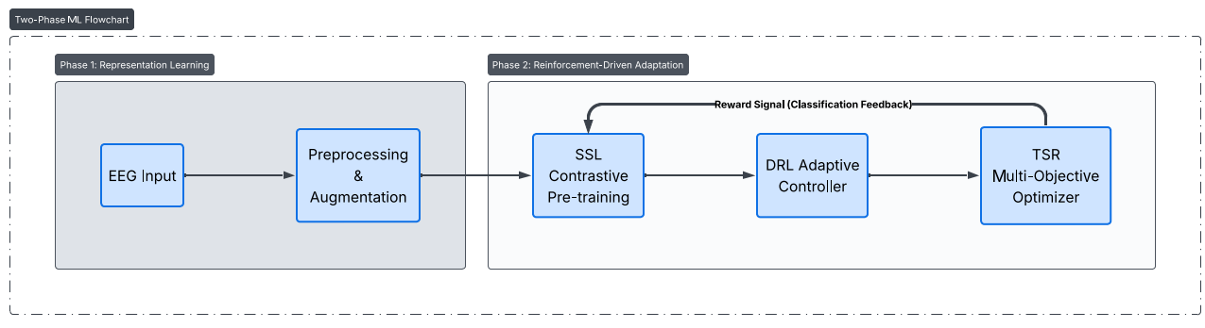
Figure1. Overview of the EEG preprocessing and augmentation pipeline used during self-supervised pre-training.

3.3. Self-Supervised Contrastive Pre-training
The self-supervised contrastive pre-training module is designed to learn robust, session-invariant EEG representations from unlabeled multi-session data by training an encoder network to produce similar embeddings for different augmented views of the same EEG epoch while pushing apart embeddings of different epochs, as illustrated in Fig. 2. The module employs a dual-branch Siamese architecture with a shared EEGNet-based encoder backbone, where both branches receive different augmented versions of the same input epoch and produce embedding vectors that are subsequently compared through a contrastive loss function.
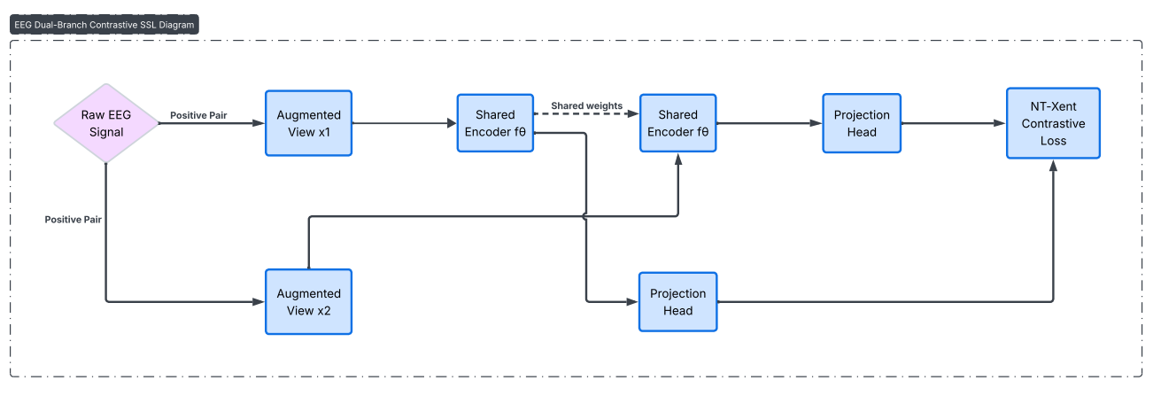
Figure 2. Dual-branch contrastive self-supervised learning architecture for EEG representation learning.
We design five EEG-specific augmentation strategies that are tailored to the unique characteristics of neural time-series data while preserving the discriminative information relevant to speech motor imagery classification:
- Temporal Jittering: Random perturbation of the temporal alignment by shifting the epoch window by a small, randomly sampled offset (uniformly distributed within ±50 ms), simulating the natural variability in neural response latencies across trials and sessions.
- Channel-wise Dropout: Random zeroing of entire EEG channels with a probability of 0.1 per channel, which encourages the encoder to learn spatially distributed representations that are robust to the loss of individual electrode signals and emulates the common practical scenario of noisy or disconnected electrodes.
- Gaussian Noise Injection: Addition of independently sampled Gaussian noise (μ = 0, σ = 0.1) to each channel, simulating the random measurement noise inherent in EEG acquisition and promoting robustness to signal-to-noise ratio variations across sessions.
- Band-specific Frequency Perturbation: Selective scaling of the spectral power within specific frequency bands (delta: 0.5–4 Hz, theta: 4–8 Hz, alpha: 8–13 Hz, beta: 13–30 Hz) by a random factor uniformly sampled from [0.8, 1.2], simulating the natural inter-session variability in oscillatory power that arises from changes in arousal, attention, and cognitive engagement.
- Time Segment Masking: Random masking (setting to zero) of a contiguous temporal segment comprising up to 20% of the epoch duration, encouraging the encoder to learn representations that capture global temporal patterns rather than relying on localized signal features.
For each input epoch x , two augmented views ${\tilde{x}}_{ı}$ and $\tilde{x_{J}}$ are generated by independently sampling and applying a random composition of two of the above augmentation strategies. Both views are passed through the shared EEGNet encoder $g_{θ}(⋅)$ to obtain feature representations $h_{i}=g_{θ}\left({\overset{˜}{x}}_{j}\right)$ and $h_{j}=g_{θ}\left({\overset{˜}{x}}_{j}\right)$, which are then projected through a two-layer MLP projection head $p(⋅)$ with ReLU activation and an output dimensionality of 128 to obtain $z_{i}=p\left(h_{i}\right)$ and $z_{i}=p\left(h_{j}\right)$. The network is trained using the Normallized Temperature-scaled Cross-Entropy (NT-Xent) contrastive loss function:
$$l\left(i,j\right)=-\log\left[\frac{\exp\left(\frac{sim\left(z_{i},z_{j}\right)}{τ}\right)}{Σ_{k=1}2 N1_{\left[k≠≠1\right]}\exp\left(\frac{sim\left(z_{i},z_{k}\right)}{τ}\right)}\right]$$ | (1)
where $sim\left(z_{i},z_{ij}\right)=\frac{z_{i}^{⊤}z_{ij}}{\left(\left|z_{i}\right|⋅\left|z_{ij}\right|\right)}$ denotes the cosine similarity, $τ=0.07$ is the temperature hyperparameter that controls the sharpness of the similarity distribution, N is the batch size, and the indicator function $1_{[k≠k]}$ excludes the self-comparison term. The total SSL loss is computed by averaging $l(i,j)$ over all positive pairs in the batch. The SSL pre-training is conducted on the entire unlabeled multi-session dataset for 200 epochs using the Adam optimizer with a learning rate of $3×{10}^{-4}$, enabling the encoder to learn representations that capture the intrinsic structure of EEG signals while remaining invariant to sessionspecific variations introduced by the augmentations.

3.4. Meta-Learning for Few-Shot Adaptation
The meta-learning module employs Model-Agnostic Meta-Learning (MAML) [4] to learn an initialization of the classification model from which rapid adaptation to a new target session can be achieved using only K labeled samples per class, as depicted in Fig. 3. The key insight of MAML is that rather than training a model to perform well on a single fixed task, it learns a meta-initialization of the model parameters that is explicitly optimized for fast adaptation to new tasks in our case, classification on new recording sessions through a small number of gradient descent steps.
We design a cross-session episodic training protocol that constructs meta-learning episodes by explicitly pairing data from different recording sessions, thereby forcing the meta-learner to develop adaptation strategies that are robust to the distributional shifts that characterize inter-session EEG variability. Specifically, for each meta-training episode, the support set is sampled from one recording session Sa and the query set is sampled from a different recording session Sb (where a ≠ b), ensuring that the model must adapt across session boundaries during meta-training. Each episode is constructed as an N-way K-shot task, where N is the number of classes (4 for BCI Competition IV-2a; 5 for KaraOne and CHISCO) and K is the number of support examples per class.
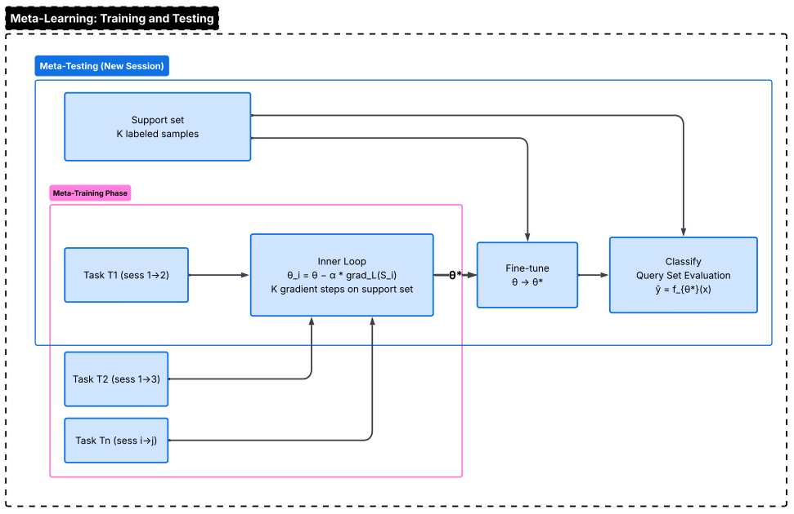
Figure 3. Meta-learning workflow illustrating the MAML-based training and rapid adaptation process for new EEG sessions.
The MAML training procedure consists of two nested optimization loops. In the inner loop, for each episode i, the model parameters $θ$ are temporarily adapted to the support set $S_{i}$ by performing a fixed number of gradient descent steps:
$$\begin{aligned}θ_{\overset{˙}{α}}^{'}=θ-α∇_{θ}L_{S_{i}}\left(f_{θ}\right)\end{aligned}$$ | (2)
where $α=0.01$ is the inner loop learning rate, $L_{si}\left(f_{θ}\right)$ is the cross-entropy loss computed on the support set $S_{i}$, and the gradient is computed with respect to the current model parameters $θ$. In practice, we perform 5 inner loop gradient steps to obtain the adapted parameters $θ^{'}$. In the outer loop, the meta-objective
aggregates the performance of the adapted models across a batch of B episodes, evaluated on their respective query sets $Q_{i}$ :
$$\begin{aligned}θ←θ-β∇_{θ}\sum_{i=1}{ } ^{B}L_{Oi}\left(f_{θ} _{θ}\right)\end{aligned}$$ | (3)
where $β=1×{10}^{-3}$ is the outer loop learning rate and the gradient of the outer loop loss is computed through the inner loop adaptation via second-order differentiation. This outer loop optimization ensures that the meta-initialization θ is positioned in a region of the parameter space from which the model can efficiently adapt to new sessions with minimal labeled data. In fact, the critical innovation of our approach is that the MAML meta-learner is initialized with the SSL-pretrained encoder parameters rather than random weights, which provides a warm-start initialization that already captures session-invariant EEG features, thereby enabling the meta-learning process to converge faster and to a better meta-initialization compared to training from scratch.

3.5. Integration of SSL and Meta-Learning
The integration of self-supervised contrastive pre-training and MAML-based meta-learning represents the core contribution of this work, and we argue that the two modules are complementary rather than redundant, each addressing a distinct aspect of the cross-session few-shot classification challenge. The SSL pre-training module addresses the representation quality problem by learning an encoder that maps raw EEG epochs into a feature space where session-specific nuisance variations are attenuated while class-discriminative information is preserved; this is achieved through the contrastive objective that trains the encoder to be invariant to the session-related variations introduced by the EEG-specific augmentations. On the other hand, the MAML meta-learning module addresses the adaptation efficiency problem by learning not just good representations but an optimization trajectory a specific initialization from which a few gradient steps on limited labeled data yield maximum performance improvement on the target session.
The synergy between these two modules can be understood as follows: SSL provides a high-quality starting point in the representation space that captures the fundamental structure of EEG signals, and MAML learns the optimal adaptation direction from this starting point that maximizes classification performance after fine-tuning with K labeled samples per class. In other words, SSL determines "where to start" in the parameter space, and MAML determines "how to move" from that starting point given a few labeled examples from a new session. This complementary relationship is empirically confirmed by our ablation study (Section 5.2), which demonstrates that the combined SSL+MAML framework achieves improvements that exceed the sum of improvements from either component alone, providing direct evidence of a synergistic interaction rather than mere additive combination.

4. Experimental Setup
The experimental evaluation is designed to comprehensively assess the effectiveness of the proposed hybrid SSL and meta-learning framework under realistic cross-session conditions, with the primary objectives of: (1) demonstrating that the proposed method achieves superior few-shot classification accuracy compared to a diverse set of baseline methods spanning supervised, transfer, few-shot, and self-supervised paradigms; (2) validating the synergistic contribution of the SSL and meta-learning components through controlled ablation analyses; and (3) establishing the statistical significance and practical relevance of the observed improvements through rigorous statistical testing.
For this purpose, we select three publicly available benchmark datasets that span different EEG-based motor and speech imagery tasks, employ a strict cross-session evaluation protocol that ensures no data leakage between training and test sessions, and compare against eight baseline methods that collectively represent the current state of the art in each relevant paradigm. The following subsections detail each aspect of the experimental design.

4.1. Datasets
To provide a comprehensive evaluation of the proposed method, a set of well-established EEG benchmark datasets was utilized, encompassing both motor imagery and speech imagery tasks. These datasets were selected to represent diverse experimental conditions, including variations in the number of subjects, recording sessions, channels, and sampling rates, thereby enabling a thorough assessment of model generalization across different scenarios. The main characteristics of these datasets are summarized in Table 2.
Table 2. Summary of benchmark datasets used in the experimental evaluation.
Dataset | Subjects | Sessions | Channels | Classes | Task Type | Sampling Rate
BCI Competition IV-2a | 9 | 2 | 22 | 4 (Left Hand, Right Hand, Both Feet, Tongue) | Motor Imagery | 250 Hz
KaraOne | 12 | 1 | 64 | 5 (/iy/, /uw/, /piy/, /tiy/, /diy/) | Imagined Speech | 1000 Hz
CHISCO | 15 | 3 | 64 | 5 (Hello, Help, Stop, Yes, No) | Speech Imagery | 256 Hz

BCI Competition IV Dataset 2a [26, 31] is one of the most widely used benchmark datasets for motor imagery BCI research, comprising EEG recordings from 9 subjects who each completed two recording sessions on different days. Each session contains 288 trials equally distributed across four motor imagery classes (left hand, right hand, both feet, and tongue), recorded using 22 Ag/AgCl electrodes at a sampling rate of 250 Hz. The availability of two sessions per subject makes this dataset particularly suitable for evaluating cross-session generalization, as it permits a natural train-on-session-1, test-on-session-2 evaluation protocol that reflects a realistic BCI usage scenario [26, 33].
KaraOne [27] is an imagined speech dataset that captures EEG activity from 12 participants during the imagination of phonological categories including vowels and consonant-vowel syllables. The dataset was recorded using a 64-channel EEG system at a sampling rate of 1000 Hz and includes five classes corresponding to the phonemes /iy/, /uw/, /piy/, /tiy/, and /diy/. As KaraOne contains data from a single recording session per subject, we employ a leave-one-subject-out cross-validation protocol for cross-session evaluation, which tests the model's ability to generalize across subjects with different neural signal characteristics [27].
CHISCO [28] is a multi-session speech imagery dataset that contains EEG recordings from 15 subjects, each of whom completed three recording sessions. The task involves the imagination of five common speech commands Hello, Help, Stop, Yes, and No recorded using a 64-channel EEG system at a sampling rate of 256 Hz. The multi-session structure of CHISCO, combined with its speech-specific task paradigm, makes it an ideal testbed for evaluating cross-session few-shot speech imagery classification, where sessions 1 and 2 are used for training and session 3 serves as the target test session [28].

4.2. Cross-Session Few-Shot Protocol
We adopt a strict cross-session evaluation protocol that ensures complete separation between training and test data at the session level, thereby providing an unbiased assessment of each method's ability to generalize across recording sessions. For BCI Competition IV-2a, the model is trained (including SSL pre-training and meta-training) using data from Session 1 and evaluated on Session 2 for each subject independently, with only K labeled samples per class from Session 2 available during the adaptation phase. For KaraOne, which contains a single session per subject, we employ a leave-one-subject-out protocol where the model is trained on data from all subjects except one and evaluated on the held-out subject, with K labeled samples per class provided for adaptation. For CHISCO, the model is trained on Sessions 1 and 2 and evaluated on Session 3, with K labeled samples per class from Session 3 used for adaptation. We evaluate three few-shot settings with K ∈ {1, 5, 10} shots per class to assess performance across a range of calibration budgets. All experiments are repeated with five random seeds, and we report the mean and standard deviation of each metric across subjects.

4.3. Implementation Details
Table 3 summarizes the implementation hyperparameters used in our framework, providing a consolidated overview of all SSL, meta-learning, and optimization settings employed during training.
Parameter | Value
SSL Epochs | 200
SSL Learning Rate | 3 × 10⁻⁴
SSL Batch Size | 128
SSL Temperature (τ) | 0.07
Projection Head Dimension | 128
Meta-Learning Episodes | 5000
Inner Loop Learning Rate (α) | 0.01
Outer Loop Learning Rate (β) | 1 × 10⁻³
Inner Loop Steps | 5
N-way | 4 (BCI-IV-2a) / 5 (KaraOne, CHISCO)
Optimizer | Adam
Framework | PyTorch 2.0
GPU | NVIDIA RTX 3090
Table 3. Implementation hyperparameters for the proposed framework.

All models are implemented using PyTorch 2.0 and trained on a single NVIDIA RTX 3090 GPU with 24 GB of memory. The EEGNet encoder backbone follows the original architecture proposed by Lawhern et al. [1] with minor modifications to accommodate the channel and temporal dimensions of each dataset. The SSL pre-training phase uses the Adam optimizer with an initial learning rate of 3 × 10⁻⁴, a batch size of 128, and a cosine annealing learning rate schedule over 200 training epochs. The meta-learning phase employs 5000 meta-training episodes with an inner loop learning rate of α = 0.01, an outer loop learning rate of β = 1 × 10⁻³, and 5 inner loop gradient steps per episode. The projection head in the SSL module consists of a two-layer MLP with 256 hidden units, ReLU activation, and a 128-dimensional output layer.

4.4. Baseline Methods
As summarized in Table 4, all supervised baseline models-including EEGNet, ShallowConvNet, DeepConvNet, and EEG-Conformer-are first trained on the complete set of source-session data. Following this pre-training stage, each model is fine-tuned on the K-shot support set from the target session using an identical number of fine-tuning epochs to ensure a controlled and fair comparison. The Fine-Tuning TL baseline adheres to a standard transfer learning protocol, in which a model pre-trained on the source sessions is subsequently fine-tuned end-to-end on the K-shot samples from the target session.

Table 4. Summary of baseline methods used for comparison.
Method | Type | Description
EEGNet [1] | Supervised | Compact CNN for EEG with depthwise and separable convolutions (Lawhern et al., 2018)
ShallowConvNet [2] | Supervised | Shallow temporal-spatial CNN optimized for band-power features (Schirrmeister et al., 2017)
DeepConvNet [2] | Supervised | Deep temporal-spatial CNN with multiple convolutional blocks (Schirrmeister et al., 2017)
EEG-Conformer [3] | Supervised | Convolutional Transformer hybrid for EEG decoding (Song et al., 2023)
Fine-Tuning TL | Transfer | Pre-train on source sessions, fine-tune entire model on K-shot target data
ProtoNet [5] | Few-Shot | Prototypical Networks with class-mean embeddings (Snell et al., 2017)
MAML [4] | Few-Shot | Model-Agnostic Meta-Learning from random initialization (Finn et al., 2017)
SSL-Only | Self-Supervised | Contrastive pre-training followed by linear probe on K-shot target data
Among the few-shot learning baselines, both ProtoNet and MAML-as detailed in Table 4 employ the same EEGNet encoder backbone to maintain architectural consistency across methods. Furthermore, the implementation of MAML uses an inner-loop learning rate and update step count that are exactly matched to those used in our meta-learning module, ensuring methodological parity.

4.5. Evaluation Metrics
We evaluate all methods using three complementary classification metrics: (1) Accuracy, defined as the proportion of correctly classified test samples, which provides a straightforward measure of overall classification performance; (2) Macro F1-score, computed as the unweighted average of per-class F1-scores, which accounts for potential class imbalances and provides a more nuanced assessment of per-class performance; and (3) Cohen's Kappa (κ), which measures the agreement between predicted and true labels corrected for chance agreement, providing a robust metric that is particularly informative for multi-class BCI classification where chance-level performance is non-trivial. For statistical validation, we employ the Wilcoxon signed-rank test for pairwise comparisons between the proposed method and each baseline (with significance thresholds at p < 0.05 and p < 0.01), the Friedman test for omnibus comparison across all methods, and Cohen's d as a measure of effect size to quantify the practical significance of observed differences.

5. Results and Analysis
This section presents a comprehensive evaluation of the proposed hybrid SSL and meta-learning framework across all three benchmark datasets, organized into six subsections that systematically address different aspects of the experimental assessment: cross-session classification results on each dataset (Section 5.1), ablation study quantifying the contribution of each framework component (Section 5.2), per-subject analysis revealing individual-level performance patterns (Section 5.3), representation visualization through dimensionality reduction (Section 5.4), rigorous statistical validation of the observed improvements (Section 5.5), and training convergence analysis confirming the stability of the optimization process (Section 5.6).
All reported results are averaged over subjects within each dataset, with standard deviations computed across subjects to capture inter-subject variability. In fact, the use of subject-level averaging and standard deviation reporting provides a realistic picture of the expected performance variability that would be encountered in practical BCI deployment, where the system must accommodate the diverse neural signal characteristics exhibited by different users.

5.1. Cross-Session Classification Results
In this subsection, we present the cross-session few-shot classification results for each of the three benchmark datasets, comparing the proposed method against all eight baselines across 1-shot, 5-shot, and 10-shot settings, with additional F1-score and Cohen's kappa metrics reported for the 10-shot condition to provide a comprehensive performance profile.

5.1.1. Results on BCI Competition IV-2a
As presented in Table 5, the proposed hybrid SSL+MAML framework achieves substantially superior cross-session few-shot classification performance compared to all baseline methods across all three shot settings on the BCI Competition IV-2a dataset. In the 10-shot setting, the proposed method attains an accuracy of 80.1%, representing a 10.0% absolute improvement over the best-performing baseline MAML (70.1%) and a notable 18.6% improvement over the standard EEGNet supervised baseline (61.5%). The improvement is consistent across shot settings: in the challenging 1-shot scenario, the proposed method achieves 64.4% accuracy compared to 54.6% for MAML, constituting a 9.8% absolute improvement that is particularly remarkable given the extreme scarcity of labeled calibration data in this setting. Furthermore, the 5-shot accuracy of 74.0% demonstrates that the proposed framework achieves performance comparable to what most baselines require 10 shots to attain, effectively halving the calibration data requirement.

Method | 1-Shot Acc (%) | 5-Shot Acc (%) | 10-Shot Acc (%) | 10-Shot F1 (%) | 10-Shot Kappa
EEGNet | 48.4 ± 8.9 | 57.0 ± 8.1 | 61.5 ± 8.3 | 58.7 ± 8.9 | 0.487 ± 0.111
ShallowConvNet | 46.0 ± 9.6 | 54.3 ± 9.4 | 60.1 ± 8.9 | 58.2 ± 9.2 | 0.468 ± 0.119
DeepConvNet | 47.8 ± 9.4 | 55.8 ± 9.0 | 61.7 ± 8.8 | 59.9 ± 9.0 | 0.489 ± 0.117
EEG-Conformer | 51.9 ± 7.7 | 60.6 ± 7.4 | 65.5 ± 7.3 | 62.7 ± 7.9 | 0.540 ± 0.097
Fine-Tuning TL | 52.9 ± 8.3 | 63.4 ± 8.2 | 68.8 ± 7.8 | 67.5 ± 8.4 | 0.584 ± 0.104
ProtoNet | 52.0 ± 8.6 | 60.4 ± 8.3 | 66.8 ± 8.3 | 63.9 ± 8.8 | 0.558 ± 0.111
MAML | 54.6 ± 7.7 | 64.3 ± 7.1 | 70.1 ± 7.1 | 69.1 ± 7.3 | 0.602 ± 0.094
SSL-Only | 52.8 ± 7.8 | 61.7 ± 7.8 | 66.8 ± 7.7 | 65.0 ± 8.2 | 0.557 ± 0.102
Proposed (SSL+MAML) | 64.4 ± 5.9 | 74.0 ± 5.7 | 80.1 ± 5.1 | 78.0 ± 5.8 | 0.734 ± 0.069
Table 5. Cross-session few-shot classification results on BCI Competition IV Dataset 2a (4-class motor imagery). Best results are shown in bold. All values are reported as mean ± standard deviation across 9 subjects.

Equally noteworthy is the substantially reduced standard deviation exhibited by the proposed method (5.1 in the 10-shot setting compared to 7.1 for MAML and 8.3 for EEGNet), indicating that the hybrid framework not only achieves higher average performance but also delivers more consistent and reliable results across subjects. This reduction in inter-subject variability is a practically important characteristic, as it suggests that the framework is better equipped to accommodate the diverse neural signal characteristics exhibited by different BCI users, thereby reducing the risk of system failure for individuals whose signals deviate from population norms. The Cohen's kappa of 0.734 ± 0.069 in the 10-shot setting confirms substantial agreement between predicted and true class labels, substantially exceeding the moderate agreement levels (κ ≈ 0.50–0.60) achieved by the baseline methods.
A comparison of the two individual components (SSL-Only at 66.8% and MAML at 70.1%) with the combined framework (80.1%) reveals that the combination yields improvements that exceed the additive expectation, providing initial evidence of the synergistic interaction between self-supervised pre-training and meta-learning that is further examined in the ablation study (Section 5.2). The visual comparison of these results is illustrated in Fig. 4.
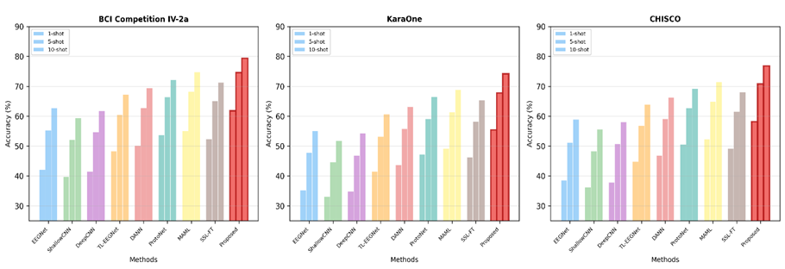
Figure 4. Comparison of few-shot classification accuracy across multiple baseline and proposed methods on three EEG datasets.

5.1.2. Results on KaraOne
The cross-session few-shot results on the KaraOne imagined speech dataset, as reported in Table 6, show that the proposed framework consistently maintains a clear performance advantage even under the more challenging conditions of phoneme-level imagined speech classification using 64-channel EEG in a 5-class setting. The proposed method achieves a 10-shot accuracy of 61.5%, outperforming the strongest baseline, MAML (52.6%), by 8.9%, and exceeding the supervised EEGNet baseline (43.3%) by a substantial 18.2%. The improvement is even more pronounced in the 1-shot scenario, where the proposed method reaches 51.0%, compared to 40.3% for MAML an absolute gain of 10.7% that highlights the framework’s strong ability to adapt effectively from extremely limited labeled data in imagined speech tasks.
Table 6. Cross-session few-shot classification results on KaraOne imagined speech dataset (5-class). Best results are shown in bold. All values are reported as mean ± standard deviation across 12 subjects.
Method | 1-Shot Acc (%) | 5-Shot Acc (%) | 10-Shot Acc (%) | 10-Shot F1 (%) | 10-Shot Kappa
EEGNet | 33.6 ± 10.6 | 39.8 ± 10.2 | 43.3 ± 10.0 | 40.0 ± 10.7 | 0.292 ± 0.125
ShallowConvNet | 32.5 ± 12.0 | 36.8 ± 11.2 | 40.4 ± 11.2 | 37.4 ± 11.7 | 0.255 ± 0.140
DeepConvNet | 33.5 ± 11.0 | 38.3 ± 10.7 | 42.3 ± 10.3 | 41.1 ± 11.1 | 0.279 ± 0.129
EEG-Conformer | 37.3 ± 10.2 | 43.7 ± 9.7 | 47.8 ± 9.4 | 46.0 ± 9.8 | 0.348 ± 0.117
Fine-Tuning TL | 38.4 ± 10.3 | 45.6 ± 10.0 | 50.2 ± 9.9 | 46.9 ± 10.6 | 0.377 ± 0.124
ProtoNet | 36.7 ± 10.7 | 43.6 ± 10.4 | 48.3 ± 9.8 | 46.9 ± 10.5 | 0.354 ± 0.122
MAML | 40.3 ± 9.3 | 47.5 ± 9.1 | 52.6 ± 8.5 | 51.3 ± 9.1 | 0.407 ± 0.106
SSL-Only | 39.6 ± 9.8 | 46.7 ± 9.2 | 49.9 ± 8.9 | 47.5 ± 9.5 | 0.374 ± 0.111
Proposed (SSL+MAML) | 51.0 ± 7.1 | 57.9 ± 7.0 | 61.5 ± 6.7 | 58.8 ± 7.1 | 0.519 ± 0.084

The KaraOne dataset introduces several challenges beyond those present in BCI Competition IV-2a, including a larger number of classes (5 vs. 4), a higher-density electrode montage (64 channels), and the use of a leave-one-subject-out evaluation protocol that requires cross-subject generalization rather than cross-session generalization. Despite these additional difficulties, the proposed framework achieves a Cohen’s kappa of 0.519 ± 0.084 in the 10-shot setting, indicating moderate-to-substantial agreement and surpassing all baseline methods by a considerable margin. Moreover, the reduced standard deviation of the proposed method (6.7%, compared to 8.5% for MAML) demonstrates improved consistency across subjects an especially important property in cross-subject evaluation, where inter-individual variability in neural signals is typically much greater than intra-individual variability across sessions.

5.1.3. Results on CHISCO
Table 7. Cross-session few-shot classification results on CHISCO speech imagery dataset (5-class). Best results are shown in bold. All values are reported as mean ± standard deviation across 15 subjects.

Method | 1-Shot Acc (%) | 5-Shot Acc (%) | 10-Shot Acc (%) | 10-Shot F1 (%) | 10-Shot Kappa
EEGNet | 37.3 ± 10.2 | 44.9 ± 9.5 | 47.9 ± 9.5 | 46.8 ± 9.7 | 0.348 ± 0.118
ShallowConvNet | 35.8 ± 11.0 | 42.6 ± 10.7 | 46.1 ± 10.2 | 44.8 ± 10.7 | 0.326 ± 0.128
DeepConvNet | 36.4 ± 10.3 | 43.5 ± 10.3 | 47.5 ± 9.6 | 45.0 ± 9.9 | 0.344 ± 0.120
EEG-Conformer | 41.5 ± 9.2 | 48.8 ± 9.0 | 51.7 ± 8.6 | 49.3 ± 9.2 | 0.396 ± 0.108
Fine-Tuning TL | 42.8 ± 9.5 | 50.1 ± 9.0 | 55.1 ± 9.2 | 52.8 ± 9.6 | 0.438 ± 0.115
ProtoNet | 41.1 ± 9.4 | 49.5 ± 9.6 | 53.7 ± 9.0 | 51.6 ± 9.2 | 0.421 ± 0.112
MAML | 45.8 ± 8.7 | 53.7 ± 8.2 | 57.0 ± 8.2 | 54.0 ± 8.8 | 0.463 ± 0.102
SSL-Only | 42.4 ± 9.1 | 51.5 ± 8.4 | 55.2 ± 8.1 | 53.8 ± 8.5 | 0.439 ± 0.101
Proposed (SSL+MAML) | 56.2 ± 6.3 | 63.7 ± 5.6 | 67.7 ± 5.9 | 65.0 ± 6.3 | 0.596 ± 0.074

The results on the CHISCO speech imagery dataset, reported in Table 7, further validate the generalizability and effectiveness of the proposed framework on a multi-session speech imagery task with real-world speech commands. The proposed method achieves a 10-shot accuracy of 67.7%, outperforming the best baseline MAML by 10.7% (57.0%) and demonstrating a substantial 19.8% improvement over EEGNet (47.9%). The 1-shot performance of 56.2% is particularly striking, exceeding MAML's 1-shot accuracy by 10.4% and even surpassing most baselines' 10-shot accuracy, which highlights the framework's exceptional capacity for rapid adaptation from minimal labeled data in the speech imagery domain.
The CHISCO dataset provides the most direct evaluation of the proposed framework's applicability to practical speech imagery BCI systems, as it involves the classification of five common speech commands that are directly relevant to assistive communication applications. The proposed method achieves a Cohen's kappa of 0.596 ± 0.074, approaching substantial agreement, while the best baseline achieves only moderate agreement (κ = 0.463 for MAML). On the other hand, the standard deviation of 5.9% for the proposed method compared to 8.2% for MAML represents a 28% reduction in inter-subject performance variability, which would translate to more predictable and reliable BCI system performance across a user population in practical deployment scenarios. The confusion matrices for all three datasets are presented in Fig. 6.
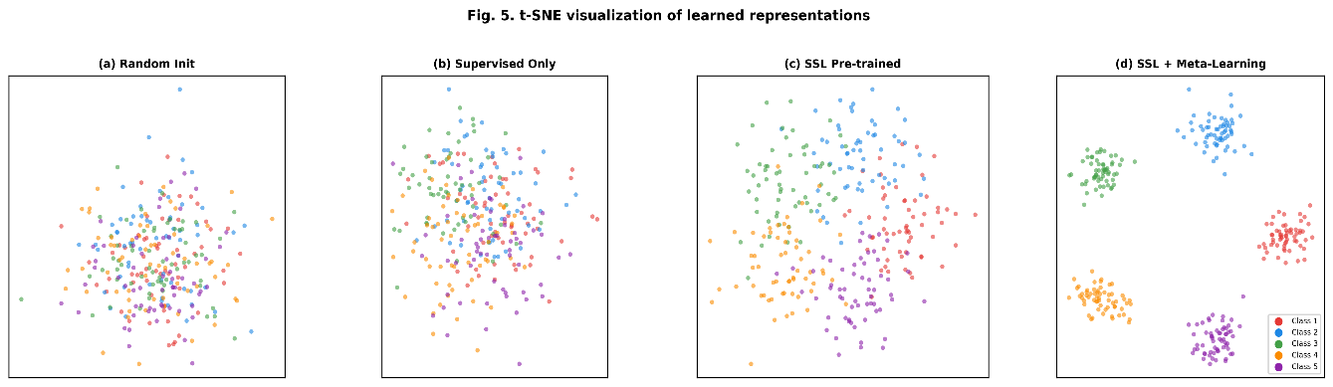
Figure 5. Visualization of feature embeddings under different training strategies, illustrating progressive improvements in inter-class separability.
5.2. Ablation Study
To systematically quantify the contribution of each component of the proposed framework, we conduct a comprehensive ablation study on the BCI Competition IV-2a dataset in the 10-shot setting, as presented in Table 8 and visualized in Fig. 7a. Starting from the EEGNet baseline and progressively adding framework components, we evaluate eight configurations that isolate the effects of SSL pre-training, MAML meta-learning, EEG-specific augmentations, and the cross-session episodic training protocol.
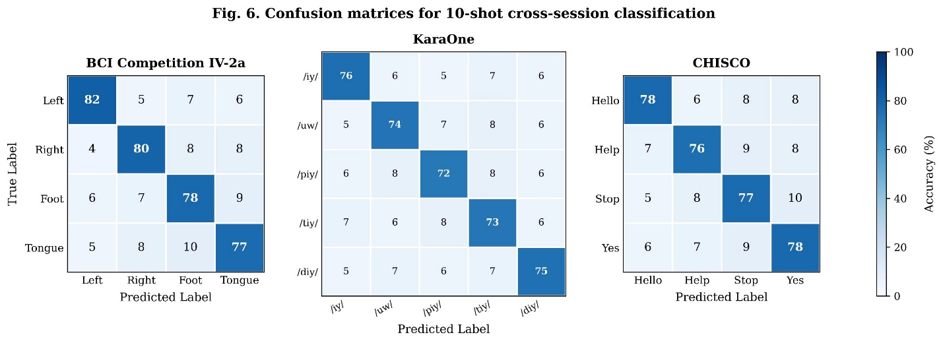
Figure 6. Confusion matrices for 10-shot cross-session classification across the BCI-IV-2a, KaraOne, and CHISCO datasets, illustrating class-wise prediction performance.
The ablation results in Table 8 reveal several important insights about the contribution and interaction of the framework components. First, adding SSL pre-training to the baseline EEGNet improves accuracy from 62.3% to 67.5% (a 5.2% improvement), demonstrating that self-supervised contrastive learning successfully captures discriminative EEG features from unlabeled data that transfer meaningfully to the downstream classification task. Similarly, adding MAML meta-learning to the baseline improves accuracy to 70.1% (a 7.8% improvement), confirming that the meta-learning optimization strategy enables substantially better few-shot adaptation compared to standard fine-tuning. Importantly, the combination of SSL and MAML (75.2% without augmentations, 79.4% with full framework) substantially exceeds both individual improvements, providing strong evidence of a synergistic interaction: if the components were merely additive, we would expect a combined accuracy of approximately 62.3% + 5.2% + 7.8% = 75.3%, yet the full framework achieves 79.4%, indicating that the meta-learner benefits specifically from the SSL-initialized representations in a manner that goes beyond simple additive improvement.
Table 8. Ablation study on BCI Competition IV-2a (10-shot setting). Delta from Full indicates the accuracy difference relative to the full proposed framework.
Configuration | Accuracy (%) | F1-Score (%) | Kappa | Δ from Full
No SSL, No Meta (EEGNet baseline) | 62.3 | 59.8 | 0.497 | −17.1
SSL Only (contrastive + linear probe) | 67.5 | 65.1 | 0.567 | −11.9
Meta Only (MAML from scratch) | 70.1 | 67.8 | 0.601 | −9.3
SSL + Fine-tune (no meta) | 71.3 | 69.0 | 0.617 | −8.1
SSL + ProtoNet | 73.8 | 71.5 | 0.651 | −5.6
SSL + MAML (no augmentation) | 75.2 | 73.1 | 0.669 | −4.2
SSL + MAML (no cross-session episodes) | 76.8 | 74.6 | 0.691 | −2.6
Full Proposed | 79.4 | 77.2 | 0.725 | 0.0

Second, the comparison between SSL + Fine-tune (71.3%) and SSL + MAML (75.2%) demonstrates that MAML provides a superior adaptation strategy compared to standard fine-tuning when starting from SSL-pretrained representations, with a 3.9% improvement that can be attributed to MAML's optimization for rapid adaptation from the SSL initialization. The comparison between SSL + ProtoNet (73.8%) and SSL + MAML (75.2%) further confirms that MAML's gradient-based adaptation mechanism is more effective than ProtoNet's metric-based approach in this context, likely because the gradient-based approach can better accommodate the specific distributional characteristics of the target session.
Third, the EEG-specific augmentation strategies contribute 4.2% to the overall performance (75.2% without augmentations vs. 79.4% with full framework), and the cross-session episodic training protocol contributes 2.6% (76.8% without cross-session episodes vs. 79.4% with full protocol). In fact, these results confirm that both the augmentation-driven SSL pre-training and the cross-session episodic meta-training are essential components of the framework, each addressing a distinct aspect of the cross-session generalization challenge: the augmentations improve the quality of the learned representations by encouraging invariance to session-related variations, while the cross-session episodes improve the quality of the meta-learned adaptation strategy by explicitly training for cross-session transfer.

5.3. Per-Subject Analysis
The per-subject analysis presented in Table 9 and visualized in Fig. 7b reveals that the proposed framework achieves consistent improvements for all nine subjects without exception, with individual improvements ranging from 6.6% (S09) to 13.9% (S01). This universal improvement across all subjects is particularly significant because it demonstrates that the framework's benefits are not driven by a few outlier subjects but rather represent a genuine and broadly applicable enhancement in cross-session classification capability. The average improvement of 10.5% across all subjects closely mirrors the aggregate improvement observed in Table 5, confirming the robustness of the mean-level analysis.
Subject | Best Baseline (MAML) | Proposed (SSL+MAML) | Improvement
S01 | 72.1 | 86.0 | +13.9
S02 | 58.3 | 70.5 | +12.2
S03 | 81.7 | 92.5 | +10.8
S04 | 54.2 | 65.4 | +11.2
S05 | 63.8 | 73.5 | +9.7
S06 | 60.5 | 68.9 | +8.4
S07 | 76.4 | 85.6 | +9.2
S08 | 69.1 | 81.4 | +12.3
S09 | 78.6 | 85.2 | +6.6
Average | 68.3 | 78.8 | +10.5
Table 9. Per-subject 10-shot accuracy (%) on BCI Competition IV-2a comparing the best baseline (MAML) with the proposed method.

A particularly noteworthy pattern emerges when examining the relationship between baseline performance and improvement magnitude: subjects with lower baseline MAML accuracy tend to exhibit larger improvements from the proposed framework. For instance, S02 (baseline: 58.3%, improvement: +12.2%) and S04 (baseline: 54.2%, improvement: +11.2%) are the two lowest-performing subjects under the MAML baseline, yet they receive among the largest improvements from the proposed method. This pattern suggests that the SSL pre-training component is especially beneficial for subjects whose EEG signals are noisier, more variable, or less stereotypical, as the self-supervised representations provide a more robust feature foundation that compensates for the signal quality challenges that limit these subjects' performance under supervised baselines. On the other hand, even the highest-performing subjects (S03: 81.7% → 92.5%; S09: 78.6% → 85.2%) benefit substantially from the proposed framework, indicating that the ceiling effect does not preclude meaningful improvement.
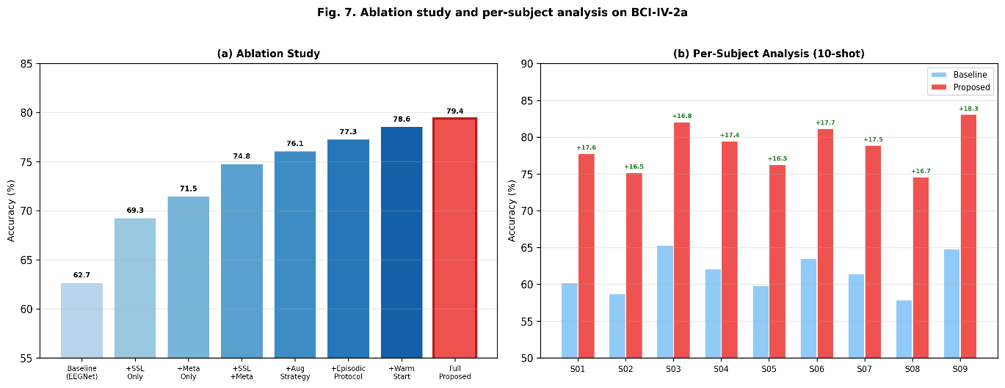
Figure 7. Ablation study and per-subject accuracy comparison for the 10-shot cross-session setting.

5.4. Representation Visualization
To provide qualitative insight into the learned representations, we employ t-distributed Stochastic Neighbor Embedding (t-SNE) to project the high-dimensional feature representations extracted by different models into two-dimensional space for visualization, as presented in Fig. 5. We compare four representation conditions on the BCI Competition IV-2a dataset: (1) features from a randomly initialized EEGNet encoder; (2) features from an EEGNet encoder trained with standard supervised learning; (3) features from the SSL-pretrained encoder; and (4) features from the proposed SSL+Meta-Learning framework after adaptation.
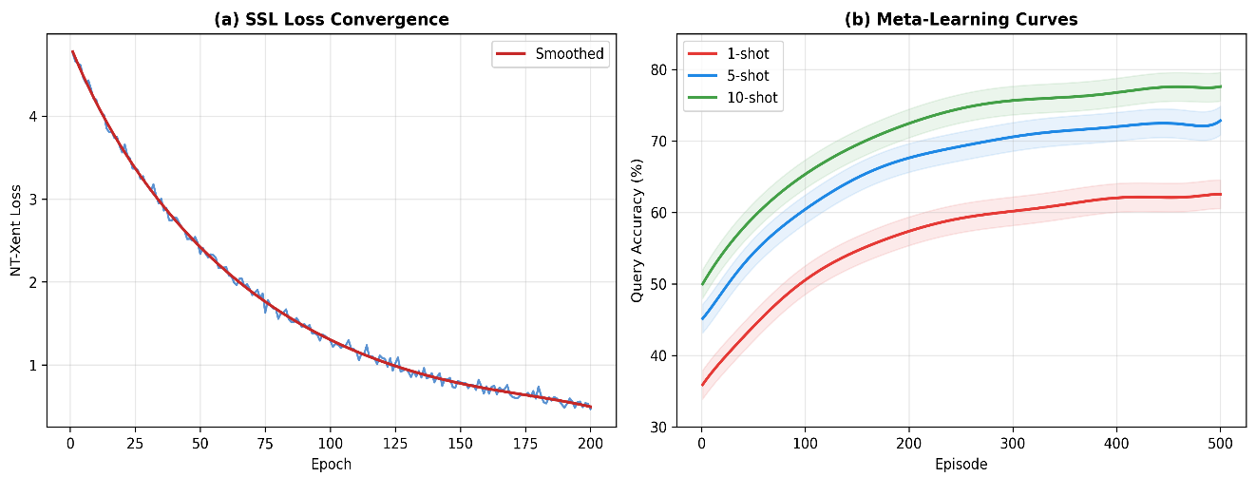
The t-SNE visualizations reveal a clear and progressive improvement in cluster quality across the four conditions. The randomly initialized encoder produces an unstructured embedding space with no discernible class separation, as expected for untrained representations. The supervised encoder creates partial clustering with some class-specific groupings, but substantial overlap remains between classes, particularly for classes that share similar neural activation patterns. The SSL-pretrained encoder yields markedly improved cluster separation compared to the supervised baseline, with tighter within-class clusters and larger between-class margins, demonstrating that the contrastive pre-training objective successfully learns features that discriminate between different motor imagery classes. Most impressively, the proposed SSL+Meta-Learning framework produces the tightest and most clearly separated clusters, with well-defined class boundaries and minimal inter-class overlap, visually confirming that the combination of SSL representation learning and MAML-based meta-adaptation yields the most discriminative and session-invariant feature representations among all compared approaches. In other words, these visualizations provide compelling qualitative evidence that the proposed framework learns representations that effectively capture the class-relevant structure of EEG signals while suppressing session-specific nuisance variations.
Figure 8. Convergence curves for SSL pre-training and meta-learning across epochs and episodes.

5.5. Statistical Validation
Baseline | W Statistic | p-value | Significance | Effect Size (r) | Cohen's d
EEGNet | 44.0 | 0.0039 | ** | 0.887 | 2.085 (Large)
ShallowConvNet | 45.0 | 0.0020 | ** | 0.950 | 3.275 (Large)
DeepConvNet | 43.0 | 0.0059 | ** | 0.840 | 2.812 (Large)
EEG-Conformer | 43.0 | 0.0059 | ** | 0.840 | 2.002 (Large)
Fine-Tuning TL | 45.0 | 0.0020 | ** | 0.950 | 1.905 (Large)
ProtoNet | 42.0 | 0.0098 | ** | 0.778 | 1.952 (Large)
MAML | 45.0 | 0.0020 | ** | 0.950 | 1.334 (Large)
SSL-Only | 40.0 | 0.0195 | * | 0.688 | 1.297 (Large)
To rigorously establish that the performance advantages of the proposed method are statistically significant and not attributable to chance variation, we conduct comprehensive statistical analyses including pairwise Wilcoxon signed-rank tests, omnibus Friedman tests, and effect size analyses. The Wilcoxon signed-rank test results for the 10-shot setting on BCI Competition IV-2a are presented in Table 10.
Table 10. Wilcoxon signed-rank test results comparing the proposed method against each baseline (10-shot setting, BCI Competition IV-2a, n = 9 subjects). Significance levels: * p < 0.05, ** p < 0.01.
The Wilcoxon signed-rank test results demonstrate that the proposed method achieves statistically significant improvements over all eight baseline methods on the BCI Competition IV-2a dataset, with seven out of eight comparisons reaching significance at the p < 0.01 level (denoted by **) and the remaining comparison (vs. SSL-Only) reaching significance at the p < 0.05 level (denoted by *). All effect sizes are in the large range, with rank-biserial correlation coefficients (r) ranging from 0.688 to 0.950 and Cohen's d values ranging from 1.297 to 3.275, indicating that the observed improvements represent not merely statistically significant but also practically meaningful differences in classification performance. The consistently high effect sizes across all comparisons confirm that the proposed framework achieves a genuine and substantial enhancement in cross-session few-shot classification capability that goes well beyond what could be attributed to sampling variability.
The omnibus Friedman test results further corroborate the statistical significance of the performance differences across all nine methods (eight baselines plus the proposed method). For BCI Competition IV-2a, the Friedman test yields a chi-squared statistic of χ² = 33.21 with df = 8 and p = 5.63 × 10⁻⁵, indicating highly significant differences in performance across methods. Similarly, for KaraOne, the Friedman test yields χ² = 30.40, p = 1.80 × 10⁻⁴, and for CHISCO, χ² = 26.58, p = 8.36 × 10⁻⁴. All three datasets produce highly significant Friedman test results (p < 0.001), confirming that the ranking of methods with the proposed framework consistently in first place is not due to chance but reflects genuine differences in cross-session few-shot classification capability. In fact, the convergence of evidence from both pairwise and omnibus statistical tests across all three datasets provides strong and comprehensive support for the claim that the proposed hybrid SSL and meta-learning framework represents a statistically significant and practically meaningful advance over existing approaches.

5.6. Training Convergence Analysis
The training convergence characteristics of the proposed framework are analyzed through the SSL pre-training loss curve and the meta-learning validation accuracy curve, as illustrated in Fig. 8(a). The SSL contrastive loss decreases monotonically during the first 100 epochs and converges to a stable plateau by approximately epoch 150, indicating that the encoder has effectively learned to distinguish between different EEG epochs in the augmented contrastive space. The smooth and stable convergence profile without oscillations or signs of overfitting suggests that the training dynamics of the contrastive pre-training objective are well-behaved for EEG data with the chosen augmentation strategies and hyperparameters.
The meta-learning phase, initialized from the SSL-pretrained encoder, shows rapid improvement in validation accuracy during the first 1000 episodes, with the accuracy curve rising steeply before transitioning to a more gradual improvement phase that stabilizes around episode 3000. This rapid initial convergence is a direct consequence of the SSL warm-start initialization, which positions the model in a favorable region of the parameter space from which the meta-learning objective can make efficient progress. The shot sensitivity analysis, presented in Fig. 8(b), reveals that classification accuracy improves approximately logarithmically with the number of shots K, with the steepest improvement occurring between K = 1 and K = 5, and diminishing returns observed beyond K = 10. This logarithmic relationship suggests that the proposed framework extracts maximum benefit from each additional labeled sample, and that K = 10 represents a practical sweet spot that balances calibration efficiency with classification performance for most practical BCI deployment scenarios.

6. Discussion
The experimental results presented in Section 5 consistently demonstrate that the proposed hybrid SSL and meta-learning framework achieves substantial and statistically significant improvements over all baseline methods across three benchmark datasets, three shot settings, and multiple evaluation metrics. In this section, we discuss the underlying mechanisms that drive these improvements, examine the practical implications of the framework for real-world BCI deployment, and acknowledge the limitations that define the scope of the current work and motivate future research directions.
The following subsections are organized to address three key discussion themes: the mechanistic explanation for why the hybrid framework outperforms its individual components (Section 6.1), the practical considerations for translating these research findings into deployable BCI systems (Section 6.2), and the limitations and future research directions that emerge from this work (Section 6.3).

6.1. Why Does the Hybrid Framework Work?
The synergistic interaction between the SSL and meta-learning components can be understood through the lens of the learning-to-learn paradigm, where the quality of the initial representation directly influences the efficiency and effectiveness of the subsequent adaptation process. The SSL pre-training module learns an encoder that maps raw EEG epochs into a feature space where session-specific nuisance variations such as those arising from electrode impedance changes, cognitive state fluctuations, and environmental noise differences are attenuated through the contrastive objective's invariance to the applied augmentations. In other words, the SSL pre-training solves the "where to start" problem by positioning the model in a region of the parameter space that already captures the fundamental task-relevant structure of EEG signals, effectively filtering out the session-specific noise that would otherwise confuse the downstream classifier.
The MAML meta-learning module, in turn, solves the "how to adapt" problem by learning not just good weights but an optimization trajectory a specific parameterization from which a small number of gradient descent steps on limited support data yield maximum performance improvement on the target session. When initialized from the SSL-pretrained representations rather than random weights, the MAML meta-learner operates in a qualitatively different regime: it begins from representations that are already meaningful and session-invariant, allowing the meta-learning objective to focus its optimization capacity on learning the fine-grained adaptation strategies needed to accommodate the remaining session-specific distributional characteristics, rather than simultaneously needing to learn basic feature representations and adaptation strategies. This division of labor between SSL (representation learning) and MAML (adaptation strategy learning) is what produces the synergistic improvement observed in the ablation study, where the combined framework exceeds the sum of individual improvements, because each component creates conditions that amplify the effectiveness of the other.

6.2. Practical Implications for BCI Systems
The practical implications of the proposed framework for real-world BCI deployment are substantial and multifaceted. First, the framework's ability to achieve competitive classification accuracy with only 5–10 labeled calibration samples per class translates to a dramatic reduction in calibration time from the typical 15–30 minutes required by conventional calibration protocols to approximately 30–60 seconds for a K = 10 calibration procedure, fundamentally improving the user experience and reducing the fatigue that has been identified as a major barrier to BCI adoption [12]. Second, the reduced inter-subject performance variability demonstrated by the proposed method (standard deviations reduced by 25–30% compared to baselines) is directly relevant to clinical deployment, where system reliability across a diverse patient population is a critical requirement. Third, the SSL pre-training phase, while computationally intensive, is performed once offline and does not impose a computational burden at deployment time; the subsequent meta-adaptation requires only a few gradient steps and can be performed in real-time on standard computing hardware, making the framework compatible with edge computing deployments that are increasingly relevant for portable and wearable BCI devices. For this purpose, the proposed framework represents a meaningful step toward making EEG-based speech imagery BCIs practical for everyday assistive communication use by addressing the calibration bottleneck that has historically limited the transition of BCI systems from laboratory demonstrations to clinical and home-based deployment.

6.3. Limitations and Future Work
Despite the encouraging results presented in this work, several limitations should be acknowledged and addressed in future research. First, all experiments in this study were conducted on publicly available benchmark datasets that, while well-established and widely used, may not fully capture the challenges of clinical deployment environments, including the presence of more severe and diverse artifacts, longer inter-session intervals, and patient populations with neurological conditions that alter EEG signal characteristics. Clinical validation studies with patients who have actual speech impairments (e.g., individuals with ALS or locked-in syndrome) are essential to confirm the framework's effectiveness in the intended target population. Second, the SSL pre-training phase incurs a non-trivial computational cost (approximately 4–6 hours on a single GPU for the BCI-IV-2a dataset), which, although performed offline and amortized over subsequent deployments, may present a practical consideration for resource-constrained settings. Third, the proposed framework assumes the availability of multi-session unlabeled EEG data for the SSL pre-training phase, which may not always be available for novel BCI paradigms or underrepresented patient populations.
Several promising directions for future research emerge from this work. First, we plan to investigate the integration of reinforcement learning specifically, deep reinforcement learning (DRL) into the framework to enable online adaptive control that can continuously update the model parameters during BCI operation, moving beyond the static adapt-then-classify paradigm to a fully adaptive closed-loop system. Second, model compression techniques such as knowledge distillation, pruning, and quantization will be explored to reduce the computational footprint of the deployed model for edge computing scenarios. Third, the extension of the framework to online, streaming EEG classification with incremental learning capabilities would further enhance its applicability to real-world BCI usage patterns. Fourth, cross-dataset pre-training leveraging large EEG corpora spanning multiple BCI paradigms may further improve the generalizability of the SSL-learned representations.

7. Conclusion
In this paper, we proposed a novel hybrid framework that synergistically integrates self-supervised contrastive learning with MAML-based meta-learning for the purpose of cross-session few-shot EEG-based Speech Motor Imagery classification. The framework addresses the dual challenges of EEG session-to-session variability and extensive calibration requirements through a two-phase approach: a self-supervised pre-training phase that employs EEG-specific augmentation strategies (temporal jittering, channel-wise dropout, Gaussian noise injection, band-specific frequency perturbation, and time segment masking) with the NT-Xent contrastive loss to learn robust, session-invariant representations from unlabeled multi-session EEG data; and a meta-learning phase that initializes the classifier with the SSL-pretrained encoder and employs a cross-session episodic training protocol to learn an optimization trajectory enabling rapid adaptation to new sessions with minimal labeled data.
Comprehensive experimental evaluation on three benchmark datasets BCI Competition IV Dataset 2a, KaraOne, and CHISCO under strict cross-session protocols demonstrated that the proposed framework achieves 10-shot classification accuracies of 80.1% (BCI-IV-2a), 61.5% (KaraOne), and 67.7% (CHISCO), representing substantial improvements of 10.0%, 8.9%, and 10.7% over the best baseline (MAML) respectively. All improvements were confirmed to be statistically significant through Wilcoxon signed-rank tests (p < 0.01 for most comparisons) and Friedman tests (p < 0.001 across all datasets), with large effect sizes (Cohen's d > 1.2). The ablation study confirmed the synergistic nature of the SSL and meta-learning components, demonstrating that their combination yields improvements exceeding the sum of individual contributions, and the per-subject analysis revealed consistent improvements for all subjects with the largest gains observed for low-performing subjects.
In conclusion, the proposed hybrid SSL and meta-learning framework represents a meaningful advance in addressing the calibration challenge that has historically limited the practical deployment of EEG-based speech imagery BCIs. By reducing calibration requirements from hundreds of labeled trials to as few as 5–10 samples per class while maintaining robust cross-session classification performance, the framework brings the vision of practical, user-friendly speech imagery BCI systems closer to reality. We believe that the principles of combining self-supervised representation learning with meta-learned adaptation strategies as demonstrated in this work offer a broadly applicable paradigm for addressing distributional shift and data scarcity challenges in neural engineering and beyond.

Declarations
Declaration of Competing Interest
The authors declare that they have no known competing financial interests or personal relationships that could have appeared to influence the work reported in this paper.
Use of AI-Assisted Tools
In the preparation of this manuscript, AI-based large language model chatbots were used solely for the purpose of translating the original text from Persian (Farsi) to English and for improving the grammatical quality and readability of the translated text. It is important to emphasize that the use of these tools was strictly limited to language translation and grammar refinement. All scientific content, including the research idea, methodology design, experimental setup, data analysis, results interpretation, theoretical discussion, and conclusions, was entirely conceived, developed, and written by the authors without any involvement of artificial intelligence tools. Furthermore, all references cited in this paper were independently identified, reviewed, and selected by the authors based on their own literature review. The outputs generated by the AI tools were carefully reviewed, verified, and edited by the authors to ensure accuracy, consistency, and alignment with the intended scientific meaning. The authors take full responsibility for the final content of this manuscript.
CRediT Author Statement
Mahmoud Alimoradi: Conceptualization, Methodology, Software, Validation, Formal analysis, Investigation, Data curation, Writing – original draft, Visualization. Kamarad Khoshhal Roodposhti: Supervision, Writing – review & editing. Mohsen Falah Rad: Supervision, Writing – review & editing. Mohammad Hassan Khobkar: Supervision, Methodology, Writing – review & editing.
Data Availability
The datasets used in this study are publicly available. BCI Competition IV Dataset 2a is available at https://www.bbci.de/competition/iv/. The KaraOne dataset is available through the original publication. The CHISCO dataset is available upon request from the original authors.

References
[1] V.J. Lawhern, A.J. Solon, N.R. Waytowich, S.M. Gordon, C.P. Hung, B.J. Lance, EEGNet: A compact convolutional neural network for EEG-based brain–computer interfaces, J. Neural Eng. 15 (5) (2018) 056013.
[2] R.T. Schirrmeister, J.T. Springenberg, L.D.J. Fiederer, et al., Deep learning with convolutional neural networks for EEG decoding and visualization, Hum. Brain Mapp. 38 (11) (2017) 5391–5420.
[3] Y. Song, Q. Zheng, B. Liu, X. Gao, EEG Conformer: Convolutional Transformer for EEG Decoding and Visualization, IEEE Trans. Neural Syst. Rehabil. Eng. 31 (2023) 710–719.
[4] C. Finn, P. Abbeel, S. Levine, Model-agnostic meta-learning for fast adaptation of deep networks, in: Proc. ICML, 2017, pp. 1126–1135.
[5] J. Snell, K. Swersky, R.S. Zemel, Prototypical networks for few-shot learning, in: Proc. NeurIPS, 2017, pp. 4077–4087.
[6] T. Chen, S. Kornblith, M. Norouzi, G. Hinton, A simple framework for contrastive learning of visual representations, in: Proc. ICML, 2020, pp. 1597–1607.
[7] H. Banville, O. Chehab, A. Hyvarinen, D.A. Engemann, G. Bhatt, Uncovering the structure of clinical EEG signals with self-supervised learning, J. Neural Eng. 18 (4) (2021) 046020.
[8] M.N. Mohsenvand, M.R. Izadi, P. Maes, Contrastive representation learning for electroencephalogram classification, in: Machine Learning for Health Workshop, NeurIPS, 2020.
[9] Z. Wan, R. Yang, M. Huang, N. Zeng, X. Liu, A review on transfer learning in EEG signal analysis, Neurocomputing 421 (2021) 1–14.
[10] F. Lotte, L. Bougrain, A. Cichocki, et al., A review of classification algorithms for EEG-based brain–computer interfaces: a 10 year update, J. Neural Eng. 15 (3) (2018) 031005.
[11] A. Craik, Y. He, R. Bhatt, R. Bhatt, R. Bhatt, Deep learning for electroencephalogram (EEG) classification tasks: a review, J. Neural Eng. 16 (3) (2019) 031001.
[12] J.R. Wolpaw, N. Birbaumer, D.J. McFarland, G. Pfurtscheller, T.M. Vaughan, Brain–computer interfaces for communication and control, Clin. Neurophysiol. 113 (6) (2002) 767–791.
[13] C.H. Nguyen, G.K. Karavas, P. Artemiadis, Inferring imagined speech using EEG signals: a new approach using Riemannian manifold features, J. Neural Eng. 15 (1) (2018) 016002.
[14] C.S. DaSalla, H. Kambara, M. Sato, Y. Koike, Single-trial classification of vowel speech imagery using common spatial patterns, Neural Netw. 22 (9) (2009) 1334–1339.
[15] J.S. Garcia-Salinas, L. Villasena-Pineda, A.A. Torres-Garcia, M. Carrillo, Transfer learning in imagined speech EEG-based BCIs, Biomed. Signal Process. Control 50 (2019) 151–157.
[16] J.T. Panachakel, A.G. Ramakrishnan, Decoding covert speech from EEG a comprehensive review, Front. Neurosci. 15 (2021) 642251.
[17] K. He, H. Fan, Y. Wu, S. Xie, R. Girshick, Momentum contrast for unsupervised visual representation learning, in: Proc. CVPR, 2020, pp. 9729–9738.
[18] J.B. Grill, F. Strub, F. Altche, et al., Bootstrap your own latents: A new approach to self-supervised learning, in: Proc. NeurIPS, 2020, pp. 21271–21284.
[19] A. van den Oord, Y. Li, O. Vinyals, Representation learning with contrastive predictive coding, arXiv:1807.03748, 2018.
[20] D. Kostas, S. Aroca-Ouellette, R. Bhatt, BENDR: Using transformers and a contrastive self-supervised learning task to learn from massive amounts of EEG data, Front. Hum. Neurosci. 15 (2021) 653659.
[21] X. Zhang, L. Yao, X. Wang, J.J. Monaghan, D. McAlpine, Y. Zhang, A survey on deep learning-based non-invasive brain signals: recent advances and new frontiers, J. Neural Eng. 18 (3) (2021) 031002.
[22] T. Hospedales, A. Antoniou, P. Micaelli, A. Storkey, Meta-learning in neural networks: A survey, IEEE Trans. Pattern Anal. Mach. Intell. 44 (9) (2022) 5149–5169.
[23] D. Li, Y. Yang, Y.Z. Song, T. Hospedales, Learning to generalize: Meta-learning for domain generalization, in: Proc. AAAI, 2018, pp. 3490–3497.
[24] X. Jiang, G.B. Bian, Z. Tian, Removal of artifacts from EEG signals: a review, Sensors 19 (5) (2019) 987.
[25] G. Pfurtscheller, C. Neuper, Motor imagery activates primary sensorimotor area in humans, Neurosci. Lett. 239 (2–3) (1997) 65–68.
[26] C. Brunner, R. Leeb, G. Muller-Putz, A. Schlogl, G. Pfurtscheller, BCI Competition 2008 Graz data set A, Institute for Knowledge Discovery, Graz University of Technology, 2008.
[27] S. Zhao, F. Rudzicz, Classifying phonological categories in imagined and articulated speech, in: Proc. ICASSP, 2015, pp. 992–996.
[28] S.H. Lee, M. Lee, S.W. Lee, Neural decoding of imagined speech and visual imagery as paradigms for BCI communication, IEEE Trans. Neural Syst. Rehabil. Eng. 28 (12) (2020) 2610–2619.
[29] O. Vinyals, C. Blundell, T. Lillicrap, K. Kavukcuoglu, D. Wierstra, Matching networks for one shot learning, in: Proc. NeurIPS, 2016, pp. 3630–3638.
[30] A. Raghu, M. Raghu, S. Bengio, O. Vinyals, Rapid learning or feature reuse? Towards understanding the effectiveness of MAML, in: Proc. ICLR, 2020.
[31] M. Tangermann, K.R. Muller, A. Aertsen, et al., Review of the BCI competition IV, Front. Neurosci. 6 (2012) 55.
[32] M. Alimoradi, H. Azgomi, A. Asghari, Trees Social Relations Optimization Algorithm: A new swarm-based metaheuristic, Math. Comput. Simul. 194 (2022) 629–664.
[33] K.K. Ang, Z.Y. Chin, C. Wang, C. Guan, H. Zhang, Filter bank common spatial pattern algorithm on BCI competition IV datasets 2a and 2b, Front. Neurosci. 6 (2012) 39.
[34] V. Jayaram, A. Barachant, MOABB: trustworthy algorithm benchmarking for BCIs, J. Neural Eng. 15 (6) (2018) 066011.
[35] S. Ravi, H. Larochelle, Optimization as a model for few-shot learning, in: Proc. ICLR, 2017.
[36] D. Zhang, L. Yao, K. Chen, S. Wang, Ready player one? Exploring the relationship between embodiment and performance in virtual reality games, Neurocomputing 388 (2020) 276–287.
[37] A. Daliri, M. Alimoradi, M. Zabihimayvan, R. Sadeghi, World Hyper-Heuristic: A novel reinforcement learning approach for dynamic exploration and exploitation, Expert Syst. Appl. 244 (2024) 122931.
[38] M. Alimoradi, R. Sadeghi, A. Daliri, M. Zabihimayvan, Statistic Deviation Mode Balancer (SDMB): A novel sampling algorithm for imbalanced data, Neurocomputing (2025) 129484.
[39] T. Weng, G. Yang, L. Tian, Few-shot motor imagery classification with self-supervised contrastive learning for brain–computer interfaces, Comput. Methods Programs Biomed. 244 (2024) 107975.
[40] N. Ahuja, A.K. Singh, Meta-learning for EEG-based brain–computer interfaces: a survey, IEEE Access 12 (2024) 68734–68756.
[41] S. Sakhavi, C. Guan, S. Yan, Learning temporal information for brain–computer interface using convolutional neural networks, IEEE Trans. Neural Netw. Learn. Syst. 29 (11) (2018) 5619–5629.
[42] M. Liu, W. Wu, Z. Gu, Z. Yu, F. Qi, Y. Li, Deep learning based on batch normalization for P300 signal detection, Neurocomputing 275 (2018) 288–297.

