Encapsulation of Silymarin via chitosan- PLGA Nanoparticles for Drug Delivery

F.Hosseinzadeha,∗, M.SharifzadehBaeib, H. Mehtarifarª

a Department of Chemical Engineering, Mazandaran University of Science and Technology, Babol, Iran
bDepartment of Chemical Engineering, Ayatollah Amoli Branch, Islamic Azad University, Amol, Iran

ABSTRACT
The herbal extracts of Milk Thistle, known as silymarin, are used to treat liver diseases. Chitosan is a natural polymer with high biodegradability, which is used as a coating for many drugs to improve drug delivery. Polylactic-co-glycolic acid (PLGA) is non-toxic and one of the most successful polymers used in drug delivery. In this study, in addition to silymarin loading in each of the coatings, a combination of polymeric coatings of chitosan and PLGA were used as carrier agents. The second stage is the rate of release and swelling in phosphate buffer solution ( pH= 7.4), as well as the morphology of the coated drugs using FTIR and SEM. SEM images indicate that the particles obtained are spherical. In addition, by adding PLGA nanoparticles to the combination of chitosan nanoparticles and the drug, the density and integrity of the nanoparticles increase, and their size will be diminished due to the interaction between the molecules. By examining the percentages of encapsulation, chitosan showed the best results at lower concentrations, which is equal to 84 %. Also, with the addition of PLGA polymer, it also yields higher efficiency to reach 92 %. The results showed that PLGA nanoparticles delay the release of drug and increase drug's residence time inside the body. Generally, the presence of chitosan-PLGA increases the encapsulation efficiency, and as a result, the coating of nanoparticles of chitosan-PLGA can be a suitable polymeric carrier for releasing control, as well as delivering silymarin-based herbal drugs.
Keywords: Silymarin, Chitosan, PLGA Nanoparticles, Drug Delivery, Encapsulation

1. Introduction
Since ancient times, natural drugs have been used as essential ingredients in pharmaceutical systems. To date, natural products continue to be a significant source of medication. For example, roughly 60% of anti-cancer compounds and 75% of medications are infectious diseases, natural products or natural product derivatives. However, the evolution of the natural formulation of the drug was slow over the years, because the quality and quantity of data on safety and efficacy of natural medicines were not enough to meet the criteria for supporting its users worldwide. Although the effectiveness of natural medicines has not yet been clarified, the recent improvement in drug delivery systems for synthetic drugs stimulates the usage of modern drug delivery techniques for natural drugs. Last decades, many new drug delivery systems or pharmaceutical forms using in natural medicines, including solid dispersion, incorporated compounds, self-emulsifying delivery systems, release systems, nanoparticles, and microspheres, have been consistent. The use of new drug delivery technologies seems to be somewhat delayed. This problem is related to the complexity of the components of natural drugs and requires maintaining the ratio of the mass of active molecules. A herbal drug is defined as a set of effective molecular components in a specific mass ratio. The pharmacologic effect heavily depends on these components, which are significant changes in their effect on the drug. Therefore, it is desirable to maintain the ratio of the mass of multiple components to dosage forms and to be performed simultaneously in both in vitro and in vivo conditions [1]. Milk thistle is a widely-consumed botanical used for an array of purported health benefits. The primary extract of milk thistle is termed silymarin, a complex mixture that contains a number of structurally related flavonolignans, the flavonoid, taxifolin, and a number of other constituents. The major flavonolignans present in most extracts are silybin A, silybin B, isosilybin A and isosilybin B, silydianin, silychristin and isosilychristin [2] and its name is derived from two features of its leaves. It has white thistly leaves and also has a milky extract. During 2000 years, botanists used the seeds of this plant to maintain and care for the liver against toxins and treat chronic diseases. In addition, silybinin has multiple anti-cancer effects in a variety of tumor cells, such as prostate, clone and bladder. Its multiple effects against tumor cell types are without any harm [3]. Chitosan the second most abundant next to cellulose, naturally occurring amino polysaccharide, derived as a deacetylated form of chitin. Its nontoxic, biocompatible, antibacterial and biodegradable properties have led to significant research towards biomedical and pharmaceutical applications, such as drug delivery, tissue engineering, wound-healing dressing etc. [4, 5]. Choosing the proper carrier is very important in the delivery of oral medication. A wide range of materials, such as natural and synthetic polymers, cyclodextrins and dendrimers have been selected as carriers to improve the bioavailability of drugs. Poly (lactic-co-glycolic acid) or PLGA is a synthetic copolymer that is biodegradable and biocompatible. PLGA can be used as a protein carrier in the delivery system [6, 7].

2. Materials and Methods
2.1. Materials
Poly d , l -lactic-co-glycolic acid (PLGA: Sigma-Aldrich; lactic-glycolic acid ratio: 50:50, Mw = 30,000-60,000, Sigma-Aldrich), Polyvinyl alcohol (PVA: Sigma-Aldrich, Mw ~ 25,000, 88% hydrolysed, Sigma-Aldrich), chitosan (Cs: Low molecular weight (LMwt), Sigma-Aldrich) , Silymarin (SM: Zardband Co.) , Ethanol (98%), Penta-sodium tripolyphosphate (TPP: Sigma-Aldrich), Dichloromethane (DCM: Sigma-Aldrich),acetic acid.

2.2. Preparation of Polymeric Coating of Chitosan Containing Silymarin
In this method, at first chitosan with ratios of 0.24 % w/v, 0.32 % w/v, 0.4 % w/v and 0.48 % w/v dissolved in acetic acid 2% and also silymarin with concentration of 1 mg/ml dissolved in ethanol [8]. Chitosan solution was placed on a magnetic stirrer for 30 minutes, and the solution of silymarin and ethanol was added dropwise to the chitosan solution. In the next step, the chitosan solutions were adjusted to pH 5 with 1 M NaOH [9].On the other hand, a solution of TPP with a concentration of 0.133% w/v was prepared with distilled water as solvent [8], and its pH was adjusted to 5 using 0.1 M hydrogen chloride solution [9] and then TTP solvent with a ratio of 1 to 4 was added to the chitosan-drug solution as droplet [8]. Then, it was placed on a magnetic stirrer for 1 hour at a speed of 800 rpm to make the solution uniform. The nanoparticles were obtained at a speed of 11,000 rpm for 45 minutes at 10 °C in a refrigerated centrifuge apparatus. The centrifuge sludge was separated from suspension and mixed with a certain amount of distilled water. Then it was placed in the ultrasonic bath for 30 minutes. Finally, the various concentration solutions were put in to the -80 °C freezer and after one day that they were frozen, they were entered into the freezer dryer (FD- 10V, Iran) until they were completely dried and became nanoparticle packs [9].
2.3. Preparation of Polymeric Coatings of PLGA Carrier Silymarin
In this section, the emulsion evaporation method is used. In this method, 50 mg of PLGA and 5 mg of silymarin were dissolved in 3 ml of dichloromethane and 2 ml of acetone, respectively. Then, 0.5% w / v of PVA was mixed with 10 ml of distilled water and placed in a hot water bath to be well dissolved in distilled water. The PLGA solution was then added to a solution of polyvinyl alcohol and distilled water at a temperature of 4 °C. The solution was placed in an ultrasonic bath for 5 minutes until the solution was uniform and then placed at a temperature of 4 °C for one day on a magnetic stirrer at 100 rpm for complete solvent Evaporation. Finally, the solution was placed in a refrigerator centrifuge at 20 °C for 20 minutes at 4 °C at a speed of 15,000 rpm to separate sediment from Suspension. The precipitate was frozen at -80 °C and they were completely dried by freezer dryer (FD- 10V, Iran) [10].

2.4. Preparation of Chitosan Nanoparticles - PLGA Nanoparticles Loaded with Silymarin
In order to make the combined coating of chitosan-PLGA nanoparticles loaded with silymarin, according to the previous step, after centrifuging the solution, the precipitate was extracted again with 10 ml of a solution of 0.5% w / v of polyvinyl alcohol with water. The operation was achieved at 4 °C. On the other hand, in order to make a chitosan solution, the best concentration with the highest value of encapsulation was used. The 0.24% chitosan was added to 2% acetic acid and pH was adjusted to 5. To prepare a PLGA-chitosan nanoparticle solution, PLGA nanoparticles were passed through a 0.45 μm membrane filter and added to chitosan with ratios of 5: 5, 7: 3 and3: 7. The solutions were placed on a magnetic stirrer for 4 hours at 4 °C and then centrifuged for 20 minutes at 4 °C at a speed of 15,000 rpm to separate the nanoparticles fromsuspension. The prepared nanoparticles were frozen at-80 °C and dried by freezer dryer (FD-10V, Iran) to obtain nanoparticles [10].

2.5. Determination of Encapsulation Efﬁciency
After centrifuging, clear prepared sediment was separated from suspension and diluted with distilled water to define the value of silymarin by using UV-visible spectrophotometer at λ_{max} = 287 nm. Encapsulation efficiency (EE) of nanoparticles was calculated by using the following equation [9]:
$EE(\%)=(\frac{total amount of drug added-amount of free drug}{total amount of drug added}) ×100$

2.6. Scanning Electron Microscopy (SEM)
SEM defined the shape and surface characteristics of freeze-dried nanoparticles. The beads were sputter-covered with Au using a vacuum evaporator and examined using a scanning electron microscope [11].

2.7. Fourier Transforms Infrared Spectroscopy (FTIR)
The FTIR transmission spectrum of three samples (chitosan nanoparticles with silymarin, PLGA nanoparticles with silymarin, PLGA – chitosan nanoparticles with silymarin) was determined. Each of the samples was powdered and mixed with dry KBr, and then prepared under low pressure in a hydraulic pressure. Each pill is placed in a special chamber and then by RAYLEI'GH model WQF 510 FTIR device, each of the spectra was determined [12].

2.8. Swelling Characteristics
In order to determine the values of nanoparticle swelling, each sample was weighed after drying and then placed within 40 ml of phosphate buffered solution, with pH 7.4 for 6 hours. Subsequently, the swollen samples were weighed after reducing of surface water. The percentage of nanoparticle inflation was obtained using the following equation:
$$S\left(\%\right)=\frac{Wt-Wo}{Wo}×100$$
Where Wo is the initial weight and Wt is the ﬁnal weight of the swollen nanoparticles at time t [13, 14].

2.9. Drug Release Study
In order to determine the amount of drug release from the synthesized nanoparticles, after drying and weighing the samples, they were put inside 40 ml of phosphate buffer with pH 7.4 on a magnetic stirrer. The ambient temperature of release was 37 ° C and the speed of stirrer was 100 rpm. At an interval of one hour, 2 ml of the solution was taken by the sampler and the absorbance was read by the UV-visible spectrophotometer (UV1800-DP200A, Taiwan) in λ_{max} = 287 nm. Each time, 2 mg phosphate buffered was replaced. The operation took place within 6 hours. The data were placed in the following equation and the release rate was obtained for each sample [15, 16, 17]:
Drug release percentage=$\frac{Mt}{Mn}×100$
Where M_{t} is the amount of drug released at time t and M_{n} is the amount of drug loaded with nanoparticles.

3. Result and Discussion
3.1. Entrapment Efﬁciency of Nanoparticles
The previous studies were showed that the best ratio for chitosan: TPP was considered about 4:1which was used in this study, too [8]. Also, the highest entrapment efficiency with a value of 81.52 % was related to the lowest concentration [9]. In current study, entrapment efficiencies at concentrations of 0.24, 0.32, 0.4, and 0.48 % were 84, 79, 57 and 51 %, respectively and show that the lowest concentration has the highest yield. On the other hand, using the best ratio for silymarin loaded PLGA nanoparticles (1: 20) from recent reports [1] gave us the value of 84 %.Moreover ,the best efficiency was related to the 50:50 ratio of silymarin loaded chitosan – PLGA nanoparticles(92 %).

3.2. Microstructure and Surface Morphology (SEM)
The morphology of the particles obtained by scanning electron microscopy (SEM) shows the porosity of the particles, as well as their spherical size and the particle diameter, as shown in Figure 1.
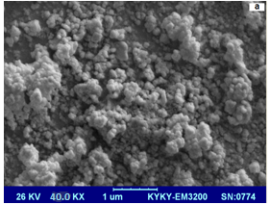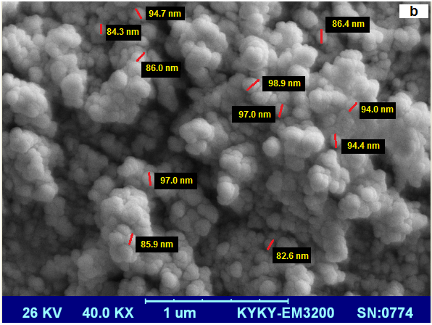
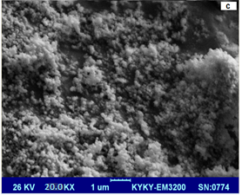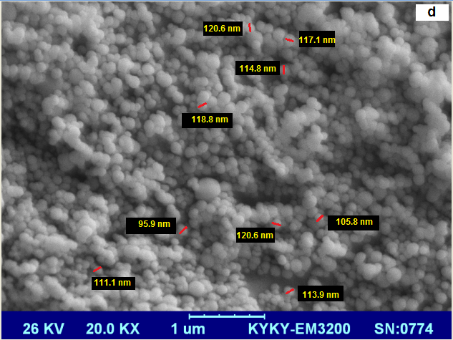
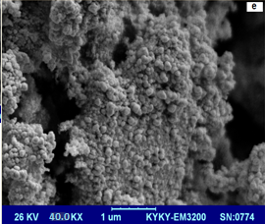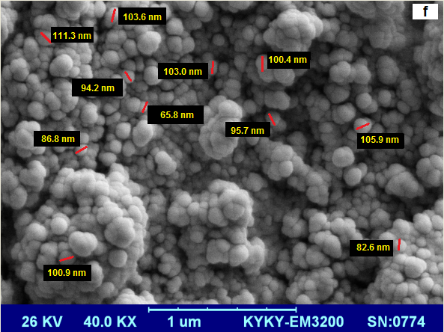
Figure 1. SEM images: a) Silymarin loaded with chitosan nanoparticles at a concentration of 0.24% by the magnification of KX 40.0 b) Determination of particle size in silymarin loaded with chitosan nanoparticles at a concentration of 0.24%. c) Silymarin loaded in PLGA nanoparticles with a magnification of KX 20.0 d) Determination of particle size in silymarin loaded in chitosan nanoparticles; e) Silymarin loaded in a combination of chitosan nanoparticles with a concentration of 0.24% - PLGA with a ratio of 5 to 5 by the magnification of KX 40.0 F) Determination of the particle size of the silymarin loaded in the combination of chitosan nanoparticles with a concentration of 0.24% - PLGA with a ratio of 5 to 5.

According to the images obtained from chitosan nanoparticles with silymarin, it is possible to see how the drug is placed in chitosan particles, and it can also be seen that its particle diameter is less than 100 nm (Figures a and b) which had similar result with the mean particle size of silymarin loaded chitosan nanoparticles in previous studies [9]. Also, it is cited from recent studies that the particle shapes are spherical and the mean particle size of silymarin loaded PLGA nanoparticles is about 80 nm [1]. Also, present images that were obtained from PLGA nanoparticles containing silymarin show the porosity and very high dispersion between particles. Due to the presence of PLGA nanoparticles, the particle diameter varies between 90 and 120 nanometers (Figures c and d). The images obtained from the synthesized nanoparticles with silymarin show that the bond between the amino acid group of chitosan and the PLGA’s polyester group is well formed, resulting in smaller cavities and less porosity. Also, the size of the particles in the combined coatings of chitosan and PLGA nanoparticles with silymarin is also between 90 and 120 nanometers (Figures e and f). The results showed that by increasing the chitosan concentration, the particle size also increased. The increase of particles is due to the presence of intermolecular bonding (due to the presence of –OH groups) and electrostatic intermolecular explosion (according to the +NH groups) between the chitosan [19]. As chitosan concentrations increase, more molecules of chitosan interfere with each other and bind to TPP for forming a larger particle [20].

3.3. The FTIR Transmission Spectrum of Nanoparticles
The data of this study and previous studies were compared and the following results were obtained. Figure 2 shows FTIR spectrum of pure silymarin, pure chitosan and chitosan nanoparticles with silymarin. Index peaks for pure silymarin show 3437 cm⁻¹ for OH stretching [21], 1700 cm⁻¹ for carbonyl ester stretching, 1636 cm⁻¹ for the reactive flavonolignan ketone, 1560 cm⁻¹ for the aromatic ring stretching vibrations and 1033 cm⁻¹ for the benzopyran ring ( Figure 2a) [22, 23]. According to the peaks in the pure chitosan spectrum, it can be found that adsorption in region 3419 cm⁻¹ is related to the N-H groups and in zone 2922 cm⁻¹ the tensile vibrations of the C-H stretch are shown. Absorption of region 1653 cm⁻¹ of the vibrational groups -NH2 (Amide I link), the region between 1458 and 1325 cm⁻¹ related to the CH bend and 1260 cm⁻¹ belongs to the C-O group. In area 667 cm⁻¹, the group is C-H (Figure2b) [9, 17, 24]. The FTIR transmission spectrum of chitosan- silymarin nanoparticles shows 2923.6 cm⁻¹ for O-H stretching, 1727.9 cm⁻¹ for C=O and –NH₂ stretching, 1122.4 cm⁻¹ for C-O stretching, and 671.1 cm⁻¹ for C-H stretching (Figure 2c) [9].
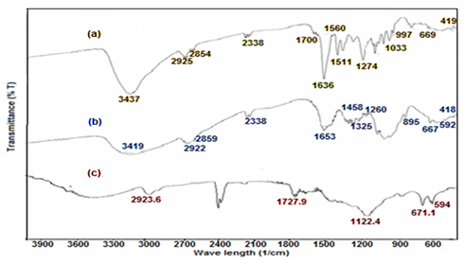
Figure 2. FTIR spectrum for (a) pure silymarin, (b) pure chitosan, (c) chitosan nanoparticles / silymarin.

Figure 3 shows FTIR spectrum of pure silymarin, pure PLGA and PLGA nanoparticles with silymarin The FTIR transmission spectrum of pure PLGA shows the C=O absorption band at 1651 cm⁻¹[6]. FTIR spectrum of PLGA nanoparticle-silymarin shows 2942 cm⁻¹ for O-H stretching, 1739.5 cm⁻¹for C=O stretching and 1157.1 cm⁻¹ for C-Ostretching (Figure 3c).

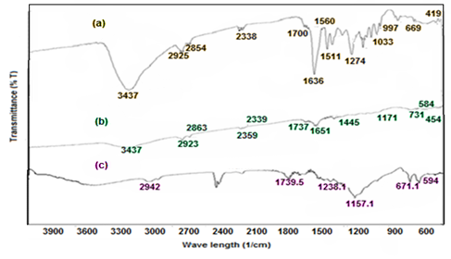
Figure 3. FTIR spectrum for (a) pure silymarin, (b) pure PLGA, (c) PLGA nanoparticles / silymarin.

Figure 4 shows FTIR spectrum of pure silymarin, pure chitosan, pure PLGA and chitosan-PLGA nanoparticles with silymarin. The FTIR transmission spectrum of PLGA-chitosan nanoparticle with silymarin demonstrates 2942.8 cm⁻¹ for C-H stretching, this spectrum and 1724 cm⁻¹ indicates that the chitosan is a very suitable coating on to the PLGA nanoparticle surface in physical and chemical aspects. Chitosan peak at 1730-1660 cm⁻¹ is shown in the PLGA-Chitosan nanoparticles which means that the chitosan has been successfully coated onto the PLGA nanoparticle. The amine group (-NH₂) stated the chitosan on PLGA nanoparticle surface enables drug delivery carriers that based on PLGA (Figure 4d) [17].

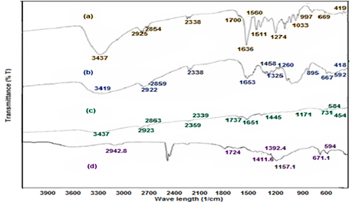
Figure 4. FTIR spectrum for (a) pure silymarin, (b) pure chitosan, (c) pure PLGA, (c) PLGA- chitosan nanoparticles / silymarin.

3.4. Swelling Results for Nanoparticles
Due to the amount of swelling of each of the samples tested during the same period of time and the calculation of the inflation percentage of each of the samples, as presented in Figure 5, it is seen that in different concentrations of chitosan, the highest inflation is related to the highest concentration for every sample. In addition, it is clear that by adding a certain concentration of chitosan to PLGA, the percentage of swelling of the samples has increased that by adding a certain concentration of chitosan to PLGA, the percentage of swelling of the samples has increased. Previous studies showed that increasing chitosan concentration causes a concentration gradient in the solution, which means that the driving force of chitosan increases on the content of solution and raise the rate of the reaction and molecular diffusion. Therefore, it enhances the swelling values [25, 26].
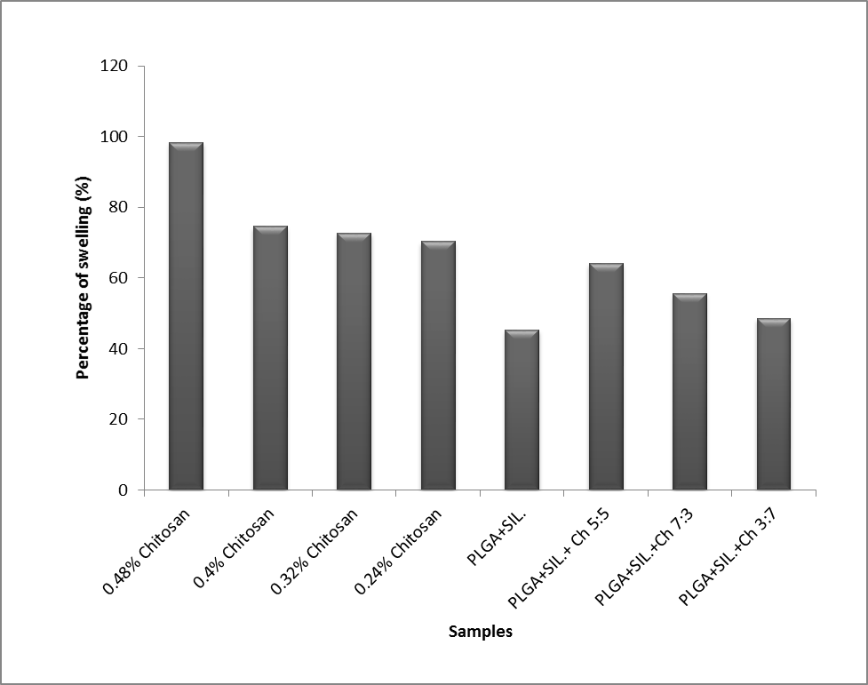
Figure 5. Swelling percentages.

3.5. Drug Release Results
Figure 6 shows the release behavior of various concentrations of chitosan nanoparticles with silymarin. Due to increased time, drug release increases. Also, the drug release rate has a direct correlation with chitosan concentrations in the particles.
According to previous studies, the formulations of the PLGA and chitosan – PLGA nanoparticles showed that the release was fast during the initial period and then slowed down over time [12]. Figure7 shows the release behavior of PLGA nanoparticles with silymarin, which is much lower than chitosan release with silymarin, due to the presence of PLGA polymer in the mixture, because this polymer increases the amount of residence time and half-life in the body and drug release happens over a longer period of time. However, because of the lack of sufficient facilities in the laboratory, a 6-hour release for each sample was counted.
Figure 8 shows the release behavior of the various ratios of chitosan nanoparticles to PLGA -silymarin, which as in the previous figures, due to the presence of PLGA polymer, its release rate was significantly lower than the chitosan nanoparticle containing silymarin.
Chitosan is more hydrophilic than PLGA, which helps to penetrate easily into the networks of nanoparticles in PBS solution (pH = 7.4) and more drug will be released over time [17]. Therefore, in figure6, the drug release is much higher than the other cases. Moreover, the drug release in the curve that is related to the ratio of 30:70 in PLGA to chitosan nanoparticles is greatest which is shown in figure 8.

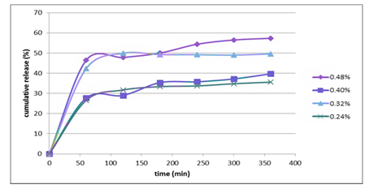
Figure 6. Drug release of chitosan nanoparticle with silymarin.

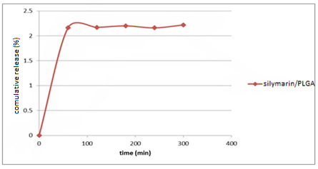
Figure 7. Drug release of PLGA nanoparticle with silymarin.

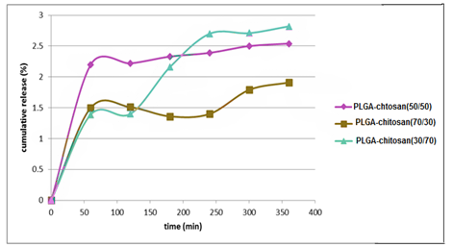
Figure 8. Drug release of chitosan / PLGA nanoparticle with silymarin.

4. Conclusion
This study described a new combination of polymeric coatings to improve silymarin’s properties. By adding a tripolyphosphate solution to a chitosan solution as well as a polyvinyl alcohol solution to a solution of PLGA and silymarin, spherical beads were formed. By increasing the concentration of chitosan in chitosan-containing silymarin nanoparticles, the amount of encapsulation decreased, whereas its drug release increased. Due to the rising half-life and the residence time of drugs loaded with PLGA nanoparticles, adding these nanoparticles to other particles will reduce its release and also release it over a longer period of time. Inflammation levels in various concentrations of chitosan nanoparticles containing silymarin were higher than other ones. Also, increasing the amount of polyvinyl alcohol and PLGA along with chitosan, increased the amount of inflammation as well as encapsulation. The results obtained from SEM images showed that by increasing the chitosan concentration, particle size also increased. Also, with the addition of PLGA nanoparticles, the density and integrity of the particles increase, so it can be seen that the combination of chitosan and PLGA nanoparticles loading by silymarin gives the best particles and due to the increase in intermolecular interactions, the particle size is reduced.

5. References
[1] Yunchang Xie, Yueneng Yi, Xiongwei, Hu, Mingzhu Shangguan, Lijuan Wang, Yi Lu, Jianping Qi, and Wei Wu, Synchronous Microencapsulation of Multiple Components in Silymarin into PLGA Nanoparticles by an Emulsification / Solvent Evaporation Method. Journal of Pharmaceutical Development and Technology, 21(6) (2015) 672-679.
[2] Ahmed A. Albassam, Reginald F. Frye, John S. Markowitz, The effect of milk thistle (Silybum marianum) and its main flavonolignans on CYP2C8 enzyme activity in human liver microsomes, journal of Chemico-Biological Interactions, 271 (2017) 24-29.
[3] V.Vahdatirad, S. H. Ghaffari, M. Momeny, H. Shahbani Zahiri, Effect of Silibinin on the Metabolic Activity of the 8305c Cell Line in Thyroid Cancer. New Cellular and Molecular Biotechnology Journal, 3 (12) (2014) 25-30.
[4] Akbar Ali, Shakeel Ahmed, A review on chitosan and its nanocomposites in drug delievery. International Journal of Biological Macromolecules, 109 (2018) 273-286.
[5] Mohsen Sadeghi, Fariba Ganji, Seyyed Mojtaba Taghizadeh, Bahram Daraei, Preparation and Characterization of Rivastigmine Transdermal Patch Based on Chitosan Microparticles. Iranian Journal of Pharmaceutical Research, 15(3) (2016) 283–294.
[6] Xiaoxia Xie, Qing Tao, Yina Zou, Fengyi Zhang, Miao Guo, Ying Wang, Hui Wang, Qian Zhou, Shuqin Yu, PLGA Nanoparticles Improve the Oral Bioavailability of Curcumin in Rats: Characterizations and Mechanisms. Journal of Agricultural and Food chemistry, 59 (2011) 9280-9289.
[7] Saieede Soltani, Parvin Zakeri-Milani, Mohammad Barzegar-Jalali, Mitra Jelvehgari, Fabrication and in-vitro Evaluation of Ketotifen Fumarate-loaded PLGA Nanoparticles as a Sustained Delivery System. Iranian Journal of Pharmaceutical Research, 16(1) (2017) 22–34.
[8] Lay Hong Chuah, Nashiru Billa, Clive J. Roberts, Jonathan C. Burley, and Sivakumar Manickam, Curcumin-Containing Chitosan Nanoparticles as a Potential Mucoadhesive Delivery System to the Colon. Pharmaceutical Development and Technology, 18(3) (2013) 591–599.
[9] Swati Gupta, Shailendra Kumar Singh, Priti Girotra, Targeting Silymarin for Improved Hepatoprotective Activity through Chitosan Nanoparticles. International Journal of Pharmaceutical Investigation, 4(4) (2014) 156 -163.
[10] Sang-Myung Jung, Gwang Heum Yoon, Hoo Chul Lee, Moon Hee Jung, Sun Il Yu, SeungJu Yeon, Seul Ki Min, Yeo Seon Kwon, Jin Ha Hwang, Hwa Sung, Thermodynamic Insights and Conceptual Design of Skin-Sensitive Chitosan Coated Ceramide/PLGA Nanodrug for Regeneration of Stratum Corneum on Atopic Dermatitis Shin. Journal of Scientific Reports, 5 (18089) (2015) 1-12.
[11] M.Tavakol, E.Vasheghani-Farahani, T.Dolatabadi-Farahani, S.Hashemi-Najafabadi, Sulfasalazine Release from Alginate - N, O-Carboxymethyl Chitosan Gel Beads Coated by Chitosan. Carbohydrate Polymers, 77(2) (2009) 326-330.
[12] Suphiya Parveen, Sanjeeb K. Sahoo. Long Circulating Chitosan/PEG Blended PLGA Nanoparticle for Tumor Drug Delivery. European Journal of Pharmacology, 670(2-3) (2011) 372–383.
[13] Ibrahim M. El-Sherbiny, Mamdouh Abdel-Mogib, Abdel-Aziz M. Dawidar, Ahmed Elsayed, Hugh D.C. Smyth, Biodegradable pH-Responsive Alginate-Poly (lactic-co-glycolic acid) Nano/Micro Hydrogel Matrices for Oral Delivery of Silymarin. Carbohydrate Polymers, 83(3) (2011) 1345–1354.
[14] Seddiki Nesrinne, Aliouche Djamel. Synthesis, Characterization and rheological behavior of pH sensitive poly (acrylamide-co-acrylic acid) hydrogels. Arabian Journal of Chemistry, 10(4) (2017) 539-547.
[15] Ya‐Ni Dai, Ping Li, Jun‐Ping Zhang, Ai‐Qin Wang, Qin Wei, Swelling Characteristics and Drug Delivery Properties of Nifedipine-Loaded pH Sensitive Alginate–Chitosan Hydrogel Beads. Journal of Biomedical Materials Research Part B: Applied Biomaterials, 86(2) (2008) 493-500.
[16] Ya‐Ni Dai, Ping Li, Jun‐Ping Zhang, Ai‐Qin Wang, Qin Wei, A Novel pH Sensitive N-Succinyl Chitosan/Alginate Hydrogel Bead for Nifedipine Delivery. Journal of Biopharmaceutics & drug disposition, 29(3) (2008) 173-184.
[17] Yichao Wang, Puwang Li, Lingxue Kong, Chitosan-Modified PLGA Nanoparticles with Versatile Surface for Improved Drug Delivery. American Association of Pharmaceutical Scientists Pharm Sci Tech, 14(2) (2013) 585-592.
[18] Mitra Amoli-Diva, Rasoul Sadighi-Bonabi, Kamyar Pourghazi, Switchable on/off drug release from gold nanoparticles-grafted dual light- and temperature-responsive hydrogel for controlled drug delivery. Journal of Materials Science and Engineering. C, Materials for Biological Applications, 76 (2017) 242-248.
[19] G.Qun,W. Ajun, Effects of Molecular Weight, Degree of Acetylation and Ionic Strength on Surface Tension of Chitosan in Dilute Solution. Journal of Carbohydrate Polymers, 64(1) (2006) 29–36.
[20] W. Fan, W. Yan, Z. Xu, H. Ni, Formation Mechanism of Monodisperse, Low Molecular Weight Chitosan Nanoparticles by Ionic Gelation Technique. Journal of Colloids and Surfaces B, 90(1) (2012) 21–27.
[21] D. Sonai, S. Tejal, T. Vaischali, G. Tejal, Silymarin – Solid Dispersions: Characterization and Influence of Preparation Methods on Dissolution. Journal of Acta Pharmaceutica, 60(4) (2010) 427–43.
[22] Suvadra Das, Partha Roy, Runa Ghosh Auddy, Arup Mukherjee, Silymarin Nanoparticle Prevents Paracetamol-Induced Hepatotoxicity. International Journal of Nanomedicine, 6 (2011) 1291–1301.
[23] O. N. El-Gazayerly, A. I. A. Makhlouf, A. M. A. Soelm, M. A. Mohmoud, Antioxidant and Hepatoprotective Effects of Silymarin Phytosomes Compared to Milk Thistle Extract in CCl₄ Induced Hepatotoxicity in Rats. Journal of Microencapsul, 31(1) (2014) 23–30.
[24] Nezamaddin Mengelizadeh, Nematollah Jafarzadeh Haghighifard, Afshin Takdastan, Mina Hormozinejad, Physicochemical Characterization of Biopolymer Chitosan Extracted from Shrimp Shell. Iranian Journal of Polymer Science and Technology, 27(6) (2015) 371-380.
[25] Xiudong Liu, Weiming Xue, Qun Liu, Weiting Yu, Yingli Fu, Xin Xiong, Xiaojun Ma, Quan Yuan, Swelling Behaviour of Alginate–Chitosan Microcapsules Prepared by External Gelation or Internal Gelation Technology. Journal of Carbohydrate Polymers, 56(4) (2004) 459–464.
[26] Khashayar Modaresifar, Afra Hadjizadeh, Hassan Niknejad, Design and fabrication of GelMA/chitosan nanoparticles composite hydrogel for angiogenic growth factor delivery. International Journal of Artificial Cells, Nanomedicine, and Biotechnology, 46(8) (2017) 1799-1808.

* Corresponding author; e-mail: fahym2020@gmail.com

