GitLab Web IDE
un-pass:
janez.vegan@gmail.com
pass:
geslo je v: \Documents\gesla

Hello World project
- Kreiraj nov projekt
- Naredi git clone …..
- Kreiraj datoteko .gitlab-ci.yml
- Napolni jo
- Izvedi git add -A
- Izvedi git commit -m "add Hello World Pipelines" (šele sedaj boš videl vejo v git branch -a)
- git push

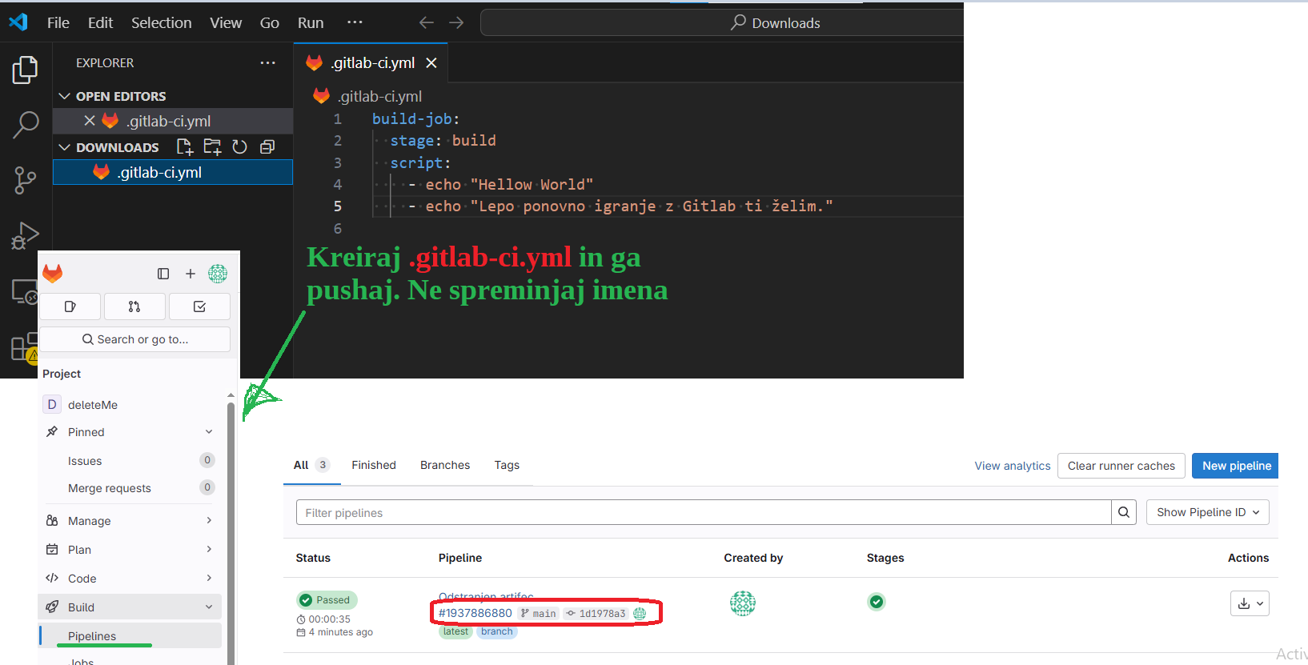

Dodaj še korake z artifect-i in 2-ema zaporednima ter 2x paralelna koraka

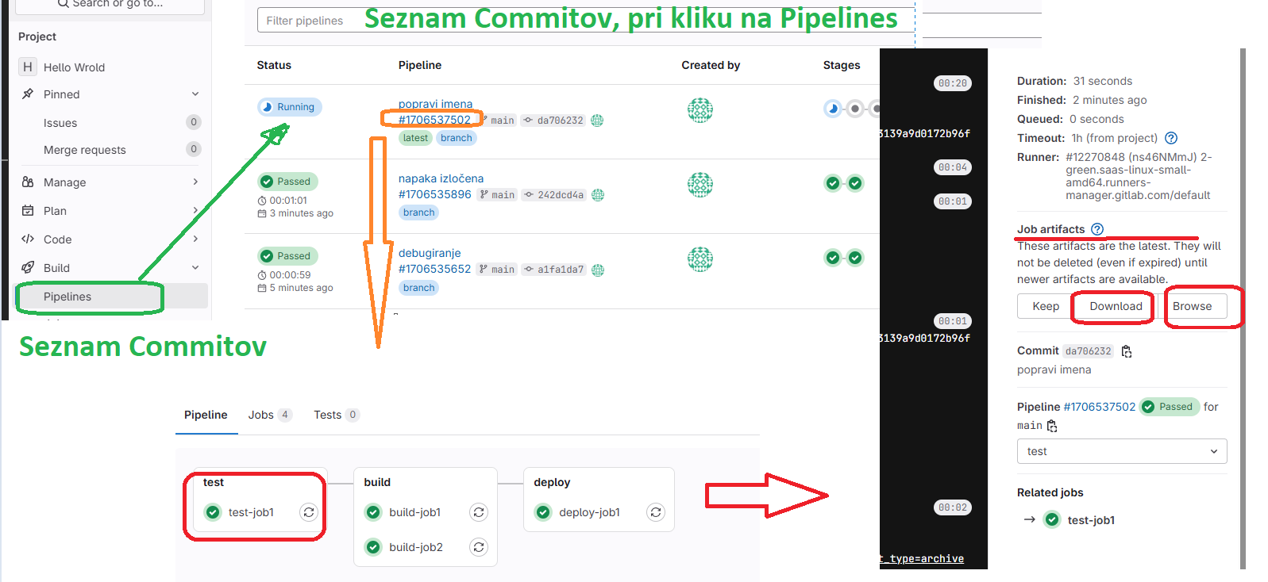

Vsebina datoteke “.gitlab-ci.yml” :
stages:
- test
- build
- deploy

build-job1:
stage: build
script:
- echo "Hello World"
- echo "Lep dan in vikend ti želim"

build-job2:
stage: build
script:
- echo "Hello World iz paralelne mašine"
- echo "Lep plezalni dan ju3"

test-job1:
stage: test
script:
- echo "Nekaj z Artifekti"
- echo "Hello World" > hello_world.txt
- pwd
- ls -l
artifacts:
paths:
- hello_world.txt

deploy-job1:
stage: deploy
script:
- echo "Lep zanimiv večer"

Objava na aws amazon.

- Uporabniku (IAM) dodaj Access key
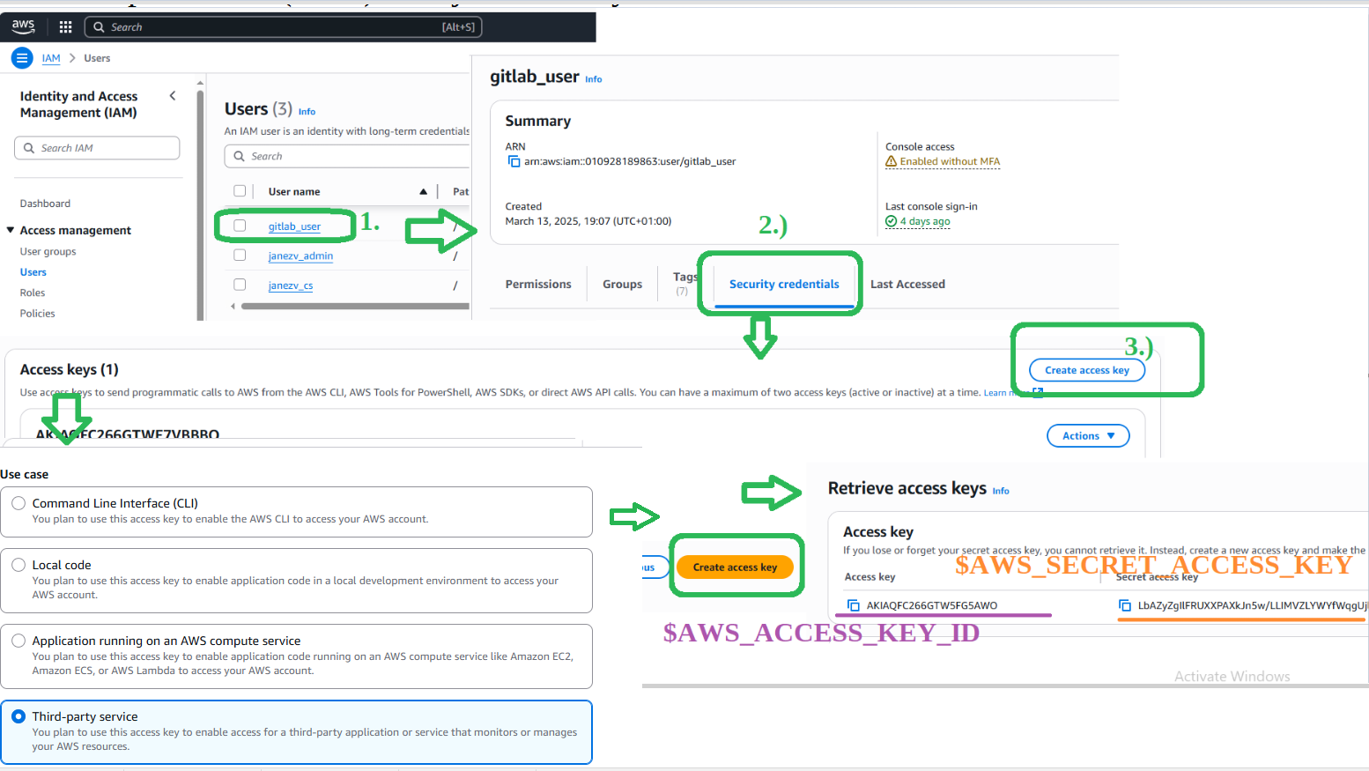

iz GitLab upload na amazon aws s3
- Na DockerHub najdeš image (aws-cli) in ‘tag’ uporabi v .gitlab-ci.yml
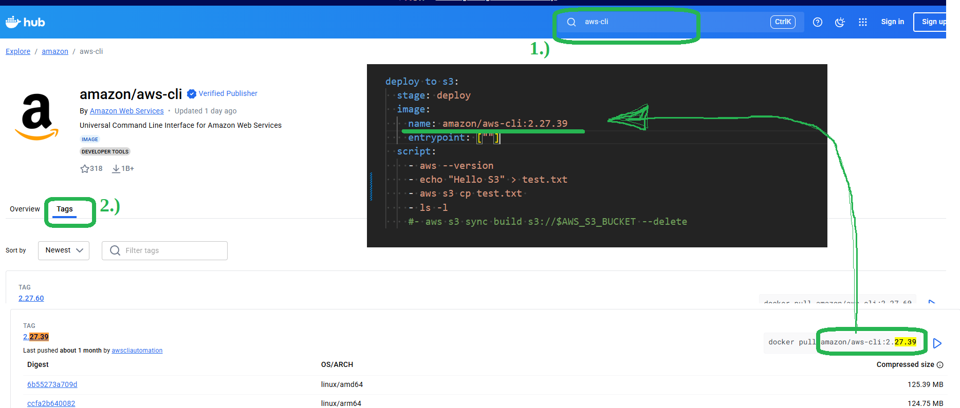

- V aws_amazon kreiraj s3 Bucket in “Destination” kopiraj v .gitlab-ci.yml

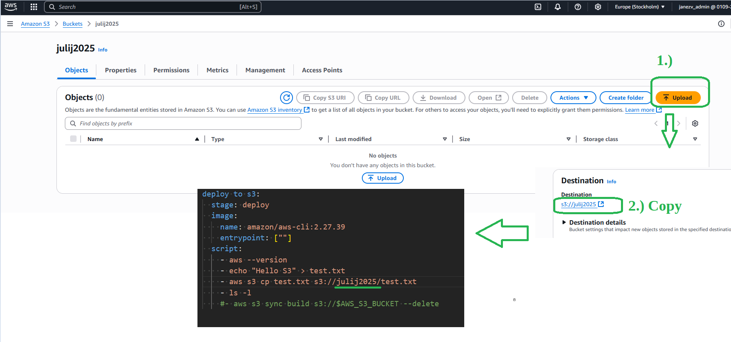

- V gitLab nastavi AWS_ACCESS_KEY_DI in AWS_SECRET_ACCESS_KEY

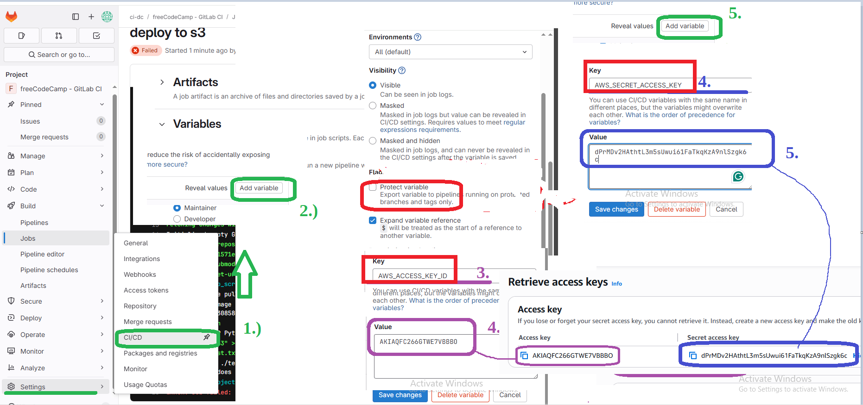

- na AWS amazon kreiraj bucket in kopiraj acces point v GitLab job, ki bo kopiral .txt dokument v Backet
stages:
- deploy

deploy to s3:
stage: deploy
image:
name: amazon/aws-cli:2.27.39
entrypoint: [""]
script:
- aws --version
- echo "Hello S3" > test.txt
- aws s3 cp test.txt s3://julij2025/test.txt
- ls -l

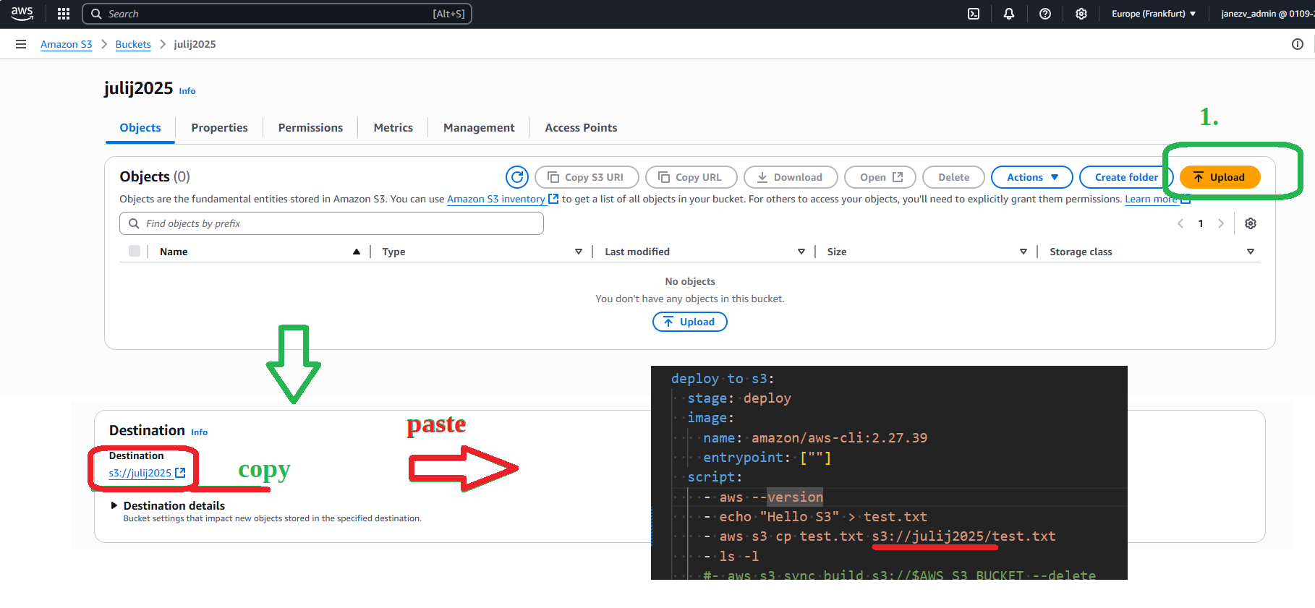

Yarn ukazi (kot npm)
yarn install
yarn build
yarn test

Generiraj ssh v C:\Users\janezv\.ssh
https://www.youtube.com/watch?v=Vmt0V6a3ppE
ssh-keygen

Tips & Tricks
Disable job:
Daj piko pred ime joba

Omogoči git push -f . To naredi v settings od projekta

Zanimivi Linki:
https://www.youtube.com/watch?v=Kkl_CO57Quo

Links

kreiran s3 Bucket:
jvegan-20250309
https://youtu.be/PGyhBwLyK2U?t=8614
- AWS Command Line Interface:
https://youtu.be/PGyhBwLyK2U
https://youtu.be/PGyhBwLyK2U?t=8721
https://youtu.be/PGyhBwLyK2U?t=9181
- Variable
https://youtu.be/PGyhBwLyK2U?t=9219
https://youtu.be/PGyhBwLyK2U?t=9530
- Structure a pipeline
https://youtu.be/PGyhBwLyK2U?t=7856
- aws upoda from gitlub
https://youtu.be/PGyhBwLyK2U?t=8618
- Uploading a file to s3
https://youtu.be/PGyhBwLyK2U?t=8945
- Dodaj password od aws v gitlub
https://youtu.be/PGyhBwLyK2U?t=9532
https://youtu.be/PGyhBwLyK2U?t=10010

