HW 6.1
Which of the following statements are true about MongoDB replication. Check all that apply.
Principio del formulario
The minimum sensible number of voting nodes to a replica set is three.
MongoDB replication is synchronous.
The Mongo shell is capable of attaching to a replica set and automatically failing over.
By default, using the new MongoClient connection class, w=1 and j=1.
The oplog utilizes a capped collection.
Final del formulario

HW 6.2
Let's suppose you have a five member replica set and want to assure that writes are committed to the journal and are acknowledged by at least 3 nodes before you proceed forward. What would be the appropriate settings for w and j?
Principio del formulario
w=1, j=1
w="majority", j=1
w=3, j=0
w=5, j=1
w=1,j=3
Final del formulario

HW 6.3
Which of the following statements are true about choosing and using a shard key:
Principio del formulario
The shard key must be unique
There must be a index on the collection that starts with the shard key.
Mongo can not enforce unique indexes on a sharded collection other than the shard key itself.
Any update that does not contain the shard key will be sent to all shards.
You can change the shard key on a collection if you desire.
Final del formulario

HW 6.4
You have a sharded system with three shards and have sharded the collections "grades" in the "test" database across those shards. The output of sh.status() when connected to mongos looks like this:
mongos> sh.status()
--- Sharding Status ---
sharding version: { "_id" : 1, "version" : 3 }
shards:
{ "_id" : "s0", "host" : "s0/localhost:37017,localhost:37018,localhost:37019" }
{ "_id" : "s1", "host" : "s1/localhost:47017,localhost:47018,localhost:47019" }
{ "_id" : "s2", "host" : "s2/localhost:57017,localhost:57018,localhost:57019" }
databases:
{ "_id" : "admin", "partitioned" : false, "primary" : "config" }
{ "_id" : "test", "partitioned" : true, "primary" : "s0" }
test.grades chunks:
s1 4
s0 4
s2 4
{ "student_id" : { $minKey : 1 } } -->> { "student_id" : 0 } on : s1 Timestamp(12000, 0)
{ "student_id" : 0 } -->> { "student_id" : 2640 } on : s0 Timestamp(11000, 1)
{ "student_id" : 2640 } -->> { "student_id" : 91918 } on : s1 Timestamp(10000, 1)
{ "student_id" : 91918 } -->> { "student_id" : 176201 } on : s0 Timestamp(4000, 2)
{ "student_id" : 176201 } -->> { "student_id" : 256639 } on : s2 Timestamp(12000, 1)
{ "student_id" : 256639 } -->> { "student_id" : 344351 } on : s2 Timestamp(6000, 2)
{ "student_id" : 344351 } -->> { "student_id" : 424983 } on : s0 Timestamp(7000, 2)
{ "student_id" : 424983 } -->> { "student_id" : 509266 } on : s1 Timestamp(8000, 2)
{ "student_id" : 509266 } -->> { "student_id" : 596849 } on : s1 Timestamp(9000, 2)
{ "student_id" : 596849 } -->> { "student_id" : 772260 } on : s0 Timestamp(10000, 2)
{ "student_id" : 772260 } -->> { "student_id" : 945802 } on : s2 Timestamp(11000, 2)
{ "student_id" : 945802 } -->> { "student_id" : { $maxKey : 1 } } on : s2 Timestamp(11000, 3)
If you ran the query
use test
db.grades.find({'student_id':530289})
Which shards would be involved in answering the query?
Principio del formulario
s0,s1 and s2
s0
s1
s2
Final del formulario

HW 6.5
Create three directories for the three mongod processes. On unix, this could be done as follows:
mkdir -p /data/rs1 /data/rs2 /data/rs3
Now start three mongo instances as follows. Note that are three commands. The browser is probably wrapping them visually.
./mongod --replSet m101 --logpath "1.log" --dbpath /data/rs1 --port 27017 --smallfiles --fork

./mongod --replSet m101 --logpath "2.log" --dbpath /data/rs2 --port 27018 --smallfiles --fork

./mongod --replSet m101 --logpath "3.log" --dbpath /data/rs3 --port 27019 --smallfiles --fork
Now connect to a mongo shell and make sure it comes up
./mongo --port 27017
Now you will create the replica set. Type the following commands into the mongo shell:
config = { _id: "m101", members:[
{ _id : 0, host : "localhost:27017"},
{ _id : 1, host : "localhost:27018"},
{ _id : 2, host : "localhost:27019"} ]
};
rs.initiate(config);
At this point, the replica set should be coming up. You can type
rs.status()
to see the state of replication.
m101:PRIMARY> rs.status()
{
"set" : "m101",
"date" : ISODate("2013-06-20T11:35:56Z"),
"myState" : 1,
"members" : [
{
"_id" : 0,
"name" : "localhost:27017",
"health" : 1,
"state" : 1,
"stateStr" : "PRIMARY",
"uptime" : 195,
"optime" : Timestamp(1371728094000, 1),
"optimeDate" : ISODate("2013-06-20T11:34:54Z"),
"self" : true
},
{
"_id" : 1,
"name" : "localhost:27018",
"health" : 1,
"state" : 2,
"stateStr" : "SECONDARY",
"uptime" : 60,
"optime" : Timestamp(1371728094000, 1),
"optimeDate" : ISODate("2013-06-20T11:34:54Z"),
"lastHeartbeat" : ISODate("2013-06-20T11:35:54Z"),
"pingMs" : 0
},
{
"_id" : 2,
"name" : "localhost:27019",
"health" : 1,
"state" : 2,
"stateStr" : "SECONDARY",
"uptime" : 60,
"optime" : Timestamp(1371728094000, 1),
"optimeDate" : ISODate("2013-06-20T11:34:54Z"),
"lastHeartbeat" : ISODate("2013-06-20T11:35:54Z"),
"pingMs" : 1
}
],
"ok" : 1
}
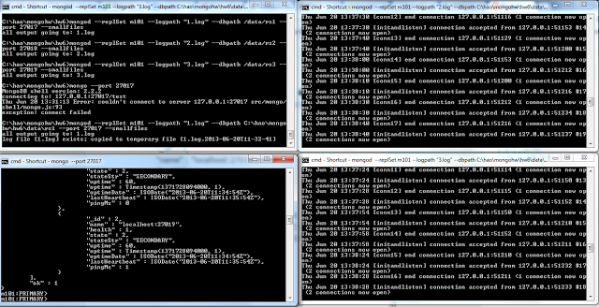

\\M101J\Week6\week6-lessons>python validate.py

Welcome to the HW 6.x replica Checker. My job is to make sure you started a replica set with three nodes

Looks good. Replica set with three nodes running

Tests Passed for HW 6.5. Your HW 6.5 validation code is CongratsYouRock2012

