|  |  |  |
| --- | --- | --- |
| ***Consistency*** | [***Availability***](https://en.wikipedia.org/wiki/Availability) | [***Partition tolerance***](https://en.wikipedia.org/wiki/Network_partitioning) |
| Every read receives the most recent write or an error | Every request receives a (non-error) response – without guarantee that it contains the most recent write | The system continues to operate despite an arbitrary number of messages being dropped (or delayed) by the network between nodes |

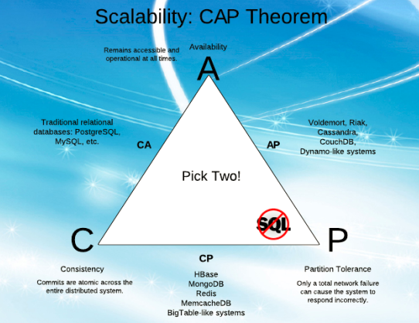

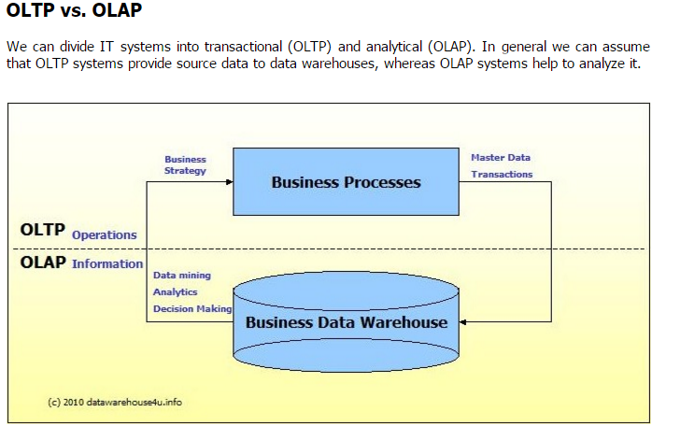

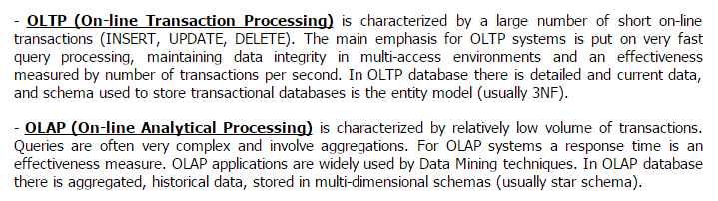

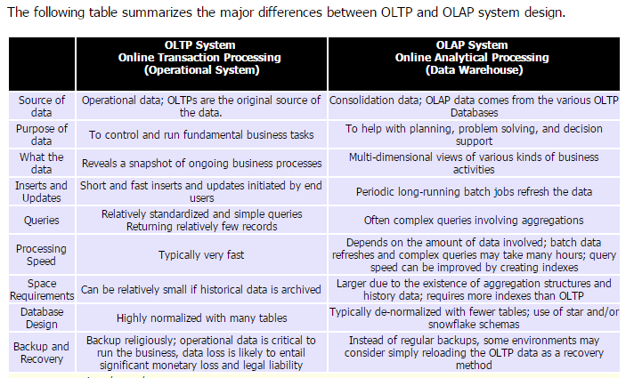

Row Oriented Databases are more suitable for transactional (OLTP) workloads whereas columnar databases are more appropriate for analytical (OLAP) workloads.

<https://www.quora.com/What-is-the-difference-between-a-column-oriented-and-a-row-oriented-database>

