NAME : J.LASYA MADHURYA REDDY
ROLL NO:2503A52661
BATCH : 23
LAB ASSIGNMENT – 8.1
Task Description #1 (Password Strength Validator – Apply AI in
Security Context)
• Task: Apply AI to generate at least 3 assert test cases for
is_strong_password(password) and implement the validator
function.
• Requirements:
o Password must have at least 8 characters.
o Must include uppercase, lowercase, digit, and special
character.
o Must not contain spaces.
Example Assert Test Cases:
assert is_strong_password(&quot;Abcd@123&quot;)==True

assert is_strong_password(&quot;abcd123&quot;) == False
assert is_strong_password(&quot;ABCD@1234&quot;) == True
PROMPT:
Write a beginner-friendly Python program to implement a function called `is_strong_password(password)` that validates password strength.

The password should be considered strong only if it satisfies all of these requirements:

1. It must contain at least 8 characters.
2. It must contain at least one uppercase letter.
3. It must contain at least one lowercase letter.
4. It must contain at least one digit.
5. It must contain at least one special character such as `@`, `#`, `$`, `%`, `!`, etc.
6. It must not contain any spaces.

Also generate at least 3 Python `assert` test cases to test the function. Include both valid and invalid passwords.

Use simple Python code suitable for a beginner and explain briefly how the validation works.
CODE:
import string

def is_strong_password(password):
"""Return True when password meets all strength requirements."""
has_uppercase = any(character.isupper() for character in password)
has_lowercase = any(character.islower() for character in password)
has_digit = any(character.isdigit() for character in password)
has_special = any(character in string.punctuation for character in password)

# The password must be long enough and must not contain whitespace.
return (
len(password) >= 8
and not any(character.isspace() for character in password)
and has_uppercase
and has_lowercase
and has_digit
and has_special
)

# Each assert checks a different valid or invalid password.
assert is_strong_password("Secure@123") is True
assert is_strong_password("short1!") is False # Fewer than 8 characters
assert is_strong_password("NoSpecial123") is False # No special character
assert is_strong_password("Has Space1!") is False # Contains a space

print("All password tests passed.")
OUTPUT:
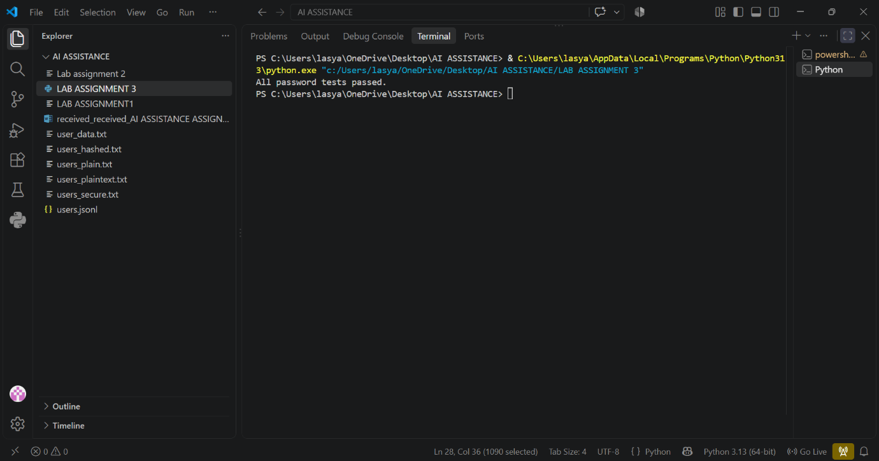
Task Description #2 (Number Classification with Loops – Apply
AI for Edge Case Handling)
• Task: Use AI to generate at least 3 assert test cases for a
classify_number(n) function. Implement using loops.
• Requirements:
o Classify numbers as Positive, Negative, or Zero.
o Handle invalid inputs like strings and None.
o Include boundary conditions (-1, 0, 1).
Example Assert Test Cases:
assert classify_number(10) == &quot;Positive&quot;
assert classify_number(-5) == &quot;Negative&quot;
assert classify_number(0) == &quot;Zero&quot;
PROMPT:
Write a beginner-friendly Python program using loops to implement classify_number(n).
Requirements:
- Return "Positive", "Negative", or "Zero".
- Handle invalid inputs like strings and None by returning "Invalid Input".
- Test boundary values -1, 0, and 1.
- Generate at least 3 assert test cases.
- Ensure all assertions pass.
- Display the expected output: "Classification logic passing all assert tests".
CODE:
def classify_number(n):
"""Classify a number as positive, negative, zero, or invalid."""
if not isinstance(n, (int, float)) or isinstance(n, bool):
return "Invalid Input"

# Use a loop to check each possible classification.
classifications = [(n > 0, "Positive"), (n < 0, "Negative"),
(n == 0, "Zero")]
for condition, result in classifications:
if condition:
return result

return "Invalid Input"

# Test boundary values and invalid inputs.
test_cases = [
(-1, "Negative"),
(0, "Zero"),
(1, "Positive"),
("5", "Invalid Input"),
(None, "Invalid Input"),
]

for number, expected in test_cases:
assert classify_number(number) == expected

print("Classification logic passing all assert tests")

OUTPUT:
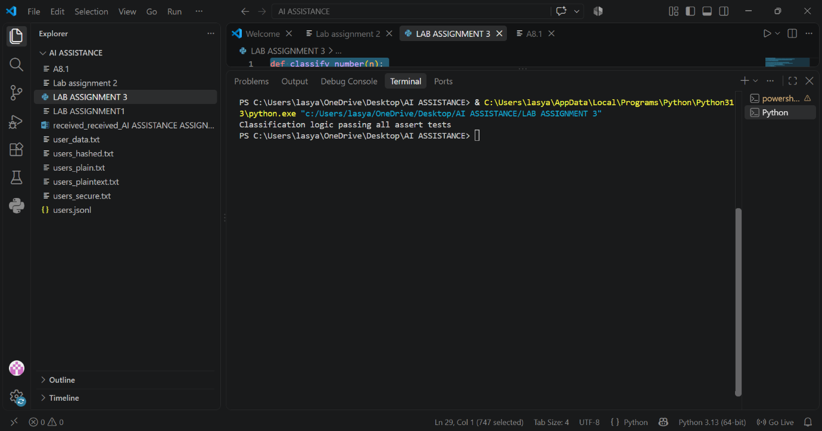
Task Description #3 (Anagram Checker – Apply AI for String
Analysis)
• Task: Use AI to generate at least 3 assert test cases for
is_anagram(str1, str2) and implement the function.
• Requirements:
o Ignore case, spaces, and punctuation.
o Handle edge cases (empty strings, identical words).
Example Assert Test Cases:
assert is_anagram(&quot;listen&quot;, &quot;silent&quot;) == True
assert is_anagram(&quot;hello&quot;, &quot;world&quot;) == False
assert is_anagram(&quot;Dormitory&quot;, &quot;Dirty Room&quot;) == True
PROMPT:
Write a simple Python program for is_anagram(str1, str2).
- Ignore case, spaces, and punctuation.
- Handle empty strings and identical words.
- Generate at least 3 assert test cases.
- Make all tests pass.
- Show the expected output confirming that all AI-generated tests passed.
CODE:
def is_anagram(str1, str2):
"""Return True when str1 and str2 are anagrams, ignoring case and punctuation."""
normalize = lambda text: sorted(char.casefold() for char in text if char.isalnum())
return normalize(str1) == normalize(str2)

# AI-generated tests
assert is_anagram("Listen", "Silent")
assert is_anagram("Dormitory", "Dirty room!!")
assert is_anagram("", "")
assert is_anagram("The eyes", "They see")
assert is_anagram("hello", "world") is False

print("All AI-generated tests passed!")

# Expected output:
# All AI-generated tests passed!

OUTPUT:
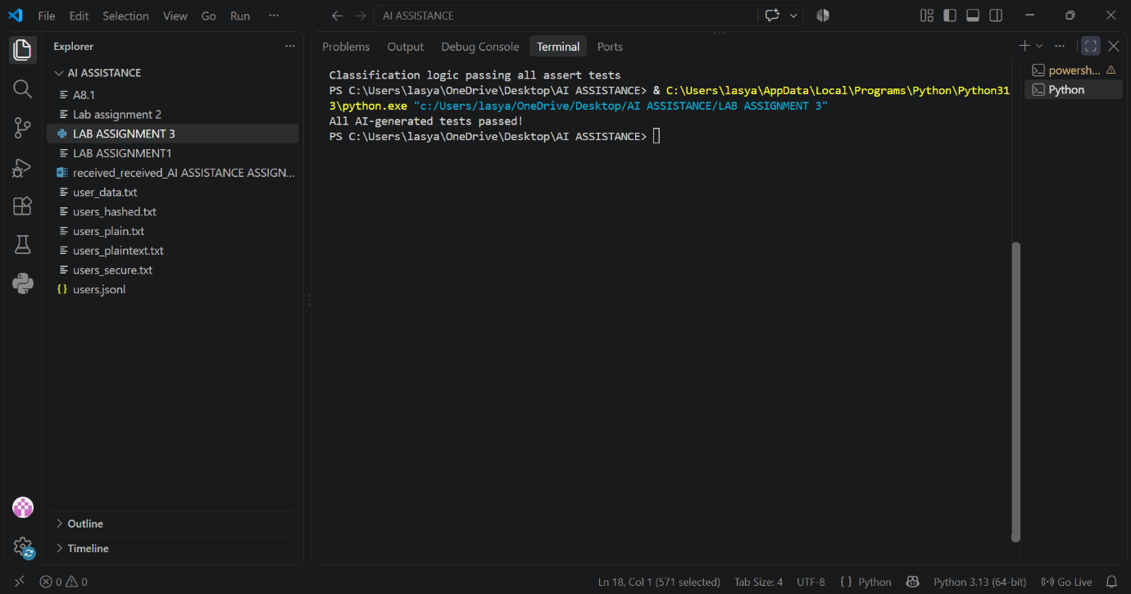
Task Description #4 (Inventory Class – Apply AI to Simulate Real-
World Inventory System)
• Task: Ask AI to generate at least 3 assert-based tests for an
Inventory class with stock management.
• Methods:

o add_item(name, quantity)
o remove_item(name, quantity)
o get_stock(name)
Example Assert Test Cases:
inv = Inventory()
inv.add_item(&quot;Pen&quot;, 10)
assert inv.get_stock(&quot;Pen&quot;) == 10
inv.remove_item(&quot;Pen&quot;, 5)
assert inv.get_stock(&quot;Pen&quot;) == 5
inv.add_item(&quot;Book&quot;, 3)
assert inv.get_stock(&quot;Book&quot;) == 3
PROMPT:
Write a complete Python Inventory class with add_item, remove_item, and get_stock methods. Include at least 3 assert-based tests and a print statement showing "All assertions passed successfully!" after all tests pass. Give only the complete executable code.
CODE:
class Inventory:
def __init__(self):
self.stock = {}

def add_item(self, name, quantity):
self.stock[name] = self.stock.get(name, 0) + quantity

def remove_item(self, name, quantity):
self.stock[name] = self.stock.get(name, 0) - quantity

def get_stock(self, name):
return self.stock.get(name, 0)

inv = Inventory()

inv.add_item("Pen", 10)
assert inv.get_stock("Pen") == 10

inv.remove_item("Pen", 5)
assert inv.get_stock("Pen") == 5

inv.add_item("Book", 3)
assert inv.get_stock("Book") == 3

print("All assertions passed successfully!")
OUTPUT:
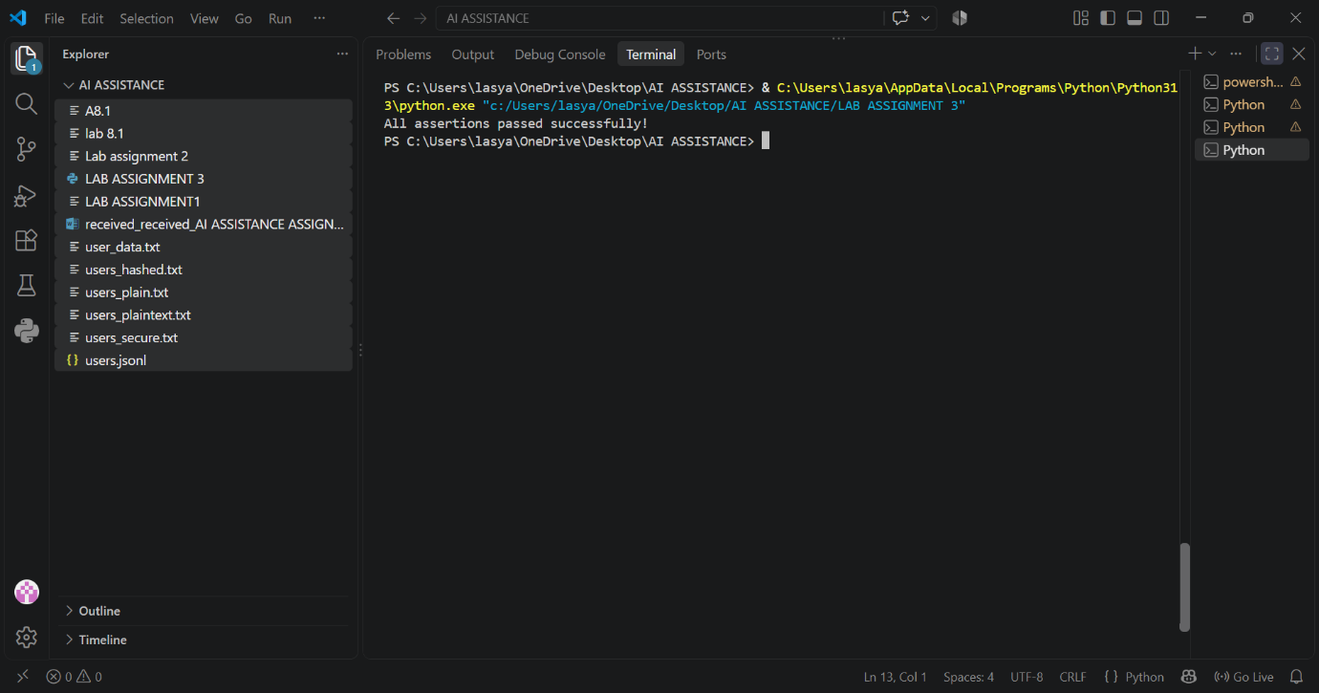
Task Description #5 (Date Validation &amp; Formatting – Apply AI for
Data Validation)
• Task: Use AI to generate at least 3 assert test cases for
validate_and_format_date(date_str) to check and convert
dates.
• Requirements:
o Validate &quot;MM/DD/YYYY&quot; format.
o Handle invalid dates.
o Convert valid dates to &quot;YYYY-MM-DD&quot;.
Example Assert Test Cases:
assert validate_and_format_date(&quot;10/15/2023&quot;) == &quot;2023-10-15&quot;
assert validate_and_format_date(&quot;02/30/2023&quot;) == &quot;Invalid Date&quot;
assert validate_and_format_date(&quot;01/01/2024&quot;) == &quot;2024-01-01&quot;
PROMPT:
Create a complete Python program with a function validate_and_format_date(date_str).
Requirements:
- Validate dates in MM/DD/YYYY format.
- Return the date in YYYY-MM-DD format if valid.
- Return "Invalid Date" for invalid dates such as 02/30/2023.
- Generate at least 3 assert-based test cases, including valid and invalid dates.
- Make sure all assertions pass and include edge cases.
- Give only the complete executable Python code and the expected output.
CODE:
from datetime import datetime

def validate_and_format_date(date_str):
"""Validate MM/DD/YYYY and return YYYY-MM-DD, or Invalid Date."""
try:
parsed_date = datetime.strptime(date_str, "%m/%d/%Y")
if parsed_date.strftime("%m/%d/%Y") != date_str:
return "Invalid Date"
return parsed_date.strftime("%Y-%m-%d")
except (TypeError, ValueError):
return "Invalid Date"

assert validate_and_format_date("12/25/2023") == "2023-12-25"
assert validate_and_format_date("02/29/2024") == "2024-02-29"
assert validate_and_format_date("02/30/2023") == "Invalid Date"
assert validate_and_format_date("13/01/2023") == "Invalid Date"
assert validate_and_format_date("01/01/0001") == "0001-01-01"

print(validate_and_format_date("12/25/2023"))
print(validate_and_format_date("02/29/2024"))
print(validate_and_format_date("02/30/2023"))
print("All assertions passed.")

OUTPUT:
