NAME : J.LASYA REDDY
BATCH : 23
ROLL NO : 2503AA52661
LAB ASSIGNMENT-10

Task Description #1 – Syntax and Logic Errors
Task: Use AI to identify and fix syntax and logic errors in a faulty
Python script.
Sample Input Code:
# Calculate average score of a student
def calc_average(marks):
Week5 -
Monday
total = 0
for m in marks:
total += m
average = total / len(marks)
return avrage # Typo here
marks = [85, 90, 78, 92]
print(&quot;Average Score is &quot;, calc_average(marks)
Expected Output:
• Corrected and runnable Python code with explanations of the
fixes.
PROMPT:- Review the following Python code for syntax errors, logic errors, and readability issues.
Fix the errors and provide the corrected runnable code.
Also explain each error and why your correction fixes it.
Follow basic PEP 8 standards

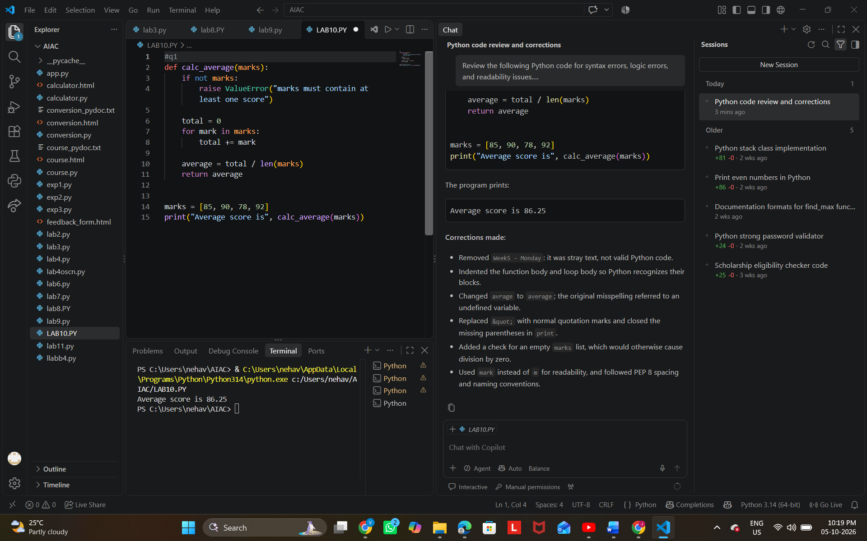

Task Description #2 – PEP 8 Compliance
Task: Use AI to refactor Python code to follow PEP 8 style
guidelines.
Sample Input Code:
def area_of_rect(L,B) : return L*B
print(area_of_rect(10,20))
Expected Output:
• Well-formatted PEP 8-compliant Python code.
Prompt:- Refactor the following Python code according to PEP 8 guidelines. Fix formatting, spacing, indentation, and variable naming while keeping the functionality unchanged. Explain the changes briefly.

def area_of_rect(L,B) : return L*B
print(area_of_rect(10,20))

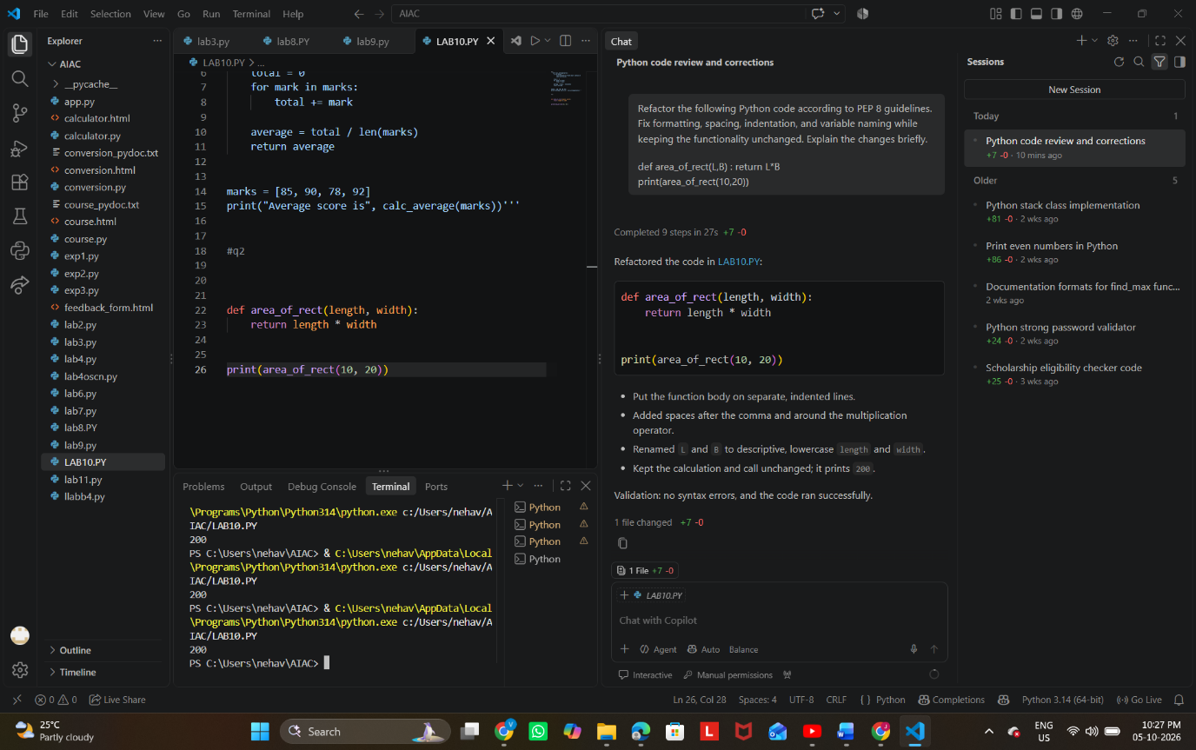
Task Description #3 – Readability Enhancement
Task: Use AI to make code more readable without changing its
logic.
Sample Input Code:
def c(x,y):
return x*y/100
a=200
b=15
print(c(a,b))
Expected Output:
• Python code with descriptive variable names, inline
comments, and clear formatting.
PROMPT:- Make the following Python code more readable without changing its logic. Use descriptive variable and function names, add inline comments, and apply clear formatting.

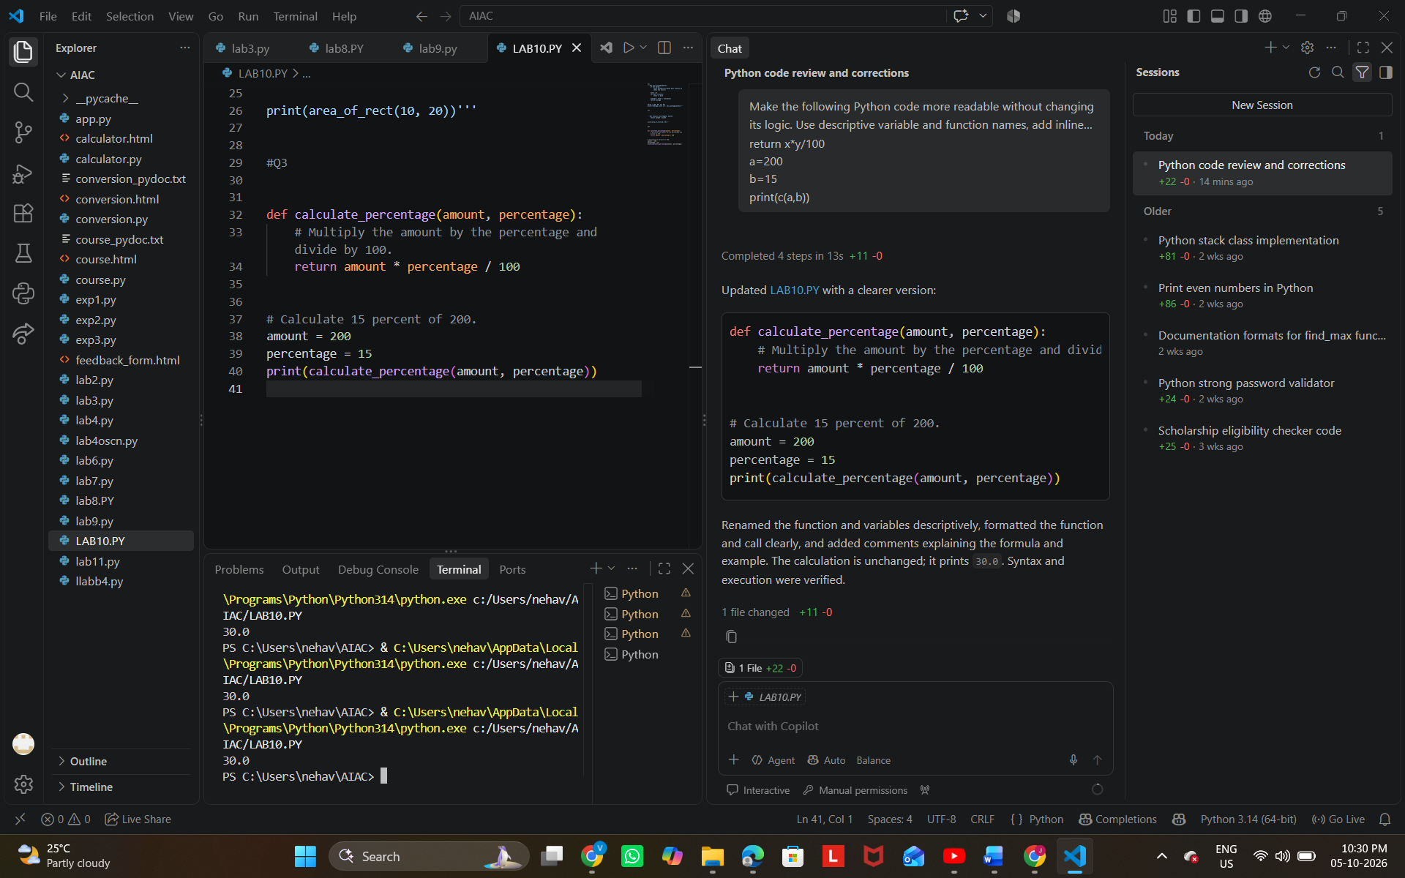
Task Description #4 – Refactoring for Maintainability
Task: Use AI to break repetitive or long code into reusable
functions.
Sample Input Code:
students = [&quot;Alice&quot;, &quot;Bob&quot;, &quot;Charlie&quot;]
print(&quot;Welcome&quot;, students[0])
print(&quot;Welcome&quot;, students[1])
print(&quot;Welcome&quot;, students[2])
Expected Output:
• Modular code with reusable functions.
PROMPT:- Refactor the following Python code for better maintainability. Create a reusable function to eliminate repetition, keep the logic unchanged, and provide clear, well-formatted code.

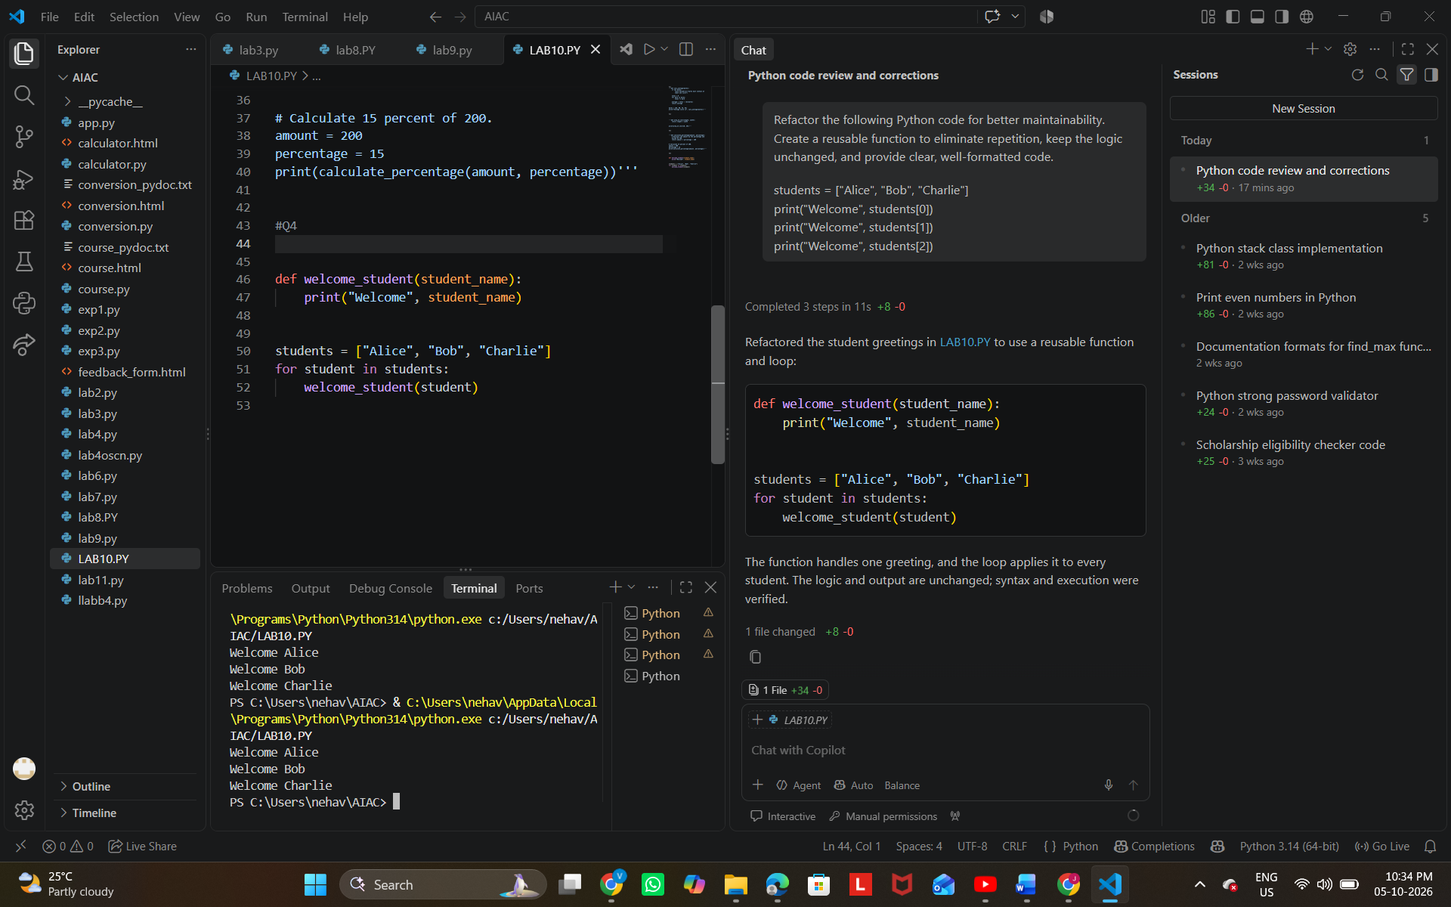
Task Description #5 – Performance Optimization
Task: Use AI to make the code run faster.
Sample Input Code:
# Find squares of numbers
nums = [i for i in range(1,1000000)]
squares = []
for n in nums:
squares.append(n**2)
print(len(squares))
Expected Output:
• Optimized code using list comprehensions or vectorized
operations.
PROMPT:- Optimize the following Python code for better performance. Use a list comprehension or other efficient approach, keep the logic and output unchanged, and explain the optimization briefly.

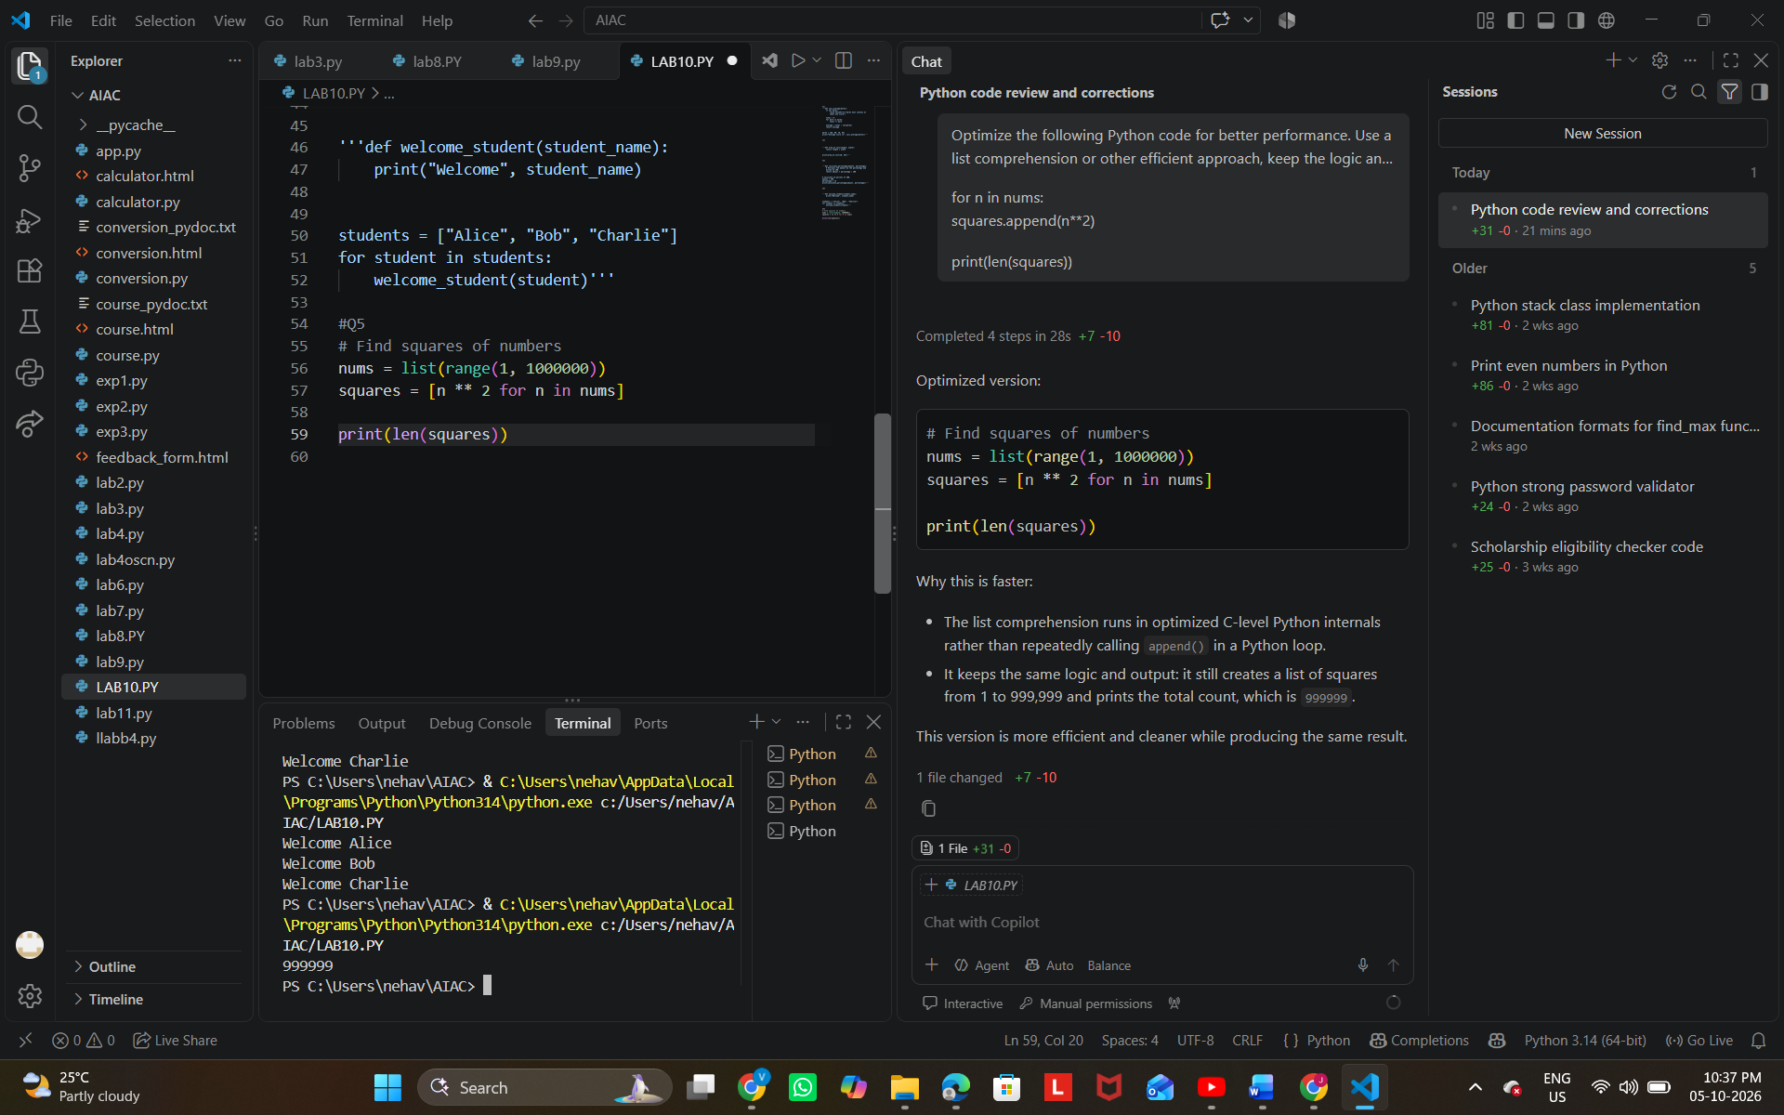
Task Description #6 – Complexity Reduction
Task: Use AI to simplify overly complex logic.
Sample Input Code:
def grade(score):
if score &gt;= 90:
return &quot;A&quot;
else:
if score &gt;= 80:
return &quot;B&quot;
else:
if score &gt;= 70:
return &quot;C&quot;
else:
if score &gt;= 60:
return &quot;D&quot;
else:
return &quot;F&quot;
Expected Output:
• Cleaner logic using elif or dictionary mapping.
PROMPT:- Simplify the following Python code to reduce its complexity. Use elif or another clean approach, keep the logic unchanged, and provide clear, readable code.

