ASSIGNMENT – 11.1
Task Description #1 – Stack Implementation
Task: Use AI to generate a Stack class with push, pop, peek, and is_empty
methods.
Sample Input Code:
class Stack:
pass
PROMPT:
Use this prompt:

**Prompt:**
"Generate a Python `Stack` class using a list to store elements. Implement the methods `push()`, `pop()`, `peek()`, and `is_empty()`. Add clear docstrings for the class and every method. Handle popping or peeking from an empty stack appropriately. Include a short example demonstrating all four methods."
CODE:
class Stack:
"""A last-in, first-out (LIFO) stack implemented with a list."""

def __init__(self):
"""Initialize an empty stack."""
self._items = []

def push(self, item):
"""Add ``item`` to the top of the stack."""
self._items.append(item)

def pop(self):
"""Remove and return the top item.

Raises:
IndexError: If the stack is empty.
"""
if self.is_empty():
raise IndexError("Cannot pop from an empty stack")
return self._items.pop()

def peek(self):
"""Return the top item without removing it.

Raises:
IndexError: If the stack is empty.
"""
if self.is_empty():
raise IndexError("Cannot peek at an empty stack")
return self._items[-1]

def is_empty(self):
"""Return ``True`` if the stack contains no items."""
return len(self._items) == 0

# Example demonstrating all four methods.
stack = Stack()
print(stack.is_empty()) # True
stack.push("first")
stack.push("second")
print(stack.peek()) # second
print(stack.pop()) # second
print(stack.is_empty()) # False

OUTPUT:
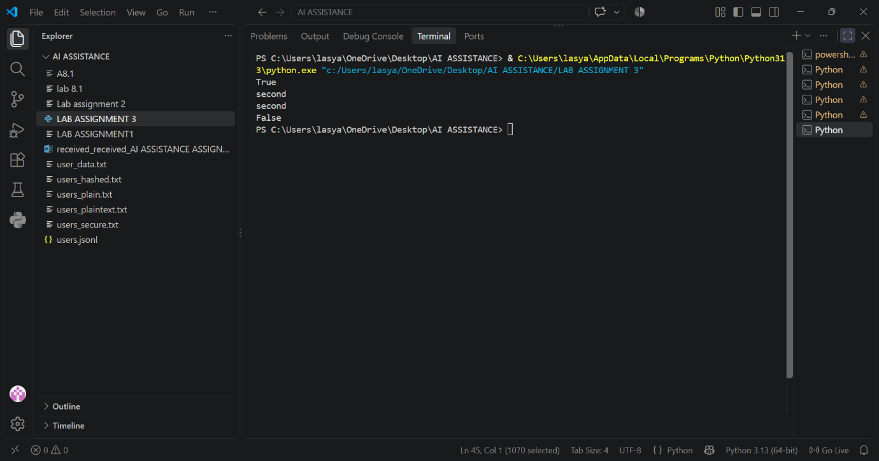
Task Description #2 – Queue Implementation
Task: Use AI to implement a Queue using Python lists.
Sample Input Code:
class Queue:
pass
PROMPT:
**Prompt:**

"Write a Python program to implement a Queue class using a list following the FIFO (First-In, First-Out) principle. Include `__init__()`, `enqueue()`, `dequeue()`, `peek()`, `size()`, and `is_empty()` methods with docstrings. Handle empty-queue cases and demonstrate the queue by adding 10, 20, and 30, then display the queue, front element, removed element, and queue size."
CODE:
class Queue:
"""A FIFO queue implemented using a Python list."""

def __init__(self):
"""Initialize an empty queue."""
self.items = []

def enqueue(self, item):
"""Add an item to the rear of the queue."""
self.items.append(item)

def dequeue(self):
"""Remove and return the front item, or None if the queue is empty."""
if self.is_empty():
return None
return self.items.pop(0)

def peek(self):
"""Return the front item without removing it, or None if the queue is empty."""
if self.is_empty():
return None
return self.items[0]

def size(self):
"""Return the number of items in the queue."""
return len(self.items)

def is_empty(self):
"""Return True if the queue is empty."""
return len(self.items) == 0

queue = Queue()
queue.enqueue(10)
queue.enqueue(20)
queue.enqueue(30)

print("Queue:", queue.items)
print("Front element:", queue.peek())
print("Removed element:", queue.dequeue())
print("Queue size:", queue.size())

OUTPUT:
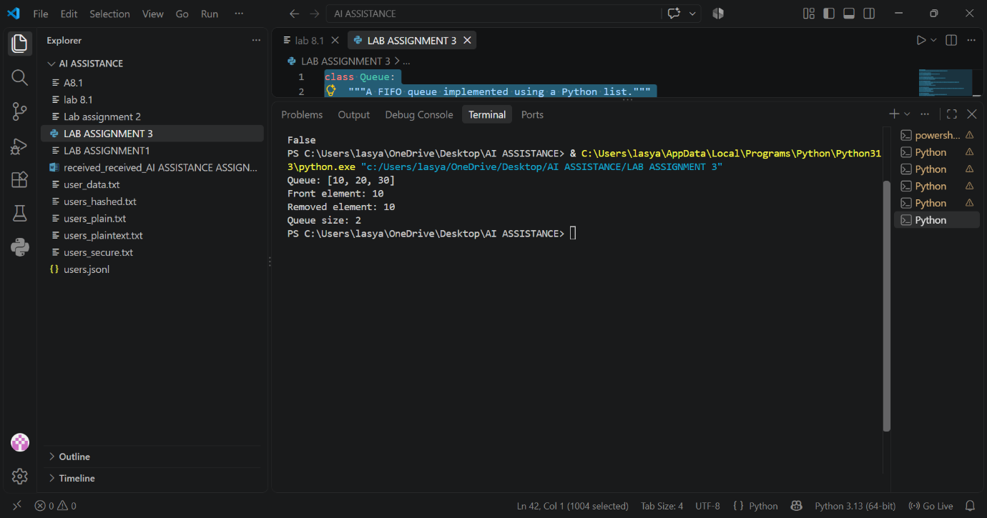
Task Description #3 – Linked List
Task: Use AI to generate a Singly Linked List with insert and display
methods.
Sample Input Code:
class Node:
pass
class LinkedList:
pass
PROMPT:

"Generate a Python program to implement a Singly Linked List using two classes: `Node` and `LinkedList`. The `Node` class should store data and a reference to the next node. The `LinkedList` class should include `insert()` and `display()` methods. Add clear docstrings and comments explaining the code. Include an example that inserts a few elements and displays the linked list."
CODE:
"""Demonstrate a singly linked list in Python."""

class Node:
"""Represent one item in a singly linked list."""

def __init__(self, data):
"""Create a node containing *data* with no successor yet."""
self.data = data
self.next = None

class LinkedList:
"""Manage a sequence of nodes linked in one direction."""

def __init__(self):
"""Create an empty linked list."""
self.head = None

def insert(self, data):
"""Insert *data* at the end of the linked list."""
new_node = Node(data)

if self.head is None:
self.head = new_node
return

# Traverse to the final node and connect the new node to it.
current = self.head
while current.next is not None:
current = current.next
current.next = new_node

def display(self):
"""Print each item in order, separated by arrows."""
elements = []
current = self.head

# Follow each next reference until the end of the list.
while current is not None:
elements.append(str(current.data))
current = current.next

print(" -> ".join(elements) if elements else "Empty list")

if __name__ == "__main__":
# Example usage: insert several values and display the result.
linked_list = LinkedList()
for value in (10, 20, 30, 40):
linked_list.insert(value)

linked_list.display()
OUTPUT:
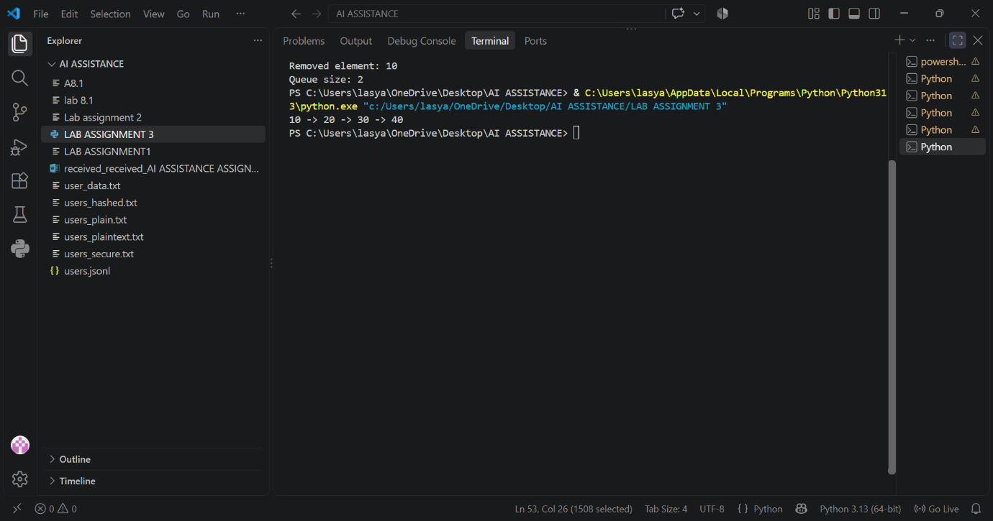
Task Description #4 – Binary Search Tree (BST)
Task: Use AI to create a BST with insert and in-order traversal methods.
Sample Input Code:
class BST:
pass
PROMPT:
**Prompt:**

"Generate a Python program to implement a Binary Search Tree (BST) using a `BST` class. Include a recursive `insert()` method to add elements and a recursive `inorder()` traversal method to display the elements in sorted order. Handle the root node properly and include clear comments/docstrings. Provide a short example demonstrating insertion and in-order traversal."
CODE:
class Node:
"""A node in a binary search tree."""

def __init__(self, value):
self.value = value
self.left = None
self.right = None

class BST:
"""Binary Search Tree with recursive insertion and in-order traversal."""

def __init__(self):
self.root = None

def insert(self, value):
"""Insert value into the tree, handling an empty root properly."""
self.root = self._insert_recursive(self.root, value)

def _insert_recursive(self, node, value):
"""Recursively place value in the appropriate position."""
if node is None:
return Node(value)

if value < node.value:
node.left = self._insert_recursive(node.left, value)
else:
node.right = self._insert_recursive(node.right, value)
return node

def inorder(self):
"""Print tree elements in sorted order using recursion."""
values = []
self._inorder_recursive(self.root, values)
print(*values)

def _inorder_recursive(self, node, values):
"""Recursively visit left subtree, node, then right subtree."""
if node is not None:
self._inorder_recursive(node.left, values)
values.append(node.value)
self._inorder_recursive(node.right, values)

# Example usage
if __name__ == "__main__":
tree = BST()
for number in (50, 30, 70, 20, 40, 60, 80):
tree.insert(number)

print("In-order traversal:")
tree.inorder() # Output: 20 30 40 50 60 70 80

OUTPUT:
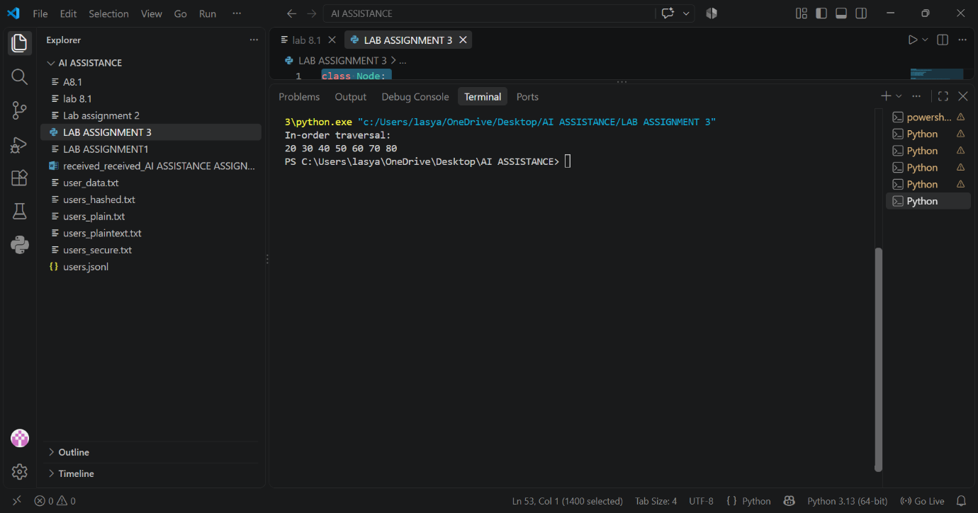
Task Description #5 – Priority Queue
Task: Use AI to implement a priority queue using Python’s heapq
module.
Sample Input Code:
class PriorityQueue:
pass
Expected Output:
• Implementation with enqueue (priority), dequeue (highest priority),
and display methods.
PROMPT:
Implement a Python Priority Queue using `heapq` with `enqueue(priority)`, `dequeue()` for the highest-priority item, and `display()` methods. Use the starter class `PriorityQueue: pass`. Include simple comments, method documentation, and sample input/output.
CODE:
import heapq

class PriorityQueue:
"""A priority queue where the smallest number has highest priority."""

def __init__(self):
"""Create an empty priority queue."""
self._items = []

def enqueue(self, priority):
"""Add a priority value to the queue."""
heapq.heappush(self._items, priority)

def dequeue(self):
"""Remove and return the highest-priority value, or None if empty."""
if not self._items:
return None
return heapq.heappop(self._items)

def display(self):
"""Display the queue in priority order without removing its items."""
print(sorted(self._items))

# Sample input
queue = PriorityQueue()
queue.enqueue(30)
queue.enqueue(10)
queue.enqueue(20)

# Sample output
queue.display() # [10, 20, 30]
print(queue.dequeue()) # 10
print(queue.dequeue()) # 20
queue.display() # [30]

OUTPUT:
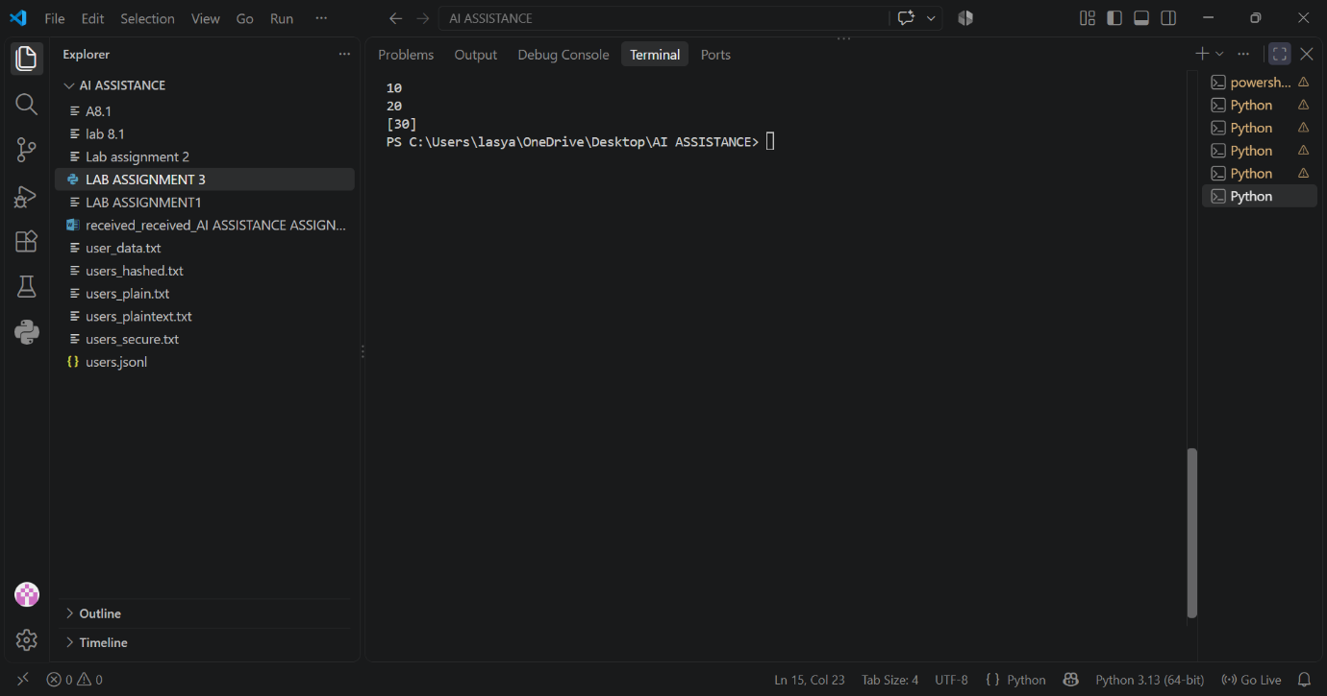
Task Description #6 – Deque
Task: Use AI to implement a double-ended queue using
collections.deque.
Sample Input Code:
class DequeDS:
pass
Expected Output:
• Insert and remove from both ends with docstrings.
PROMPT:
Implement a Python Deque using `collections.deque` with methods to insert and remove elements from both ends. Use the starter class `DequeDS: pass`. Include simple docstrings, comments, and sample input/output.
CODE:
from collections import deque

class DequeDS:
"""A double-ended queue supporting insertion and removal at both ends."""

def __init__(self):
"""Create an empty deque."""
self.items = deque()

def insert_front(self, value):
"""Insert value at the front."""
self.items.appendleft(value)

def insert_rear(self, value):
"""Insert value at the rear."""
self.items.append(value)

def remove_front(self):
"""Remove and return the front value."""
return self.items.popleft()

def remove_rear(self):
"""Remove and return the rear value."""
return self.items.pop()

def display(self):
"""Return the deque elements from front to rear."""
return list(self.items)

# Sample input/output:
# insert_rear(10), insert_front(5), insert_rear(15)
# Output: [5, 10, 15]
if __name__ == "__main__":
deque_ds = DequeDS()
deque_ds.insert_rear(10)
deque_ds.insert_front(5)
deque_ds.insert_rear(15)
print(deque_ds.display()) # [5, 10, 15]
print(deque_ds.remove_front()) # 5
print(deque_ds.remove_rear()) # 15

OUTPUT:
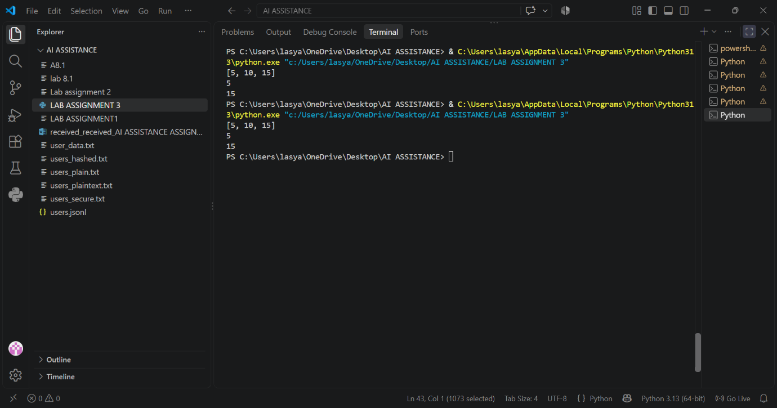
Task Description #7 Real-Time Application Challenge – Choose the
Right Data Structure
Scenario:
Your college wants to develop a Campus Resource Management System
that handles:
1. Student Attendance Tracking – Daily log of students
entering/exiting the campus.
2. Event Registration System – Manage participants in events with
quick search and removal.
3. Library Book Borrowing – Keep track of available books and their
due dates.

4. Bus Scheduling System – Maintain bus routes and stop
connections.
5. Cafeteria Order Queue – Serve students in the order they arrive.
Student Task:
• For each feature, select the most appropriate data structure from
the list below:
o Stack
o Queue
o Priority Queue
o Linked List
o Binary Search Tree (BST)
o Graph
o Hash Table
o Deque
• Justify your choice in 2–3 sentences per feature.
• Implement one selected feature as a working Python program with
AI-assisted code generation.
Expected Output:
• A table mapping feature → chosen data structure → justification.
• A functional Python program implementing the chosen feature
with comments and docstrings.
PROMPT
"Create a complete solution for a Campus Resource Management System. For each of these features—Student Attendance Tracking, Event Registration, Library Book Borrowing, Bus Scheduling, and Cafeteria Order Queue—select the most appropriate data structure from Stack, Queue, Priority Queue, Linked List, BST, Graph, Hash Table, and Deque. Provide a table with the feature, chosen data structure, and a 2–3 sentence justification. Then implement the Cafeteria Order Queue using Python's `collections.deque`, with clear comments, docstrings, and a working example that adds students, serves them in arrival order, and displays the remaining queue."
CODE:
"""Campus Resource Management System

Data-structure choices
----------------------
| Feature | Data structure | Justification |
|----------------------------|----------------|---------------|
| Student Attendance Tracking| Hash Table | A student ID can be mapped directly to attendance records for fast updates and lookups. This also makes it easy to check whether a particular student has been marked present. |
| Event Registration | Queue | A queue processes registrations in first-in, first-out order. It provides fair handling when an event has limited capacity. |
| Library Book Borrowing | BST | A binary search tree can organize books by ID or title and support efficient searching, insertion, and removal. It is useful for locating a book before recording a loan. |
| Bus Scheduling | Graph | A graph represents stops as vertices and routes as edges. It can model connections and help determine paths between campus locations. |
| Cafeteria Order Queue | Deque | A deque supports efficient insertion and removal at either end. The cafeteria uses it as a FIFO queue so students are served in arrival order. |

The executable example below implements the cafeteria order queue with
``collections.deque``.
"""

from collections import deque

class CafeteriaOrderQueue:
"""Manage cafeteria orders in first-in, first-out order."""

def __init__(self):
"""Create an empty queue of student orders."""
self._orders = deque()

def add_student(self, student_name, order):
"""Add a student's order to the back of the queue."""
self._orders.append((student_name, order))

def serve_student(self):
"""Serve and return the oldest order, or ``None`` if empty."""
if not self._orders:
return None
return self._orders.popleft()

def display_remaining(self):
"""Return a list of orders still waiting to be served."""
return list(self._orders)

def __len__(self):
"""Return the number of orders waiting."""
return len(self._orders)

def main():
"""Demonstrate adding, serving, and displaying cafeteria orders."""
cafeteria = CafeteriaOrderQueue()

cafeteria.add_student("Aarav", "Vegetable sandwich")
cafeteria.add_student("Lasya", "Pasta")
cafeteria.add_student("Maya", "Fruit bowl")

print("Served:", cafeteria.serve_student())
print("Served:", cafeteria.serve_student())
print("Remaining queue:", cafeteria.display_remaining())

if __name__ == "__main__":
main()

OUTPUT:
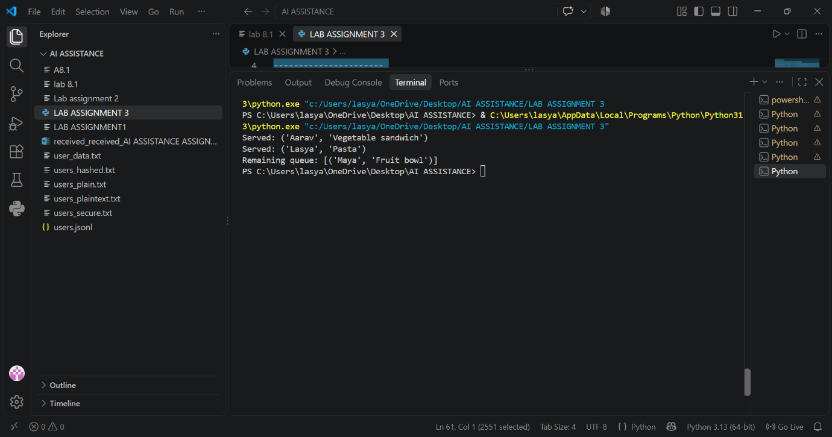
Task Description #8: Smart E-Commerce Platform – Data Structure
Challenge
An e-commerce company wants to build a Smart Online Shopping System
with:
1. Shopping Cart Management – Add and remove products
dynamically.
2. Order Processing System – Orders processed in the order they are
placed.
3. Top-Selling Products Tracker – Products ranked by sales count.

4. Product Search Engine – Fast lookup of products using product ID.
5. Delivery Route Planning – Connect warehouses and delivery
locations.
Student Task:
• For each feature, select the most appropriate data structure from
the list below:
o Stack
o Queue
o Priority Queue
o Linked List
o Binary Search Tree (BST)
o Deque
• Justify your choice in 2–3 sentences per feature.
• Implement one selected feature as a working Python program with
AI-assisted code generation.
Expected Output:
• A table mapping feature → chosen data structure → justification.
• A functional Python program implementing the chosen feature
with comments and docstrings.
PROMPT:
Use AI to select the most appropriate data structure for each e-commerce feature: Shopping Cart, Order Processing, Top-Selling Products, Product Search, and Delivery Route Planning. Use only Stack, Queue, Priority Queue, Linked List, BST, and Deque. Create a table with a 2–3 sentence justification for each choice, then implement one selected feature in Python with comments, docstrings, and working code.
CODE:
"""E-commerce data-structure selection and a working order-processing example.

Data-structure selection
------------------------

| Feature | Selected structure | Justification |
|---|---|---|
| Shopping Cart | Deque | A deque supports adding and removing items efficiently at either end, which is useful when customers add products normally or remove the most recently added item. It also supports iteration when the cart contents must be displayed. |
| Order Processing | Queue | Orders should normally be handled in first-in, first-out order so that earlier purchases are fulfilled first. Enqueueing new orders and dequeuing the next order are both efficient operations. |
| Top-Selling Products | Priority Queue | A priority queue keeps the product with the highest sales count readily available. Updating priorities and repeatedly retrieving the current top seller is more appropriate than scanning every product each time. |
| Product Search | BST | A binary search tree organizes products by a comparable key such as product name or ID. Its ordered structure supports searching, insertion, and sorted traversal without requiring a full list scan. |
| Delivery Route Planning | Linked List | A linked list represents an ordered sequence of delivery stops and allows stops to be inserted or removed without shifting all later elements. This is useful when a route changes while planning deliveries. |

The implementation below demonstrates the Order Processing choice using a queue.
"""

from collections import deque
from dataclasses import dataclass

@dataclass
class Order:
"""Represent a customer order waiting to be processed."""

order_id: int
customer: str
total: float

class OrderQueue:
"""Process orders in first-in, first-out order using a queue."""

def __init__(self):
"""Create an empty order queue."""
self._orders = deque()

def add_order(self, order: Order) -> None:
"""Place a new order at the end of the processing queue."""
self._orders.append(order)

def process_next(self) -> Order | None:
"""Process and return the oldest order, or None if the queue is empty."""
if not self._orders:
return None
return self._orders.popleft()

def __len__(self) -> int:
"""Return the number of orders waiting to be processed."""
return len(self._orders)

def main() -> None:
"""Demonstrate adding and processing orders in FIFO order."""
order_queue = OrderQueue()
order_queue.add_order(Order(1001, "Asha", 49.99))
order_queue.add_order(Order(1002, "Ben", 24.50))

while len(order_queue) > 0:
order = order_queue.process_next()
print(f"Processed order #{order.order_id} for {order.customer}: ${order.total:.2f}")

if __name__ == "__main__":
main()

OUTPUT:
