Ahmednagar Jilha Maratha Vidya Prasarak Samaj's
New Arts, Commerce and Science
College, Ahmednagar (Autonomous)
(Affiliated to Savitribai Phule Pune University, Pune)
Department of Computer Science
OJT / INTERNSHIP REPORT
Project Title:
"Toilet Seva — Public Sanitation Locator & Complaint System
for Ahilyanagar Municipal Corporation"
Student Name | Navnath Babasaheb Jangale
Roll Number | 29
Program / Degree | M.Sc. Computer Science – I
Semester | Semester II
Academic Year | 2025-26
Internship Type | In-house Web Application Development Project
Duration | 120 Hours
Guide / Mentor | Prof. ____________________
Organization | New Arts, Commerce & Science College, Ahmednagar
Live Application | https://toilet-seva.netlify.app

INDEX
Sr. No. | Title / Description | Page No.
1 | Cover Page | 1
2 | Index / Table of Contents | 2
3 | Annexure I – OJT/Internship Undertaking | 3
4 | Annexure II – Personal Information of the Student | 4
5 | Acknowledgement | 5
6 | Introduction | 6
7 | Title / Problem Statement / Objectives | 6
8 | Motivation / Scope and Rationale of Study | 7
9 | Organization / Internship Place Details | 7
10 | Methodological Details | 8-9
11 | Results / Analysis / Inferences and Conclusion | 10-13
12 | Suggestions / Recommendations | 14
13 | Annexure III – Daily Record (Week-wise Work Log) | 15
14 | Annexure IV – Supervisor Evaluation Report | 16
15 | Attendance Sheet | 17
16 | List of References | 18

Annexure I
On-Job Training / Internship Undertaking
Name of the Student | Navnath Babasaheb Jangale
Current Address | New Arts, Commerce and Science College, Ahmednagar, Balikaashram Road.
Permanent Address | At. Post. Maka, Tal. Nevasa, Dist. Ahilyanagar
Email ID | jangalenavnath333@gmail.com
Mobile Number | 9730011724
Aadhar Number | 247554879628
Total GPA | 8.55
Internship Type | In-house Web Application / Software Project
Preference 1 | Department of Computer Science, New Arts College
Preference 2 | Ahilyanagar Municipal Corporation – Sanitation Department
Preference 3 | Institutional Innovation Council (IIC)

Signature of Student: Signature of Coordinator:
Date:

Annexure II
Personal Information of the Student
Name | Navnath Babasaheb Jangale
Contact Number | 9730011724
Email ID | jangalenavnath333@gmail.com
Name of the College | New Arts, Commerce & Science College, Ahmednagar
Year | I Year (M.Sc. CS – Sem II)
Degree | Master of Science (M.Sc. CS)
Total CGPA | 8.55
Internship / Work Experience
Institute / Organization | Department of Computer Science, New Arts, Commerce and Science College, Ahmednagar
Project | Toilet Seva — Public Sanitation Locator & Complaint System
Brief Information | Developed a bilingual Progressive Web Application that maps all 26 public and community toilets of Ahilyanagar Municipal Corporation. Implemented live GPS-based nearest-first listing, interactive mapping with Leaflet.js and OpenStreetMap, a citizen rating system, a photographic complaint module, and a secure administrator dashboard backed by Cloud Firestore.
Educational Experience
Semester / Year | M.Sc. CS – I, Sem II (2025-26)
Project | Toilet Seva — Municipal Sanitation Web Application
Brief Information | Designed the user interface and experience, implemented the Haversine distance engine, browser Geolocation tracking, a bilingual Marathi–English interface system, Firebase Authentication for administrators, Firestore security rules, and deployed the application on Netlify with automatic builds from GitHub.

1. Acknowledgement
I extend my heartfelt gratitude to the Head of the Department of Computer Science, Prof. Arun D. Gangarde, for providing me with the opportunity to undertake this OJT / Internship project within the college premises.
I am deeply thankful to my mentor and guide, Prof. ____________________ (Assistant Professor, Department of Computer Science), for continuous guidance, encouragement and technical support throughout the duration of this internship. The expertise and patient guidance received were invaluable in shaping the development of the Toilet Seva project.
I would also like to thank the officers of the Ahilyanagar Municipal Corporation for making the official list of public and community toilets available, which formed the factual foundation of this application.
Finally, I thank all the faculty members of the Department of Computer Science for their cooperation, feedback and suggestions during the testing of the application.

2. Introduction
The project involved the design and development of a fully functional, responsive Progressive Web Application titled "Toilet Seva" for the citizens of Ahilyanagar and the Ahilyanagar Municipal Corporation.
Public sanitation is a basic civic service, yet in most Indian cities the location and condition of public toilets remain largely invisible to the people who need them. A citizen in an unfamiliar part of the city has no reliable way of knowing where the nearest public toilet is, whether it is open, or whether it is usable. Equally, the municipal administration has no consolidated record of which facilities are failing and how often.
Toilet Seva addresses both sides of this gap. It shows citizens the nearest facility on a live map sorted by walking distance, allows them to rate cleanliness and lodge a complaint with photographs, and gives the Municipal Corporation a secure dashboard through which every complaint can be seen, tracked and resolved.
The application is bilingual throughout, presenting English and Marathi together on every screen, and is installable on a mobile phone without requiring an app store.

3. Title / Problem Statement / Objectives
Project Title
Toilet Seva — Public Sanitation Locator and Complaint System for Ahilyanagar Municipal Corporation
Problem Statement
The Ahilyanagar Municipal Corporation maintains 26 public and community toilets across the city, but this information exists only as a printed list. Citizens have no digital means of locating these facilities, no way of knowing their condition in advance, and no formal channel through which to report a problem. Consequently, well-maintained facilities remain underused while neglected ones remain unreported. The project aimed to develop a public-facing digital platform that makes these facilities discoverable and their upkeep accountable.
Objectives
- To design and develop a responsive, installable Progressive Web Application accessible on mobile phones and computers alike.
- To map all 26 public and community toilets of the Municipal Corporation with accurate geographic coordinates.
- To implement live GPS tracking that sorts facilities by actual walking distance and updates as the citizen moves.
- To display the timing, facilities, accessibility provision and citizen rating of every facility before the user travels there.
- To provide one-tap walking directions to any selected facility.
- To implement a complaint module allowing a citizen to report a problem with up to three photographs in under a minute.
- To build a secure administrator dashboard enabling Corporation officers to view, track and resolve complaints.
- To present the entire interface bilingually in English and Marathi so that no citizen is excluded by language.
- To secure the application through server-enforced database rules and restricted API access.

4. Motivation / Scope and Rationale of Study
Motivation
The Swachh Bharat Mission has substantially increased the number of public sanitation facilities constructed across Indian cities, but construction alone does not guarantee use. A facility that citizens cannot find, or cannot trust to be clean, delivers little public value. The motivation behind this project was to make an existing public investment visible and accountable using technology that costs the municipality nothing to run.
A second motivation was inclusion. Women, elderly citizens, differently-abled persons and travellers are disproportionately affected by the absence of reliable sanitation information. An application that marks accessible facilities, sanitary provision and opening hours directly addresses their needs.
Scope
The scope of the project covers the complete front-end and back-end implementation of a public sanitation portal, including the geographic mapping of facilities, live location services, a citizen rating system, a photographic complaint workflow, an administrative dashboard, and bilingual presentation. The application is designed to be scalable to other municipal corporations with only a change of the underlying facility data.
Rationale
A Progressive Web Application was chosen over a native mobile application deliberately. It requires no app-store approval, no download, and works on any phone with a browser — an important consideration for a public service intended to reach every citizen, including those with low-end devices or limited storage. The same code serves the citizen interface and the administrative dashboard, reducing maintenance burden on the municipality.

5. Organization / Internship Place Details
Organization | New Arts, Commerce & Science College, Ahmednagar
Department | Department of Computer Science
Established | 1986
Affiliation | Savitribai Phule Pune University, Pune
NAAC Grade | A++ (CGPA 3.79 – Highest in Maharashtra, 4th in India)
Supervisor | Prof. Dr. A. A. Takate Sir
Contact | 9404276376
Internship Type | In-house / Institutional Project
Duration | 120 Hours
Location | Ahilyanagar, Maharashtra
Beneficiary Body | Ahilyanagar Municipal Corporation
The Department of Computer Science is recognised for its excellence in academics and research. The internship was conducted under the direct supervision of the Head of Department, providing a structured and supervised learning environment. The project was undertaken in the public interest, with the official toilet list of the Ahilyanagar Municipal Corporation for the year 2026 serving as the primary data source.

6. Methodological Details
6.1 Technology Stack
Category | Technology / Tool | Purpose
Frontend | HTML5, CSS3, JavaScript (ES5/ES6) | Single-page responsive interface
Application Type | Progressive Web App (PWA) | Installable, works offline
Mapping Library | Leaflet.js 1.9.4 | Interactive map rendering
Map Data | OpenStreetMap | Free map tiles, no licensing cost
Location Services | Browser Geolocation API | Live GPS position and accuracy
Database | Google Cloud Firestore | Real-time storage of facilities and complaints
Authentication | Firebase Authentication | Secure administrator login
File Storage | Firebase Storage | Complaint photographs
Hosting | Netlify | HTTPS hosting with automatic deployment
Version Control | Git / GitHub | Source code management
Offline Support | Service Worker + Cache API | Application works without internet
Geocoding | Nominatim (OpenStreetMap) | Converting addresses to coordinates
6.2 Project Structure
The application is deliberately built as a single self-contained file to eliminate build tooling and simplify deployment and maintenance by the municipality:
- index.html — the complete application: interface, styles, and logic
- manifest.json — application name, icons and colours required for installation
- service-worker.js — offline caching strategy
- icon.svg — application icon used on the home screen
- SEED_TOILETS — the 26 official facilities with coordinates, timings and amenities
- I18N — the bilingual translation dictionary driving every label on screen
6.3 Development Methodology
The project followed an iterative, Agile-like development approach across six phases:
- Phase 1 — Requirement Analysis: Studied the official Municipal Corporation toilet list; identified the information a citizen needs before travelling to a facility.
- Phase 2 — Data Preparation: Converted the printed list of 26 facilities into structured data and determined geographic coordinates for each.
- Phase 3 — Citizen Interface: Implemented the facility list, filters, live GPS distance calculation and interactive map.
- Phase 4 — Complaint and Rating System: Built the photographic complaint workflow and the transaction-safe rating mechanism.
- Phase 5 — Administrative Dashboard: Developed the officer login, complaint queue, facility management and location-correction tools.
- Phase 6 — Security, Testing and Deployment: Applied Firestore security rules, restricted the API key, tested across devices, and deployed to Netlify.
6.4 Distance Calculation
Distance between the citizen and each facility is computed using the Haversine formula, which measures the shortest distance between two points over the curved surface of the earth. This is more accurate for geographic coordinates than a simple straight-line calculation. The list re-sorts itself continuously as the citizen walks, and distances are colour-coded — green below 500 metres, amber below 2 kilometres.

7. Results / Analysis / Inferences and Conclusion
7.1 Modules Developed
Sr. | Module | Description
1 | Facility Listing | All 26 toilets sorted by live walking distance, with timing, amenities and rating
2 | Live Location | Browser GPS with accuracy indicator; list reorders as the citizen moves
3 | Interactive Map | Leaflet map with markers, clustering on zoom-out, and detail popups
4 | Search and Filters | Search by name or area; filters for women, accessible, open now and top rated
5 | Directions | One-tap walking route opened in the device map application
6 | Rating System | Star rating per facility, one vote per device, transaction-safe averaging
7 | Complaint Module | Ten complaint categories, multiple selection, description, waiting time
8 | Photo Capture | Direct camera capture and gallery selection, up to three compressed images
9 | Bilingual Interface | English and Marathi shown together on every label, button and message
10 | Admin Login | Firebase-authenticated access restricted to Corporation officers
11 | Complaint Queue | Officer view of every complaint with photographs and resolution tracking
12 | Facility Management | Open or close a facility, edit details, add a new facility
13 | Location Editor | Correct a facility position by dragging its pin on the map
14 | QR Code Generation | Printable QR code per facility for on-the-spot complaint filing
15 | Analytics | Chart of the most frequent complaint categories
16 | Offline Support | Service worker caching so the application opens without internet
17 | Installation | Add-to-home-screen support on Android and iOS

7.2 Application Screenshots
Figure 1 — Citizen Facility Listing
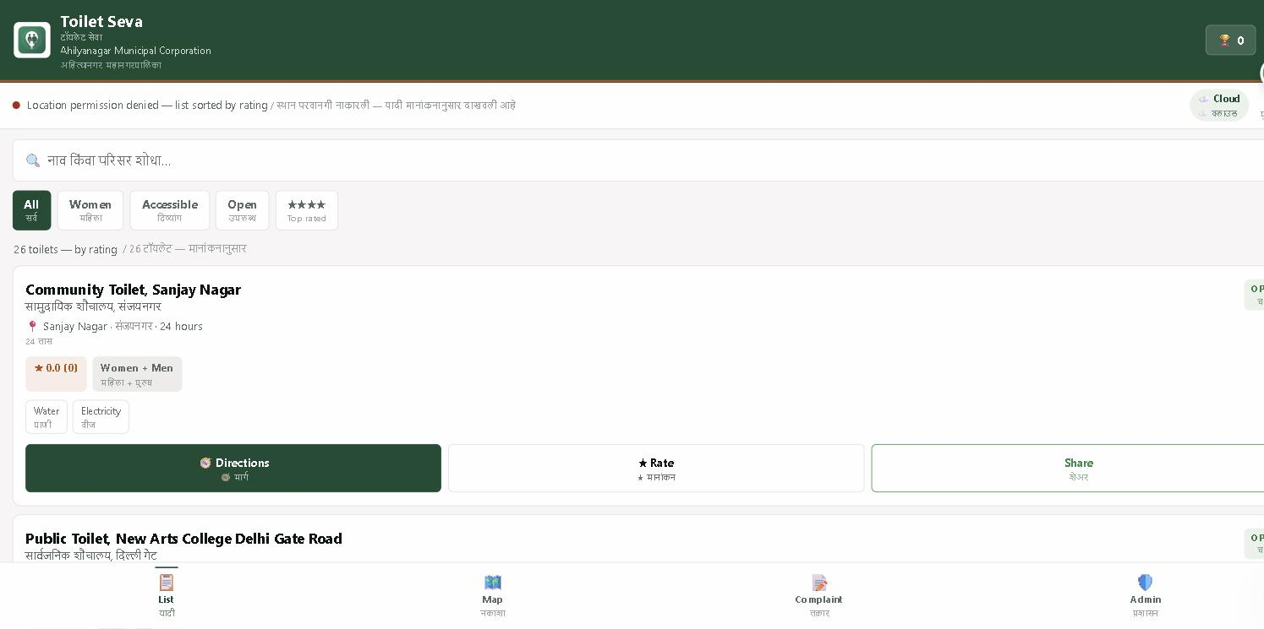
The facility list showing all 26 toilets, bilingual headings, filter chips, ratings, amenities and action buttons.
Figure 2 — Interactive Map
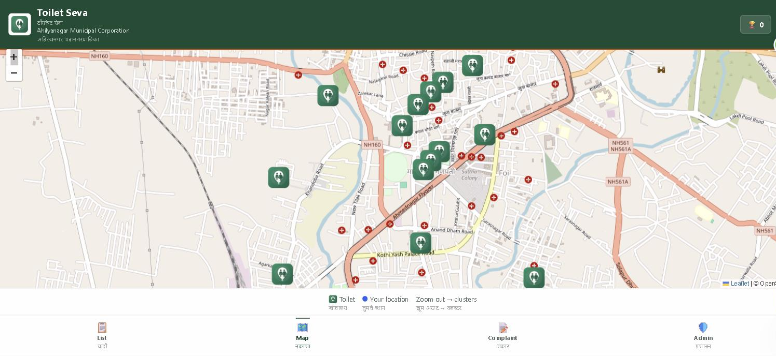
All 26 facilities plotted on the live OpenStreetMap view of Ahilyanagar with the map legend below.

Figure 3 — Complaint Registration Form
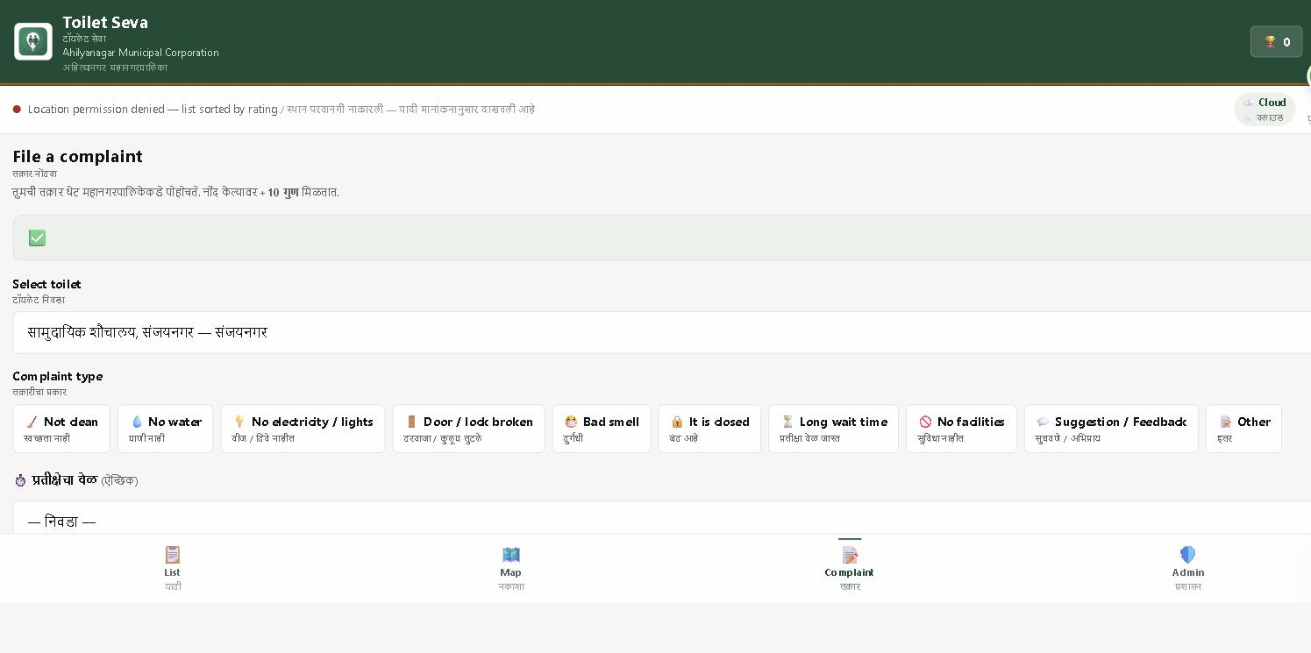
The complaint form showing facility selection and all ten complaint categories in both languages.
Figure 4 — Administrator Dashboard
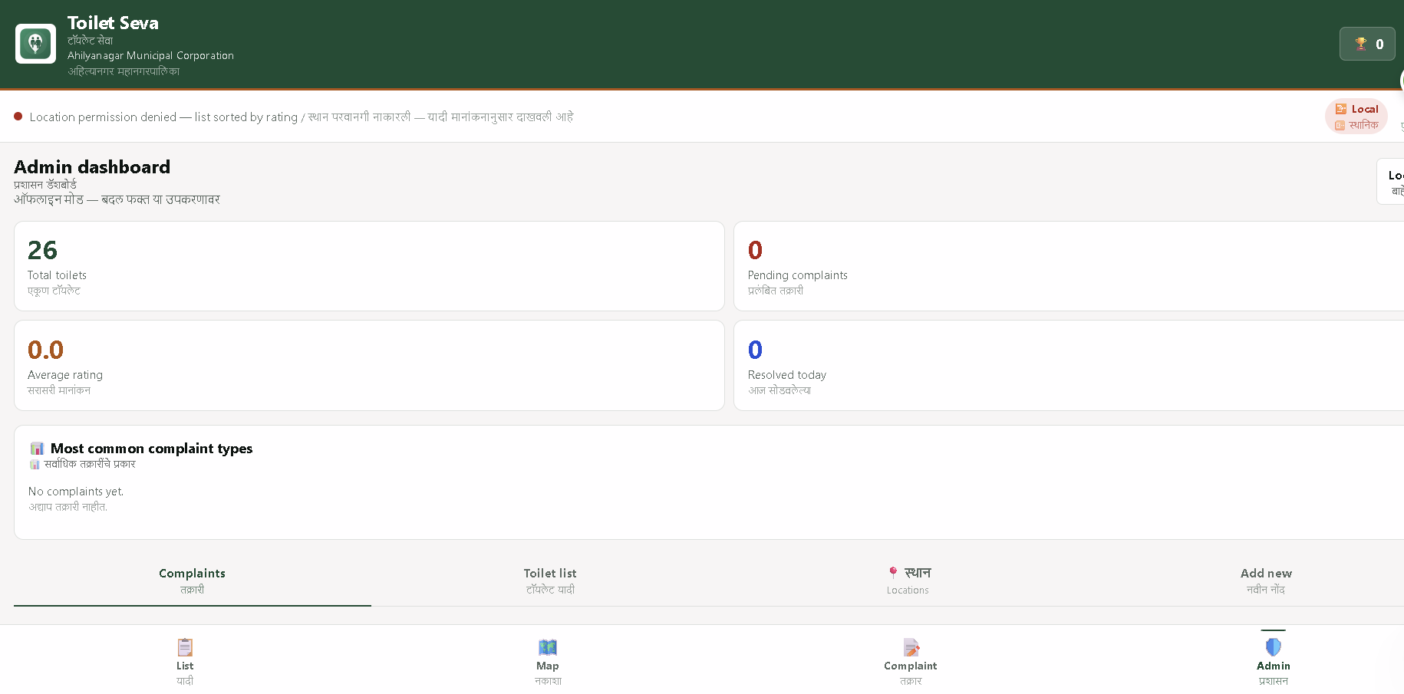
The officer dashboard showing live statistics, the complaint analysis chart and the four management tabs.

7.3 Key Technical Achievements
- Implemented the Haversine formula for accurate geographic distance, with continuous re-sorting as the user walks.
- Built an in-place DOM update mechanism so that distance values refresh without redrawing the list, eliminating visible flicker on every GPS reading.
- Solved an Android Chrome limitation where the capture and multiple attributes conflict, by separating camera and gallery into two distinct file inputs.
- Implemented client-side image compression using the Canvas API, reducing each photograph to approximately 400 KB so that complaints succeed on slow connections.
- Designed a single bilingual translation system driving every label, making the addition of a third language straightforward.
- Applied server-enforced Firestore security rules that cannot be bypassed from the browser, and restricted the Firebase API key to the official domain.
- Implemented transaction-based rating updates so that simultaneous votes are never miscounted.
- Built a location-correction tool allowing officers to fix a facility position by dragging its pin, with the change saved to the cloud instantly.
- Achieved offline capability through a service worker, so the facility list remains available without internet.
- Deployed with automatic builds from GitHub, so a code change reaches the public site within two minutes.
7.4 Analysis and Inferences
The project successfully demonstrated the practical application of modern web technologies to a civic problem. The most instructive part of the work was not the coding but the data: converting a printed municipal list into accurate geographic coordinates proved considerably harder than expected, because many local landmarks are simply not recorded in open mapping databases. This led to the design of the location-correction tool, which lets officers who know the city fix positions directly rather than relying on automated geocoding.
A second important inference concerns performance perception. The application initially redrew the entire facility list on every GPS reading, which was functionally correct but produced visible flicker roughly every second. Replacing this with targeted in-place updates made the application feel substantially faster without any change in the underlying computation — a useful reminder that perceived performance and actual performance are different problems.
The bilingual requirement also shaped the architecture. Rather than treating translation as an afterthought, every user-visible string was routed through a single dictionary from the outset, which made the later reversal of language priority — English first, Marathi below — a change of one function rather than a rewrite.
7.5 Conclusion
The OJT / Internship project titled "Toilet Seva — Public Sanitation Locator and Complaint System" was successfully completed within the stipulated 120 hours. All 26 public and community toilets of the Ahilyanagar Municipal Corporation have been mapped, the application is live on the internet at https://toilet-seva.netlify.app, and it runs entirely within the free tiers of the services used, imposing no recurring cost on the municipality.
The project provided practical experience in front-end development, geographic computation, cloud database design, authentication, security rule configuration, progressive web application architecture and deployment automation. Beyond the technical learning, it demonstrated how a modest software effort can make an existing public investment visible and accountable to the citizens it was built for.

8. Suggestions / Recommendations
- Publish the application on the Google Play Store using PWABuilder, so that citizens can discover it through the store as well as the web.
- Implement push notifications through Firebase Cloud Messaging so that sanitation officers are alerted the moment a complaint is filed.
- Introduce complaint routing, assigning each complaint automatically to the sanitation worker responsible for that ward.
- Add a citizen-side status view so that a person who files a complaint can see when it has been resolved.
- Print and affix the generated QR codes at each facility, enabling on-the-spot complaint filing without searching for the facility in the list.
- Extend the interface to Hindi in addition to Marathi and English, to serve migrant workers and visitors.
- Integrate a monthly analytics report for the Corporation showing complaint trends by facility and by category.
- Add photographic verification of resolution, requiring the officer to upload an "after" photograph when closing a complaint.
- Acquire a custom domain such as toiletseva.in for official municipal use.
- Extend the system to other municipal corporations in Maharashtra by replacing only the facility dataset.

Annexure III – Daily Record
Week | Work Assigned | Work Done | Learning Outcome | Comments
1 | Requirement analysis and data study | Studied the official Municipal Corporation toilet list of 2026; identified the information a citizen needs before travelling; finalised feature scope | Requirement gathering, civic problem analysis, project scoping | Good
2 | Data preparation and geocoding | Converted the printed list of 26 facilities into structured data; determined latitude and longitude for each location | Geographic data handling, coordinate systems, geocoding services | Good
3 | Interface design and layout | Designed the citizen interface, colour scheme and navigation; built the responsive card layout for the facility list | Responsive design, CSS custom properties, mobile-first layout | Excellent
4 | Live GPS and distance engine | Implemented browser Geolocation; wrote the Haversine distance function; built nearest-first sorting with accuracy display | Geolocation API, spherical distance mathematics, live data handling | Excellent
5 | Interactive map integration | Integrated Leaflet.js with OpenStreetMap tiles; added facility markers, clustering on zoom-out and detail popups | Mapping libraries, tile services, marker clustering logic | Excellent
6 | Search, filters and directions | Built search by name and area; added filters for women, accessible, open and top rated; implemented one-tap walking directions | Array filtering, state management, external application linking | Good
7 | Rating system | Implemented star ratings with one vote per device; used database transactions to keep averages correct under concurrent voting | Database transactions, concurrency, duplicate prevention | Excellent
8 | Complaint module | Built the complaint form with ten categories and multiple selection; added description and waiting-time fields | Form design, multi-select handling, validation | Good
9 | Photograph capture and compression | Implemented direct camera capture and gallery selection; added Canvas-based compression to approximately 400 KB per image | Media capture, Canvas API, image compression, browser quirks | Excellent
10 | Bilingual interface system | Built the translation dictionary and rendering system presenting English and Marathi together on every label and message | Internationalisation architecture, dynamic text rendering | Excellent
11 | Administrator dashboard | Developed officer login with Firebase Authentication; built the complaint queue, facility management, location editor and QR generation | Authentication flows, protected routes, CRUD operations | Excellent
12 | Security, testing and deployment | Applied Firestore security rules; restricted the API key to the official domain; tested across devices; deployed to Netlify with automatic builds | Security rules, API restriction, cross-device testing, CI deployment | Excellent

Internship Supervisor:
Date:

Annexure IV – OJT/Internship Supervisor
Evaluation Report
Name of the Student | Navnath Babasaheb Jangale
Name of the Work Supervisor | Dr. A. A. Takate
Institute / Organization | Dept. of Computer Science, New Arts, Commerce and Science College, Ahmednagar
Duration of OJT | 01 March 2026 to 31 March 2026
Project | Toilet Seva — Public Sanitation Locator & Complaint System

Criteria | Needs Improvement | Satisfactory | Good | Excellent
Behaviour
Reliability
Interpersonal Relations
Interest in Work
Training Speed
Entrepreneurship
Quality of Work
Sense of Responsibility
Ability to Accept Criticism
Teamwork
Use of Technological Skills
Judgement
Creativity
Analytical Skills
Work Independently
Oral Communication
Written Skills
Professional Attitude
Professional Behaviour
Punctuality
Time Management

Attendance Sheet
(Letterhead of the Department of Computer Science)
Name of the Organization | Dept. of Computer Science, New Arts, Commerce and Science College, Ahmednagar
Name of the Student | Navnath Babasaheb Jangale
Roll Number | 29
Course | M.Sc. Computer Science – I
Start Date of Internship | 01/03/2026
End Date of Internship | 31/03/2026
Total Hours | 120 Hours

Signature of OJT Supervisor:
Stamp of Organization:

9. List of References
- Leaflet.js Documentation – https://leafletjs.com/reference.html
- OpenStreetMap – https://www.openstreetmap.org
- Nominatim Geocoding Service – https://nominatim.org
- Firebase Documentation – https://firebase.google.com/docs
- Cloud Firestore Security Rules – https://firebase.google.com/docs/firestore/security/get-started
- MDN Geolocation API – https://developer.mozilla.org/en-US/docs/Web/API/Geolocation_API
- MDN Progressive Web Apps – https://developer.mozilla.org/en-US/docs/Web/Progressive_web_apps
- MDN Canvas API – https://developer.mozilla.org/en-US/docs/Web/API/Canvas_API
- Netlify Documentation – https://docs.netlify.com
- Haversine Formula – R. W. Sinnott, "Virtues of the Haversine", Sky and Telescope, 1984
- Swachh Bharat Mission (Urban) – https://swachhbharaturban.gov.in
- Ahilyanagar Municipal Corporation — Official List of Public and Community Toilets, 2026
- New Arts, Commerce & Science College, Ahmednagar – https://newartscollege.ac.in
- OJT / Internship Guidelines – New Arts College, Ahmednagar (2023-24)
- NEP-CBCS Guidelines for M.Sc. Students, Savitribai Phule Pune University
- Live Application – https://toilet-seva.netlify.app

