**Instruction**

Complete all questions in **1 hour.**

1. What is flip flop? Describe the working mechanism RS flip flop.

1. Construct the timing diagram for half adder and half subtractor, full adder.
2. Describe the working mechanism of 4-bit register by constructing the circuit using D flip flop.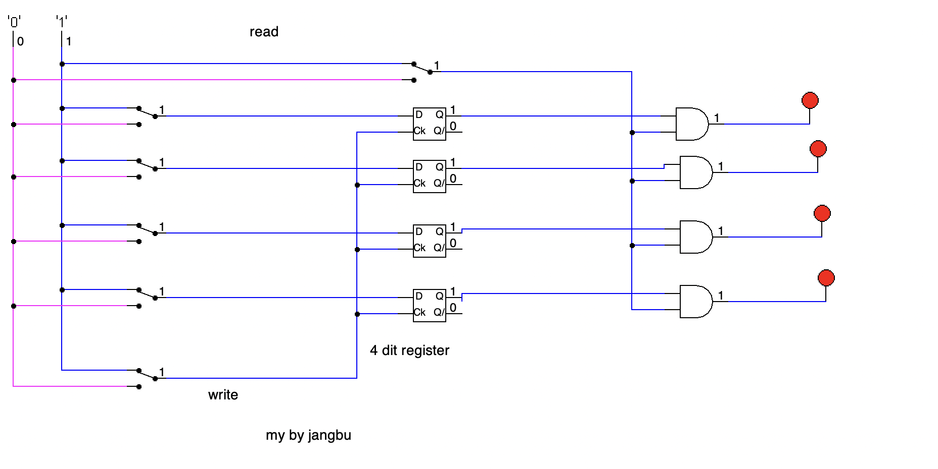
3. Differentiate between:
4. Flip flop and Latch
5. Combinational circuit and Sequential circuit
6. SIPO and PISO shift register