Heart Disease Risk Prediction: End-to-End MLOps Pipeline
  - MLOps (AIMLCZG523), Assignment 01
()
October 2026
Table of Contents

Code repository: https://github.com/jangde-aboli/MLOPs_assignment_HeartML
Demo video:

1. Overview
The goal is a classifier that predicts whether a patient has heart disease from 13 routine clinical measurements, delivered as a production-style service rather than a notebook. The pipeline covers:
- Data: a scripted download from the UCI repository, then cleaning and EDA.
- Modelling: three model families compared with tuned hyperparameters, all inside one scikit-learn Pipeline that also does the preprocessing.
- Tracking: every run is logged to MLflow (parameters, metrics, plots, tuning tables, model), and the final model is registered.
- CI/CD: GitHub Actions runs lint → tests → training with a quality gate → Docker build and smoke test.
- Serving: a FastAPI service in Docker, deployed to Kubernetes behind a LoadBalancer Service and an Ingress.
- Monitoring: structured JSON request logs plus Prometheus metrics, shown on a provisioned Grafana dashboard.
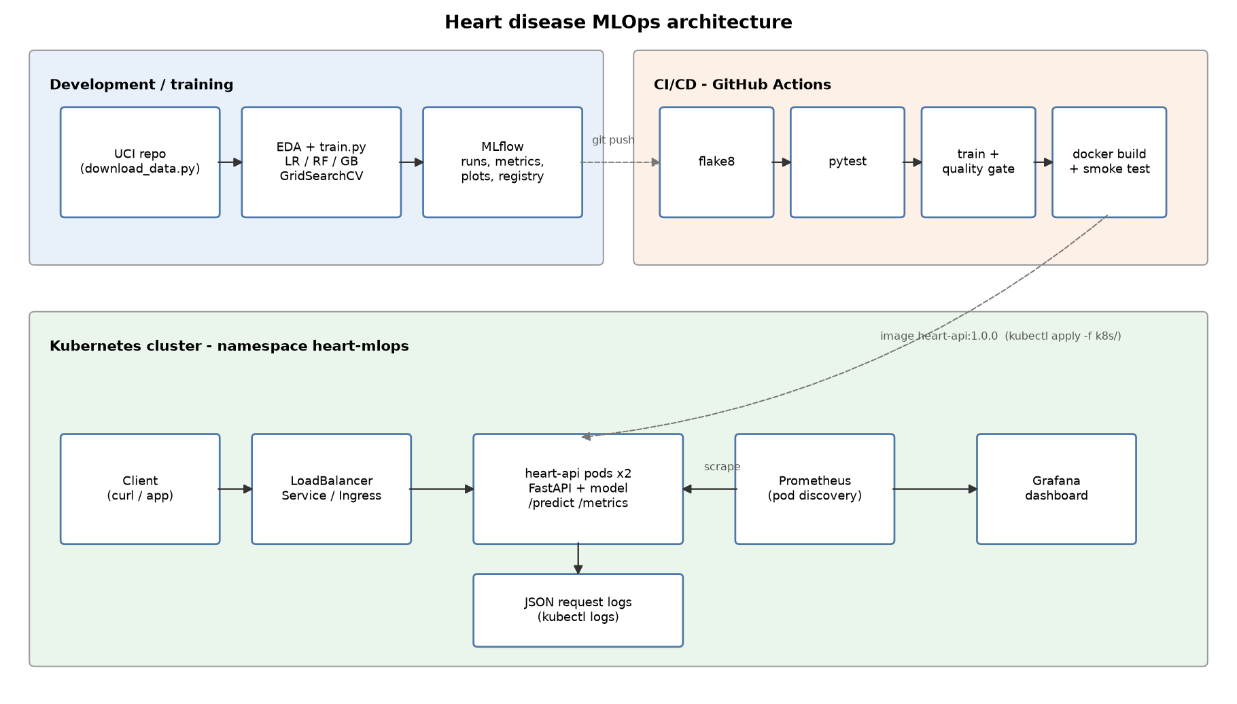
Architecture
Figure 1: System architecture.

2. Setup and installation
git clone https://github.com/jangde-aboli/MLOPs_assignment_HeartML.git && cd MLOPs_assignment_HeartML
python -m venv .venv && source .venv/bin/activate # Windows: .venv\Scripts\activate
pip install -r requirements.txt
python scripts/download_data.py # raw + cleaned CSV
python -m heartml.eda # figures -> reports/figures
python -m heartml.train # MLflow runs + models/heart_model.joblib
pytest -v # 25 unit tests
uvicorn api.main:app --port 8000 # http://localhost:8000/docs
Every dependency is pinned in requirements.txt. The Docker image installs only the smaller requirements-serve.txt, which leaves out MLflow, plotting and the test tools.
Folder | Contents
heartml/ | Reusable package: config, data, features, train, predict, eda
api/ | FastAPI app and Pydantic schemas
tests/ | Pytest unit tests (data, model, API)
notebooks/ | 01 EDA, 02 training, 03 inference (they call the package)
scripts/ | Data download, smoke/load test, K8s deploy, diagram/dashboard builders
k8s/ | Deployment, Service, Ingress, Prometheus + Grafana manifests
monitoring/ | Prometheus config, Grafana provisioning and dashboard JSON
.github/workflows/ | CI/CD pipeline
screenshots/ | Evidence used in this report

3. Data acquisition and EDA

3.1 Acquisition
scripts/download_data.py downloads processed.cleveland.data from the UCI archive and falls back to the UCI static CSV if that fails. The raw file has no header and uses ? for missing values. The cleaned output is data/processed/heart_clean.csv, with 303 rows, 13 features and the target.

3.2 Cleaning decisions
Issue | Treatment | Reason
? tokens (4 in ca, 2 in thal) | Parsed as NaN; imputed inside the pipeline (most frequent value) | The API applies exactly the same imputation, so a request may leave ca/thal out
Target num takes values 0-4 | target = num > 0 | The task is presence vs. absence; levels 1-4 are rare and noisy on their own
Zero blood pressure / cholesterol | Set to NaN, then median-imputed | Physiologically impossible (none in Cleveland, but the guard protects against other UCI subsets)
Duplicate rows | Dropped | None in Cleveland; the step is kept for robustness

3.3 Findings
- Class balance: 164 without disease (54%) and 139 with disease (46%). This is close enough to balanced that no resampling is needed, and stratified splits keep the ratio.
- Strongest signals (|Pearson r| with the target): thal 0.53, ca 0.46, exang 0.43, oldpeak 0.43, thalach −0.42, cp 0.41. chol (0.09) and fbs (0.03) are almost uninformative on their own.
- The disease-rate plots show the categorical codes are not ordinal in effect. For example, chest-pain type 4 (asymptomatic) carries a 73% disease rate, while types 1-3 sit around 20-30%. This is the main reason for one-hot encoding.
- Patients with disease have a clearly lower maximum heart rate (thalach) and higher ST depression (oldpeak).
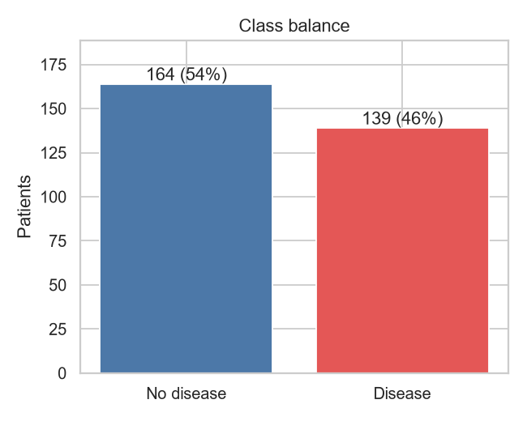
Class balance
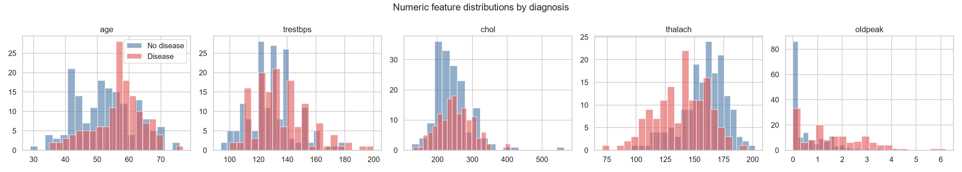
Numeric distributions
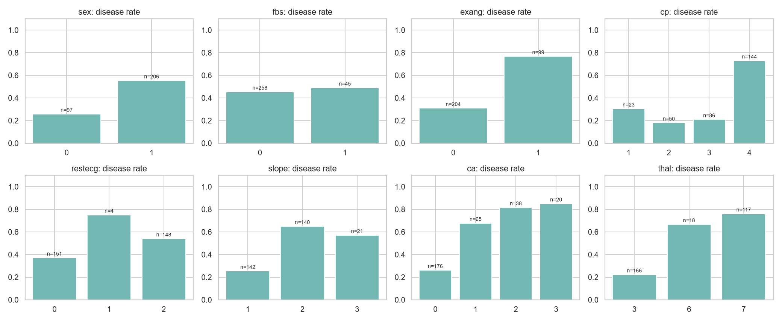
Disease rate per category
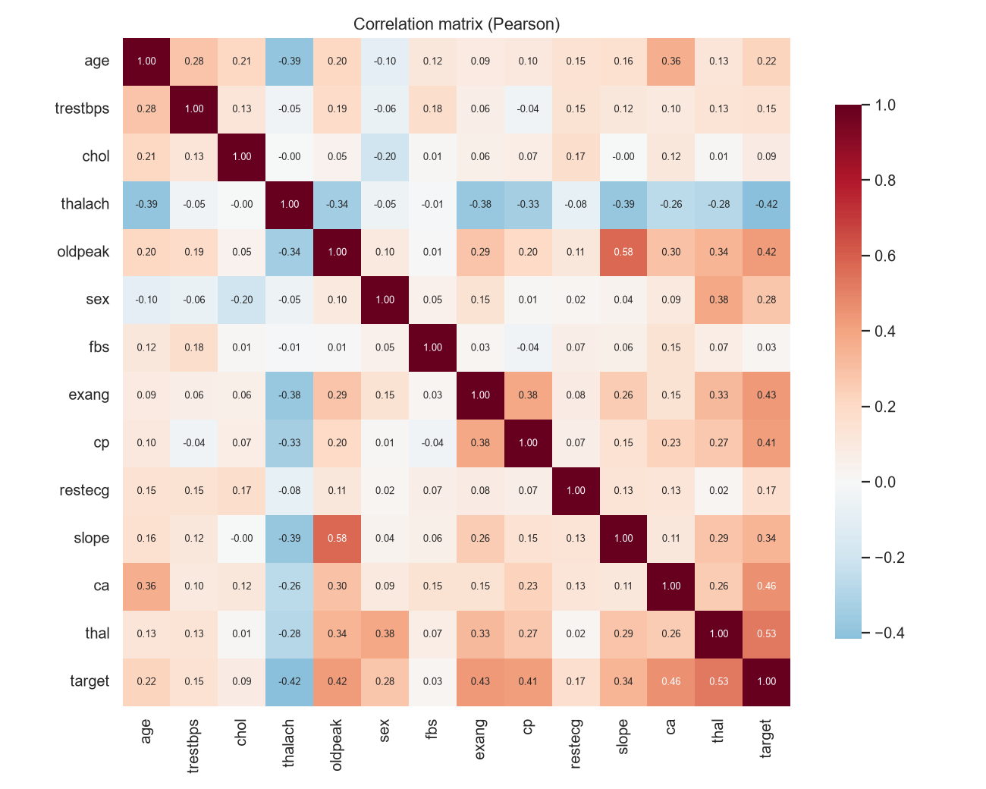
Correlation heatmap

4. Feature engineering and model development

4.1 Preprocessing (heartml/features.py)
All preprocessing is a ColumnTransformer placed in front of the estimator in one Pipeline. The saved artefact therefore takes raw feature values, and training and serving cannot drift apart.
Group | Columns | Steps
Continuous | age, trestbps, chol, thalach, oldpeak | median impute → StandardScaler
Binary | sex, fbs, exang | most-frequent impute (already 0/1)
Nominal | cp, restecg, slope, ca, thal | most-frequent impute → OneHotEncoder(handle_unknown="ignore")
handle_unknown="ignore" means an unseen category code at inference produces an all-zero one-hot vector instead of an error. The API schema already rejects out-of-range codes, so this is a second line of defence.

4.2 Models and tuning
The data was split 80/20, stratified, with a fixed seed of 42. On the 80% training part, each model family was tuned with GridSearchCV (stratified 5-fold, scored by ROC-AUC), and the tuned configuration was then cross-validated again to collect accuracy, precision, recall, F1 and ROC-AUC. The 20% test split was used only for the final report.
Model | Grid searched | Combos | Best parameters
Logistic Regression (liblinear) | C ∈ {0.01, 0.1, 1, 10}, penalty ∈ {l1, l2} | 8 | C = 1, L2
Random Forest | n_estimators {200, 400}, max_depth {None, 4, 8}, min_samples_leaf {1, 3, 5}, max_features {sqrt, 0.5} | 36 | 400 trees, depth 8, leaf 5, sqrt
Gradient Boosting | n_estimators {100, 200}, learning_rate {0.03, 0.1}, max_depth {2, 3}, subsample {0.8, 1.0} | 16 | 100 trees, lr 0.03, depth 2, subsample 0.8
Both tree models chose their most regularised settings (large leaves, shallow trees, low learning rate). With only about 240 training rows, the extra flexibility of the ensembles buys nothing.

4.3 Results
Model | CV ROC-AUC (± sd) | CV acc. | CV prec. | CV recall | Test acc. | Test prec. | Test recall | Test ROC-AUC
Logistic Regression | 0.905 ± 0.015 | 0.847 | 0.877 | 0.783 | 0.885 | 0.839 | 0.929 | 0.969
Random Forest | 0.899 ± 0.025 | 0.830 | 0.844 | 0.783 | 0.885 | 0.839 | 0.929 | 0.949
Gradient Boosting | 0.884 ± 0.030 | 0.818 | 0.846 | 0.756 | 0.902 | 0.867 | 0.929 | 0.960
Selection. The model is chosen on cross-validated ROC-AUC, not test accuracy. With 61 test rows a single patient moves accuracy by 1.6 points, so Gradient Boosting’s higher test accuracy (0.902 against 0.885) amounts to one patient. Logistic Regression has the best mean CV ROC-AUC, the lowest fold-to-fold variance, and the best test ROC-AUC. It is also interpretable: its coefficients are shown below.
The selected configuration is refit on all 303 rows before it is saved.
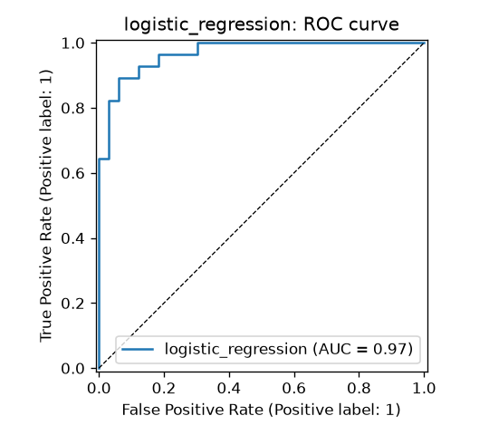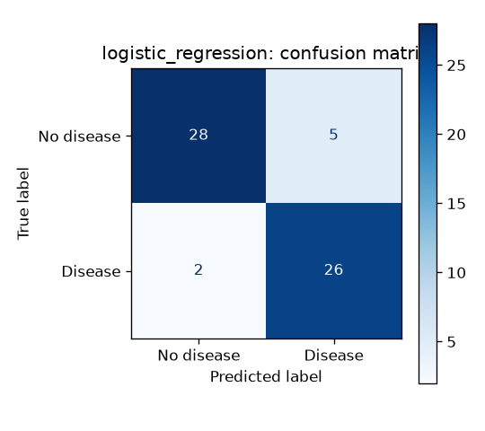
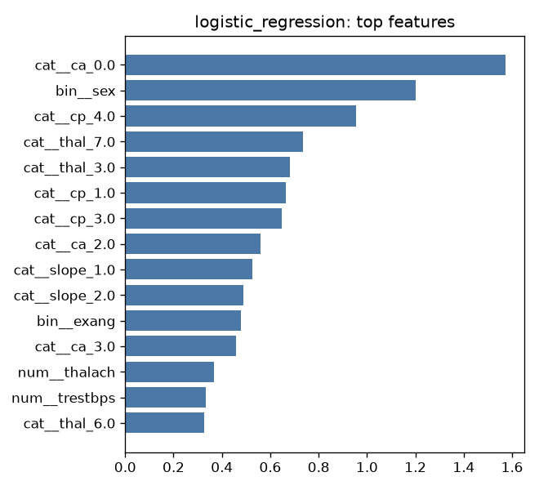
LR coefficient magnitudes

5. Experiment tracking (MLflow)
heartml/train.py stores results in an MLflow tracking store, a local SQLite database (mlflow.db) by default or any server set through MLFLOW_TRACKING_URI. Experiment: heart-disease-classification.
Each candidate run logs:
- Parameters: best hyperparameters, test_size, cv_folds, train/test sizes, grid size
- Metrics: mean and standard deviation of CV accuracy, precision, recall, F1 and ROC-AUC, plus the five test-set metrics
- Artifacts: confusion matrix, ROC curve, feature-importance plot, and the full GridSearchCV results table as CSV
- Model: an MLflow sklearn model with an inferred signature and an input example
- Tags: model family, quick mode
A final run (final_logistic_regression) logs the refit pipeline, the joblib file and model_meta.json, and registers it as heart-disease-classifier in the model registry.
To view the runs: mlflow ui --backend-store-uri sqlite:///mlflow.db → http://127.0.0.1:5000.
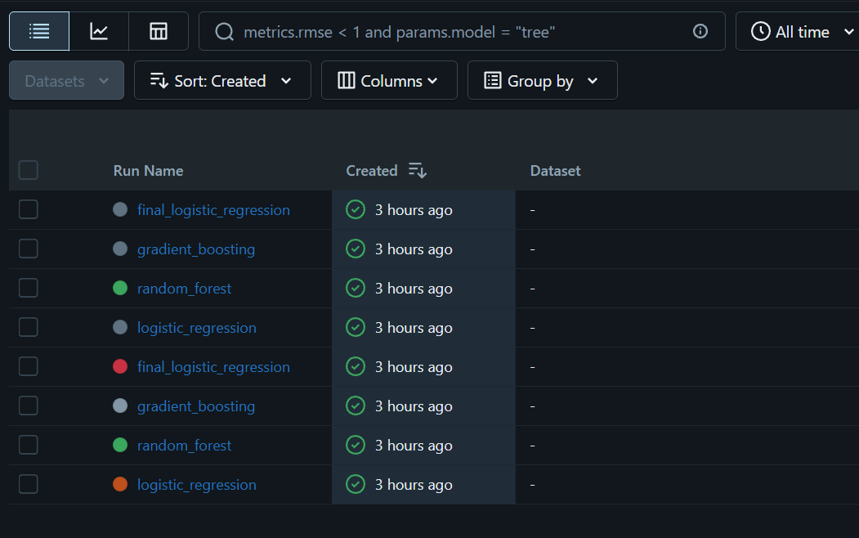
MLflow runs
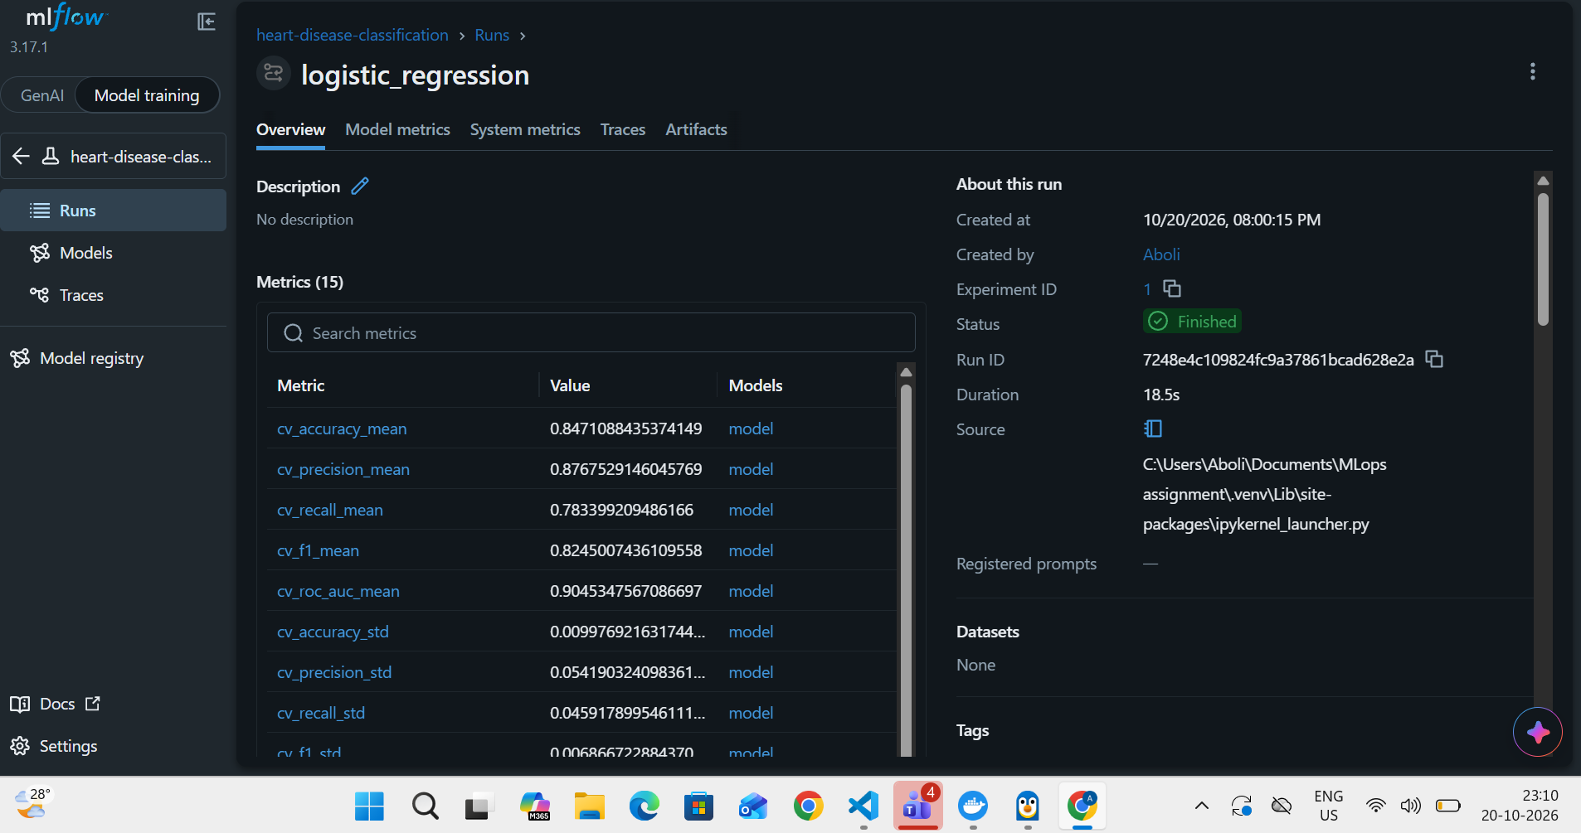
MLflow run detail
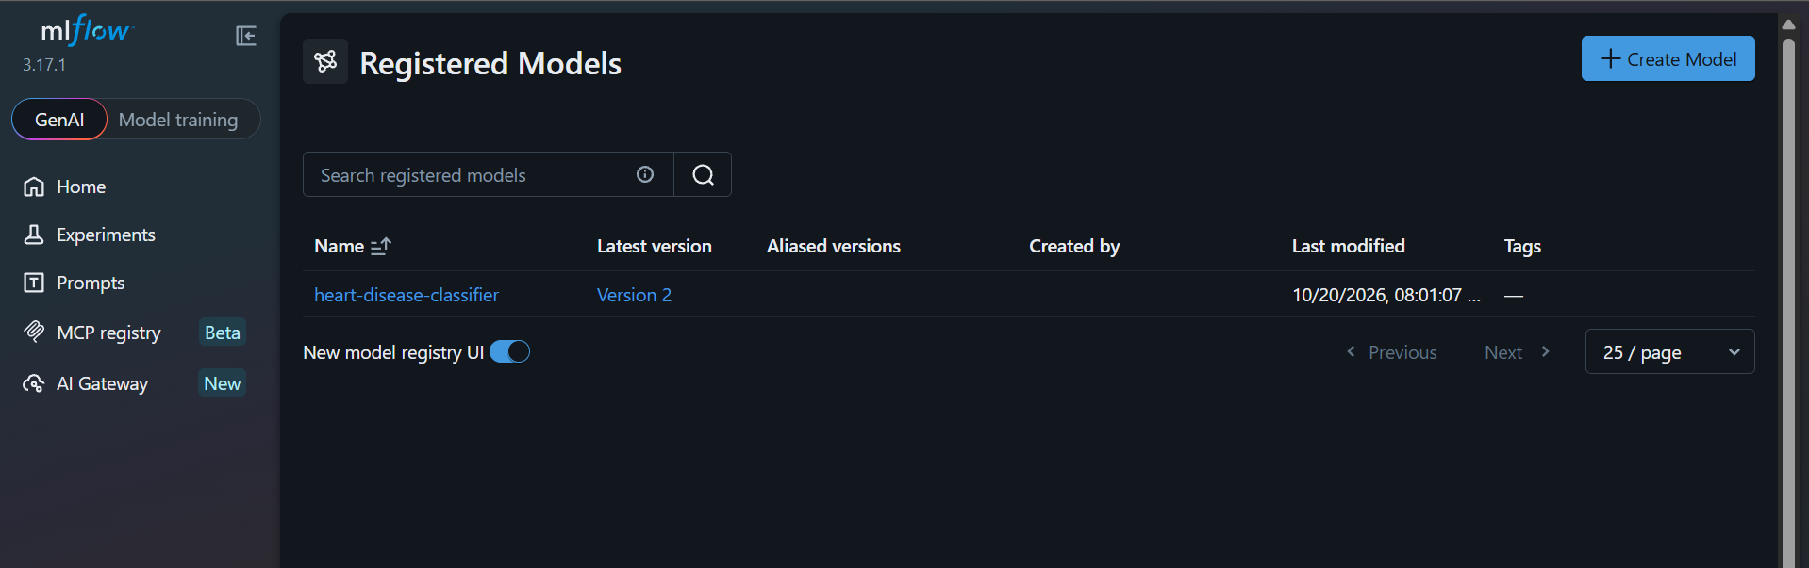
MLflow model registry

6. Packaging and reproducibility
- Model format: models/heart_model.joblib holds the complete preprocessing and model Pipeline. model_meta.json records the model name, MLflow run ID, parameters, metrics, feature order, sklearn version and training timestamp. The same model is also stored as an MLflow model (skops serialisation) in the registry.
- Determinism: a single RANDOM_STATE = 42 drives the split, the CV folds and the models, so re-running training gives the same metrics.
- Environment: requirements.txt pins all versions. The image uses Python 3.12 and requirements-serve.txt.
- Single source of truth: the notebooks, CI and the API all import the same heartml package, so no logic is copied into notebooks.

7. CI/CD pipeline and automated testing

7.1 Unit tests (tests/, 25 tests)
File | Covers
test_data.py | Binary target creation, duplicate removal, impossible values → NaN, NaNs kept for the pipeline, no mutation of input, ? parsing, X/y split
test_model.py | No NaNs after preprocessing, scaling, one-hot width, unseen categories, probability output, metric ranges, search space, confidence = P(predicted class), missing optional fields, risk bands, joblib round-trip
test_api.py | /health, /predict (prediction, confidence, request ID header), 422 on invalid or extra fields, batch endpoint, /metrics content, /model-info
The API tests train a tiny model on synthetic data inside a fixture, so they run on a fresh clone without the real dataset or a trained model.

7.2 GitHub Actions (.github/workflows/ci.yml)
The pipeline runs on every push to main, on every pull request, and on manual dispatch. Its jobs run in order; any failure stops the jobs after it.
Job | Steps | Artifacts
lint | flake8 over the package, API, tests and scripts | n/a
test | pytest -v --junitxml | test-results (JUnit XML)
train | download data → EDA → full training → quality gate (fail if CV ROC-AUC < 0.85) | model, training-reports (figures, comparison CSV, logs, clean data), mlflow-tracking
docker | download the model artifact → docker build → docker run → scripts/smoke_test.py | container-logs
The training step runs under shell: bash, which turns on pipefail, so a crash is not hidden by the | tee that saves the log. The smoke test exits non-zero on any failed check, including a check that invalid input is rejected with 422.
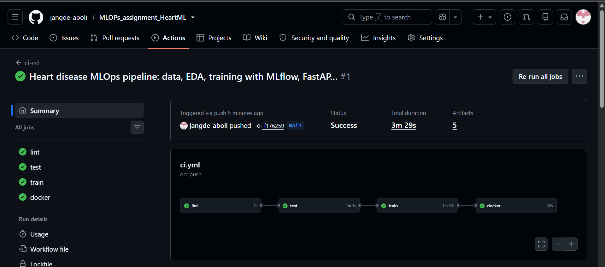
GitHub Actions run
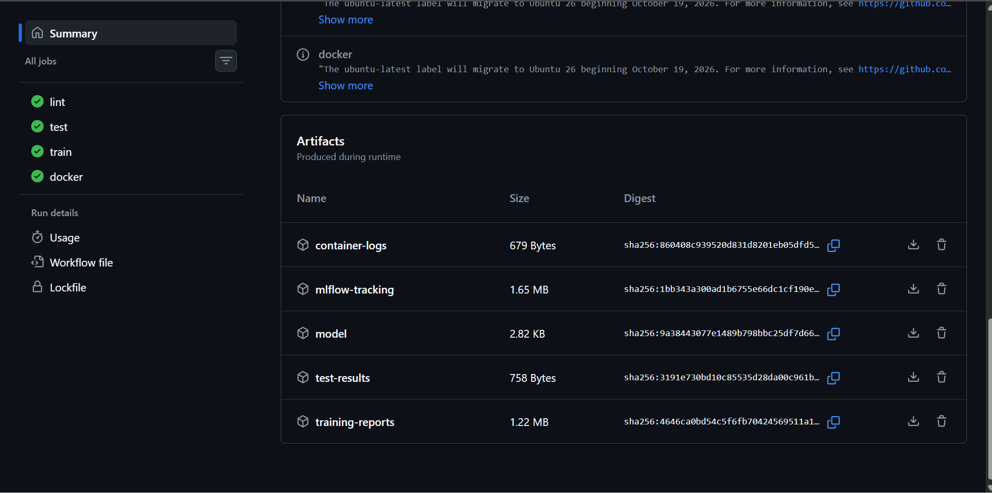
GitHub Actions artifacts

8. Containerisation
The Dockerfile builds from python:3.12-slim, installs only the serving dependencies, copies the package, the API and the trained model, runs as an unprivileged user (UID 10001), and declares a HEALTHCHECK against /health. It runs a single uvicorn worker per container because prometheus_client counters are per process; scaling happens through Kubernetes replicas.
API contract
Method | Path | Purpose
GET | /health | Liveness/readiness; reports whether the model is loaded
GET | /model-info | Contents of model_meta.json
POST | /predict | One patient → prediction, label, probability_disease, confidence, risk_level, request_id
POST | /predict/batch | Up to 100 patients
GET | /metrics | Prometheus exposition format
The Pydantic schema validates value ranges and the allowed category codes (for example cp ∈ {1, 2, 3, 4}) and rejects unknown fields, so bad input gets a clear 422 instead of a silent wrong prediction. Confidence is the probability of the predicted class. risk_level is low below 0.3, moderate from 0.3 to 0.6, and high at 0.6 or above.
docker build -t heart-api:1.0.0 .
docker run -p 8000:8000 heart-api:1.0.0
curl -X POST localhost:8000/predict -H "Content-Type: application/json" -d @samples/patient.json
{"prediction":1,"label":"heart disease","probability_disease":0.8793,"confidence":0.8793,
"risk_level":"high","model_name":"logistic_regression","request_id":"c764470a9ad4"}
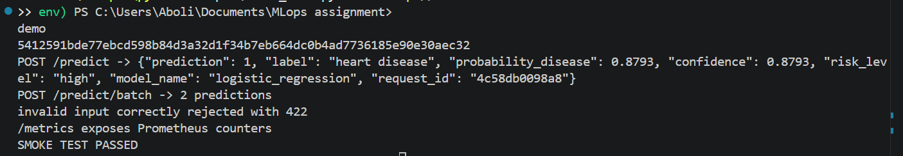
Docker build and run

9. Production deployment (Kubernetes)
k8s/api.yaml defines:
- Namespace heart-mlops
- Deployment with 2 replicas, a rolling update (maxUnavailable 0), CPU/memory requests and limits, readiness and liveness probes on /health, a non-root security context, and prometheus.io/* scrape annotations
- Service of type LoadBalancer (port 80 → 8000). Docker Desktop maps it to localhost; on Minikube it is reached through minikube tunnel
- Ingress (nginx) for host heart-api.local
scripts/deploy_k8s.sh builds the image (inside Minikube’s Docker daemon when the current context is Minikube), applies the manifests, creates the Grafana dashboard ConfigMap, and waits for the rollout.
bash scripts/deploy_k8s.sh
kubectl -n heart-mlops get pods,svc,ingress
python scripts/smoke_test.py --url http://127.0.0.1
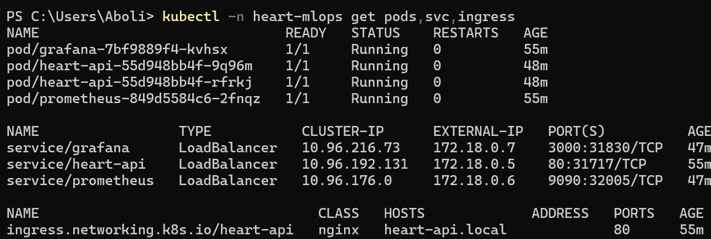
kubectl get pods,svc
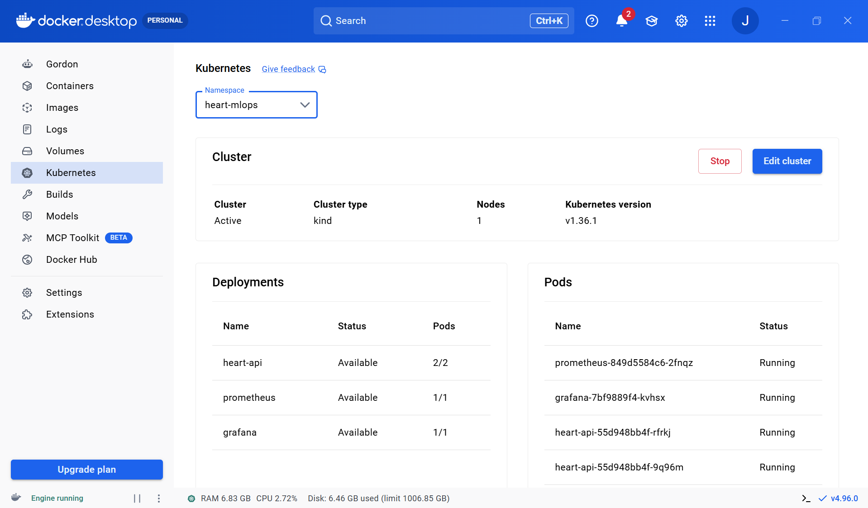
Docker Desktop Kubernetes view (namespace heart-mlops)
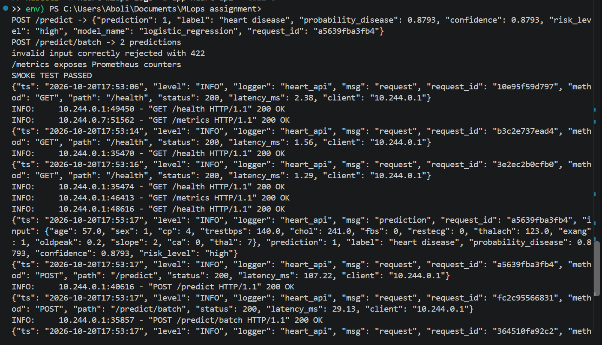
Smoke test through the LoadBalancer, followed by the pods’ JSON request logs

10. Monitoring and logging
Logging. Middleware writes one JSON line per request with the request ID, method, path, status, latency and client. Each prediction is logged with its input and output. The request ID comes from the X-Request-ID header when the caller sends one, otherwise it is generated, and it is returned to the caller so a single request can be traced. Logs go to stdout (kubectl logs), and to a file when LOG_FILE is set.
Metrics (/metrics):
Metric | Type | Use
heart_api_requests_total{method,endpoint,status} | Counter | Throughput, error rate
heart_api_request_latency_seconds{endpoint} | Histogram | p50/p95 latency
heart_api_predictions_total{label} | Counter | Class mix, a simple drift signal
heart_api_disease_probability | Histogram | Distribution of predicted risk
heart_api_model_loaded | Gauge | Model availability
Metric labels use the route template rather than the raw path, which keeps label cardinality bounded.
Stack. Prometheus discovers the API pods through their annotations (with RBAC scoped to the namespace). Grafana is provisioned with the Prometheus datasource and a nine-panel dashboard: model-loaded status, total predictions, disease share, error rate, request rate, p50/p95 latency, predictions by class, the probability distribution, and responses by status. Running scripts/smoke_test.py --load 300 generates traffic, including some invalid requests, so the error-rate panel has data. For local work, docker compose up starts the same stack without Kubernetes.
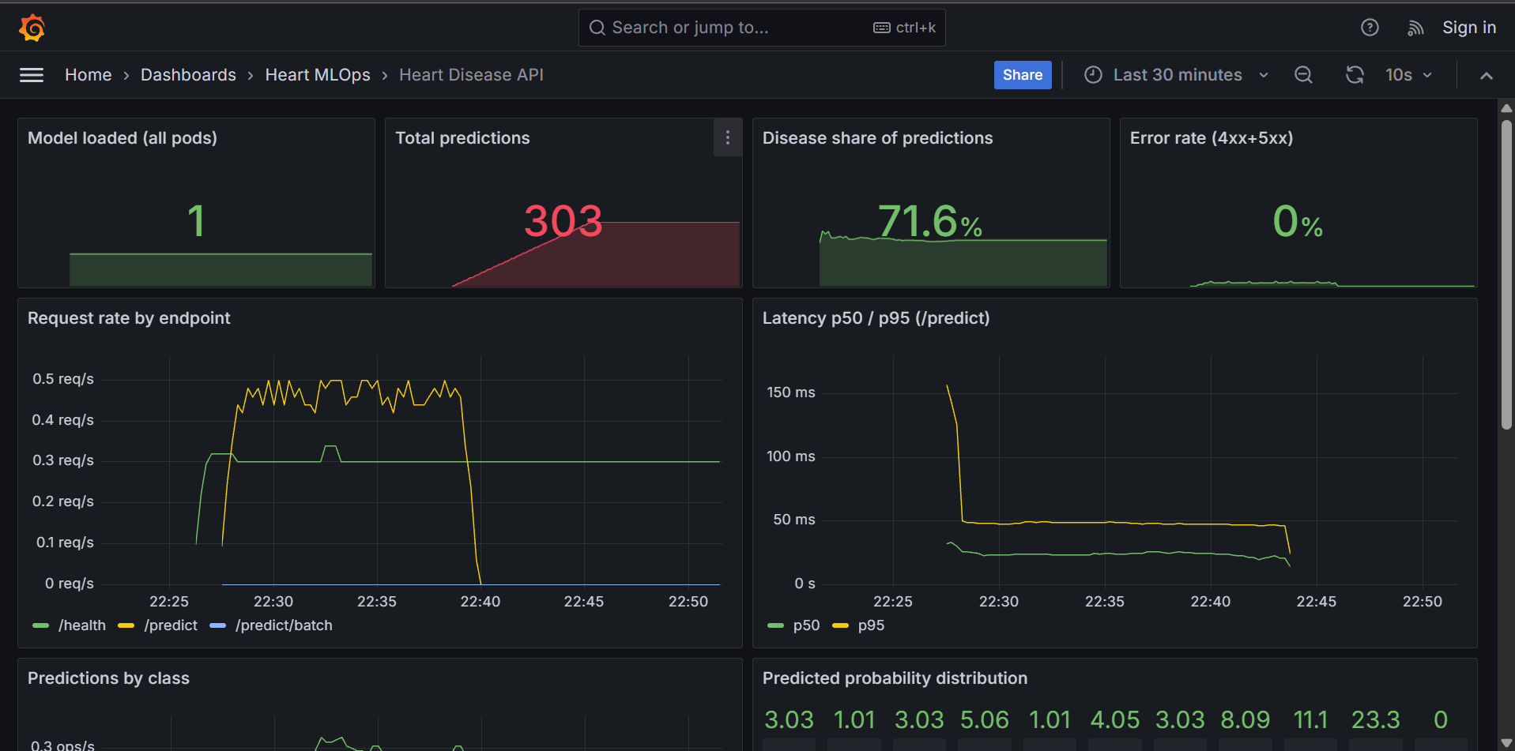
Grafana dashboard: status, throughput and latency
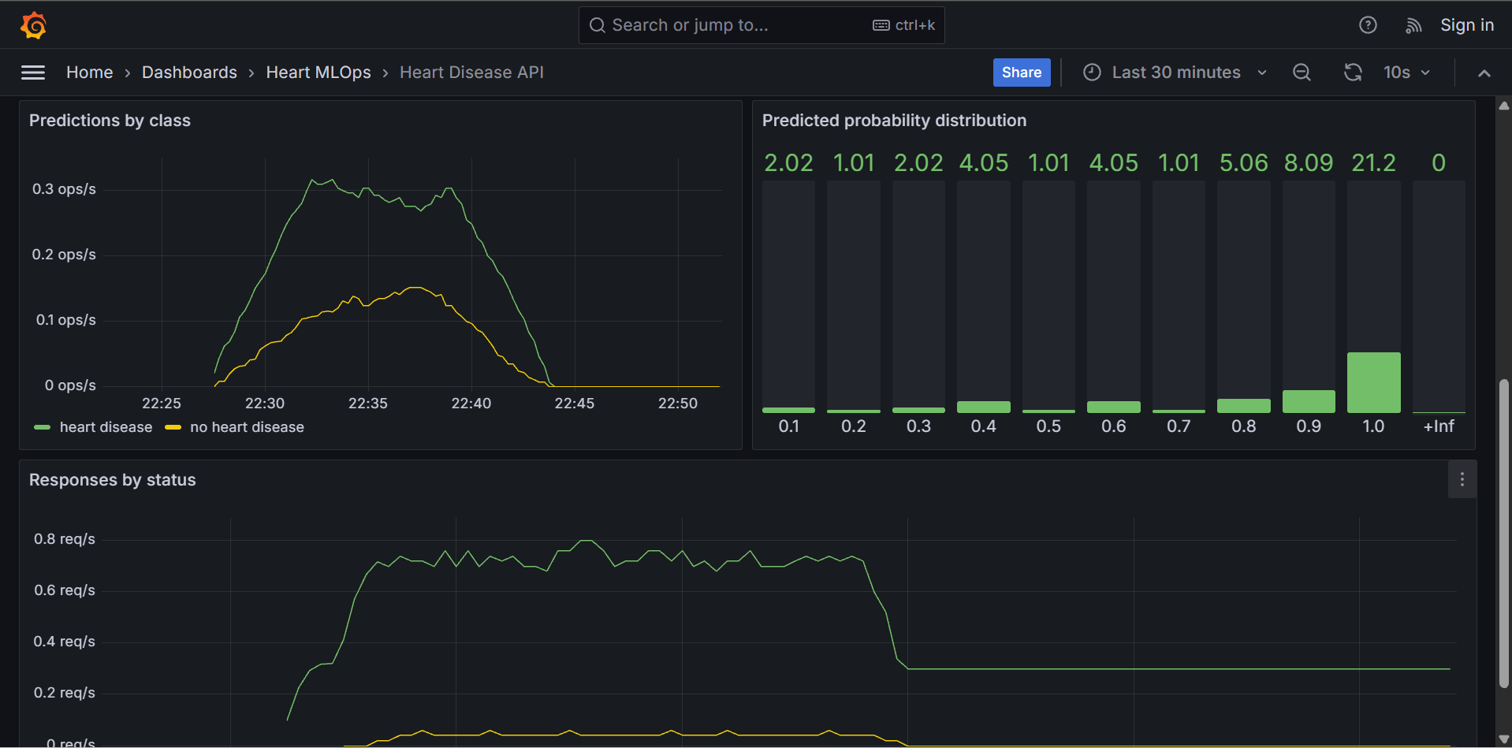
Grafana dashboard: class mix, probability distribution and response codes
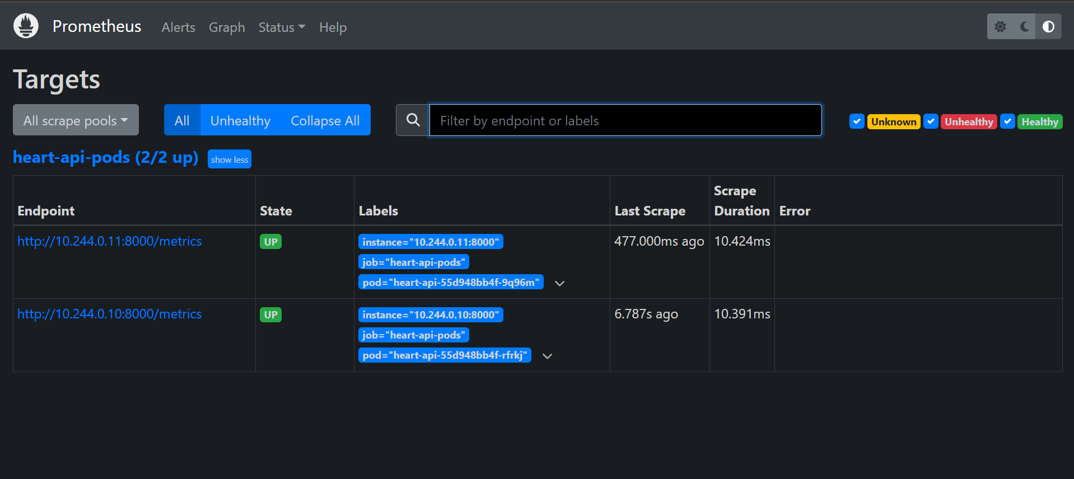
Prometheus targets

11. Limitations and next steps
- Small data: 303 patients from a single hospital. The metrics carry wide uncertainty (CV standard deviation of about 0.015-0.03 in ROC-AUC), and the model should be validated on the Hungarian, Swiss and VA subsets before any wider use.
- Fixed threshold of 0.5: in a screening setting, missing a case costs more than a false alarm. The threshold could be chosen for a target recall and stored in model_meta.json.
- Image registry: the image is built locally. The next step is to push to GHCR from CI and deploy with kubectl set image, or with Argo CD, for continuous delivery.
- Drift monitoring: the class-mix and probability histograms are a first signal. A fuller setup would compare live feature distributions against the training data, for example with Evidently.

12. Deliverables checklist
Requirement | Location
Download script + cleaned data | scripts/download_data.py, data/processed/heart_clean.csv
EDA / training / inference notebooks | notebooks/01_eda.ipynb, 02_training.ipynb, 03_inference.ipynb
≥ 2 models, CV, metrics | heartml/train.py, reports/model_comparison.csv
MLflow tracking | mlflow.db, Section 5
Saved model + reproducible pipeline | models/, heartml/features.py, requirements.txt
Unit tests | tests/
CI workflow | .github/workflows/ci.yml
Dockerfile + /predict | Dockerfile, api/main.py
K8s manifests (LoadBalancer + Ingress) | k8s/api.yaml
Monitoring | k8s/monitoring.yaml, monitoring/, docker-compose.yml
Screenshots | screenshots/
Access instructions | README.md §3-5

