Name:Hanliang Jiang

NetID:hj33

Problem 1:

1. 14 processes receives this message. Because TTL is big enough to transfer to any other nodes.
2. TTL = 3 is the minimum.
3. TTL = 2 is the minimum, because the first sender can send TTL = 2 to neighbours including the 16th process, and that process can send to all his neighbours, which is every nodes.

Name:Hanliang Jiang

NetID:hj33

Problem 2:

1. G should be fetched first, because it is the rarest.
2. Order: GFEDCAB, as we always choose the rarest, and A and B form a tie, so we choose A because it is alphabetically lower.
3. We assign G to DeGrasseTyson, so G and F have equal priority and form a tie, we choose F instead of G and thus changes the first shard fetched.

Name:Hanliang Jiang

NetID:hj33

Problem 3:

Solution: A regular Bloom filter’s false positive rate is 图示

中度可信度描述已自动生成 , where m = 4096 and k = 2.

For the Leo-any circumstance, the false positive rate is文本

For n=10, the possibility of false positive for regular is 2.3726e-5, for Leo-any is 1.9587e-14, for Leo-all is 0.0015, thus Leo-any is the best choice.

For n=1000, the possibility of false positive for regular is 0.1492, for Leo-any is 0.2942, for Leo-all is

0.9952, thus regular Bloom filter is the best choice.

In conclusion, for n = 10, Leo-any gives the best result, while for n = 1000, regular Bloom filter gives the best result.

Name:Hanliang Jiang

NetID:hj33

Problem 4:

1. Disadvantage: Bloom filter can help us easily get the information about if an item(a key) exists in SStable. If there were no Bloom filter, Cassandra needs more operations and load to query the existence of a key.

Advantage: We don’t need the space to store Bloom filter itself, which saves storage space.

1. Disadvantage: Write/read operations would be slower, because memtable can help speed up write/read operations.

Advantage: It saves the space for Memtable. Besides, we don’t need to sort the memtable or merge it into sstable, which simplifies operations.

1. Disadvantage: modifying the already-present memtable takes much time, (i.e. searching each entry from memtable is much load.)

Advantage: reduce storage space, because creating a new sstable takes much storage space.

Name:Hanliang Jiang

NetID:hj33

Problem 7:

A should be 0 and B should be 264 microseconds. Because X+0.12+0.34+0.056 should be lower that RTT = 0.78, so X should be lower than 0.78 – (X+0.12+0.34+0.056) = 0.264ms = 264 microseconds.

Name:Hanliang Jiang

NetID:hj33

Problem 8:

The new error bound can be 0!

In the circumstance above, let’s set latency to L(as latencies are identical in reverse directions). The offset = , when child send a message to parent , parent receive at ts1, and then parent send back so child receive at tr1. As child is oreal time ahead of parent node, we have tr1 = ts1 + L + oreal; then child send at ts2 and parent receive at tr2, which gives us tr2 = ts2 + L – oreal. If we calculate these two equations, we can get L = tr2 + oreal – ts2 = tr1 – ts1 -oreal. So oreal = . Thus |offset - oreal| = 0, the new error bound is 0.

Name:Hanliang Jiang

NetID:hj33

Problem 9:

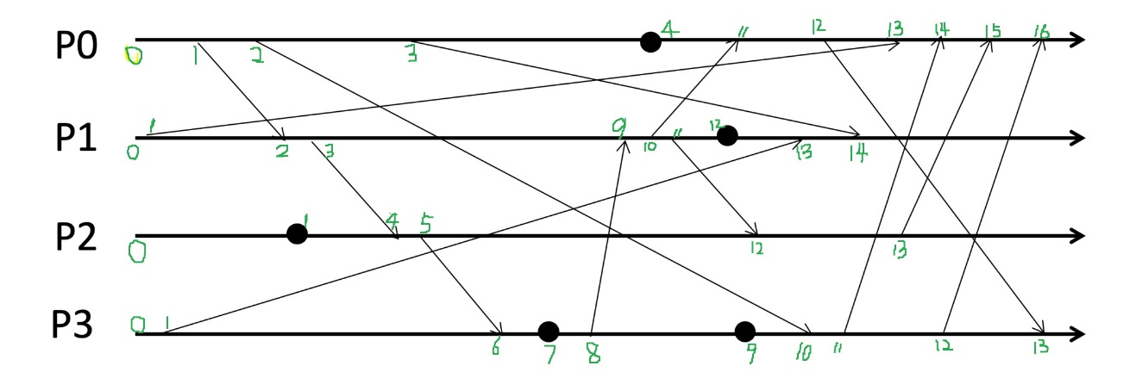

Name:Hanliang Jiang

NetID:hj33

Problem 10:

