Final Report: Pollution Levels and Energy Recovery

1. Project Overview
This report analyzes the relationship between pollution levels and energy recovery efficiency using statistical and machine learning models. The objective is to evaluate model performance and derive actionable insights for policy makers and energy planners.

2. Model Evaluation Summary
Two models were evaluated:
• Linear Regression – used to measure the impact of pollution on energy recovery.
• Logistic Regression – used to classify regions into high and low energy recovery groups.
Linear Regression showed that increasing pollution levels are associated with a decline in energy recovery efficiency. Logistic Regression effectively identified regions at risk of low energy recovery, making it useful for classification-based decisions.

3. Key Insights
• Pollution has a strong negative effect on energy recovery.
• Regions with lower pollution consistently achieve higher energy recovery rates.
• Classification results indicate that pollution level is a reliable indicator of recovery performance.
• Energy recovery efficiency drops sharply beyond certain pollution thresholds.
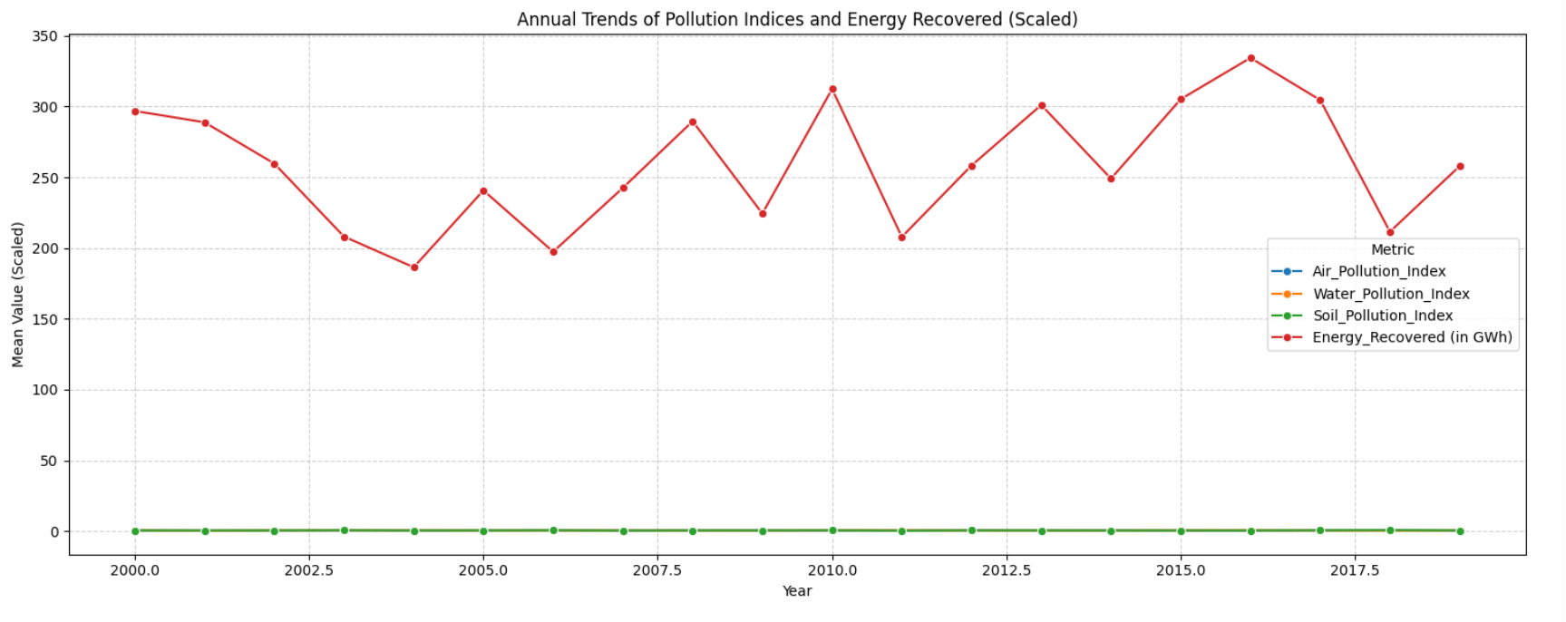

4. Country-Level Implications
Countries with high industrial activity and poor emission control mechanisms show the lowest energy recovery outcomes. Developing and rapidly industrializing nations have the greatest opportunity for improvement by adopting cleaner technologies. Countries with strong environmental regulations demonstrate better energy utilization efficiency.
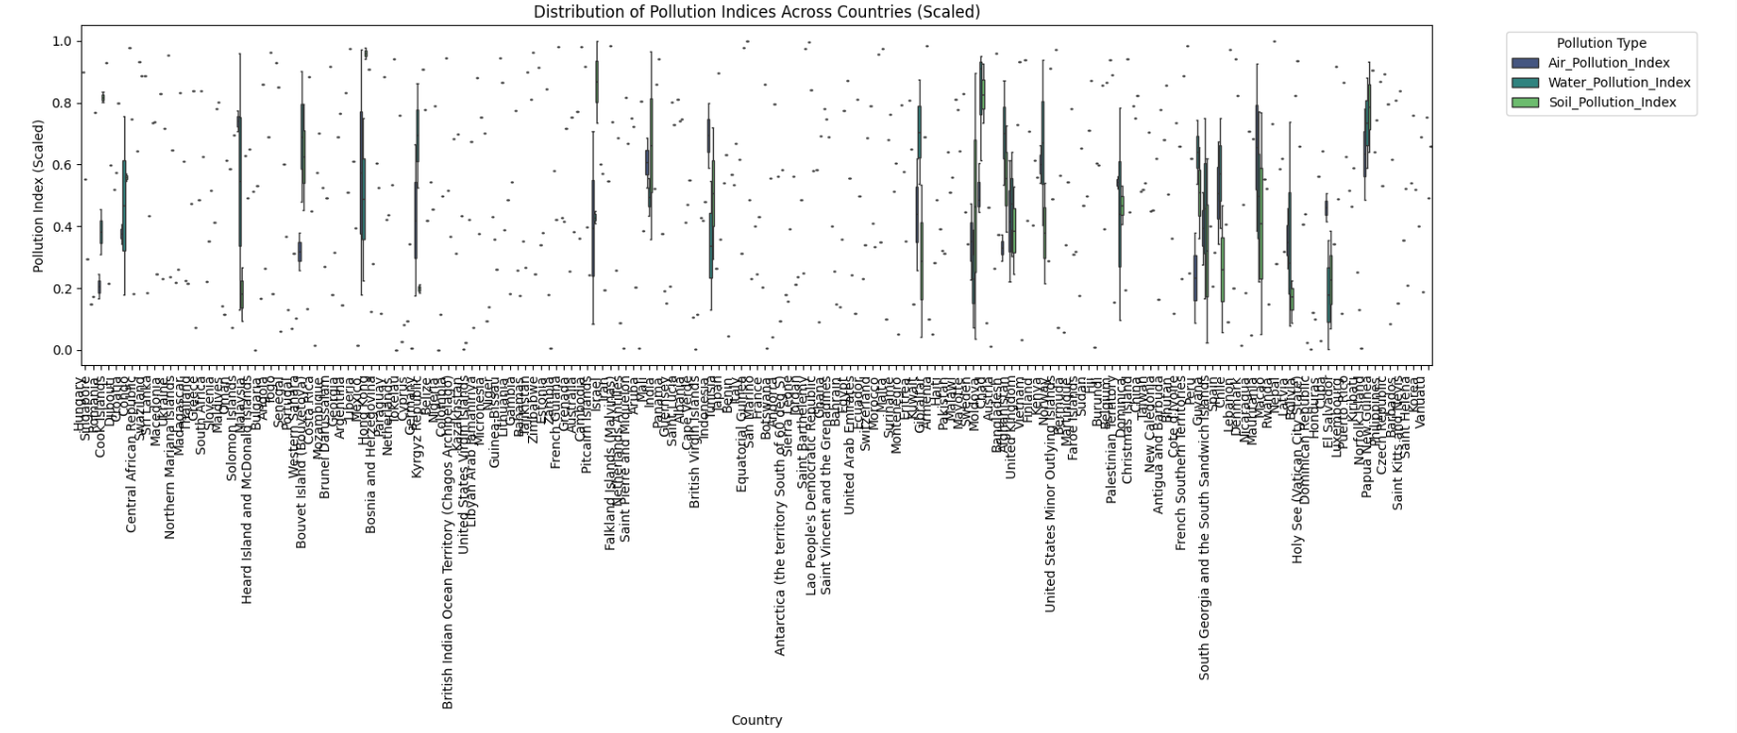

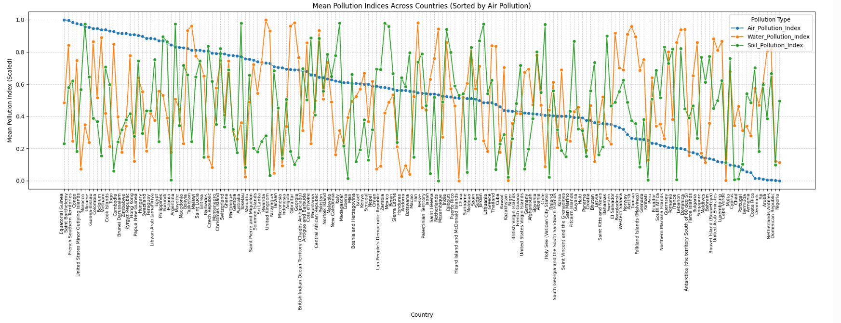

5. Actionable Recommendations
1. Implement stricter pollution control and emission standards.
2. Invest in waste-to-energy and energy recovery technologies.
3. Promote renewable and cleaner energy sources.
4. Encourage international collaboration for green technology transfer.
5. Use data-driven monitoring systems to track pollution and recovery trends.

6. Conclusion
Reducing pollution is not only critical for environmental sustainability but also essential for maximizing energy recovery. The findings support the need for proactive environmental policies and technological investments to improve global energy efficiency.

