T^{U}R^{E}S_{D}V^{EN}

LO^{AD}I^{N}G Y
O
^{U}R _{RO}
A _{GNI R}A
The hum of your bike engine as you conquer Khardung La.

HOME LOCATIONS GALLERY ENQUIRY ABOUT US REV &
REV &
ROAR
ROAR
Welcome to Rev & Roar! Conquer the Himalayas your way—on a bike,
in a tempo traveler, or with your crew. Adventure starts here!
Thrilling high-altitude passes with expert guides.
Location
Roaring Tour Packages
E^{N}R^{OLL NOW}. _{R}
W.
O
^{A}R ^{N} _{W}O
O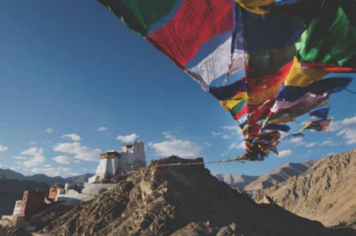_{RNE. L}L ^{NO}
_{NOW.}E^{NROLL N}O_{W.}
Ladakh
Date- 10th Jan- 21th Jan
Price- 30,900/-
CONTACT US
Ready to Rev & Roar? Let’s make it happen! • Call Us: +91 [Your Number]
• Email: info@revandroar.com
• WhatsApp: Tap the button below for instant queries.

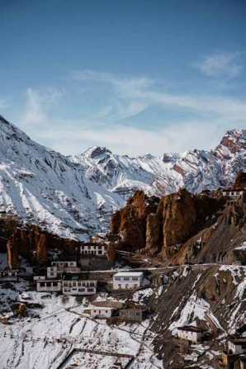
_{RO}A^{R}
Spiti
Date- 21th Jan- 5th Fri
Price- 30,900/-
. WON
E^{N}R^{O} L^{L}
Follow us on Instagram and Facebook to see what adventure looks like!
A shared laugh with friends under the starry skies of Spiti.
HOME LOCATIONS GALLERY ENQUIRY ABOUT US REV &

DESTINATIONS ROAR WE CALL HOME
REV &
ROAR
R^{OL}L ^{NOW.}
E^{N}R^{O}L_{L}
N
^{NOW}. _{O}^{R N}RA
W_{O .}E
LadakhThink Pangong Tso’s magical hues,
the thrill of KhardungLa, and the
warm smiles of Nubra Valley.
_{N}O^{W.}L
R^{OL}
ENR^{O}L^{L NOW.} R^{O}A_{R}
Spiti ^{A remote wonderland with}
^{N}E. W_{O}N
crystal-clear skies, ancient
monasteries, and landscapes
that belong in a dream.
CONTACT US
Ready to Rev & Roar? Let’s make it happen!
• Call Us: +91 [Your Number]
• Email: info@revandroar.com
• WhatsApp: Tap the button below for instant queries. Follow us on Instagram and Facebook to see what adventure looks like!
HOME LOCATIONS GALLERY ENQUIRY ABOUT US ^{REV &} GALLERY ROAR
A Picture is Worth a Thousand Adventures
Explore our gallery featuring glowing sunsets over Pangong Lake, joyful group shots in Spiti, and the sheer thrill of biking through the Himalayas.
_{R}E ^{N}O^{W}.
RO^{A}R_{I}^{N}G T
R
^{S}. _{L}C _{OT KCI} E^{XP}L^{O} P^{I}
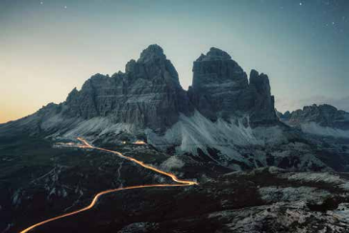_{Ladakh} ^{L}_{L}^{adakh} _{L}^{adakh} _{adakh L}^{Spiti} adakh
_{R}E ^{N}O^{W}.
RO^{A}R_{I}^{N}G T
R
^{S}. _{L}C _{OT KCI} E^{XP}L^{O}
P^{I}
TESTIMONIALS
N^{E}H^{A} SH^{A}R_{MA} L^{A}D_{A H}K _{EKI B} T^{R} P_{I}
_{R}A^{H}_{U}L KAP^{OO}R
“This trip was the best decision of my life! Riding through Ladakh with Rev & Roar felt like living a dream. Their team made every moment unforgettable!”
L_{A}^{DA} H^{K E}KI _{B} T^{R} P_{I}“As a corporate group, we were blown away by their professionalism and attention to detail. From tempo rides to adventure-packed days, every detail was perfect!”
N^{E}H^{A} SH^{A}R_{MA} L^{A}D_{A H}K _{EKI B} T^{R} P_{I}
“This trip was the best decision of my life! Riding through Ladakh with Rev & Roar felt like living a dream. Their team made every moment unforgettable!”

