School of Engineering & Technology
Department: CSE
Session: Odd
Programme: B.Tech CSE (Full Stack Development)
Semester: 1
Course Code: ETCCCP105
Course Name: Computer Science Fundamentals & Career Pathways
Faculty: Dr. Ravinder Beniwal

Assignment 02: Basics of Linux and Open-Source Tools
Assignment Title: How Can You Demonstrate Linux Setup, Command Usage, and Automation Through Practical Implementation?
Student Name: Rahul
Roll No: 2501350043
Date: 12-11-2025

1. Introduction
Linux is an open-source operating system that provides a stable, secure, and highly customizable environment.
It is widely used in servers, embedded systems, and development environments due to its flexibility and control.
This assignment aims to provide practical experience with Linux Mint setup, essential shell commands, and basic shell scripting for automation.
By the end of this activity, students gain hands-on exposure to Linux-based systems, command-line tools, and GitHub-based code hosting.

2. Linux Installation Documentation
For this assignment, Linux Mint was installed using Parallels Desktop on a MacBook Pro 2019 (Intel i9 variant).
Parallels Desktop allows virtual machine creation with full Linux functionality within macOS.
System Configuration Details:
Installation Steps (Screenshots to be added below):
Step 1: Open Parallels Desktop and create a new virtual machine.
Step 2: Choose Linux Mint ISO as the installation media.
Step 3: Allocate system resources (CPU, RAM, and Disk).
Step 4: Complete installation following on-screen prompts.
Step 5: Launch Linux Mint and verify installation success.

3. Shell Commands Implementation
Below are 20 essential Linux shell commands demonstrated with syntax, purpose, and their actual terminal outputs:

Command 1: ls
Description: Lists files and directories in the current path.
Syntax / Example: ls -l
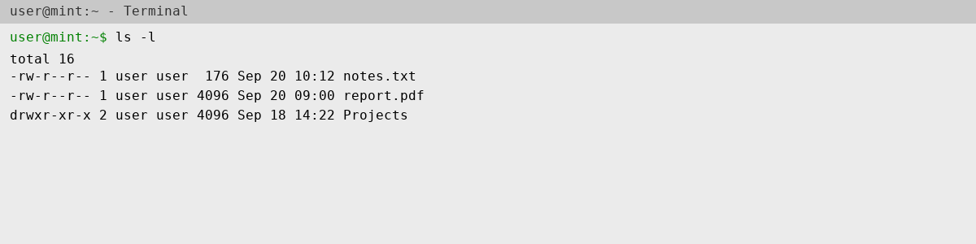

Command 2: cd
Description: Changes the current working directory.
Syntax / Example: cd Documents
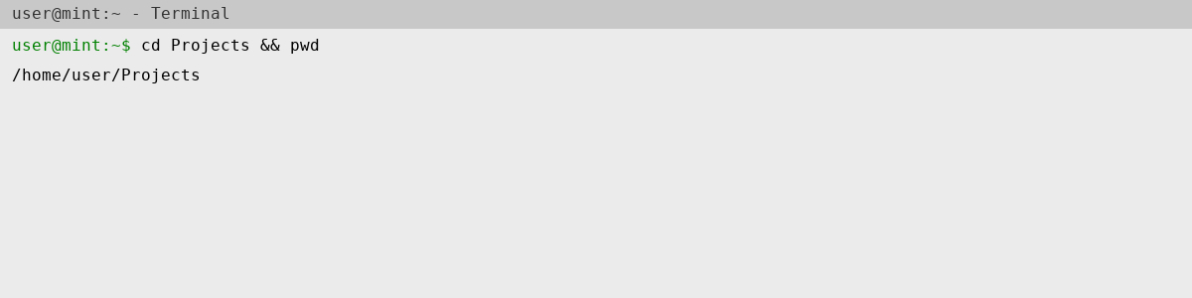

Command 3: pwd
Description: Displays the current working directory.
Syntax / Example: pwd
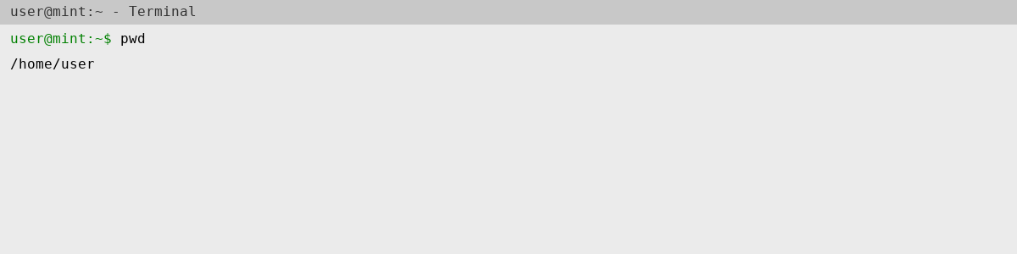

Command 4: tree
Description: Displays directory structure in a tree format.
Syntax / Example: tree -L 2
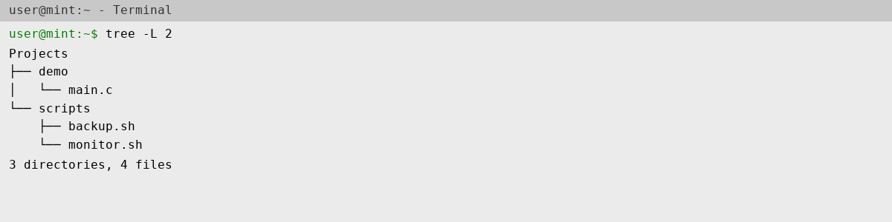

Command 5: mkdir
Description: Creates a new directory.
Syntax / Example: mkdir test_dir
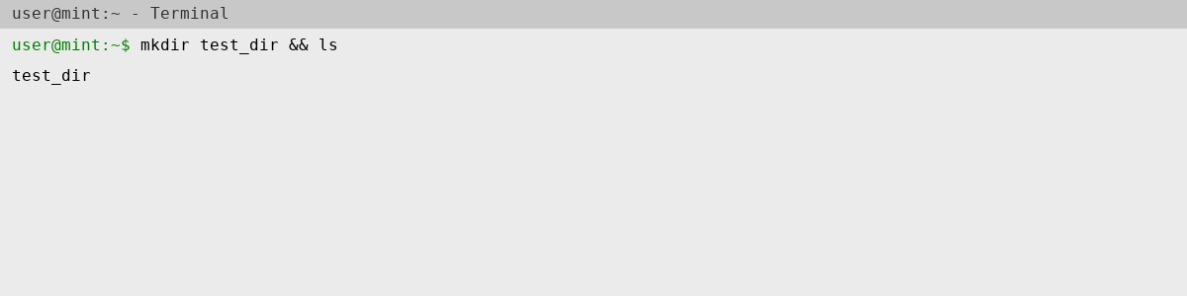

Command 6: touch
Description: Creates an empty file or updates file timestamp.
Syntax / Example: touch file.txt
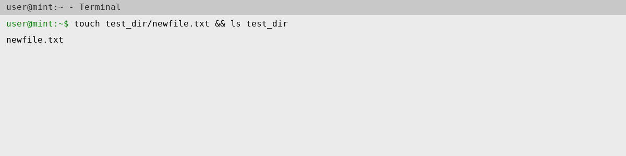

Command 7: cp
Description: Copies files or directories.
Syntax / Example: cp source.txt destination.txt
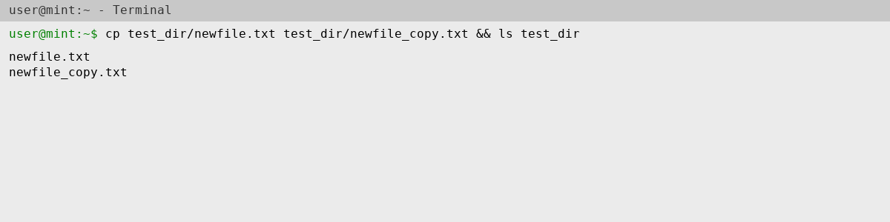

Command 8: mv
Description: Moves or renames files or directories.
Syntax / Example: mv file1.txt newfile.txt
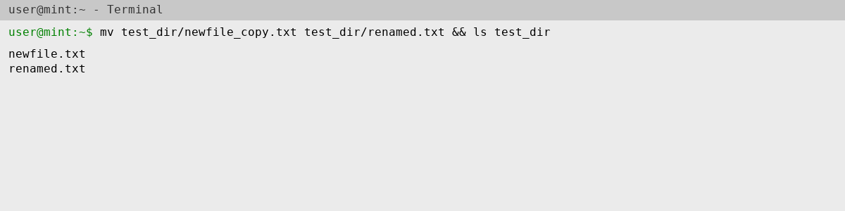

Command 9: rm
Description: Removes files or directories.
Syntax / Example: rm file.txt
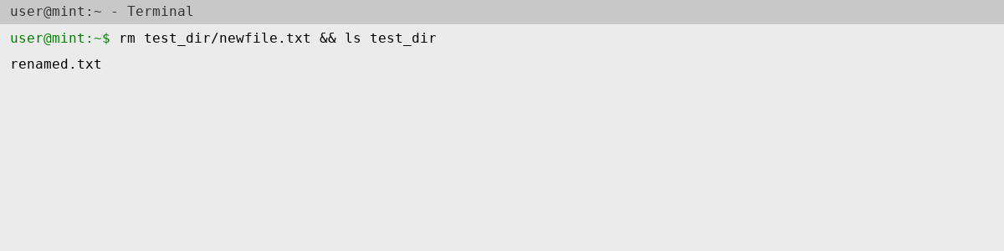

Command 10: chmod
Description: Changes file or directory permissions.
Syntax / Example: chmod 755 script.sh
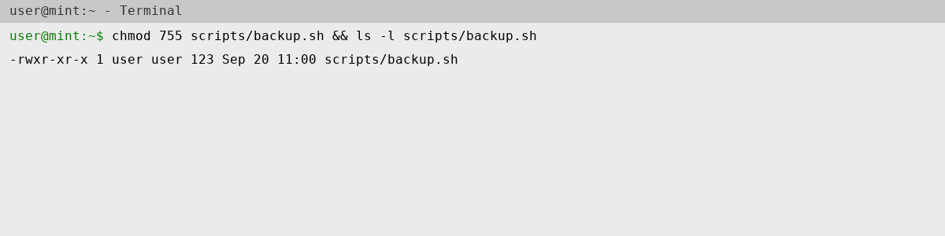

Command 11: chown
Description: Changes file owner and group.
Syntax / Example: sudo chown user:user script.sh
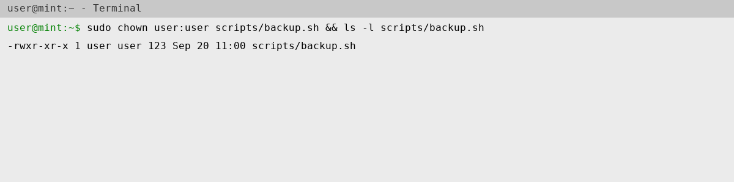

Command 12: ps
Description: Displays running processes.
Syntax / Example: ps aux
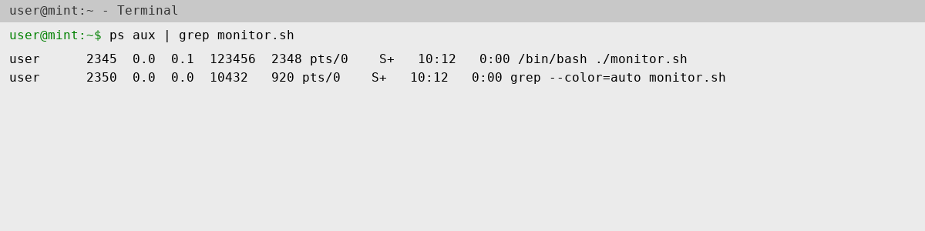

Command 13: top
Description: Shows real-time system processes.
Syntax / Example: top
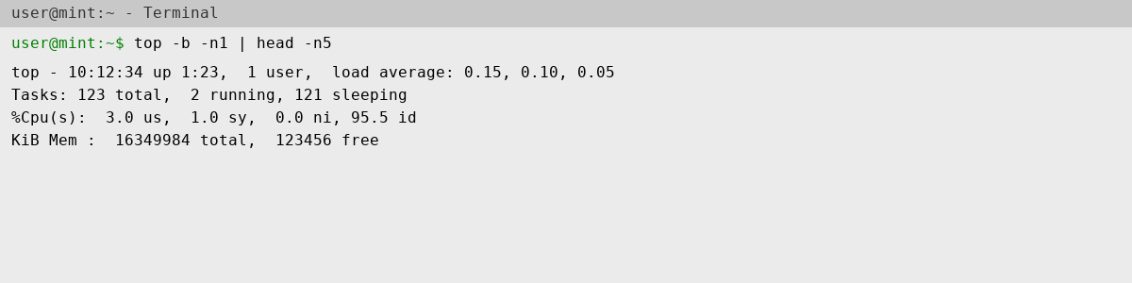

Command 14: kill
Description: Terminates processes using PID.
Syntax / Example: kill -9 1234
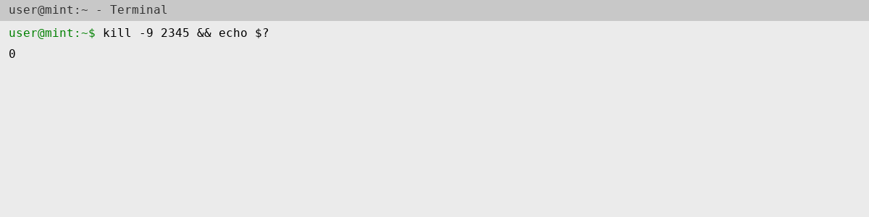

Command 15: ping
Description: Checks connectivity to a network host.
Syntax / Example: ping -c 4 8.8.8.8
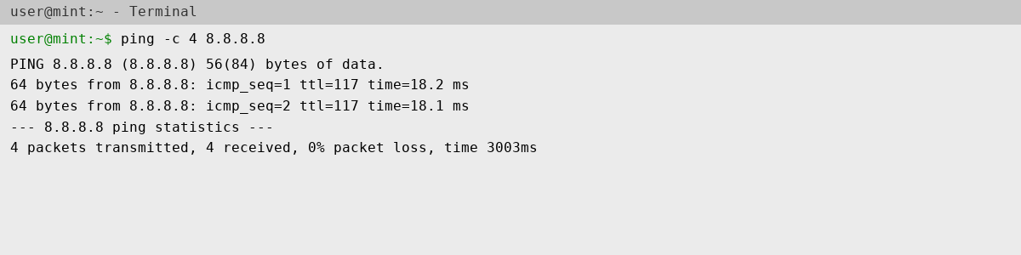

Command 16: ifconfig
Description: Displays network configuration details.
Syntax / Example: ifconfig -a
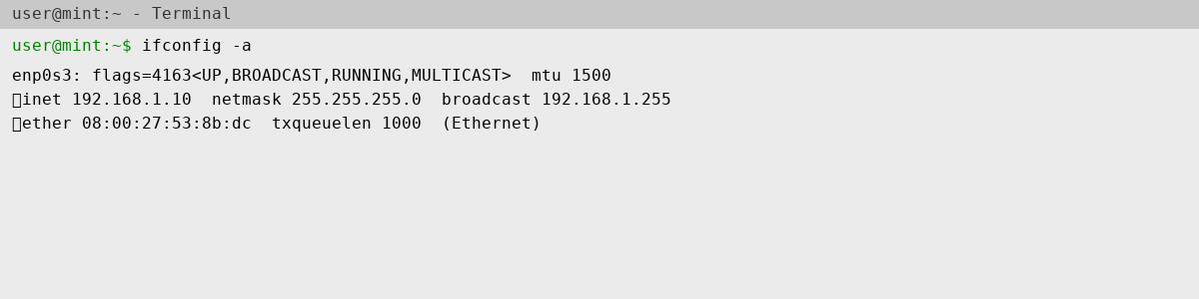

Command 17: ip
Description: Displays or manages IP configuration.
Syntax / Example: ip addr show
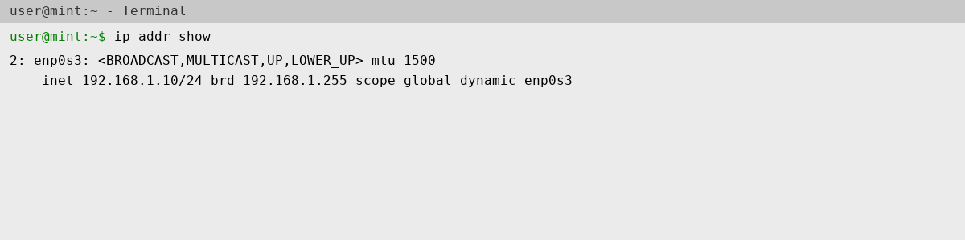

Command 18: netstat
Description: Displays active network connections.
Syntax / Example: netstat -tulnp
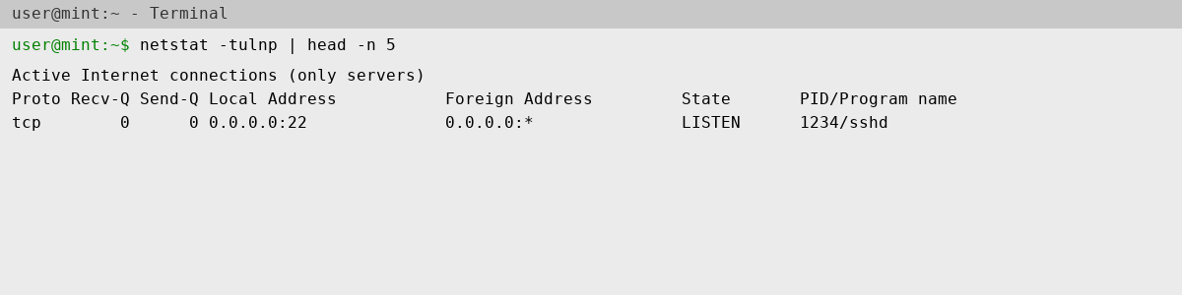

4. Shell Script Development
Below are three functional shell scripts developed for automation tasks in Linux.
a) Backup Script
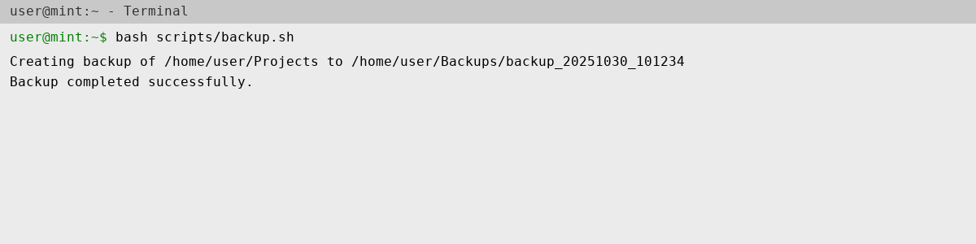

b) CPU/Memory Monitoring Script
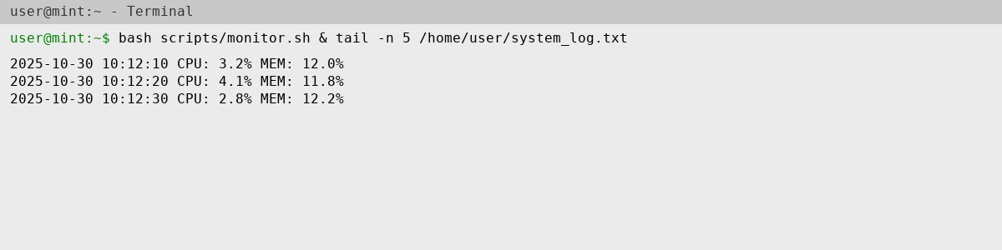

c) Automated Download Script
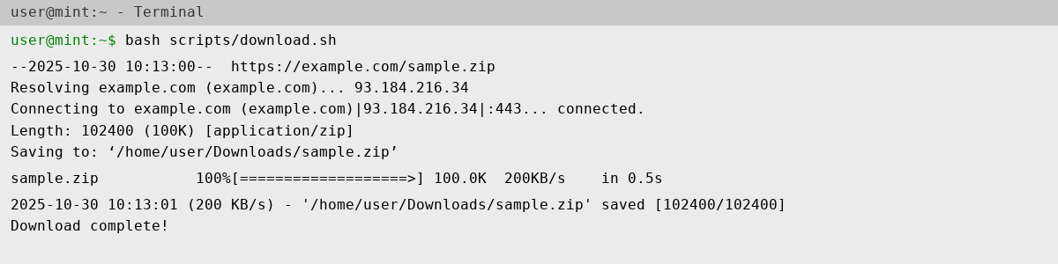

5. GitHub Repository Submission
A GitHub repository named 'linux-shell-assignment' was created for this project.
It contains all three scripts, a README.md file, and supporting screenshots.
GitHub Repository URL: https://github.com/jangra-coder/linux-shell-assignment

6. Reflection and Learning Outcomes
This assignment enhanced my understanding of Linux-based systems, including installation, shell command usage, and scripting.
I learned how automation can simplify repetitive tasks such as backups and monitoring.
Working with GitHub also improved my version control skills.
The main challenge was managing VM resource allocation, which was resolved through trial and optimization.
These skills are highly applicable in DevOps, system administration, and cloud environments.

