Atlas RAN Twin User Manual
  - Program operation and engineering study workflows
Edition 1.0 | 2 October 2026 | Current React and TypeScript application

About this program
Atlas RAN Twin is a local workspace for preparing 5G radio access network studies. Use it to organize projects, retain GPS measurement evidence, position sites and cells, freeze engineering inputs, inspect propagation, and export planning artifacts. This manual takes a new user through those tasks in the order they are usually performed.
The application stores confirmed project changes in a local SQLite database. Its optional Sionna-RT worker can execute a bounded path calculation on the server computer. RAN endpoints, software UEs, hardware discovery, package trials, dataset generation, and delivery scheduling remain preparation features.

Read the result labels
Label or view | What the user can conclude
Synthetic | Demonstration values or assumptions; no physical measurement is established.
Imported and unverified | The file was accepted for viewing; its network origin and accuracy are not verified.
Geometric preview | Visibility, blockage, distance and travel time from the adopted geometry.
Local solver and uncalibrated | A local Sionna-RT calculation returned paths under stated modeling assumptions.

Find the task you need
Page | Task
2 | Start the program and manage projects
3 | Import and retain measurement datasets
4 | Use geographic maps and analyze drive evidence
5 | Configure sites and cell sectors
6 | Define studies and freeze baseline and candidate versions
7 | Inspect propagation and run optional local paths
8 | Review run history and recover interrupted work
9 | Use supporting workspaces and export project artifacts
10 | Resolve common problems and look up key terms

Follow pages 2 through 9 for a first study. Each page names the workspace and the action to use; page 10 explains blocked actions and save conflicts.

Start the program and manage projects

Start from the project folder
The base application requires Node.js 22.12 or newer and Python 3.10 or newer. The project recommends Node.js 24 LTS; the base Python API uses the standard library and SQLite. Open a terminal in the checkout, then run:
npm run setup
npm start
Setup installs the pinned frontend dependencies. Start builds the frontend and serves it with the local database API. Open the printed URL in Chrome or Edge; the usual address is http://127.0.0.1:8765/. Keep the terminal running and stop the server with Ctrl+C. Open the HTTP address rather than index.html directly.
On Windows, use npm.cmd if PowerShell blocks npm.ps1. On macOS or Linux, make setup and make run are equivalent shortcuts. To require a particular port, use npm start -- --port 8766. Otherwise the launcher can try the next ten ports; always use the URL it prints.

Create or open a project
1. Choose Projects in the sidebar. Enter Project name, City / location, and Cluster in Create a project.
2. Select Create project. The new project opens in Mission control. Check the active project name before editing or importing files.
3. To resume another project, select Open project on its card. Use Duplicate for an independent copy and Rename followed by Save name to change its display name.
4. Use Archive to retain a recoverable plan and Restore to reactivate it. At least one project must remain active. Delete permanently is available for archived projects and cannot be undone.

Navigate by engineering stage
Sidebar section | Workspaces
Overview | Mission control
Data and Twin Setup | Study definition, Measurement datasets, RAN topology
Network Design | City map, Sites and Cells, Baselines & candidates
Simulation and Experiments | Ray tracing lab, Jobs & runs, Virtual UE fleet, Package A/B test, AI-RAN data generation
Validation and Optimization | Virtual drive test
Operations and Reports | Monitoring, Project artifacts, Task board, Schedule, Activity
Platform settings | Hardware inventory, Software management

Workspace preset shortens the menu for an RF engineer, Operations user, or Platform administrator. Choose All workspaces when locating a missing tool. On a narrow screen, open Navigation first. Confirm All changes saved before freezing inputs or switching measurement evidence.

Import and retain measurement datasets
Open Data and Twin Setup > Measurement datasets. A retained version preserves its source and interpretation; the working selection determines what the current maps and analysis display. Frozen studies continue to use the evidence captured with them.

Import a GPS CSV
1. Select Import GPS CSV and choose a UTF-8 CSV. Each file is limited to 1 MB, 5,000 data rows, and 512 source columns.
2. In Review drive evidence, declare Dataset origin and Source date. Choose Synthetic example for generated data. Field measurement is a declaration and remains unverified.
3. Open Column and unit mapping. Map the five required fields below. Map available KPIs and event annotations; choose the original units before normalization.
4. Select Validate and preview. Review accepted rows, duplicates retained, KPI availability, WGS84 extent, and unresolved cell identifiers. Correct invalid provided values in the source or mapping and validate again.
5. Select Save GPS dataset. Wait for the saved confirmation. The import is retained in the library and selected for working analysis.
Required canonical column | Value or unit
time_s | Elapsed time; source seconds or milliseconds
technology | LTE / 4G or NR / 5G
serving_cell | Original serving-cell identifier
latitude | WGS84 latitude in degrees
longitude | WGS84 longitude in degrees

Optional columns are rsrp_dbm, rsrq_db, sinr_db, dl_mbps, ul_mbps, and event. Throughput can normalize from Mbps, kbps, or bps. Missing columns and blank, NA, N/A, or NULL KPI values remain unavailable. A valid zero-throughput observation remains zero; an invalid supplied number rejects the import.

Review versions and identities
Select a version under Source versions to inspect it. Use for working analysis changes the active evidence; reviewing a card alone does not. Clear working selection removes the active selection while preserving history. Retain current dataset registers a pre-existing capture when offered. Download original CSV and Download normalized snapshot provide different export forms.
For the active version, select Review cell identities. Associate a source identifier and radio technology with a compatible project cell, then save the interpretation. Unresolved or ambiguous identifiers remain unresolved. Associations do not rewrite observations, verify network identity, or modify earlier frozen studies.
The library allows 20 retained versions and 2 MB, within a 3 MB project snapshot limit. A save over a limit is rejected; history is not automatically pruned. Source and normalization SHA-256 values identify content, not measurement accuracy.

Use maps and analyze drive evidence
Open Network Design > City map. Set the project center latitude, longitude, and area radius in the map scope controls. Project geometry and radio locations use WGS84 / EPSG:4326. Located sites appear on the street map; sites without coordinates remain in the inventory until positioned.
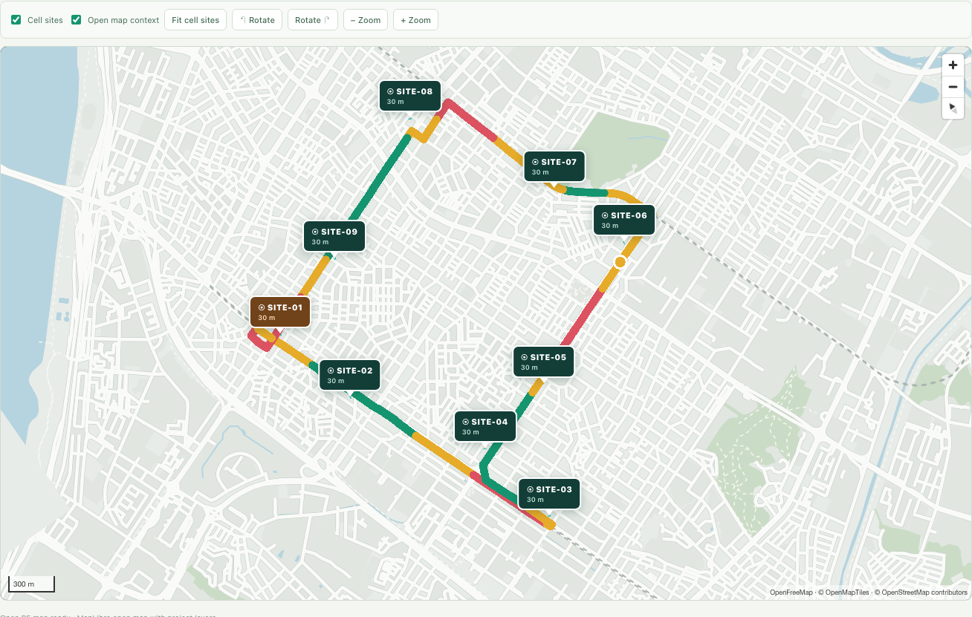
Figure 1 Project sites and a GPS route colored by SINR in the synthetic Gangnam example

Use the geographic view
1. Choose 2D map or Project 3D. Use Fit cell sites or Fit drive route to recover the relevant extent. Select a site marker or list entry to inspect that site.
2. Use Load building GeoJSON for project RF geometry. Polygon coordinates are [longitude, latitude]. Open street tiles provide context; Use visible map buildings explicitly adopts footprints and replaces the saved scene and paths.
3. Use KPI and Technology controls to show RSRP, RSRQ, SINR, or throughput for LTE and NR samples. Click a route point or scrub the inspector to review its source identity and values.

Read drive analysis
Open Validation and Optimization > Virtual drive test and use its analysis view. Select Radio access and Color route by, then use Play trace, the sample cursor, Event timeline, or Weak-zone review to inspect an observation. Analysis JSON exports the current diagnostic report.
Statistics use the available values of each KPI. Gray route points are missing values; gaps in the trend remain gaps. The 10th percentile is a lower-tail diagnostic, and the displayed weak thresholds are example bands. Serving-cell changes and annotated handovers do not establish successful network handovers. Geographic routes are not snapped to roads.
Mission control, City map, Sites and Cells, and the working-network lab share project map context and selection. Explore 3D city opens separate Silicon Valley examples; those buildings and example stations do not change project RF inputs.

Configure sites and cell sectors
Open Network Design > Sites and Cells. Use Search sites or the All, Positioned, and Needs location filters to find a site. Select the site, then choose a sector tab before editing cell-specific values. The selected site ID and cell ID identify the target of each change.

Add and position a site
1. Select New site to reach Add a planned site. Enter a name and the project X and Y positions in percent, then select Add site. A new planned site starts with three sectors.
2. Open Position in the selected-site inspector. Enter Latitude and Longitude in degrees and Height (m). Leave each field to save it, then verify All changes saved.
3. When Place on map is available, select it and choose the geographic point in City map. Review the resulting coordinates before using them in a study.
4. Use Fit sites and switch between 2D map and 3D scene to inspect the layout. In 3D, the station and its label use the saved mounting height.

Use the selected site inspector
Tab | Controls and purpose
Summary | Site name, position, height, technology, front end, cell targets, and measurement associations.
Position | WGS84 coordinates, mounting height, optional map placement, and project scope position.
RF | Radio technology, RU model or part number, band declaration, cell Tx power, and bandwidth.
Antenna | Sector bearings, Antenna or MMU front end, azimuth, downtilt, and MMU declarations when selected.
Topology | Planned architecture boundaries and links to RAN topology and measurement identities.

Check units before saving
Input | Allowed range
Latitude and longitude | Latitude -90 to 90 degrees; longitude -180 to 180 degrees
Mounting height | 1 to 300 m
Sector azimuth and downtilt | Azimuth 0 to 359 degrees; downtilt 0 to 30 degrees
Cell power and bandwidth | Tx power 0 to 60 dBm; bandwidth 5 to 400 MHz
MMU array elements | 1 to 1,024 when the MMU configuration is used

Text and numeric fields save when focus leaves the field; selections save on change. If a value is rejected, read Input rejected and enter a permitted value. Changing Map X position or Map Y position replaces geographic coordinates with a map estimate, so recheck supplied WGS84 locations after using those controls.
These are working-network planning inputs. Antenna patterns, vendor compatibility, and topology relationships remain unverified. Sector power, tilt, azimuth, and bandwidth can be retained in a candidate, but the current isotropic local path runner cannot execute those candidate changes. Use page 6 to preserve an experiment independently of the working network.

Define studies and preserve scenarios
Use a study to record the decision and retain the exact engineering inputs behind an experiment. The working network remains editable; a baseline and earlier candidate revisions retain their original values.

Define and freeze the study
1. Open Data and Twin Setup > Study definition. Enter Study objective and Operator declaration, choose Study RAT, and optionally enter Carrier frequency (MHz) and the observation window.
2. Select Save study definition. Each save retains the preceding version. The operator and dates describe the intended scope; they do not verify source evidence.
3. Review sites, coordinates, geometry, and the working measurement dataset. Confirm the database save, then open Network Design > Baselines & candidates.
4. Expand Capture baseline inputs, enter Baseline name, and select Capture baseline. The capture includes the saved network, geometry, evidence, and current definition.
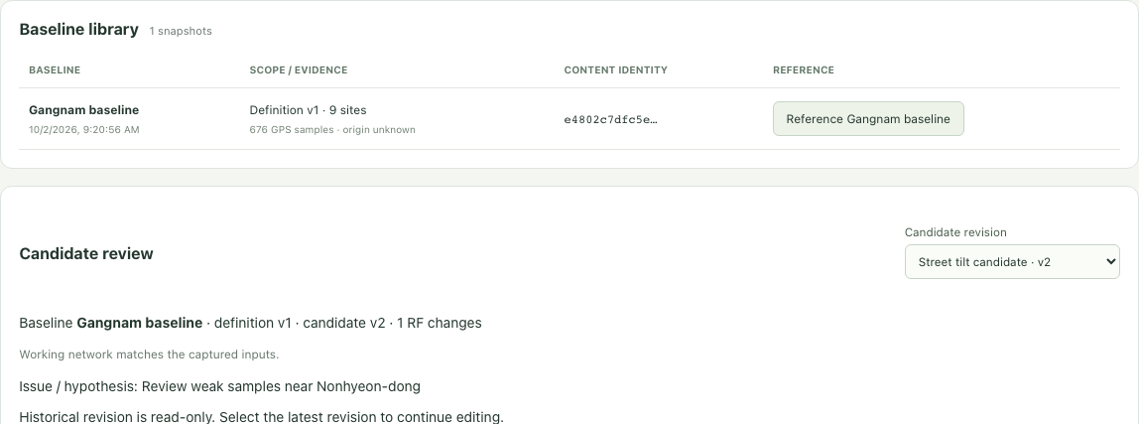
Figure 2 The baseline library and selected candidate revision retain the study context

Create and revise a candidate
1. Expand Create a candidate scenario. Choose Candidate baseline, enter Candidate name and a hypothesis, then select Create candidate.
2. Choose the latest Candidate revision. Select Candidate site, RF parameter, and Candidate sector where required. Enter Candidate value and select Save candidate revision.
3. Review Exact candidate changes: baseline value, candidate value, and delta. Revert removes a proposed change by saving another revision. Historical revisions remain read-only.
4. Select Review propagation inputs. In the lab, verify Propagation input version; its geometry, sites, and evidence must match the intended baseline or candidate revision.
Walkthrough example: capture a baseline, create a height candidate, and propose 35 m for the transmitter whose baseline height is 30 m. The delta is +5 m. This is a modeling exercise. The runner supports a height change on the selected transmitter; sector changes or changes on another site block execution. SHA-256 preserves content identity, not physical calibration.

Inspect propagation and run local paths
Open Simulation and Experiments > Ray tracing lab. Propagation input version selects the working network, a baseline, or a candidate revision. Captured network inputs are read-only; select Working network to import replacement geometry or evidence.

Inspect geometric paths
1. Expand Scene inputs and load building GeoJSON, or adopt visible map buildings. The street basemap alone is not solver geometry.
2. Choose a positioned transmitter. Place receiver on the map or enter its coordinates and height. Place transmitter edits working-network coordinates and is disabled for frozen inputs.
3. Select Trace geometric paths. Toggle Direct & blocked paths and Wall reflections. Select a candidate in Path inspector to read distance, travel time, and interactions.
The preview shows direct paths and up to twelve single wall reflections on flat ground. Radio power, material loss, diffraction, terrain, indoor links, and drive KPIs are excluded. A blocked candidate does not reach the receiver.

Enable the optional local solver
The optional solver uses an isolated runtime. Install uv, then run from the checkout:
npm run rt:setup
npm run test:rt
npm start
Restart an existing server after setup. CPU tracing requires a working LLVM backend. Read the runtime message and verify the backend with the real smoke test; native Windows path execution requires local verification.

Submit a bounded path job
Job setting | Current limit
Receiver height | 0 to 300 m; receiver must be within the map scope
Frequency | 0.5 to 100 GHz; study frequency is entered in MHz
Samples per source | 1,000 to 200,000
Maximum path depth | 0 to 4
Scene and execution | At most 100 footprints; one job at a time; 180 second limit

1. Confirm the input version, transmitter, receiver, frequency, samples, and depth. Keep the scene within the solver limit.
2. Select Run Sionna-RT paths and follow its status. Each job freezes engineering inputs, receiver, options, and solver profile, including seed 42.
3. After completion, choose Saved solver paths and inspect a path. Download ray results exports its JSON. Import ray path JSON displays compatible external results.
Local output uses concrete buildings and ground, isotropic antennas, and no refraction; it remains uncalibrated. Imported paths remain unverified. Neither path view predicts imported RSRP, SINR, or throughput.

Review runs and recover interrupted work
Open Simulation and Experiments > Jobs & runs. The list contains server-recorded local Sionna-RT jobs for the active project. Delivery tasks in Task board and Schedule remain separate planned work.

Inspect a recorded run
1. Select Refresh run list, then choose a run. Use Load older runs when more retained records are available.
2. Read the run ID, creation time, status, path count, errors, and frozen input summary. Check the baseline or candidate reference and dataset origin before interpreting its output.
3. Expand Run lifecycle to inspect events and Frozen request and result JSON to inspect retained settings and results. Active selected runs refresh their status automatically.
Status | Meaning and next action
queued | The frozen request was accepted; wait for the worker.
running | The local worker is executing; monitor or request cancellation.
cancelling | Cancellation was requested; the worker slot remains occupied until exit.
complete | The job returned output; inspect paths and retained assumptions.
failed | Read the error; repair the environment or inputs before another job.
interrupted | The server restarted before termination; consider an exact-input retry.
cancelled | The worker stopped and its subsequent output was discarded.

Cancel or retry
Use Cancel path job for a queued or running job when supported; wait for cancelled before reusing the worker slot. Failed, interrupted, or cancelled captures can offer Retry frozen inputs. It creates a linked run with the original inputs, receiver, options, and seed, excluding later working-network edits.
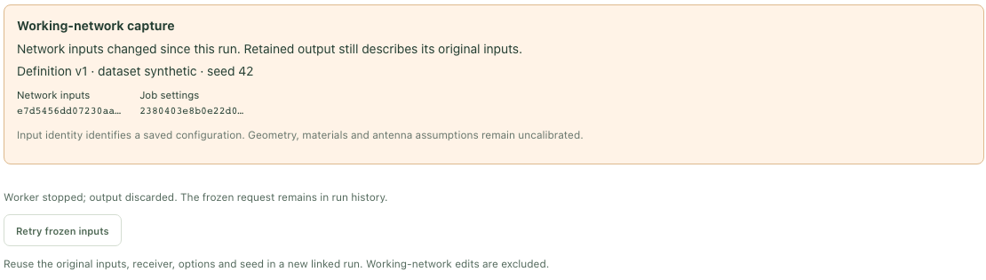
Figure 3 A cancelled run retains its captured request and offers an exact-input retry
Use Refresh accepted run if an accepted request could not refresh. Legacy runs without a frozen request require a new lab job. Retry needs an available solver, active project, and confirmed save.

Keep historical results with their inputs
Working-network edits can make output stale and prevent overlay. For candidate output, select its captured revision in Propagation input version. Retained paths remain inspectable and exportable. Baseline versus candidate KPI comparison is pending.

Use supporting tools and export artifacts

Prepare related work
Workspace | How to use it and what it produces
RAN topology | Record vCore and vDU endpoint labels and review real versus virtual boundaries. Labels do not establish a live connection.
Virtual UE fleet | Set population, mobility profile, and seed. The allocation preview plans software UEs; no UE processes execute.
Virtual drive test planning | Choose a route and samples, scrub its preview, and export its job plan. Playback does not generate measured RF KPIs.
Package A/B test | Enter two package IDs, paired seeds, and guardrails. Export A/B experiment plan retains the matrix; no packages run or winner is selected.
AI-RAN data generation | Specify the task, schema, scene variants, and split plan, then export the dataset job plan. Generated rows remain zero.
Hardware and Software | Record planned inventory, aliases, capacity, and version targets. Discovery, installation, and compatibility are unverified.
Monitoring | Set planning thresholds. Offline or no-data status means live telemetry is unavailable.
Task board and Schedule | Add planned work, dependencies, and dates. Invalid prerequisite order is rejected; dates do not dispatch tasks.

Export a project handoff
1. Confirm the active project and save status. In Operations and Reports > Activity, review the recent local changes.
2. Select Export planning manifest to download the saved preparation configuration and use-case plans. This is a planning exchange file, not a full archive of the workspace database and run history.
3. Open Project artifacts. Browse configuration, test-results, logs, and reports; select a file and use Download file. Export original measurement CSVs and normalized snapshots from Measurement datasets, and path JSON from the lab, as needed.
4. To load a planning exchange file, use Import planning manifest in Project artifacts. A valid import creates a separate project and keeps the existing project. The manifest limit is 3 MB.

Edit configuration files deliberately
Select an editable JSON artifact, choose Edit JSON, make the change, then select Save to project. The application validates it before applying it. Use Cancel to abandon the editor draft. Generated manifests and logs reflect saved state; the JSON editor does not permit rewriting retained study history.
Edited ray paths lose local solver provenance and become unverified. Saving project.json resets readiness and execution claims. Exported planning manifests do not preserve verified solver provenance. Keep the source CSV, interpretation, frozen reference, run ID, assumptions, and raw path output together when reviewing an experiment.
For a reproducible handoff, state the study objective and version, dataset origin, chosen baseline or candidate revision, and the run status. The experiment plan, diagnostic analysis, and local path result each answer a different question.

Troubleshooting and quick reference
Symptom | Action
The page does not open | Keep the server terminal running and use its printed HTTP URL. An explicit occupied port requires a different port; default startup may select a later port.
A workspace is missing | Choose All workspaces and expand its sidebar section. On a narrow screen, open Navigation. Confirm the intended active project.
CSV validation fails | Check file and row limits, required mappings, units, coordinates, and supplied numeric values. Fix the source and select Validate and preview again.
Gray route points or an empty KPI trend | Check KPI availability and the LTE / NR filter. Missing observations remain unavailable; do not replace them with zero.
A site is absent from the geographic map | Set both WGS84 coordinates in Position, confirm the save, enable Cell sites, and use Fit sites or Fit cell sites.
Trace or Run is disabled | Load RF footprints, position the selected transmitter, enter a receiver within scope, and check runtime and save status. Frozen inputs are read-only.
A candidate cannot execute | Use a height-only change on the selected transmitter. Sector parameters and other-site changes are unsupported by the current local solver.
The runtime is unavailable or a job fails | Run optional runtime setup and its real smoke test, then restart the server. Read the job error; also check the 100-footprint and 180-second bounds.
Saved paths cannot overlay | Select their captured input version. Working-network edits can make output stale; inspect or export retained results before preparing another run.
The measurement library save is rejected | Check the 20-version, 2 MB library, and 3 MB project limits. Retained history is not pruned automatically.

Resolve a database save conflict
Another browser tab can save a newer workspace revision. The application retains your local draft and offers a read-only database comparison, a save retry, or a database reload. Inspect the comparison first. Retry does not silently overwrite the newer revision; if the conflict remains, preserve the draft and reload only when ready to discard it. Complete the explicit discard confirmation before loading database state. For an unavailable database, restore the local server and use the displayed retry action.

Key terms
RAN means radio access network. RAT means radio access technology; LTE and NR identify 4G and 5G. A site groups radio cells, and a sector is a cell with a planned bearing. RSRP is reference signal received power in dBm; RSRQ and SINR are quality and interference measures in dB. DL and UL are downlink and uplink throughput in Mbps.
A baseline freezes saved engineering inputs. A candidate revision records changes against that baseline. A frozen run request retains the selected inputs and solver options. SHA-256 identifies content integrity. WGS84 / EPSG:4326 uses latitude and longitude in degrees; GeoJSON stores coordinate pairs as longitude, latitude.
Program references: repository README and engineering enhancement implementation notes. Figure values are example configurations. Run npm run help for command guidance.

