Michaud Resampled Efficient Portfolios
Markowitz (1959) mean–variance (MV) portfolio optimization has been the practical standard for asset allocation and equity portfolio management for almost 50 years. However, it is known to be overly sensitive to estimation error in risk-return estimates, which typically results in an unstable asset management framework, ambiguous portfolio optimality, and poor out-of-sample performance. Tests demonstrate that unbounded MV optimized portfolios are dominated by equal weighting and have essentially no practical investment value. The Resampled Efficiency (RE) techniques presented in Michaud (1998) introduce Monte Carlo methods to properly represent investment information uncertainty in computing MV portfolio optimality. Actually, RE optimization is an enhancement of Markowitz’s solution.
MV Optimization Limitations
The problem that limits the investment value of MV optimized portfolios is not Markowitz’ theory. Markowitz gives the right way to invest given that you know that you have exactly the correct inputs. The most serious problem is estimation error, or parameter uncertainty, in optimization inputs. Risk-return estimates are highly uncertain in investment practice and sensitivity to changes in optimization inputs leads to portfolio optimality ambiguity.
Fusai and Roncoroni (2008) point out that the limitations of MV optimized portfolios fall into three categories:
1. Low Degree of Diversification.
MV portfolios often involve very extreme positions. In particular, as the number of assets grows, the weight on each single asset does not tend to zero as suggested by a naïve notion of diversification;
2. Sudden Shifts.
Sudden shifts in the allocation of the optimal weights along the efficient frontier, i.e., the composition of the optimal portfolio are very different for individuals that differ slightly in their attitude towards risk;
3. High Sensitivity
High sensitivity of portfolio weights to small variations in expected returns. Since little changes in expected returns can completely alter the composition of MV optimal portfolios, while modifications in the variance-covariance matrix have smaller impact, it follows that errors in the sample estimates of expected return have great bearing on allocation choices.
As consequence, MV optimized efficient portfolios constructed using sampled means and sampled variance-covariance matrix from a given population generally score badly once their performance is verified using out of sample data. MV optimization creates unrealistic portfolios leading to likely underperformance even with informative inputs.
RE Technology
RE technology introduces Monte Carlo resampling and bootstrapping methods into MV optimization to more realistically reflect the uncertainty in investment information. The end result is generally more stable, realistic, and investment effective MV optimized portfolios.
Generally speaking, RE optimal portfolios are constructed as follows:
Step 1. Sample a mean vector and covariance matrix of returns from a distribution of both centered at the original (point estimate) values normally used in MV optimization.
Step 2. Calculate a MV efficient frontier based on these sampled risk and return estimates.
Step 3. Repeat Steps 1 and 2 (until enough observations are available for convergence in Step 4).
Step 4. Average the portfolio weights from Step 2 to form the RE optimal portfolio.
Step 5. (optional) Apply investability constraints to Step 4.

Comments: Step 1 is typically done with resampling, or bootstrapping. In this contest, bootstrapping generally refers to the technique of redrawing historical observations with replacement. Resampling typically refers to recreating the simulated history from an assumed probability distribution such as multivariate normality.
Example 1 (Resampled Efficient Frontier Portfolios: An Average of MV Optimal Portfolios)
Data Set
A Standard & Poor’s 500 list of stocks and their market capitalizations were taken as of October 2006. The market capitalizations were discounted back via monthly total returns to approximate market capitalizations in January 1997. The 20 Large Cap stock set was taken from a random sample of the 100 largest of these market capitalization stocks. Ten years of complete monthly returns for the sample spans January 1997 through December 2006.
Table 1 Twenty stock data set: return and standard deviation
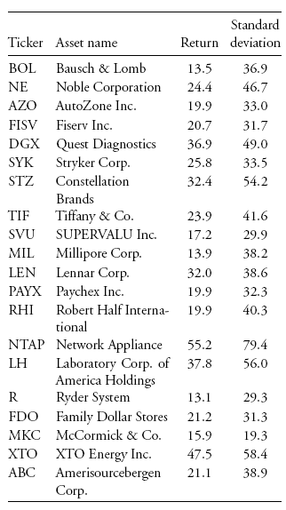
Table 2 Twenty stock data set: correlations
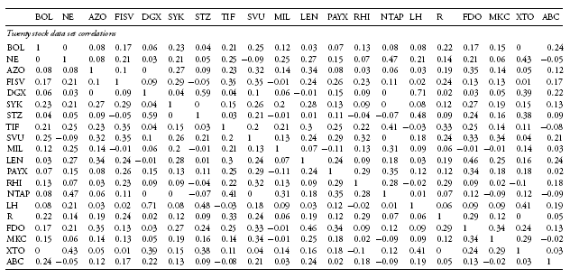
Resampled Efficient Frontier Portfolios: An Average of MV Optimal Portfolios
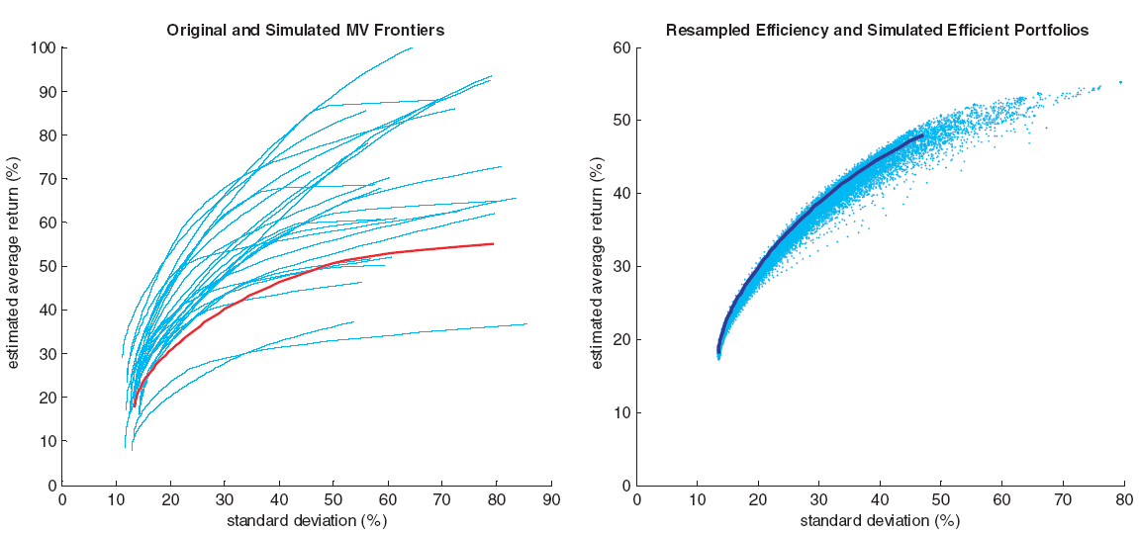
Figure 1 Original and simulated MV frontiers and the Resampled Efficient Frontier.
The left-hand panel in Figure 1 illustrates the resampled simulated MV efficient frontier procedure for 20 randomly chosen large cap stocks in the S&P500 index. The red curve is the classical Markowitz MV efficient frontier. Twenty-five (cyan) simulated MV efficient frontiers, using the repeated two steps, are also displayed. Note the enormous dispersion of the simulated frontiers. Some simulated frontiers have roughly half the range of risk of the original MV efficient frontier while others have significantly more risk. The range of returns among the simulated frontiers is even more impressive considering that the experiment reflects 10 years of data from well known securities in a major index. Since each of these frontiers represents MV portfolio optimality, MV efficiency may seem almost beyond hope of definition when estimation error is considered. The left-hand panel provides a vivid rationale for why investment managers typically avoid using MV optimization in practice or over manage the process and impose many constraints.
Each simulated efficient frontier in the left-hand panel consists of 51 portfolios from low to high return. The right-hand panel plots the risks and returns of all the portfolios computed from all the simulated efficient frontiers in the left-hand panel in terms of the risk-return estimates. RE optimization converts the simulated MV efficient frontiers into a single frontier, as displayed in the right-hand panel.
The procedure for computing the Resampled Efficient Frontier (REF) in the right-hand panel can be motivated as follows. Every simulated MV efficient frontier in the left-hand panel of Figure 1 is the right way to invest given a set of inputs. But the inputs are highly uncertain. How should an investor deal with portfolio optimality uncertainty?
In the case of a highly risk-averse investor, the minimum variance portfolio is the optimal portfolio for any given efficient frontier. Since all simulated frontiers are equally likely, the RE optimal minimum variance portfolio is defined as the average of the portfolio weights of all the simulated minimum variance portfolios. The RE optimal minimum variance portfolio is plotted at the base of the curve in the right-hand panel in Figure 1 relative to the risk-return estimates of the data in Table 1 and 2.
Alternatively, consider an investor who is indifferent to risk. In this case, the maximum return portfolio is the optimal portfolio for any given simulated efficient frontier. The RE optimal maximum return portfolio is defined as the average of the portfolio weights of all the simulated maximum return MV optimal portfolios; it is plotted at the top of the curve in the right-hand panel.
Similarly, RE optimality can be defined for the utility function that characterizes an investor’s behavior. The average of the tangent portfolios on simulated MV efficient frontiers relative to the constant expected utility curve defines the RE optimal portfolio. The Resampled Efficient Frontier is the collection of all possible RE optimal portfolios with risk aversion parameters from expected utility curves ranging from total risk aversion to total risk indifference. More generally, the REF is based on averages of all properly associated optimal portfolios on the simulated MV efficient frontiers. Mathematically, it is an integral in portfolio space, over all possible return distributions consistent with the forecast, of the expected value of the MV optimal portfolio weights conditional on the constraints. The resampling/bootstrap process is a Monte Carlo method for estimating this integral. Since REF portfolios are an average of many properly associated MV optimal portfolios, they are safer, less extreme investments.
Example 2 (RE Portfolios are Stable, Robust, Diversified, and Investment Effective)
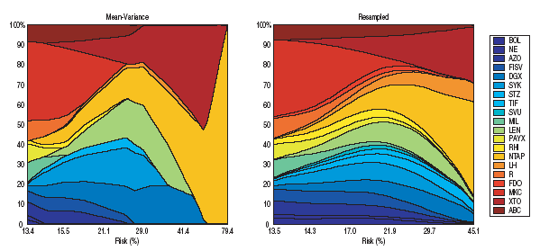
Figure 2 MV and RE frontier portfolio composition maps.
Figure 2 provides an illustration of portfolio composition differences in MV and RE optimization. The exhibit is a portfolio composition map of the MV and RE optimal asset allocations (MV and RE frontiers for the data in Table 1 and 2); it displays the allocations from minimum risk on the left-hand side of the charts, to maximum return on the right-hand side of the charts. Each color represents a particular stock. A vertical slice of the chart demonstrates the weights of each stock in the portfolio at that level of risk. The left-hand panel is the composition map for MV efficiency; the right-hand panel represents RE optimality. In the classical case no more than seven of the twenty stocks are included in the MV efficient frontier for the upper half of the curve, while three stocks are missing over the entire spectrum of risk. Similar examples can be found on nearly every MV frontier.
The composition map for the REF illustrates very different properties. REF optimality includes all assets. There is a smooth transition from one risk level to another. RE optimization is robust and fundamentally different in character and allocations even when the two frontiers are similar in mean–variance space.
One of the most attractive features of REF optimized portfolios is that they often reflect investment sense. As one illustration, consider the maximum return MV and RE efficient portfolios. As Figure 2 indicates, the maximum return MV optimal portfolio represents a 100% bet in NTAP stock. In contrast, the maximum return REF portfolio is very well diversified and a much less risky more acceptable investment. More generally, REF optimized portfolios are often consistent with the intuition of professional managers across the entire frontier without the need for constraints.
Conclusion
RE is an important new tool for defining portfolio efficiency in practice. It is useful for understanding the statistical characteristics and practical limitations of MV efficiency. In addition, in the context of a relevant constraint prior, it is provably effective on average at enhancing the out-of-sample investment value of optimized portfolios. Relative to MV efficiency, resampled efficient portfolios are also likely to be more robust and investment intuitive, two useful characteristics in many institutional contexts.
Comments:
This approach does not make any assumption on the estimation error and the distribution of the returns; it is a non-parametric approach. Instead of using the historical mean and variance of a given security over an entire period, Michaud breaks up the entire period over a number of sub-periods and constructs a set of mean variance optimal portfolios for a set of sampled sub-period. By taking the average of all sampled-portfolio weights, the final portfolio weights are then calculated and used to construct a more robust and efficient mean variance portfolio. Resampled efficiency is an averaging process that combines all the alternative efficient frontiers in a new efficient frontier with optimized portfolio weights. Intuitively, resampled efficient portfolios are optimal with respect to the many ways that assets and capital markets can perform in the investment period. Because resampled efficiency is an averaging process, it is very stable. Small changes in the inputs are generally associated with only small changes in the optimized portfolios. Resampled optimal portfolios are typically very investment intuitive without the need for constraints. This is because the uncertainty in your information, which is ignored with classical optimization, is being considered when defining the resampled optimized portfolio. Most importantly, resampled efficiency can be shown to improve investment performance, on average.
A stock with a recent run up doesn’t tell you anything about the future returns of the stock. Based on consumption CAPM, our relative risk aversion is not constant over time and it varies as a function of absolute level of aggregate wealth. As the aggregate wealth goes up the risk aversion goes down (investors take more risk) and vice versa. If you have seen very high stock return recently, that may forecast that forward looking return may be low, because you are in a period where the risk aversion of the average investor is lower. Conversely, when the market collapses, (aggregate wealth has fallen) we could expect to see higher risk aversion. Michaud’s methodology reduces the portfolio exposures to outliers - stocks that had a recent run up.
References
Fusai, G. and Roncoroni, A. (2008). Implementing Models in Quantitative Finance: Methods and Cases. Springer, New York.
Markowitz, H. (1959). Portfolio Selection: Efficient Diversification of Investments. 2nd edn. Wiley, New York.
Michaud, R. (1989). The Markowitz Optimization Enigma: Is Optimization Optimal? Financial Analysts Journal. 45(1), 31–42.
Michaud, R. (1998). Efficient Asset Management. Harvard Business School Press, New York. (Now published by Oxford University Press.)
Michaud, R. and Michaud, R. (2008). Efficient Asset Management. 2nd edn. Oxford University Press, New York.
Michaud, R. and Michaud, R. (2008). Estimation Error and Portfolio Optimization: A Resampling Solution. Journal of Investment Management. 6(1), 8-28.

