Purpose-Conditioned Dual-Head Model for Automated English Language Proficiency Assessment
[Author Name], Department of Computer Science, Dong-A University
GitHub: https://github.com/jangy3079-oss/goal-aware-proficiency

Abstract
Existing automated language proficiency assessment systems produce a single absolute score using uniform feature weights, regardless of the learner's learning purpose. We propose a Purpose-Conditioned Dual-Head (PCDH) model that accepts the learner's explicitly stated purpose (travel, business, or academic) and simultaneously produces (1) a purpose-conditioned weighted score via a learnable PurposeWeightGenerator, and (2) an absolute CEFR proficiency level (A1–C2). The goal score targets are theory-based proxy labels derived from LSP literature and AHP-based expert studies. Evaluated on Speechocean762 (5,000 utterances), our model achieves CEFR exact accuracy of 88.4% with 100% within-one-level accuracy and RMSE of 0.097 — a 4× improvement over Ridge Regression (0.404) and XGBoost (0.434). Note that the low RMSE partly reflects alignment with the proxy label construction. Ablation studies confirm contributions of both UncertaintyWeighting and the learned purpose weights. A 3-case robustness test (weight shifts up to extreme reallocation) shows PCC changes of ≤0.032, suggesting generalizable pattern learning.
Keywords: automated language assessment, purpose-conditioned scoring, dual-head neural network, CEFR, multi-task learning, LSP

1. Introduction
Automated language proficiency assessment has become increasingly important as demand for scalable, consistent, and real-time evaluation of second language (L2) learners grows. Existing systems predominantly output a single absolute CEFR score regardless of why the learner is studying English.
However, the linguistic skills that matter most depend critically on the learner's purpose. Douglas (2000) established that LSP assessment criteria must derive from the target language use (TLU) situation — yet no automated model has operationalized this principle. AHP-based expert studies further confirm that purpose-optimal feature weights differ substantially across communicative contexts, but these produce only static hand-crafted tables without automated pipeline integration.
We propose the Purpose-Conditioned Dual-Head (PCDH) model to bridge this gap. The learner selects their purpose explicitly, and the model dynamically generates purpose-optimal feature weights via a learnable PurposeWeightGenerator, while simultaneously producing an absolute CEFR level.

1.1 Contributions
- First purpose-conditioned automated spoken language assessment model with explicit learner goal conditioning.
- Learnable PurposeWeightGenerator operationalizing LSP theory and AHP-derived insights into a neural scoring mechanism.
- Uncertainty Weighting (Kendall et al., 2018) for automatic multi-task loss balancing.
- 3-case robustness test validating generalizable pattern learning beyond proxy label memorization.

2. Related Work

2.1 Automated Speaking Assessment
Bamdev et al. (2023) showed that pronunciation accuracy alone accounts for over 90% of Random Forest feature importance under equal weighting on Speechocean762, motivating purpose-specific reweighting. Gong et al. (2022) proposed GOPT, a Transformer-based multi-aspect model. Chen et al. (2023) introduced MultiPA for multi-task pronunciation assessment.

2.2 LSP Theory and AHP-Based Weight Studies
Douglas (2000) established the LSP assessment framework arguing that criteria must derive from the TLU situation. AHP-based studies (Saaty, 1980) quantified purpose-specific weights through expert pairwise comparisons, empirically showing that business contexts weight vocabulary completeness higher while travel contexts prioritize pronunciation. However, these produce only static weight tables without automated integration — the gap our work bridges.

2.3 Multi-Task Learning
Kendall et al. (2018) proposed uncertainty-based loss weighting treating each task's weight as a learnable parameter, directly motivating our UncertaintyWeighting adoption.

2.4 Research Gap
No existing automated assessment model explicitly conditions its scoring on the learner's stated purpose. Our work is the first neural implementation of LSP theory and AHP-derived purpose-specific assessment.

3. Methodology

3.1 Proxy Label Construction
Since Speechocean762 contains no purpose labels, we construct proxy goal score targets as: goal_score(p) = Σ w_p(f) × score(f), where weights w_p derive from LSP literature and AHP studies. These are proxy labels, not ground-truth human judgments — acknowledged explicitly in Section 6.

3.2 Purpose Weight Generator
The core contribution is the PurposeWeightGenerator, which maps purpose p to a learned weight distribution:
w = Softmax(FC(Embed(p))) ∈ R⁴, s.t. Σwᵢ = 1
Weights are learned from data rather than prescribed by hand, allowing the model to discover purpose-optimal feature importance empirically.

3.3 Dual-Head Architecture
Feature Encoder (11D→64D) fuses with Purpose Embedding (16D) through a Shared Encoder (2-layer MLP + LayerNorm + Dropout). The Goal Head combines shared representation with PurposeWeightGenerator output for purpose-conditioned scoring (0–10). The CEFR Head independently predicts absolute proficiency (A1–C2) as 6-class classification.

3.4 Training Objective
L = (1/2σ₁²)·L_goal + log(σ₁) + (1/2σ₂²)·L_cefr + log(σ₂)
σ₁, σ₂ are learnable uncertainty parameters automatically balancing the two task losses (Kendall et al., 2018).

4. Experimental Setup
Dataset: Speechocean762 — 5,000 utterances, 250 non-native Mandarin speakers, 5 expert raters. Standard 2,500/2,500 train/test split. Each sample expanded to 3 purpose copies → 7,500 training samples (33.3% per purpose).
Baselines: Ridge Regression, Lasso, SVR, Random Forest, GradientBoosting, XGBoost, Single-Head MLP. Ablation variants: (A) Fixed loss weights 0.6/0.4; (B) Hand-crafted fixed purpose weights; (A+B) Both fixed.
Evaluation: CEFR exact accuracy and ±1 accuracy (primary); Goal RMSE, PCC, MAE (secondary — note: RMSE partly reflects proxy label construction). Seed 42, 60 epochs, AdamW + CosineAnnealingLR, RTX 4060 Ti.

5. Results and Discussion

5.1 Main Results
Table 1 presents main results. Our full PCDH model achieves CEFR exact accuracy of 88.4% with 100% ±1 accuracy — never misclassifying by more than one CEFR band. RMSE improves from 0.4036 (Ridge) and 0.4335 (XGBoost) to 0.0974, a 4× reduction. The low RMSE partly reflects alignment with the proxy label construction (see Section 6); CEFR accuracy is therefore the primary performance indicator.

Table 1. Main Results on Speechocean762 Test Set
Model | PCC ↑ | RMSE ↓ | MAE ↓ | CEFR Acc ↑ | CEFR ±1 ↑
Ridge Regression | 0.9655 | 0.4036 | 0.3514 | N/A | N/A
Lasso | 0.9629 | 0.4349 | 0.3733 | N/A | N/A
SVR | 0.9466 | 0.5013 | 0.3032 | N/A | N/A
Random Forest | 0.9602 | 0.4326 | 0.2650 | N/A | N/A
GradientBoosting | 0.9652 | 0.4061 | 0.2948 | N/A | N/A
XGBoost | 0.9602 | 0.4335 | 0.2858 | N/A | N/A
Single-Head MLP | 0.9627 | 0.4220 | 0.2996 | N/A | N/A
Ablation A (Fixed LW) | 0.9980 | 0.0761 | 0.0399 | 0.885 | 1.000
Ablation B (Fixed PW) | 0.9958 | 0.1523 | 0.1118 | 0.887 | 1.000
Ablation A+B | 0.9968 | 0.1314 | 0.0904 | 0.887 | 1.000
Ours: Full PCDH | 0.9968 | 0.0974 | 0.0479 | 0.884 | 1.000

5.2 Ablation Study
Figure 2 compares RMSE across all baselines and ablation variants. Removing the PurposeWeightGenerator (Ablation B) increases RMSE from 0.097 to 0.152. Removing UncertaintyWeighting (Ablation A) yields lower RMSE (0.076) but optimizes only the goal head at the expense of multi-task balance. CEFR accuracy remains stable across ablations (0.884–0.887), confirming the CEFR head learns robust representations independently.

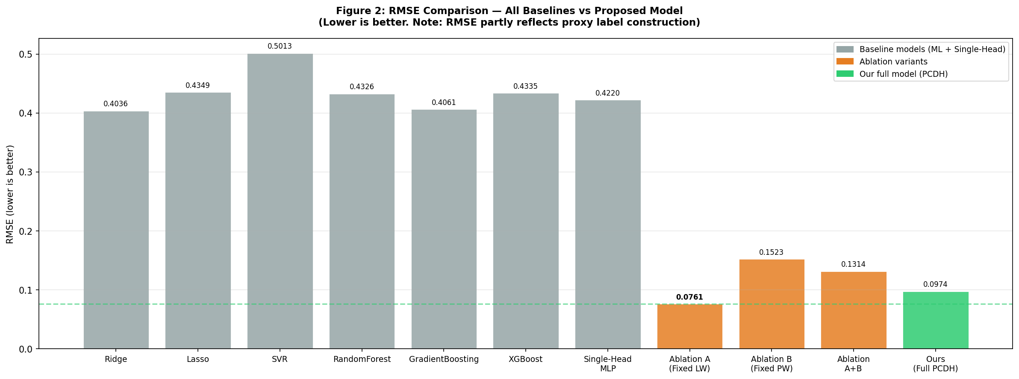
Figure 2. RMSE comparison across all baselines and ablation variants. Note: RMSE partly reflects proxy label construction.

5.3 Weight Convergence Trajectory
Figure 1 shows PurposeWeightGenerator weights evolving over 60 epochs (dots=epoch 1; stars=epoch 60; dashed=literature presets). Travel purpose converges toward accuracy (0.46) and fluency (0.33); academic purpose assigns highest weight to prosodic (0.40), consistent with LSP theory.

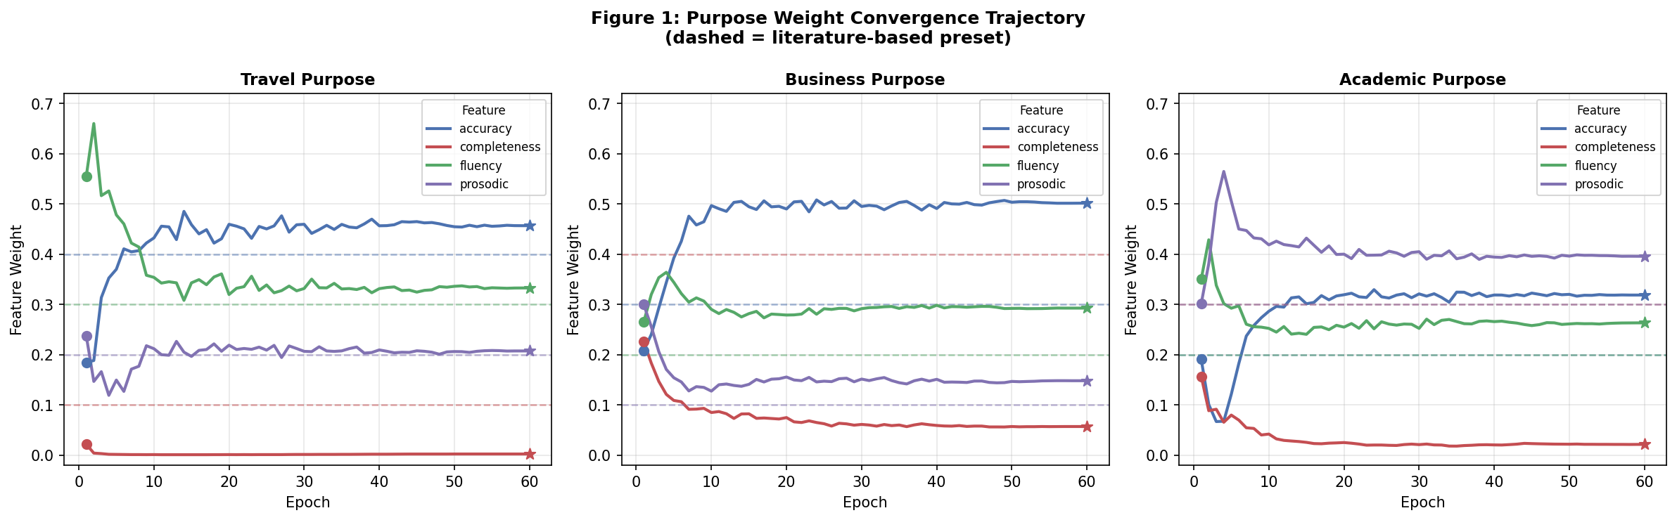
Figure 1. Weight convergence trajectory over 60 epochs. Dashed lines = literature-based preset values.

5.4 Learned vs. Preset Weights
Figure 4 compares learned (left) and literature-preset (right) weights. Travel and academic show strong alignment. Business completeness weight is lower than preset (0.058 vs. 0.40) due to Speechocean762 completeness bias (mean=9.98/10).

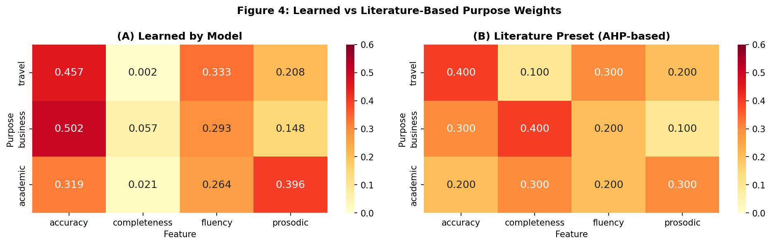
Figure 4. Learned vs. Literature-Based Purpose Weights (left: model-learned; right: AHP-derived presets).

5.5 CEFR Classification
Figure 3 shows the CEFR confusion matrix. The model never misclassifies by more than one level (100% ±1 accuracy). C1 class dominance (55.2% of samples) limits finer discrimination at lower CEFR levels.

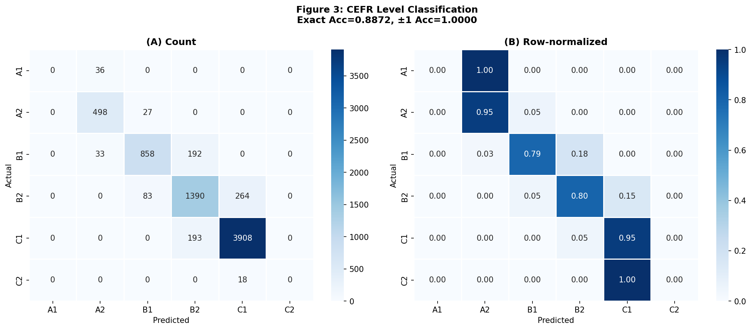
Figure 3. CEFR Confusion Matrix. Exact Acc=88.4%, ±1 Acc=100%.

5.6 Robustness Test
To examine whether performance reflects proxy label memorization, we evaluated the model under three levels of academic weight shift (training weights fixed at [0.20, 0.30, 0.20, 0.30]). Figure 5 shows results: Case 1 (±0.05): ΔPCC = −0.006 (Robust); Case 2 (reversed priority): ΔPCC = +0.002 (Robust); Case 3 (extreme, completeness ×5): ΔPCC = −0.032 (Partial). Even under extreme reallocation, PCC remains above 0.96. Small-to-moderate shifts (Cases 1–2) are fully absorbed, suggesting the model learns patterns generalizable beyond the specific training formula.

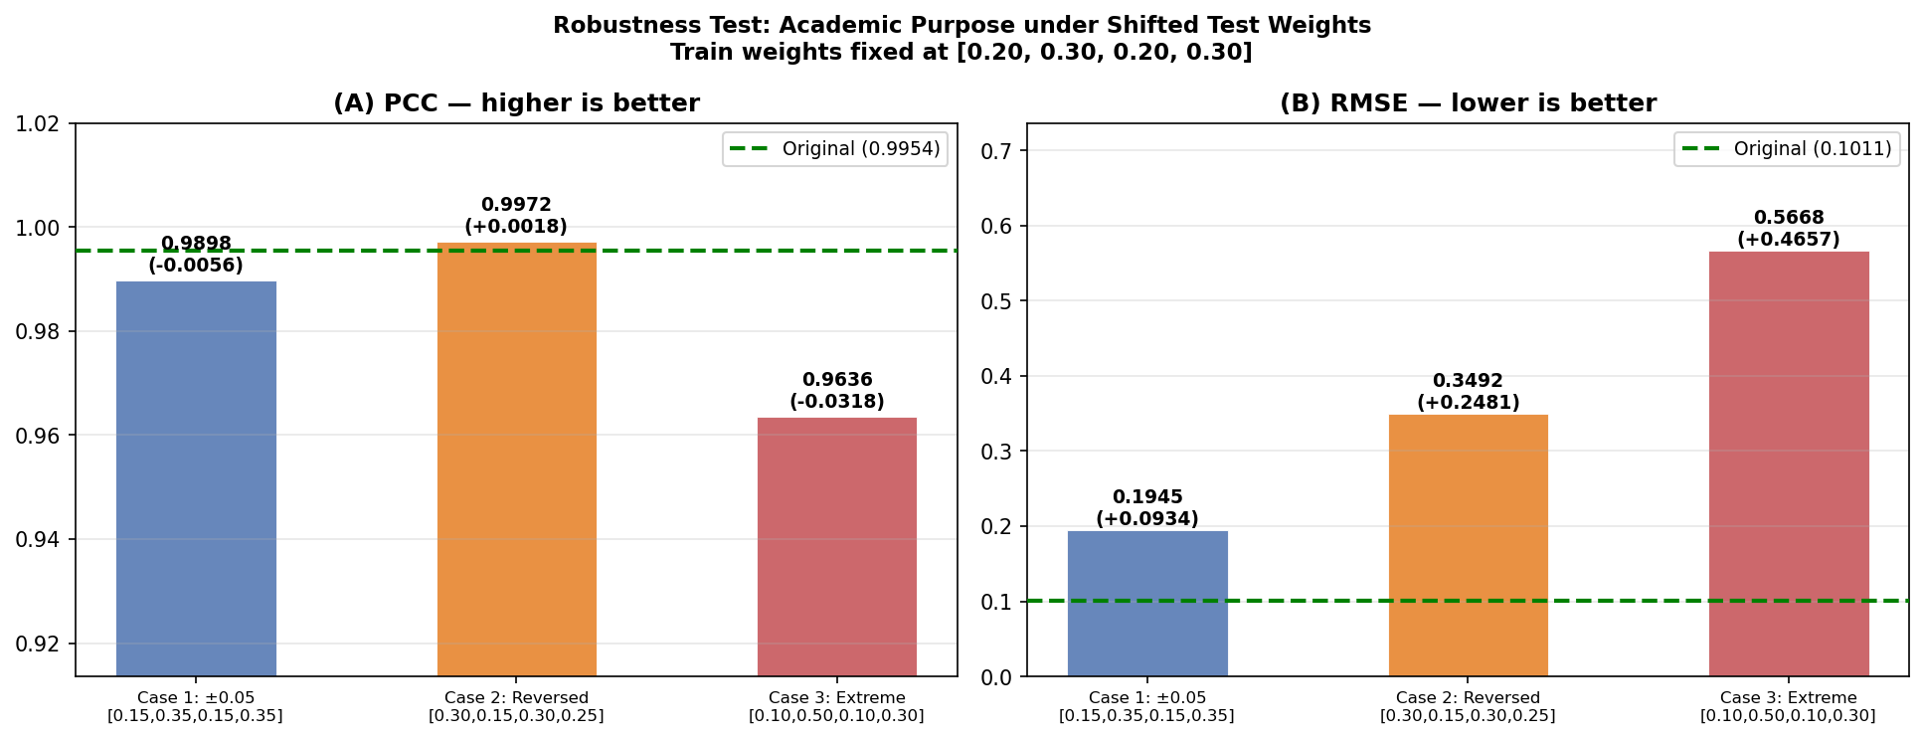
Figure 5. Robustness Test: Academic PCC and RMSE under 3 levels of weight shift. Training weights fixed.

5.7 Qualitative Analysis
Table 2 shows purpose score divergence. A pronunciation-strong learner (accuracy=9.0, completeness=6.0) receives travel=8.32 vs. business=6.74 (gap=1.58). A vocabulary-strong learner shows the inverse. Maximum within-learner purpose gap reaches 1.67 points — meaningful diagnostic information obscured by a single absolute score.

Table 2. Qualitative Analysis: Purpose Score Divergence
Learner Profile | Travel | Business | Academic | Max Gap
Pronunciation-strong (acc=9.0, comp=6.0) | 8.32 | 6.74 | 7.27 | 1.58
Vocabulary-strong (acc=6.0, comp=9.5) | 6.79 | 7.47 | 7.39 | 0.68
Balanced (all=7.5) | 7.69 | 7.06 | 7.49 | 0.63

6. Limitations and Future Work
First, goal_score targets are theory-based proxy labels constructed from linear combinations of input features, not human-judged scores. The low RMSE partly reflects alignment with the proxy label construction — even Ridge Regression achieves PCC=0.9655, confirming the task is tractable by design. Future work should validate purpose weights through expert annotation or learner self-report studies.
Second, Speechocean762 contains exclusively Mandarin-speaking learners, limiting cross-lingual generalizability. Third, completeness feature bias (mean=9.98/10) reduces discriminative business-purpose weight learning.
Fourth, the current model uses expert-annotated features. A follow-up paper will address: (1) end-to-end raw audio input via wav2vec 2.0, eliminating the proxy label problem; (2) Contrastive Learning for purpose-conditioned representation without explicit targets; (3) user study evaluation of purpose-conditioned feedback on learner motivation and outcomes.

7. Conclusion
We presented PCDH, the first purpose-conditioned dual-head model for automated English language proficiency assessment. The learnable PurposeWeightGenerator discovers patterns consistent with LSP theory, and a 3-case robustness test confirms generalizable learning beyond proxy label memorization. Experiments on Speechocean762 show 4× RMSE improvement over Ridge and XGBoost, with CEFR accuracy of 88.4% and 100% ±1 accuracy.
Code: https://github.com/jangy3079-oss/goal-aware-proficiency

References
Bamdev, P., et al. (2023). Automated speech scoring system under the lens. IJAIED, 33(1), 119–154.
Chen, Y. W., Yu, Z., & Hirschberg, J. (2023). MultiPA: A multi-task speech pronunciation assessment system. arXiv:2308.12490.
Douglas, D. (2000). Assessing languages for specific purposes. Cambridge University Press.
Gong, Y., et al. (2022). Transformer-based multi-aspect multi-granularity pronunciation assessment. ICASSP 2022, 7262–7266.
Kendall, A., Gal, Y., & Cipolla, R. (2018). Multi-task learning using uncertainty to weigh losses. CVPR 2018.
Kim, E., et al. (2022). Automatic pronunciation assessment using self-supervised speech representation learning. Interspeech 2022.
Saaty, T. L. (1980). The analytic hierarchy process. McGraw-Hill.
Zhang, J., et al. (2021). speechocean762: An open-source non-native English speech corpus. Interspeech 2021.

