1. Finding best clustering on data

GCML.AutoML provides functionality for automatically analyze and plot clustering results With this user documentation and walkthrough, you can find out how to use this module, and its function.

The advantages of using AutoML are:

* Effective when trying to find best effective clustering: User doesn’t have to worry about cost on developing on debugging or build code to analyze big dataset.
* Effective when trying to find with varying hyperparameters: User can input hyperparameter with other models another hyperparameters.
* User can use various scalers on dataset easily, so user doesn’t have to find out which scaler fits best on various clustering.
* User can find out how well the clustering has done with plot on their result: The best results will plot so user can eyeball the results.
  1. Finding clustering

User just have to do only one thing to model : Set only three core parameter: models , params and

Scalers used on finding out the best parameter. When the best parameter has computed, the module will plot its result.

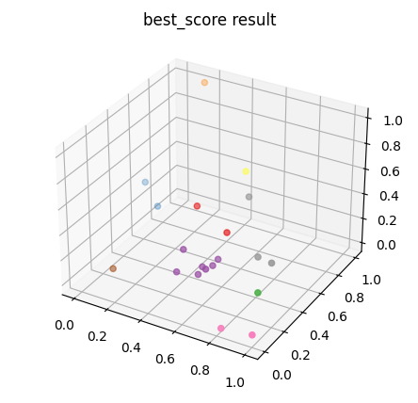

Example result: the best clustering result with scaled values.

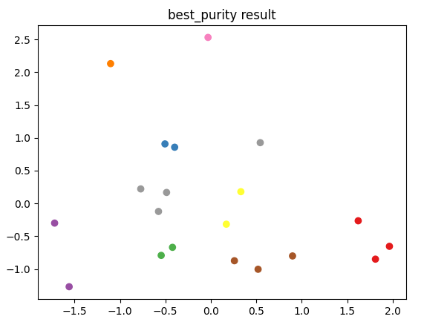

Also, this module supports 2-D plotting, user can see through plots.

Like the two results , after the computation is over, the module returns best data.

It shows both plots and various evaluation scores, such as silhouette score or purity score, and

T

1.2 Tips on practical Use

* Check if you input scalers in right form: If the scaler hasn’t implemented, the result doesn’t include effect of the scaler doesn’t included if the scaler you input hasn’t implemented yet.
* Check various hyperparameters: Hyperparameters are various: Find out which result is best.