Aguilar, Brian A. 2ECE-A   
Hapis, Jan Heidrich C. 12/08/2019

PROBLEM 1: Write a program that will implement the function

$$f\left(n\right)=\left\{\begin{aligned}n^{2}-7, \\ f\left(n-10\right),\end{aligned} \begin{matrix}n ≤9 \\ n ≥10\end{matrix}\right.$$

where 𝑛 is an integer and 𝑛 ≥ 0. Using your program, graph 𝑓(𝑛) from 𝑛 = 0 to 𝑛 = 99 using **stem()**.Provided with figures, describe and comment on the graph 𝑓(𝑛).

SOLUTION: **PYTHON**

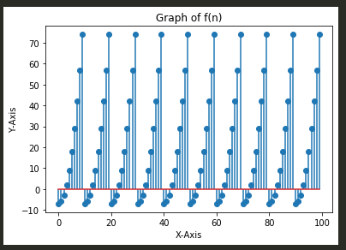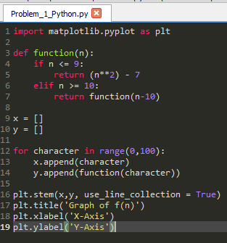Code: Output:

Fig 1.1 The code for graphing f(n) where n=0:99 in Python Fig 1.2 The graph of f(n) where n=0:99 in Python

Upon entering and running the code to graph f(n) of problem 1, the value of f(n) was evaulated correspondingly for every value of n from 0 to 9. However, when the value of n reaches 10 and above, the value of the input variable goes back to 0 going to 9 again. This results in a reapeating pattern of graph as seen in Fig 1.2 for every interval of n from 0 to 9 for every multiple of 10. For instance, when n = 30, f(30) corresponds to f(30-10) which is equal to f(20). f(20), on the other hand, corresponds to f(20-10) which is equal to f(10). Lastly, f(10) corresponds to f(10-10) which is equals to f(0) which when evaluated gives a value of -7. Therefore, the value of f(30) = f(0) = -7. The same is true for any values of n greater than 10 where it is looped to decrease by 10 every time the value is still greater than 10 before it can be evaluated again to get the same repeating results and the graph at Fig 1.2 perfectly illustrates the behavior of f(n).