Aguilar, Brian A. 2ECE-A   
Hapis, Jan Heidrich C. 12/08/2019

PROBLEM 2: Write a program that accepts as input three points (𝑥,𝑦) lying on a circle in a 2- dimensional Cartesian plane. The program must return the following parameters of the circle on which the three points lie:

* center (h, 𝑘);
* radius 𝑟;
* vector [𝐷, 𝐸, 𝐹], where 𝐷, 𝐸, and 𝐹 are the coefficients in the general equation of a circle 𝑥2 +

𝑦2 + 𝐷𝑥 + 𝐸𝑦 + 𝐹 = 0;

Recall from your analytic geometry/pre-calculus class that the standard and general equations, respectively, are given as

(𝑥 − h)2 + (𝑦 − 𝑘)2 = 𝑟2

𝑥2 + 𝑦2 + 𝐷𝑥 + 𝐸𝑦 + 𝐹 = 0

SOLUTION: **PYTHON**

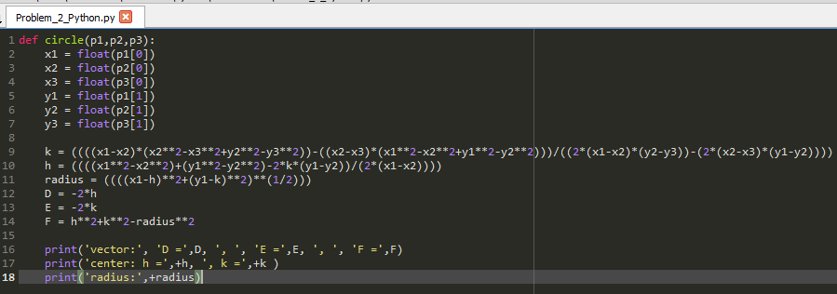Code:

Fig 2.1 The code for finding the parameters of a circle given 3 points found at the circumference of the circle

Output:

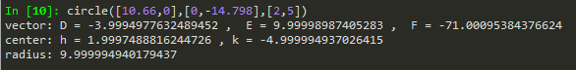Results shown are based on assuming inputs of 3 points were not simultaneously colinear together and found at the circumference of the circle formed with the given parameters.

Fig 2.2 The parameters of the circle formed from the three points found at its circumference namely the vectors, radius and its center.

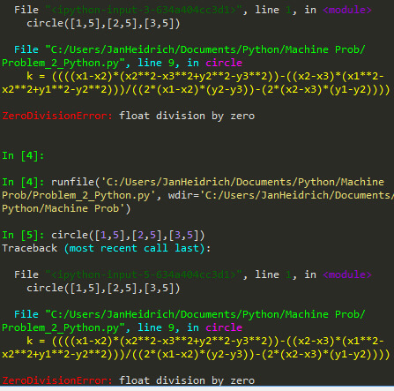This error would pop-up if the given input of three points are all colinear with each other relative to either in x-axis or in y-axis. There would be a division by zero in the formula/code and at the same time, a circle from which its three points along its circumference are colinear in 2D plane.

Fig 2.3 An error prompts stating that the code cannot divide by 0  
from three colinear points.