Aguilar, Brian A. 2ECE-A   
Hapis, Jan Heidrich C. 12/08/2019

PROBLEM 3: Given a certain set of experimental points (𝑥𝑖 , 𝑦𝑖 ), regardless of how many, the program must be able to return the coefficients of the polynomial 𝑓(𝑥) that would best approximate the data according to the least-norm error vector 𝑒(𝑥) in Experiment 4, i.e.

𝑒(𝑥𝑖) = 𝑦𝑖 − 𝑓(𝑥𝑖)

Limit your polynomials from the 1st degree up to the 10th degree. The set of points should be input in the form of an 𝑛 × 2 matrix where 𝑛 is the number of experimental data. Note that the data points should only be the user input, and not 𝑛.

SOLUTION: **PYTHON**

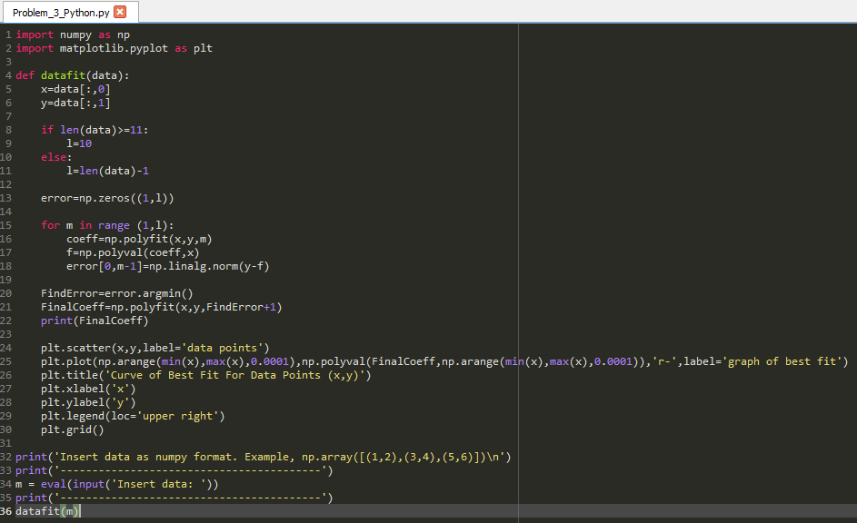Code:

Fig 3.1 The code for getting the coefficients of the polynomial that would best fit the graph for any given *n* x 2 data points (xi,yi)

Output:

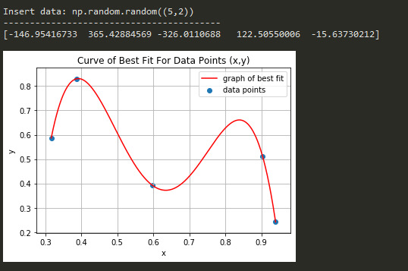For any given number of data points less than 10 like for instance, a 5 x 2 randomly generated numbers were graphed, the polynomial of best fit will always have a degree 1 less than the number of data points ,*n.*

Fig 3.2 The scatterplot of the data points less than 10 with its polynomial of best fit while and  
the code returning the values of the coefficient of the polynomial of 5th degree that best fit the data points.

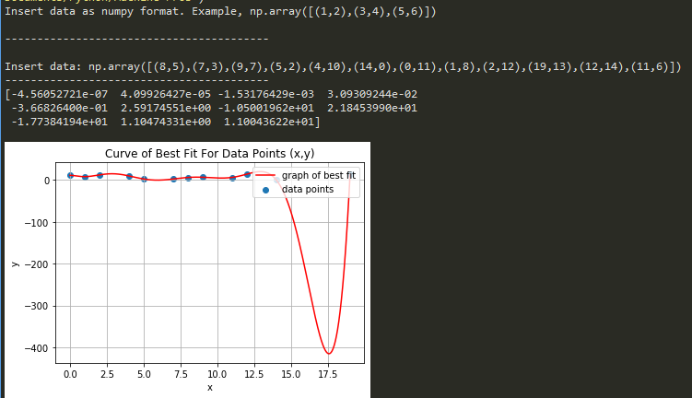Given with data points greater than ten such as the 12 sample data points input, the line of best fit will cap at the tenth degree as the problem stated but it still produces the lowest norm of error which is why from all polynomial degree from 1 to 10, the polynomial of tenth degree will best represent the number of data points greater than 10

Fig 3.3 The scatterplot of the data points greater than ten with its polynomial of best fit while and  
the code returning the values of the coefficient of the polynomial of 10th degree that best fit the data points.