Aguilar, Brian A. 2ECE-A   
Hapis, Jan Heidrich C. 12/08/2019

PROBLEM 4: In your physics class, projectile motion has two components: constant-velocity motion in the horizontal direction and free-fall motion in the vertical direction. However, in reality, the horizontal motion has acceleration due to air resistance, wind, and other factors. The goal of this problem is to visualize the trajectory of a projectile for both ideal and non-ideal motion.

Create a program that plots the trajectory, from the initial height to the ground, of a projectile accelerating both in the horizontal and vertical directions. The program must accept the following as inputs:

* the initial height of the projectile above the ground in meters;
* the magnitude of the velocity in m/s;
* the angle in degrees with respect to the +𝑥-axis at which the projectile is fired;
* the 𝑥-component of the acceleration, considering the sign, in m⁄s2;
* the 𝑦-component of the acceleration, considering the sign, in m⁄s2;

The program must also have error detection for the instance the user inputs zero acceleration for the vertical component. (If the vertical acceleration is zero, then there would be no free fall.) You may use the error command.

Do not forget to put axis labels and grids on your plot. No restrictions on the line style and width. Do not use white for the line color.

SOLUTION: **PYTHON**

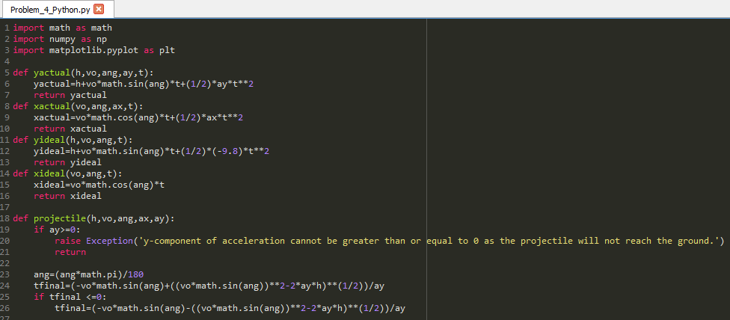Code:

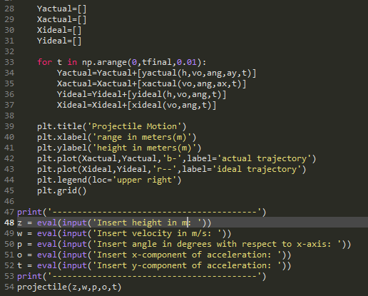

Fig 4.1 The code for graphing the trajectory in both ideal and non-ideal situations given the  
 initial conditions of velocity, initial height, angle with respect to x-axis, acceleration in x and in y

Output:

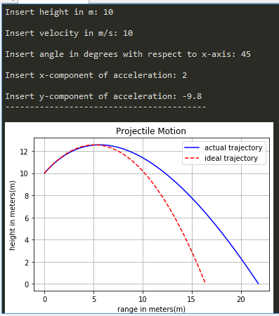Two graphs were superimposed with each other to visualize both situations. The line represents the actual trajectory of the object based on the initial conditions and taking in consideration of the air resistance. The broken lines represent the ideal trajectory of the object in the air resistance were not considered or under the ideal conditions. In order to simulate the effects of air resistance, there would be changes in the acceleration in both x and y directions which greatly affects the trajectory of the object as reflected in Fig 4.2.

Fig 4.2 The graph of both actual and ideal trajectory of the object given  
the initial conditions especially the air resistance for the actual trajectory.

The problem specifies that the acceleration in the y direction should not be equal or greater than zero or else, the trajectory will not reach the ground. An error message were to appear if such an initial condition were set as input in order to display the error and terminating the program.

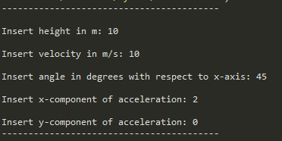



Fig 4.3 The error message displayed when giving an invalid initial condition for the trajectory especially when the acceleration in y is greater than or equal to zero.