Aguilar, Brian A. 2ECE-A   
Hapis, Jan Heidrich C. 12/08/2019

PROBLEM 5: For **n = 0:199**, given the user-input 𝑥(𝑛), determine 𝑦(𝑛) if

$$y\left(n\right)= \left\{\begin{aligned}-1.5x\left(n\right)+2x\left(n+1\right)-0.5\left(n+2\right), \\ 0.5x\left(n+1\right)-0.5x\left(n-1\right), \\ 1.5x\left(n\right)-2x\left(n-1\right)+0.5x\left(n-2\right),\end{aligned} \begin{matrix}n=0 \\ 0<n ≤198 \\ n=199\end{matrix}\right.$$

Test your program for

$$x\left(n\right)=\sin\left(\frac{3π}{100}n\right)$$

Superimpose the graphs of 𝑥(𝑛) and of 𝑦(𝑛) with different line colors in one figure window. Do not forget to put legends.

SOLUTION: **PYTHON**

Code:

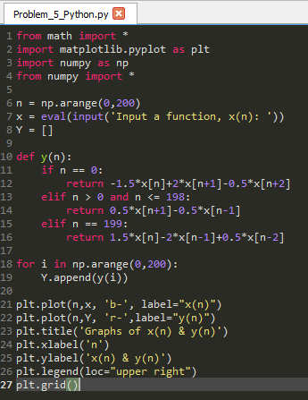

Fig 5.1 The code for superimposing the graph of both the input, x(n)   
and the functiony(n) for the given interval of 0 to 199

Output:

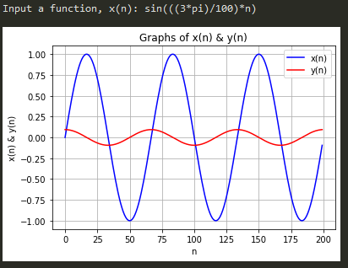The program will prompt the user to input a function of n, x(n). The input function would be graphed and is represented by the blue line. In line with this, y(n) would also be evaluated based on the given function x(n) and would be graphed as well superimposed together with the graph of x(n). Fig 5.2 would be the resulting graph if the function $x\left(n\right)=\sin\left(\frac{3π}{100}n\right)$,represented by the blue line were to be the input as suggested by the problem together with its corresponding graph of y(n) represented by the red line. This goes true for any function of *n* that will be given by the user.

Fig 5.2 The superimposed graph of the x(n) and y(n) from n=0 to n=199 given the input   
of x(n) and evaluating y(n)