Jan Heidrich Hapis ECE2112

2ECE-A

PROGRAMMING ASSIGNMENT: Data Wrangling Using Pandas

**PROBLEM 1:**

**INPUT:**

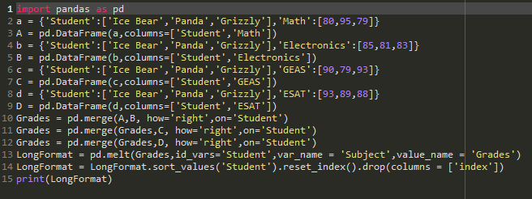

**DATASETS:**

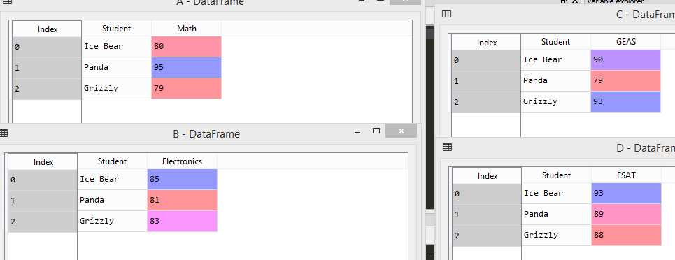

**MERGE:**

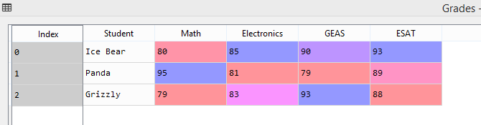

**LONG FORMAT:**

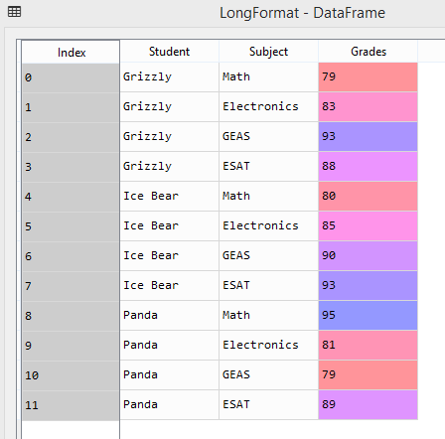

**PROBLEM 2:**

**INPUT:**

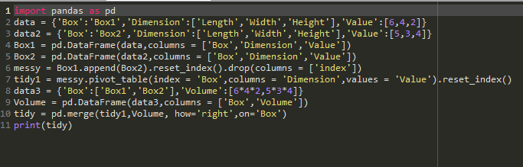

**MESSY:**

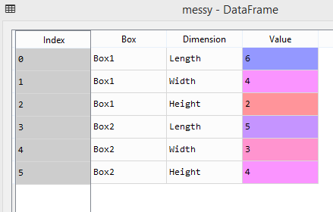

**TIDY:**

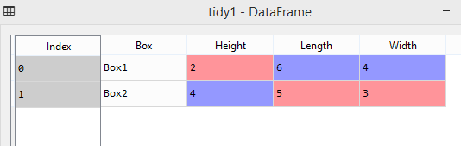

**TIDY WITH VOLUME:**

