Jan Heidrich Hapis ECE2112

2ECE-A

**HANGAROO GAME**

**isWordGuessed**:

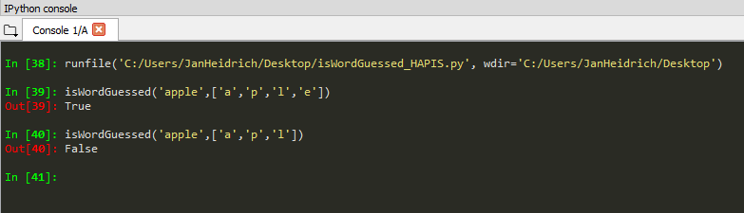

**getGuessedWord:**

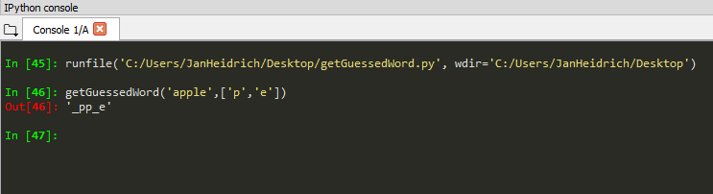

**getAvailableLetters:**

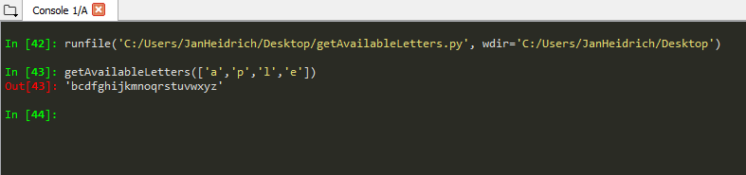

**Hangaroo:**

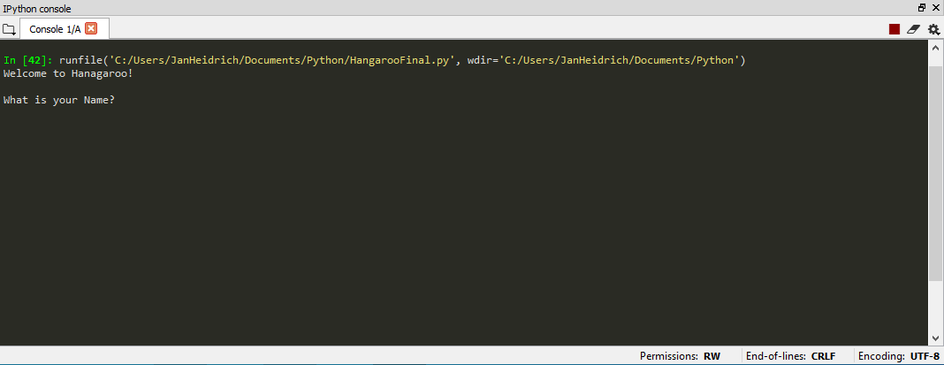

>> Start of Program.

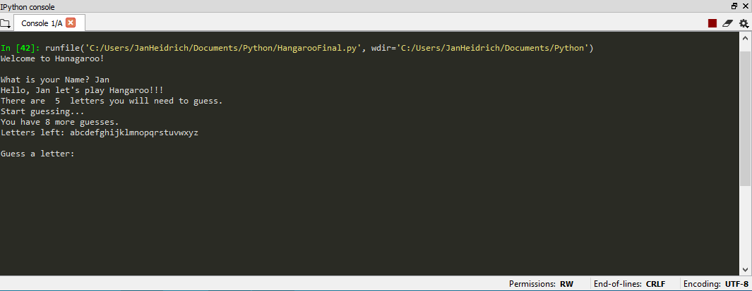

>> Interactions to players.

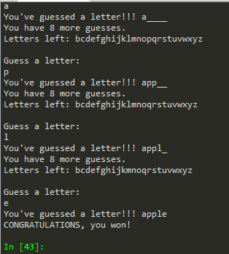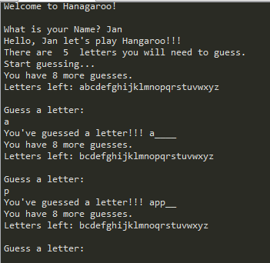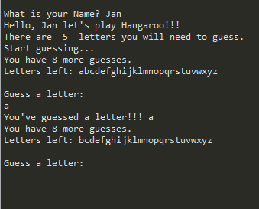

>> If the secret word was guessed.

>> Shows the underscores, available letters left, and the number of lives.

>> If the guessed letter is correct.

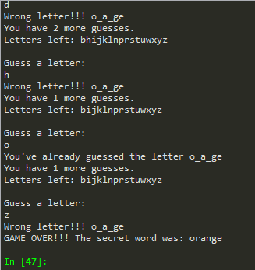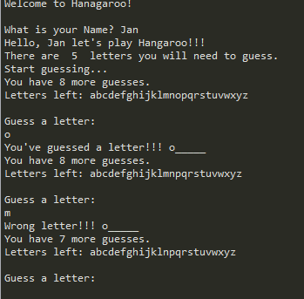

>> If the secret word was not guessed

>> If the guessed letter is incorrect.