Jan Heidrich Hapis ECE2112

2ECE-A

**Programming Assignment: Pandas**

**PROBLEM 1:**

Input:

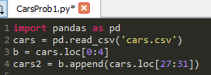

Output:

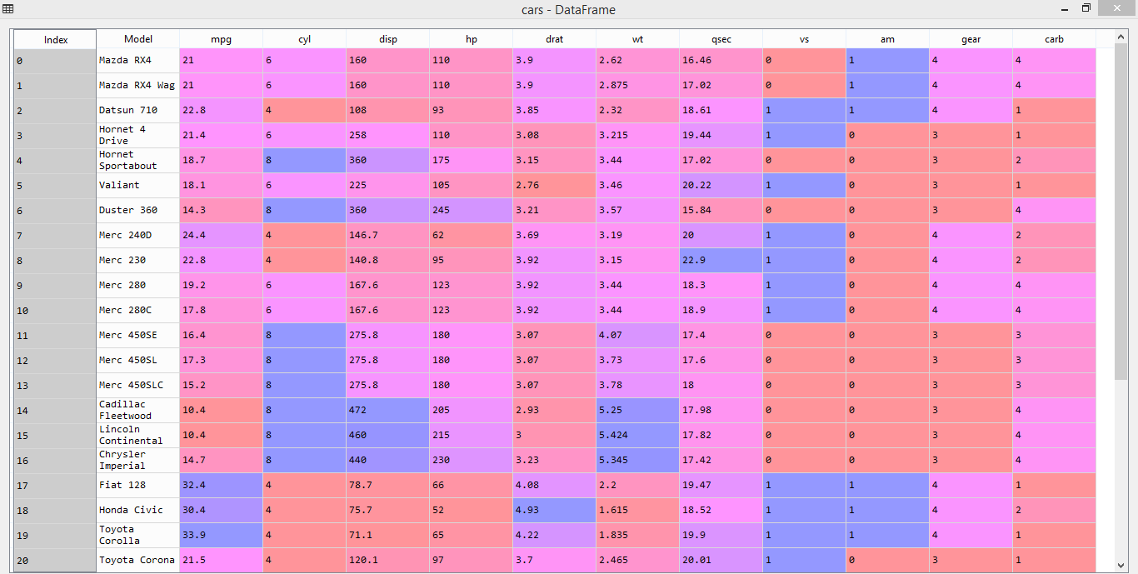**A:**

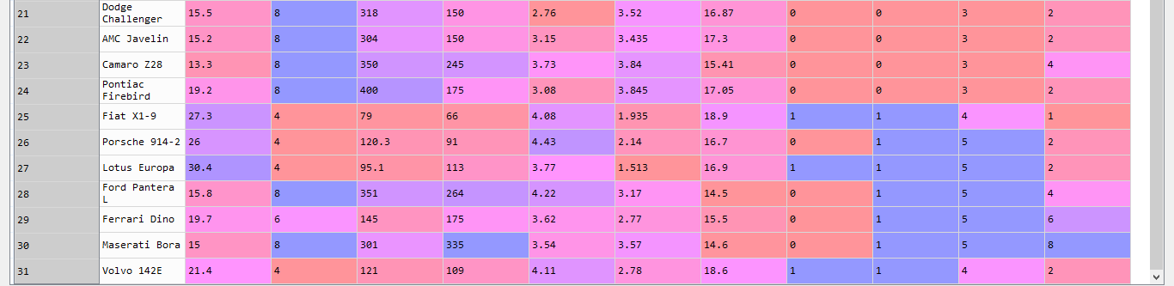

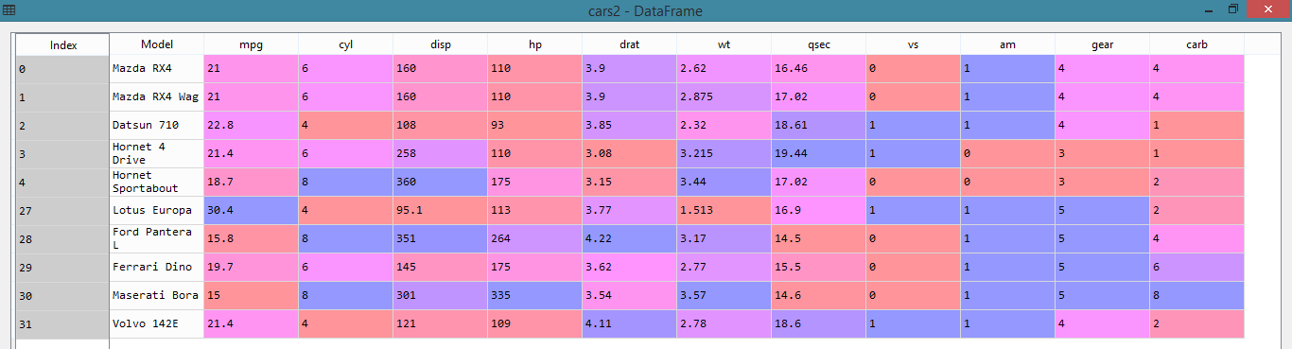**B:**

**PROBLEM 2:**

Input:

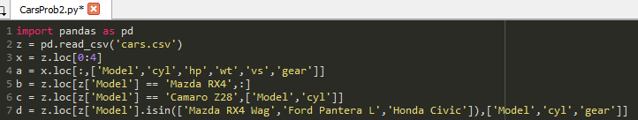

Output:

**A:**

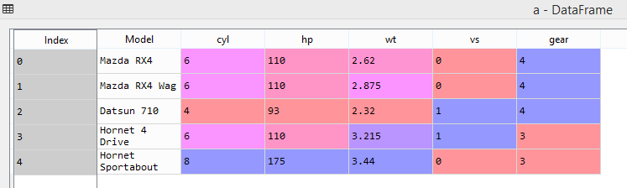

**B:**

**C:**

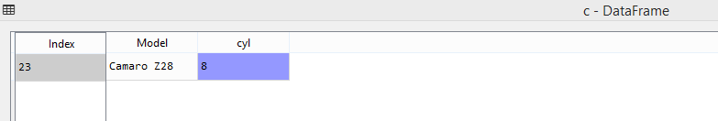

**D:**

