Make sure you have jdk 11 for electric eel version of android studio , also change the following settings
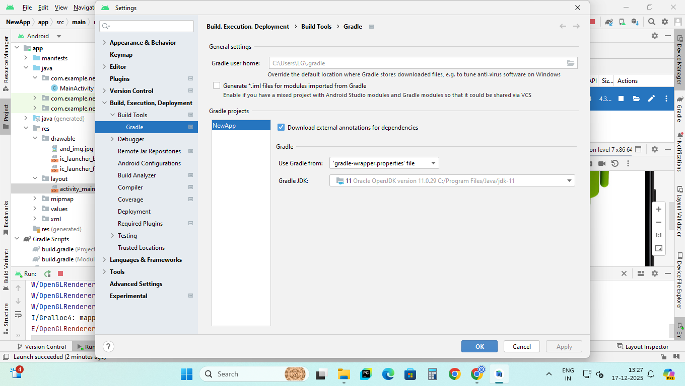
In build.gradle(module:app) change the highlighted lines :
dependencies {
implementation 'androidx.appcompat:appcompat:1.6.1'
implementation 'com.google.android.material:material:1.9.0'
implementation 'androidx.constraintlayout:constraintlayout:2.1.4'
testImplementation 'junit:junit:4.13.2'
androidTestImplementation 'androidx.test.ext:junit:1.3.0'
androidTestImplementation 'androidx.test.espresso:espresso-core:3.7.0'
}
----------------------------------------------------------------------------------------------------------------
The entire build.gradle(module:app) file for reference:

plugins {
id 'com.android.application'
}
android {
namespace 'com.example.newapp'
compileSdk 33
defaultConfig {
applicationId "com.example.newapp"
minSdk 24
targetSdk 33
versionCode 1
versionName "1.0"
testInstrumentationRunner "androidx.test.runner.AndroidJUnitRunner"
}
buildTypes {
release {
minifyEnabled false
proguardFiles getDefaultProguardFile('proguard-android-optimize.txt'), 'proguard-rules.pro'
}
}
compileOptions {
sourceCompatibility JavaVersion.VERSION_1_8
targetCompatibility JavaVersion.VERSION_1_8
}
}
dependencies {
implementation 'androidx.appcompat:appcompat:1.6.1'
implementation 'com.google.android.material:material:1.9.0'
implementation 'androidx.constraintlayout:constraintlayout:2.1.4'
testImplementation 'junit:junit:4.13.2'
androidTestImplementation 'androidx.test.ext:junit:1.3.0'
androidTestImplementation 'androidx.test.espresso:espresso-core:3.7.0'
}
Now go to file and click - sync project with gradle files
Go to build -> clean project -> build project

