Pract 5- Configuring OSPF
OSPF stands for Open Shortest Path First.
In OSPF, we write the network addresses with Wild card mask.
Create the following topology and configure the given ip addresses to PCs and Routers.
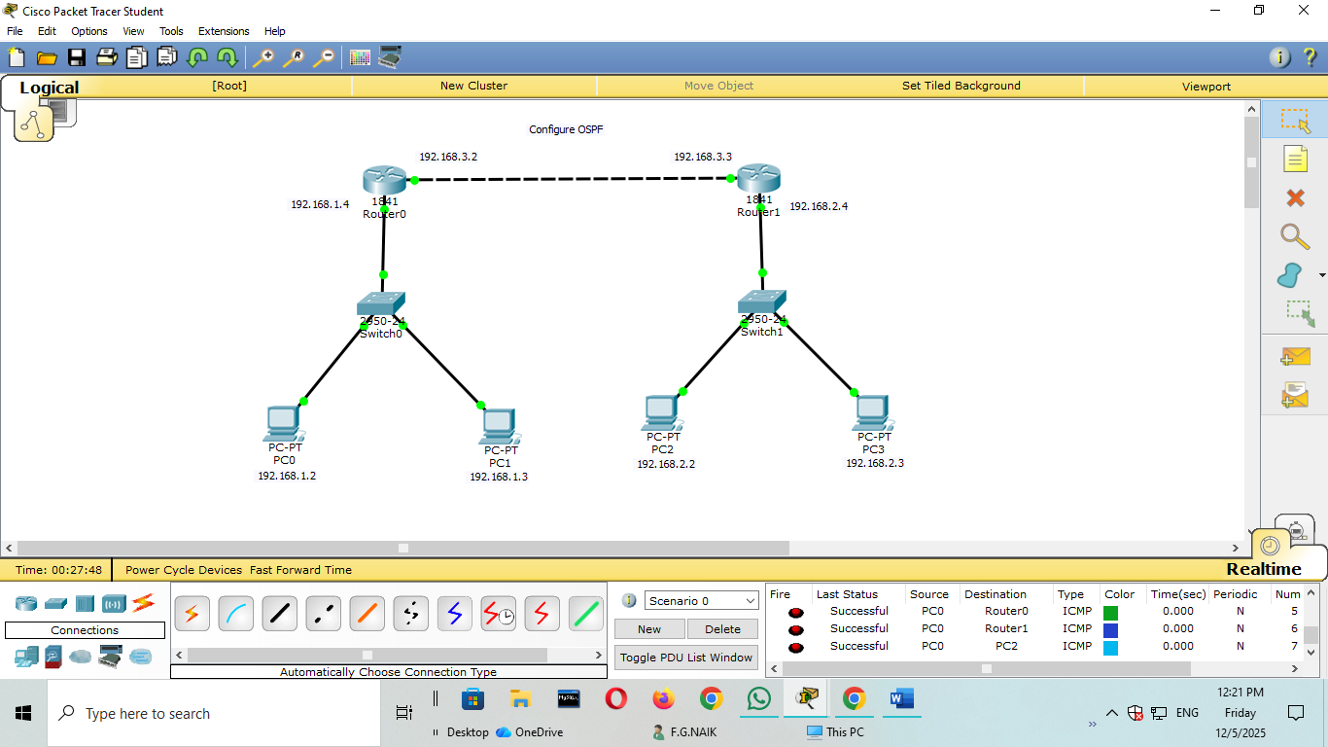
Open command line interface of the router 0 and type the following commands.

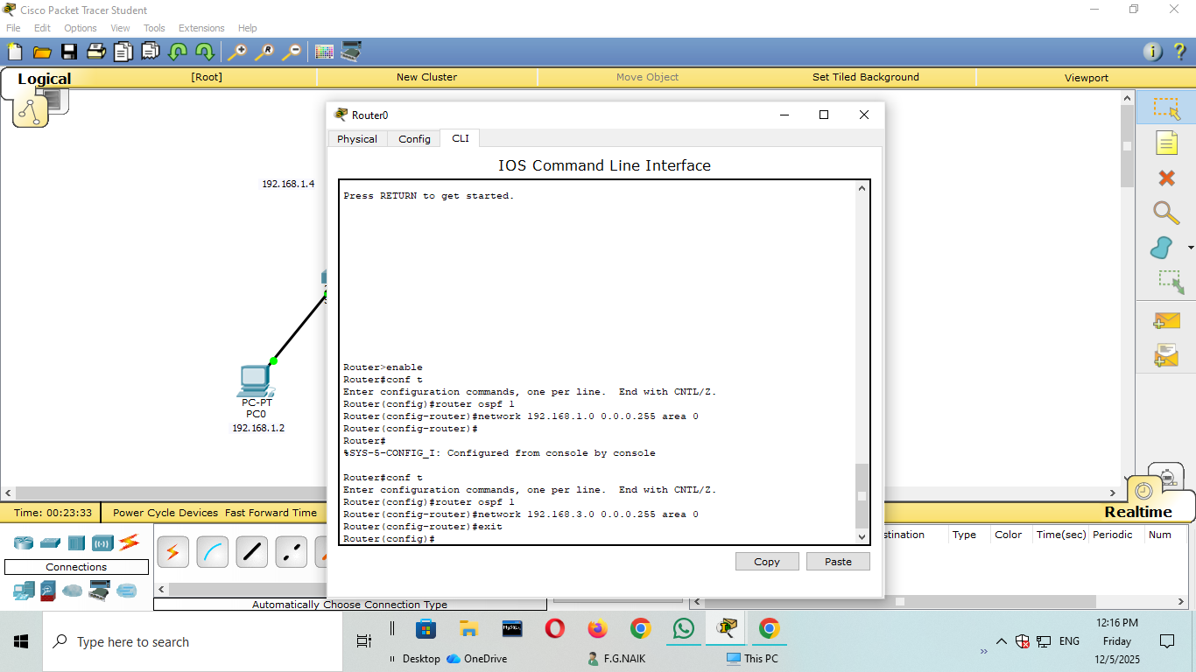
Open command line interface of the router 1 and type the following commands.
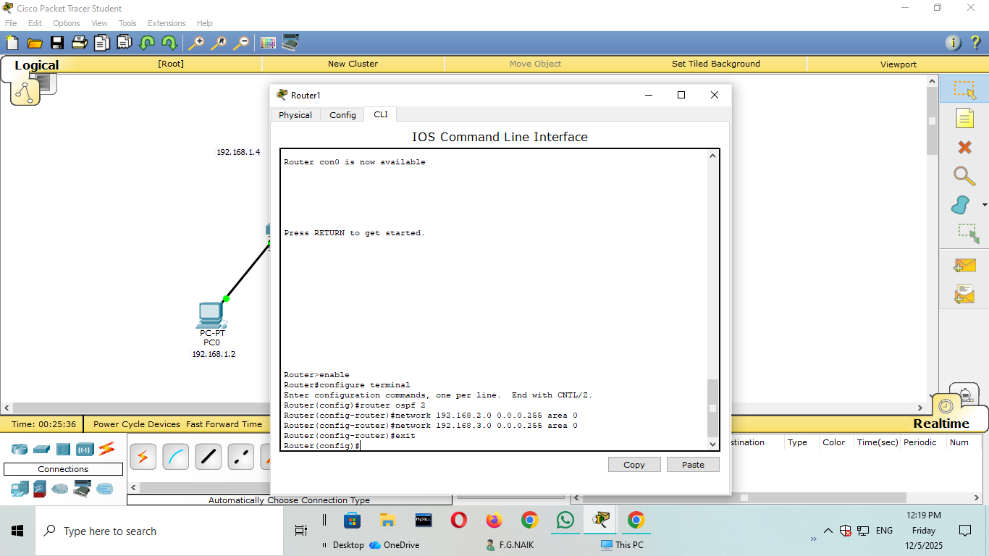
Now ping the pcs using cmd prompt.

