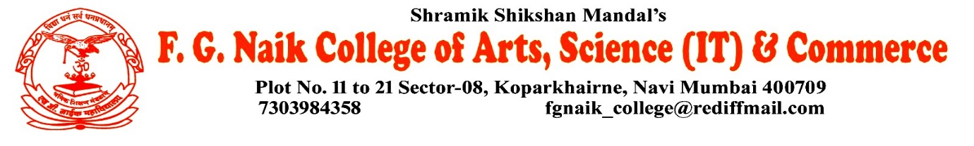

NSS UNIT
CIVIL DEFENCE CERTIFICATE DISTRIBUTION
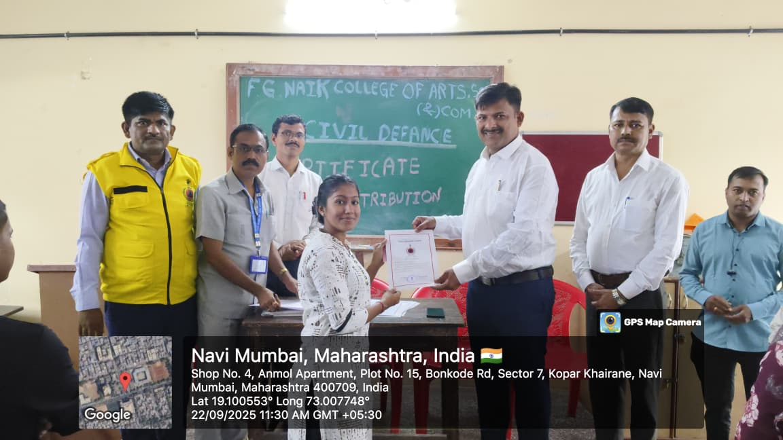
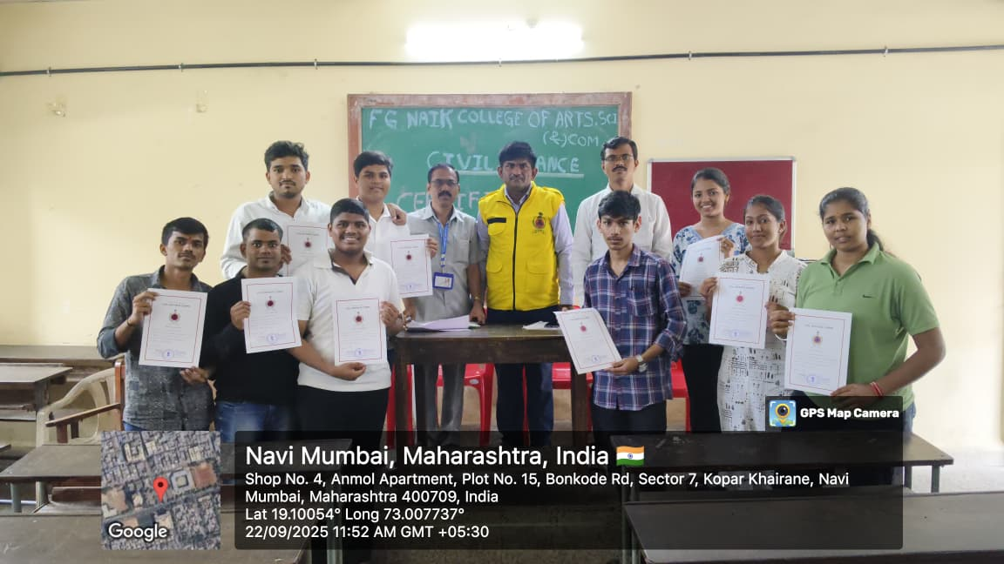

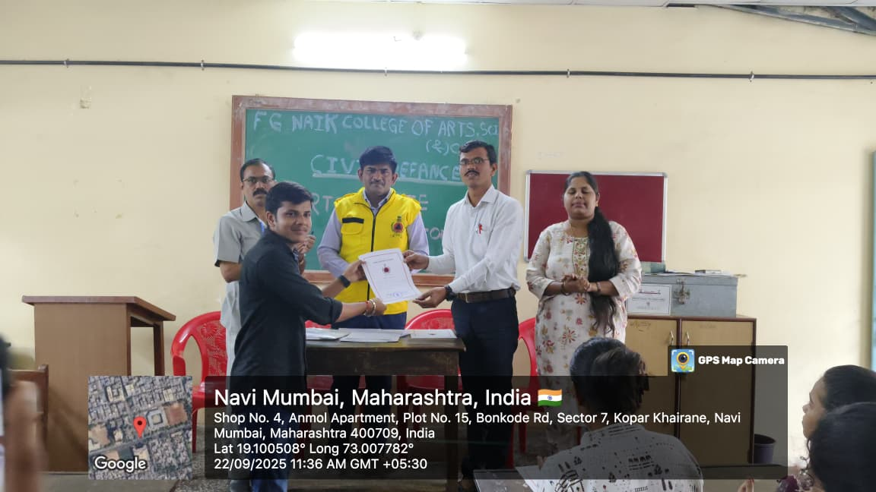
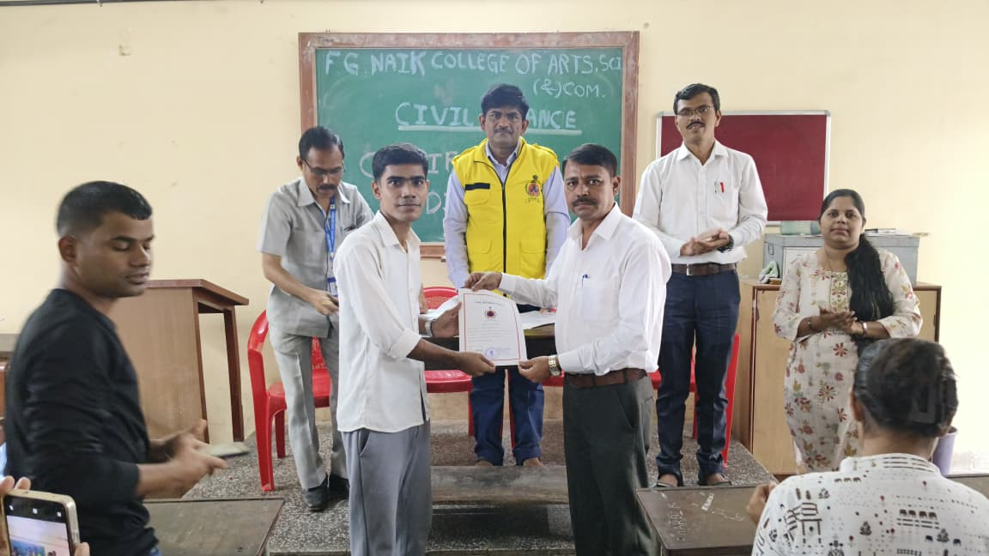

OBJECTIVE OF PROGRAM: To distribute Civil Defence certificates to volunteers and participants in recognition of their training, service, and contribution towards disaster management and public safety awareness.
DATE: 22/09/2025
LOCATION: F.G NAIK College
PARTICIPATING STAFF: All the NSS volunteers, teaching and the non-teaching staff of the college.
NUMBER OF VOLUNTEERS PARTICIPATING: 24
The NSS volunteers actively participated in the Civil Defence Certificate Distribution program. The event was organized to acknowledge and appreciate the efforts of volunteers who successfully completed Civil Defence training and contributed to community safety initiatives. Certificates were formally distributed to the participants as a mark of recognition for their dedication and discipline.
The program was informative and motivating, encouraging students to actively participate in Civil Defence activities and understand their role in disaster preparedness and emergency response.
PROGRAM DETAILS: The program commenced with a formal welcome, setting a respectful and positive tone for the event.
The NSS Unit successfully organized the Civil Defence Certificate Distribution ceremony, highlighting the importance of Civil Defence training and its role in building a responsible and prepared society.

NSS IQAC
PROGRAM OFFICER CO-ORRDINATOR I/C PRINCIPAL

