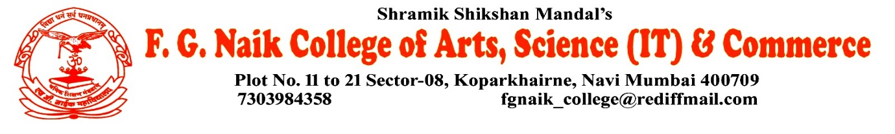

NSS UNIT
HIV/AIDS AWARENESS LECTURE
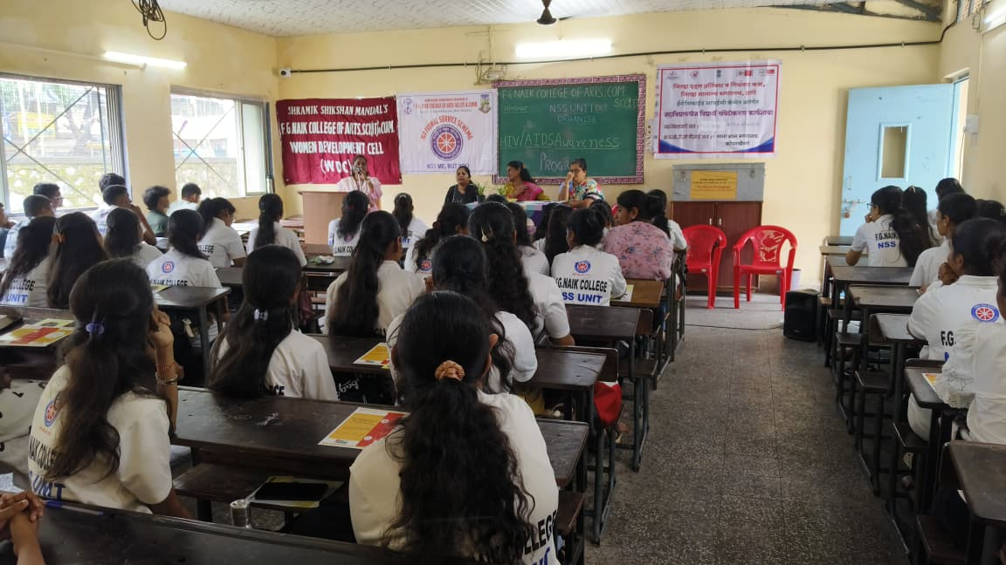
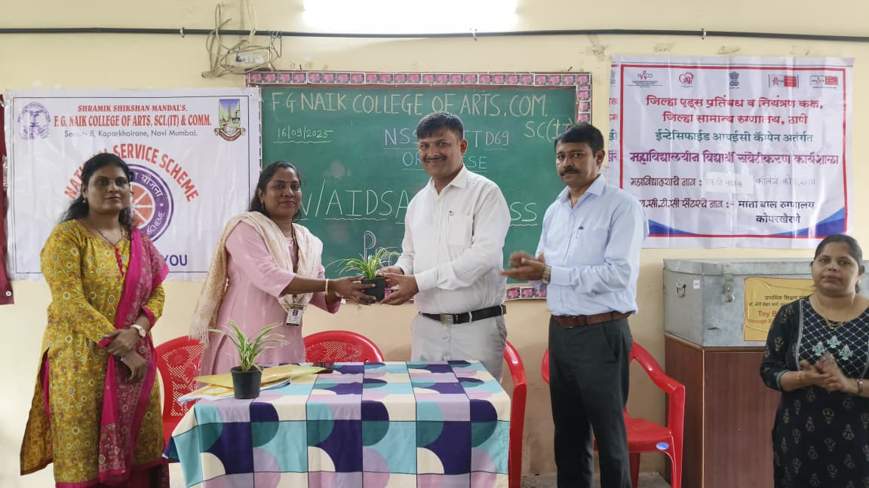

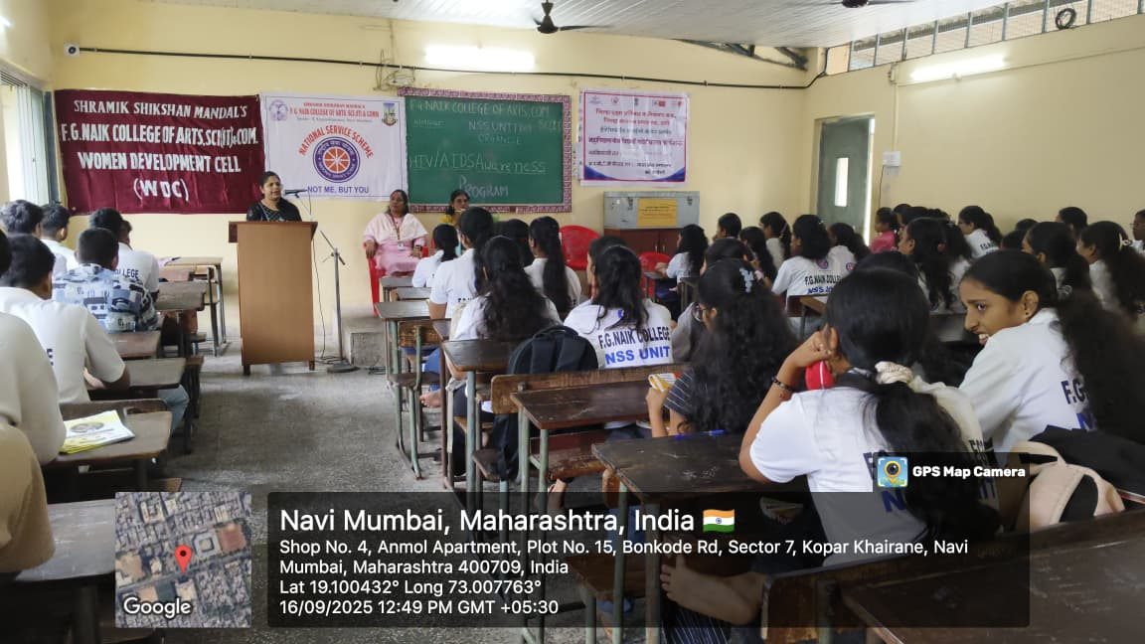
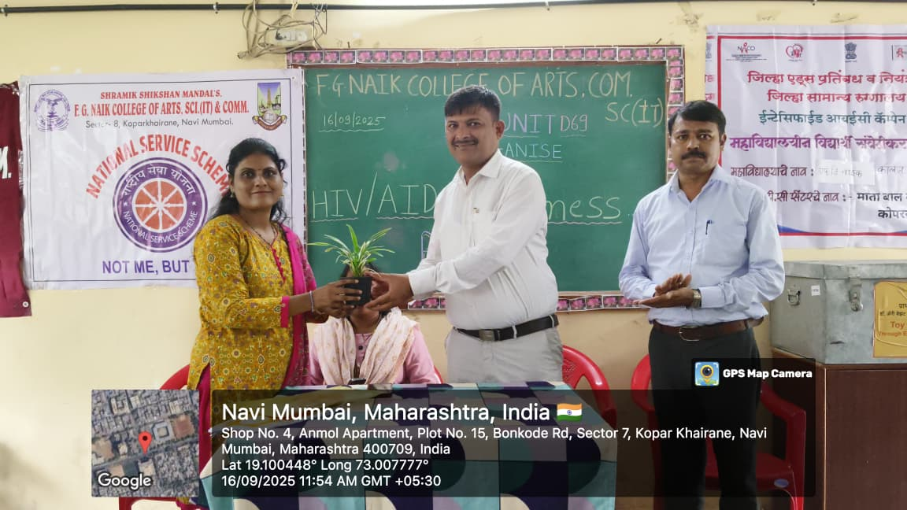

OBJECTIVE OF PROGRAM: To create awareness about HIV/AIDS among students and promote accurate knowledge regarding its causes, modes of transmission, prevention, and the importance of adopting healthy and responsible behavior.
DATE: 26/09/2025
LOCATION: F.G Naik College
PARTICIPATING STAFF: All the NSS volunteers, teaching and the non-teaching staff of the college.
NUMBER OF VOLUNTEERS PARTICIPATING: 24
The NSS Unit organized an HIV/AIDS Awareness Lecture to educate students about HIV/AIDS and its impact on individuals and society. The lecture focused on explaining the meaning of HIV and AIDS, methods of transmission, preventive measures, and the importance of early testing and treatment. Emphasis was also laid on removing misconceptions and reducing stigma associated with the disease.
The lecture was informative and thought-provoking, encouraging students to be aware, responsible, and supportive towards people living with HIV/AIDS. It helped in promoting a positive attitude and spreading correct information among the participants.
PROGRAM DETAILS: The program commenced with a formal welcome, creating an attentive and respectful environment for the session.
The NSS Unit successfully conducted the HIV/AIDS Awareness Lecture, highlighting the importance of awareness, prevention, and social responsibility in combating HIV/AIDS.

NSS IQAC
PROGRAM OFFICER CO-ORRDINATOR I/C PRINCIPAL

