

NSS UNIT
CLEANLINESS DRIVE
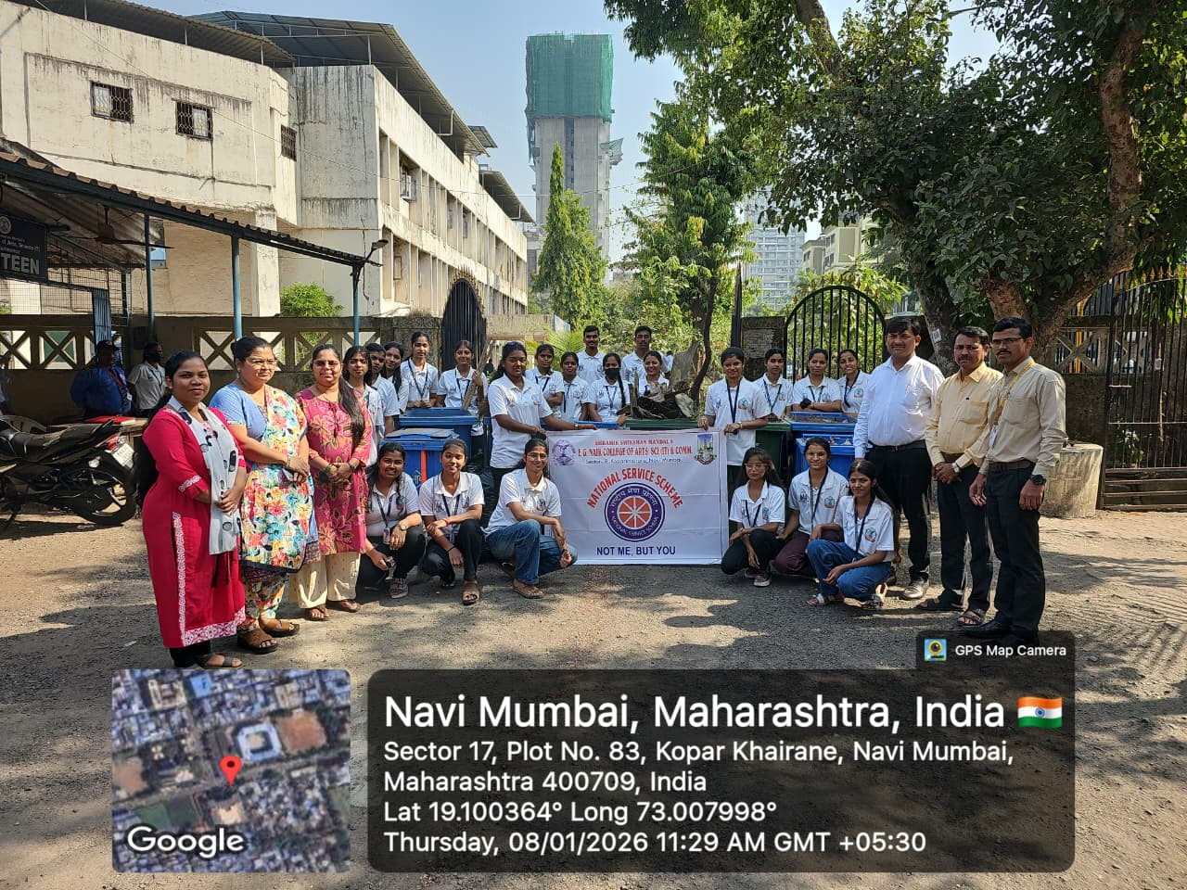

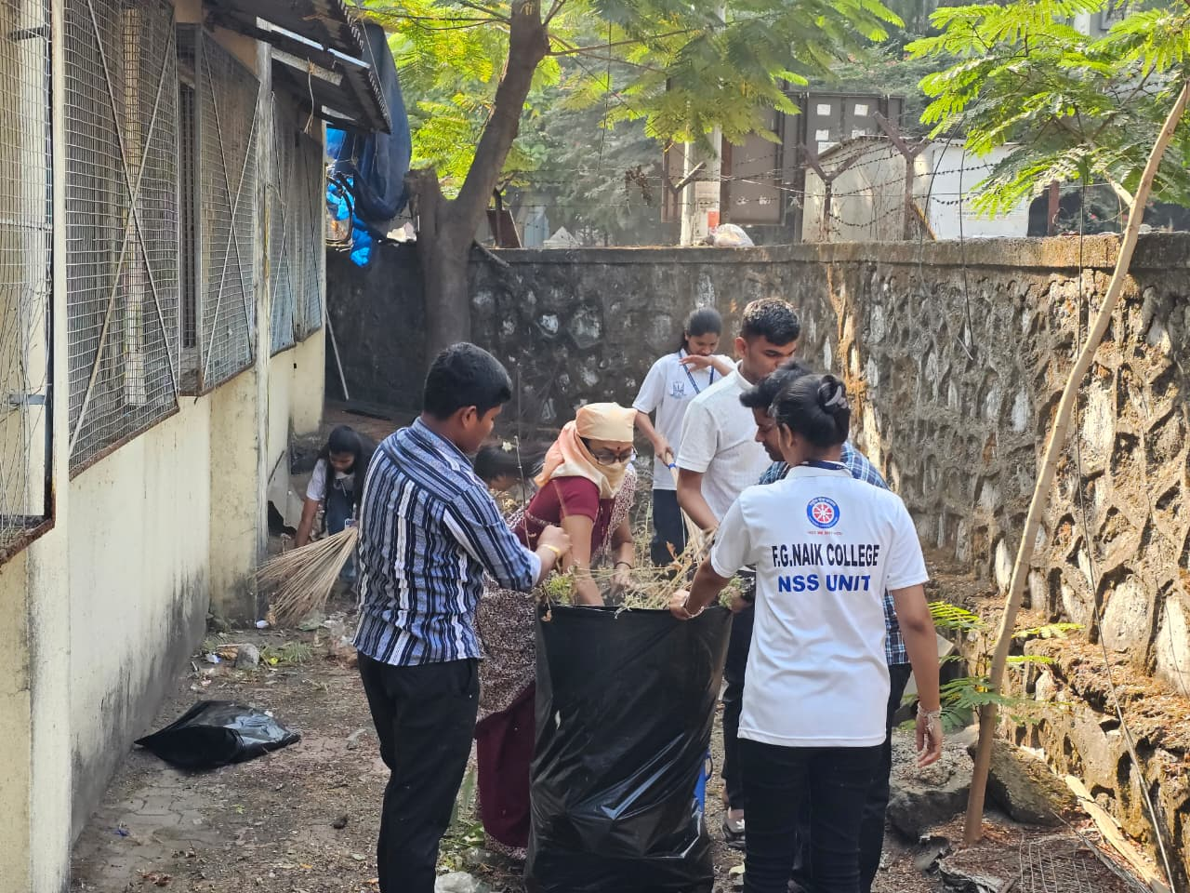
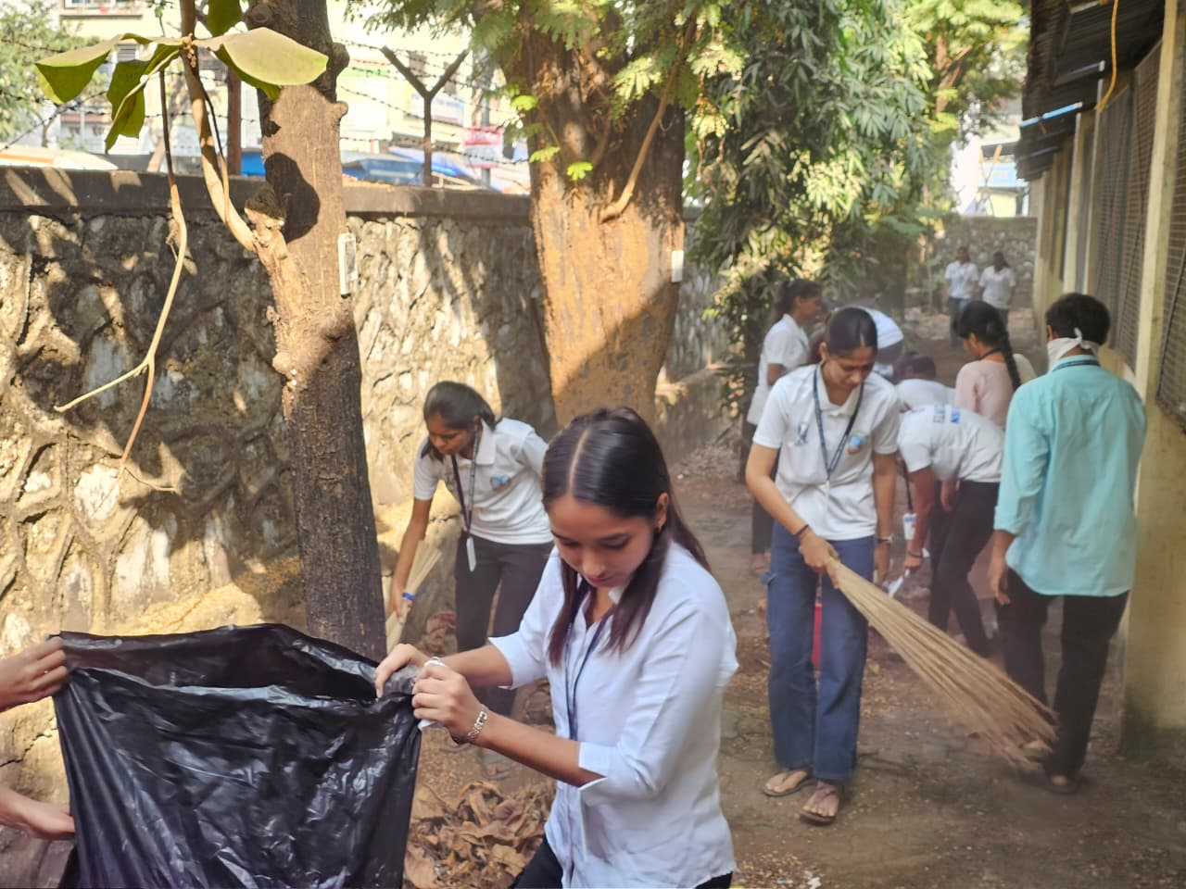

OBJECTIVE OF PROGRAM: Promote cleanliness and hygiene among the community, emphasizing the importance of keeping our surroundings clean.
DATE: 08/01/2026
LOCATION: College premises
PARTICIPATING STAFF: All the NSS volunteers, teaching and the non-teaching staff of the college.
NUMBER OF VOLUNTEERS PARTICIPATING: 24
The NSS volunteers actively participated in the cleanliness drive by cleaning the surroundings of the campus. They enthusiastically collected plastic waste, used tea cups, and dry leaves scattered across the area. All collected waste was systematically gathered in trash bags and handed over at the designated collection point arranged by the University for proper disposal.
The cleanliness drive was highly inspiring and motivating, fostering a strong sense of responsibility and teamwork among the NSS volunteers.
PROGRAM DETAILS: The event commenced with a welcome of the Principal, Heads of Departments, faculty members, staff, and student participants. A total of 24 students, faculty, and staff members actively participated in the program.
The NSS Unit conducted a comprehensive cleanliness drive within the college campus, focusing on maintaining cleanliness and hygiene in the surrounding areas.

NSS IQAC
PROGRAM OFFICER CO-ORRDINATOR I/C PRINCIPAL

