SUBQUERIES

1. Passengers who have completed payment

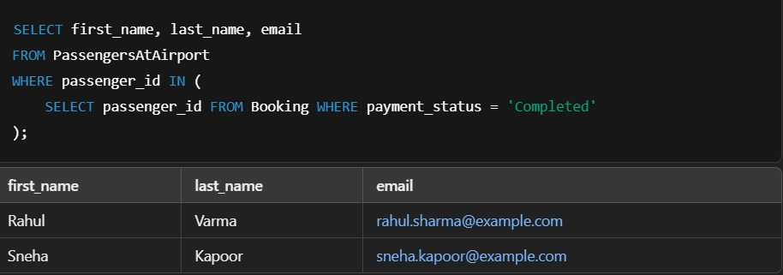

1. Flights where payment is still pending

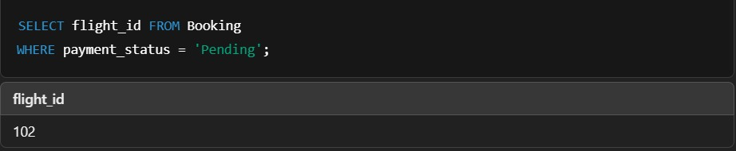

1. Passenger with the highest ticket price

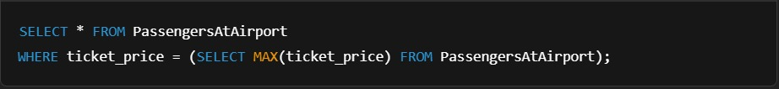

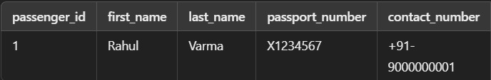

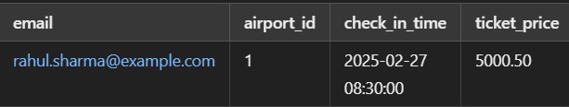

JOINS

Inner join – passengers with their booking details

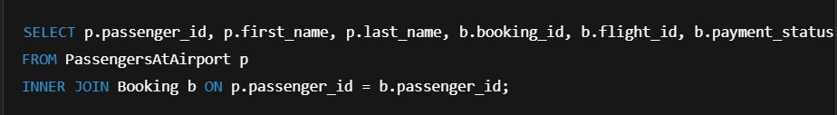

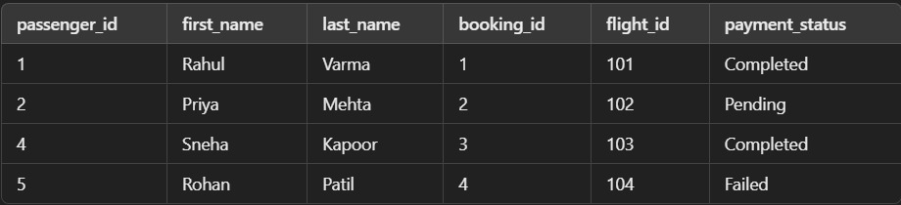

Left join – Show all passengers and their booking info

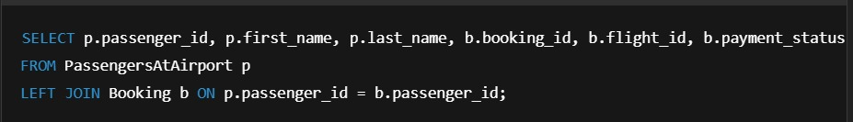

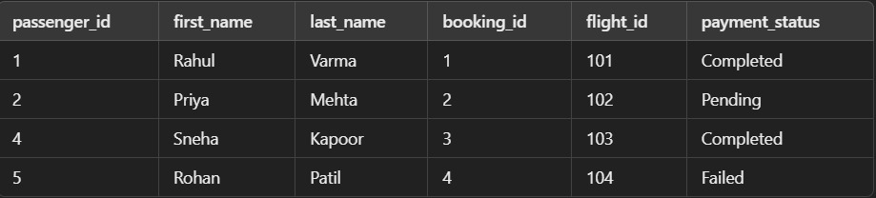

Right join – Show all bookings and their passenger info

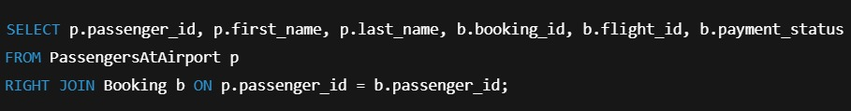

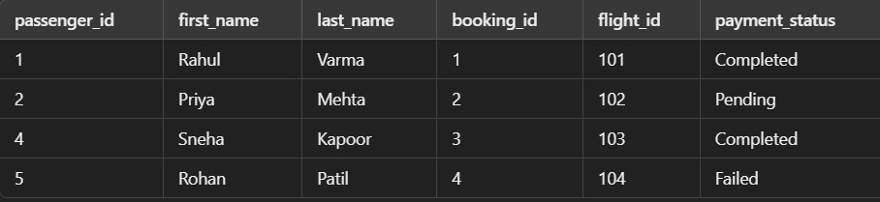

Full outer join – show all passengers and booking

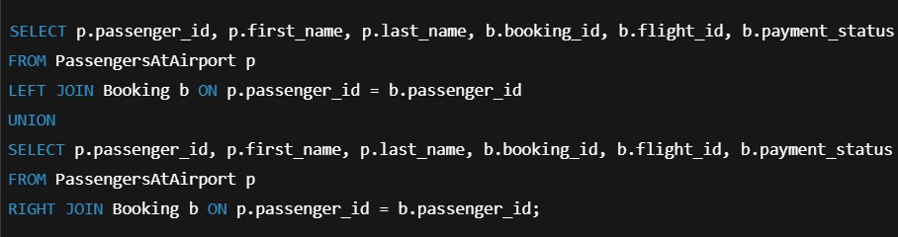

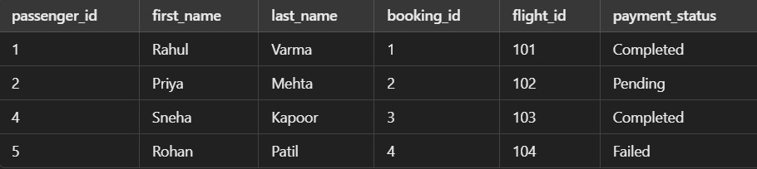

Natural join



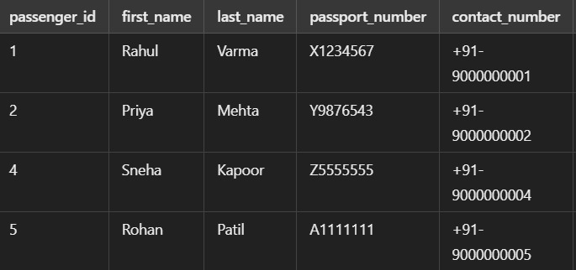

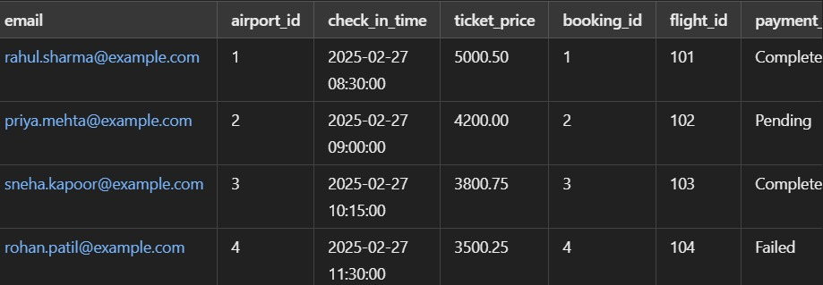

Semi join

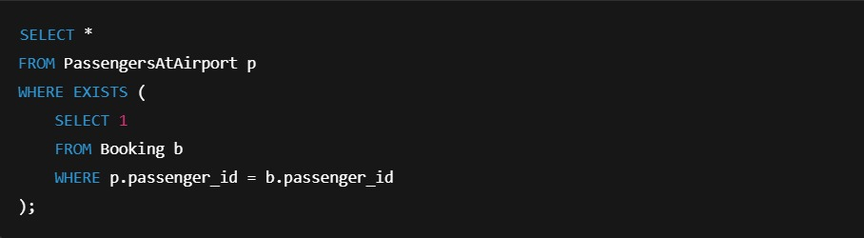

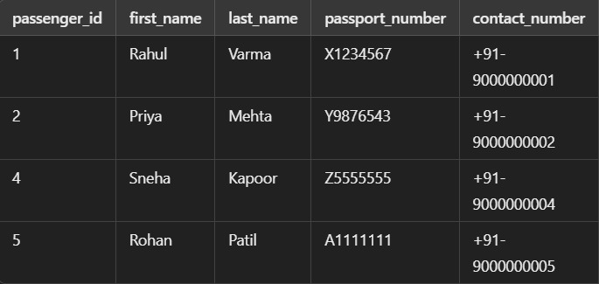

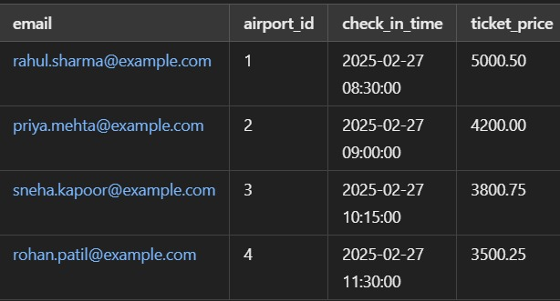

Anti join

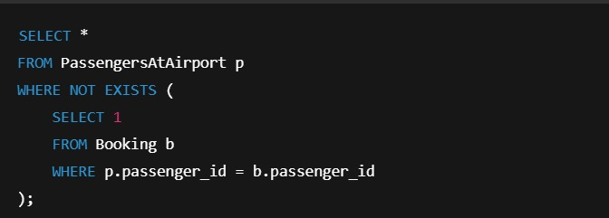

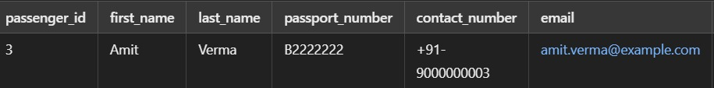

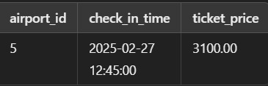

Theta join

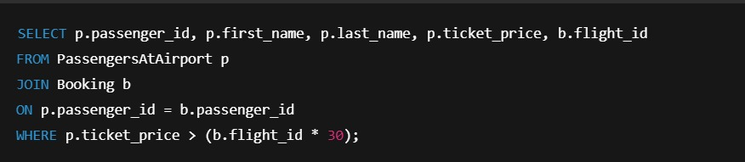

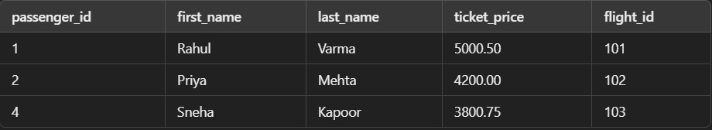

Division join

