Employee Task Management System

FullStack Web Application Development Hands-on Activity

Submitted By
Name: Janhavi Agrawal (002OD0744)
Role: Experienced Frontend Developer
Technology: FullStack Development (MERN Stack)

1. Project Overview
The Employee Task Management System is a role-based web application developed using the MERN stack (MongoDB, Express.js, React.js, Node.js).
The application allows employees to manage assigned tasks, managers to monitor and assign tasks, and administrators to oversee the entire system. The solution implements secure authentication, role-based access control, CRUD operations, database integration, and testing.
This project was developed as part of the FullStack Web Application Development Hands-on Activity.

2. Problem Statement
Organizations require a centralized platform for managing employee tasks and collaboration.
The system should provide:
- Secure user registration and login
- Role-based access control
- Task management capabilities
- Comment management
- Notification management
- Dashboard summaries
- Audit visibility for administrators
The application must support Admin, Manager, and Employee roles.

3. Selected Scenario
Scenario 1: Employee Task Management System

Roles

Admin
- Manage all users
- View all tasks
- View comments
- View notifications
- Access complete dashboard

Manager
- Create tasks
- Assign tasks
- Monitor task progress
- Access manager dashboard

Employee
- View assigned tasks
- Update tasks
- Add comments
- Access employee dashboard

4. Technology Stack

Frontend
- React.js
- React Router DOM
- Axios
- JavaScript
- HTML5
- CSS3

Backend
- Node.js
- Express.js
- JWT Authentication
- Bcrypt.js
- Express Validator

Database
- MongoDB
- Mongoose ODM

Testing
- Jest
- Supertest

Version Control
- Git
- GitHub

5. System Architecture
The application follows a three-tier architecture:

Presentation Layer
React Frontend
Components:
- Home
- Register
- Login
- Dashboard
- Tasks
- Comments
- Notifications

Business Logic Layer
Node.js + Express.js
Modules:
- Authentication
- Authorization
- Dashboard
- Task Management
- Comment Management
- Notification Management

Data Layer
MongoDB Database
Collections:
- Users
- Tasks
- Comments
- Notifications

6. Database Design

User Collection
Fields:
- _id
- name
- email
- password
- role
- createdAt
- updatedAt

Task Collection
Fields:
- _id
- title
- description
- status
- assignedTo
- assignedBy
- createdAt
- updatedAt

Comment Collection
Fields:
- _id
- task
- comment
- user
- createdAt
- updatedAt

Notification Collection
Fields:
- _id
- user
- message
- isRead
- createdAt
- updatedAt

MongoDB Collections Screenshot
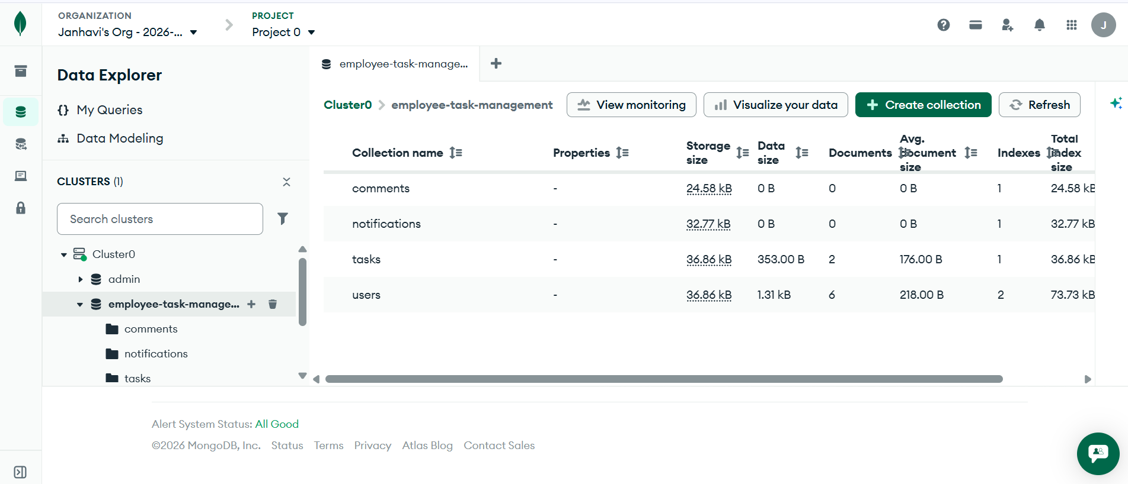

7. API Design

Authentication APIs

Register User
POST /api/auth/register
Request:
{ “name”:“John”, “email”:“john@example.com”, “password”:“password123”, “role”:“Employee” }

Login User
POST /api/auth/login
Request:
{ “email”:“john@example.com”, “password”:“password123” }

Logout User
POST /api/auth/logout

Dashboard APIs
GET /api/dashboard

Task APIs
POST /api/tasks
GET /api/tasks
GET /api/tasks/:id
PUT /api/tasks/:id
DELETE /api/tasks/:id

Comment APIs
POST /api/comments
GET /api/comments
PUT /api/comments/:id
DELETE /api/comments/:id

Notification APIs
POST /api/notifications
GET /api/notifications
PUT /api/notifications/:id/read
DELETE /api/notifications/:id

8. Authentication Implementation
Authentication is implemented using JWT (JSON Web Token).
Features:
- User Registration
- Password Hashing using Bcrypt
- User Login
- JWT Token Generation
- Protected APIs
- Logout Functionality
Security Measures:
- Passwords stored in encrypted format
- JWT verification on protected routes
- Middleware-based authorization

9. Authorization and RBAC
Role Based Access Control (RBAC) has been implemented.

Roles Supported
- Admin
- Manager
- Employee

Backend Authorization
Middleware:
- authMiddleware
- roleMiddleware

Frontend Authorization
Protected Route Component:
- ProtectedRoute.jsx
Unauthorized users cannot access secured pages.

10. Features Implemented

Screens

Home Page
Features:
- Application Introduction
- Public Access
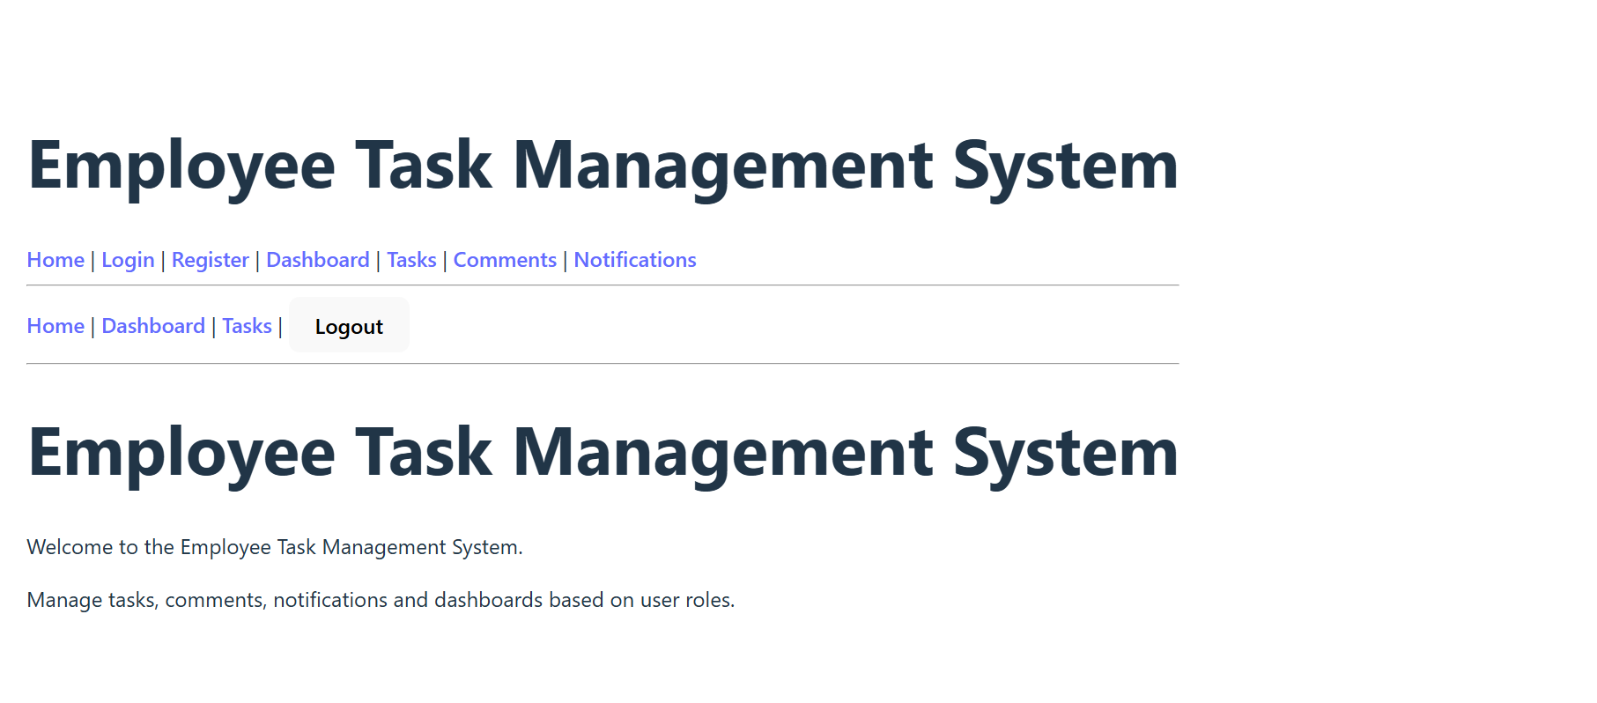

Registration Page
Features:
- Name
- Email
- Password
- Role Selection
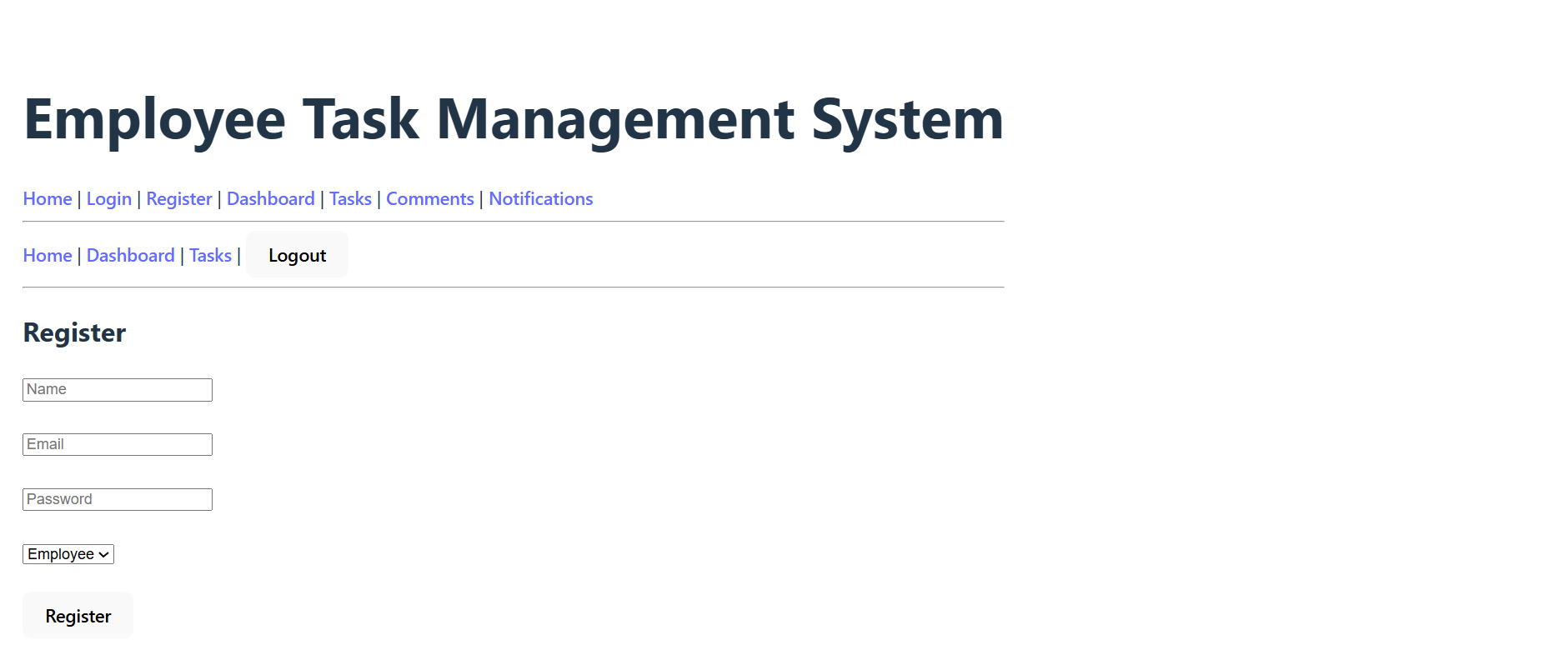

Login Page
Features:
- Credential Validation
- JWT Generation
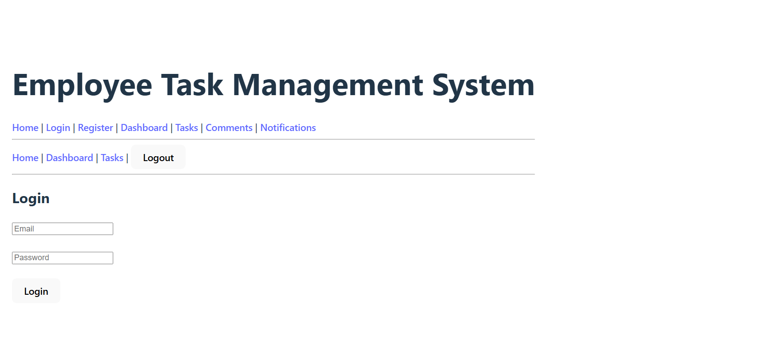

Dashboard
Features:
- Role Specific Dashboard
- Summary Statistics
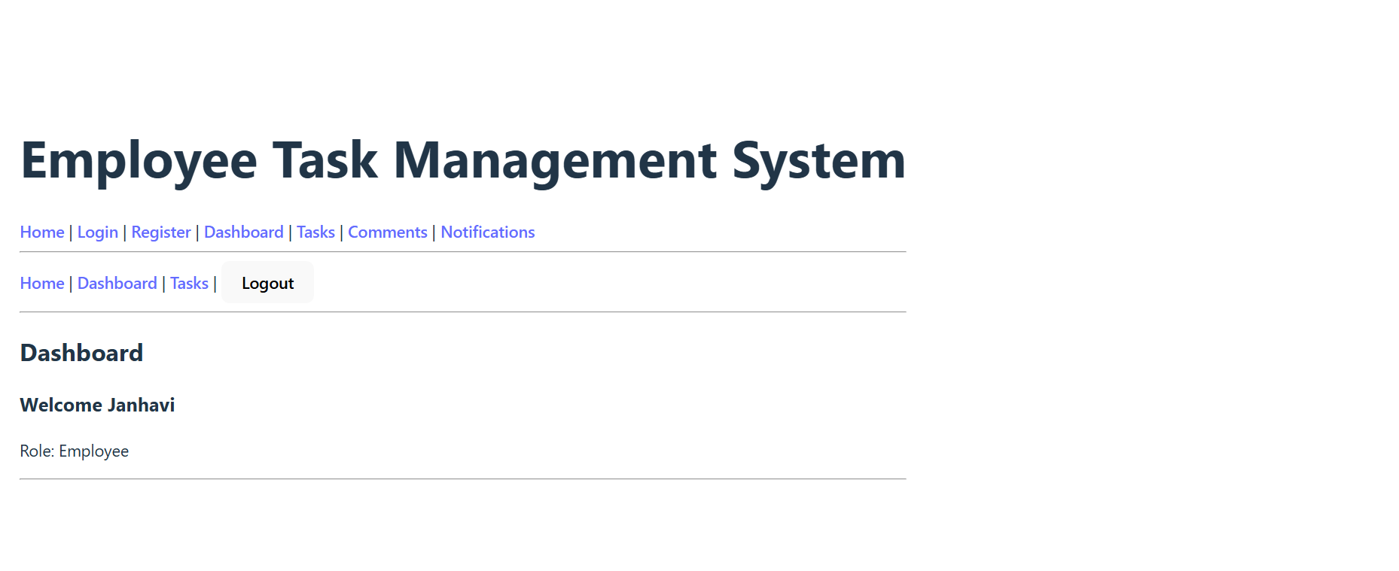

Tasks Module
Features:
- Create Task
- View Tasks
- Update Task
- Delete Task
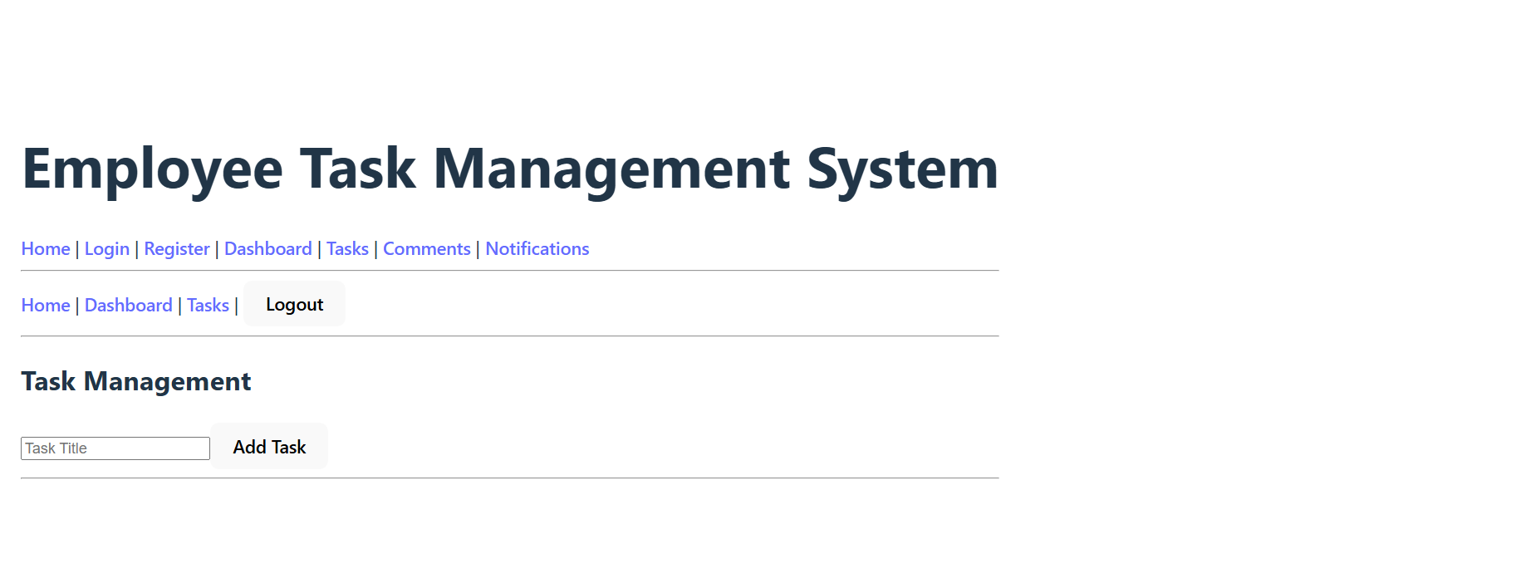

Comments Module
Features:
- Create Comment
- View Comments
- Update Comment
- Delete Comment
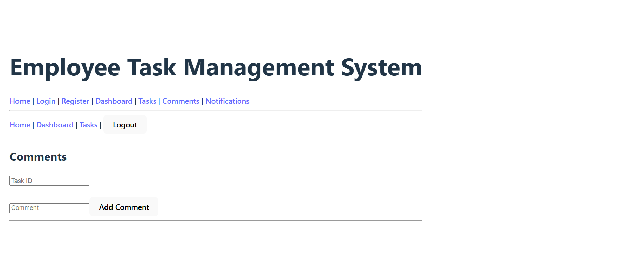

Notifications Module
Features:
- Create Notification
- View Notifications
- Mark As Read
- Delete Notification
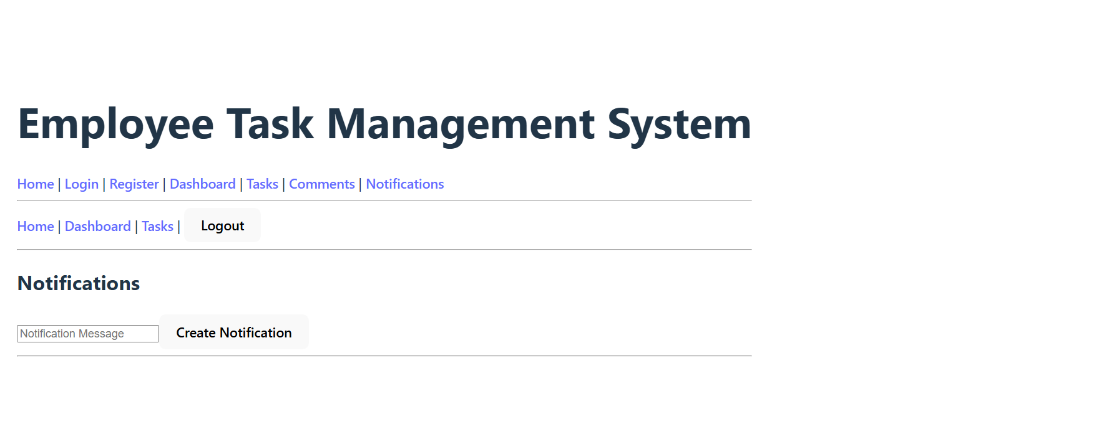

11. Error Handling
Backend Error Handling:
- 400 Validation Errors
- 401 Unauthorized
- 403 Forbidden
- 404 Not Found
- 500 Server Errors
Frontend Error Handling:
- Validation Messages
- Loading Indicators
- Error Alerts
- User Friendly Messages

12. Testing
Backend Testing
Backend APIs were tested using Jest and Supertest.
Test Cases Covered
- Root API
- User Registration
- User Login
- Invalid Login
- User Logout
Results
All backend test cases passed successfully.

Frontend Testing
Frontend components were tested using Vitest and React Testing Library.
Components Tested
- Home Page
- Login Page
- Register Page
- Dashboard Page
- Tasks Page
Results
All frontend test cases passed successfully.

Test Execution Screenshot and Coverage Report Screenshot

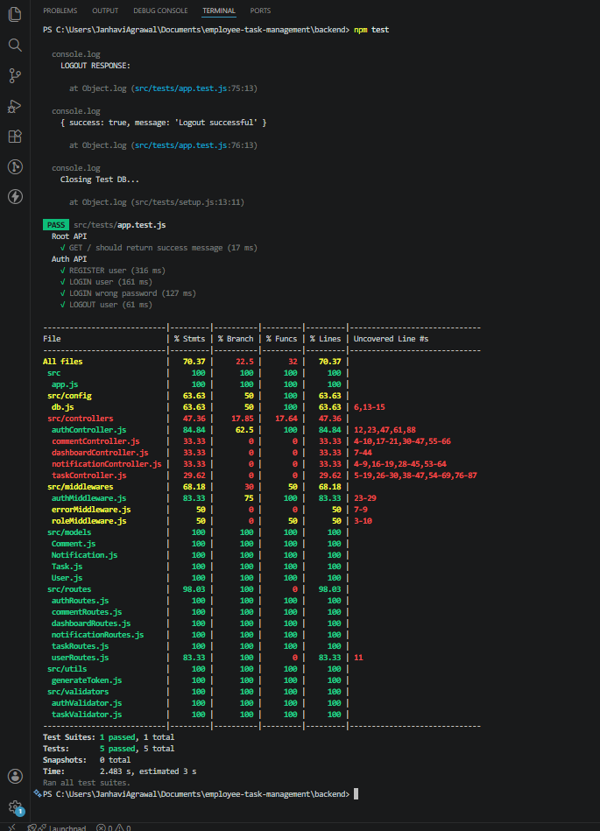
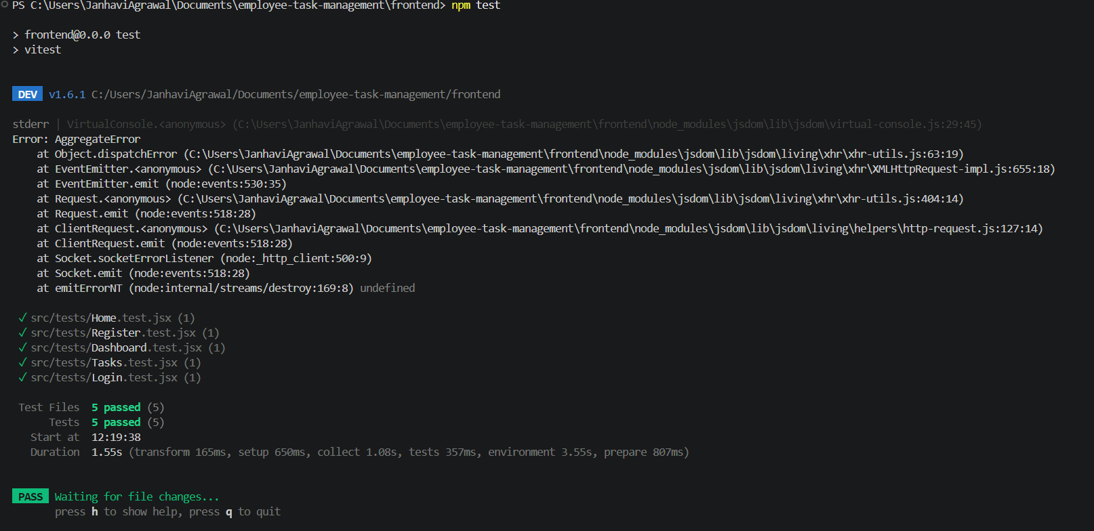
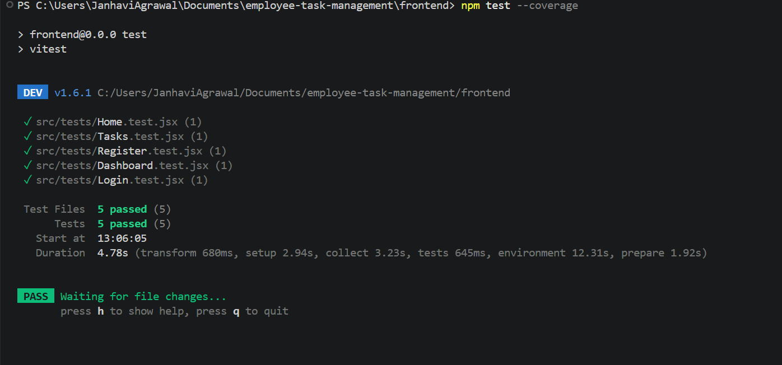

13. Challenges Faced
- Establishing MongoDB connection during Jest testing.
- Fixing JWT authentication and authorization issues.
- Implementing protected routes on frontend and backend.
- Synchronizing CRUD operations between frontend and backend.
- Role-based rendering for Admin, Manager and Employee users.
- Adding loading indicators and user-friendly error handling.
- Configuring frontend testing environment using Vitest.

14. Learnings
Through this project, practical experience was gained in:
- React component development and routing.
- Building RESTful APIs using Express.js.
- MongoDB schema design and Mongoose integration.
- JWT-based authentication and role-based authorization.
- CRUD operations with validation.
- Middleware and error handling techniques.
- Unit and integration testing using Jest, Supertest, Vitest and React Testing Library.
- Full-stack application architecture and deployment workflow.

15. Conclusion
The Employee Task Management System was successfully developed using the MERN stack. The application implements all mandatory requirements specified in the assignment, including authentication, authorization, role-based access control, CRUD operations, MongoDB integration, error handling, and testing.
The project demonstrates end-to-end FullStack development capabilities and provides a scalable foundation for enterprise task management applications.

16. Github Link

