**Industrial Internship Report on**

**” HEALTHCARE DATA MANAGEMENT”**

**Prepared by**

**JANHAVI LALL**

|  |
| --- |
| *Executive Summary* |
| This report provides details of the Industrial Internship provided by upskill Campus and The IoT Academy in collaboration with Industrial Partner UniConverge Technologies Pvt Ltd (UCT).  This internship was focused on a project/problem statement provided by UCT. We had to finish the project including the report in 6 weeks’ time.  My project was Healthcare data management system that includes registration and login of the patients, blood type, donor information, storage space, and blood deposit locations. The information about the blood bank is saved on the cloud. The technology will assist users in identifying blood donors by comparing the information recorded in the database with the information entered into the system.  This internship gave me a very good opportunity to get exposure to Industrial problems and design/implement solution for that. It was an overall great experience to have this internship. |

**TABLE OF CONTENTS**

1 Preface 3

2 Introduction 4

2.1 About UniConverge Technologies Pvt Ltd 5

2.2 About upskill Campus 7

2.3 Objective 9

2.4 Reference 11

3 Problem Statement 12

4 Existing and Proposed solution 13

5 Proposed Design/ Model 16

6 Performance Test 17

6.1 Test Plan/ Test Cases 17

6.2 Test Procedure 19

6.3 Performance Outcome 21

7 My learnings 22

8 Future work scope 23

# Preface

During this 6-week training in cloud computing I got to know about clod computing in depth.

In the first week I got to know about basic of cloud computing and in the second week I got to know about its types and about service model provided. In the third week I learnt about AWS and how to create an account in it and learnt about Arduino software. Fourth week was about Thingspeak and IoT tools. Fifth week was about soft skills which will help us in our placement drives in the colleges. And finally, the sixth week was about making project.

Internships have become an integral part of career development for students and young professionals. A relevant internship provides hands-on experience, enhances skill sets, and opens up numerous opportunities for career growth. Like Industry Insights, Practical Experience etc.

My team has work on the project titled “Healthcare data management” system that includes registration and login of the patients, blood type, donor information, storage space, and blood deposit locations. The information about the blood bank is saved on the cloud. The technology will assist users in identifying blood donors by comparing the information recorded in the database with the information entered into the system.

Opportunity given by USC/UCT.

How Program was planned

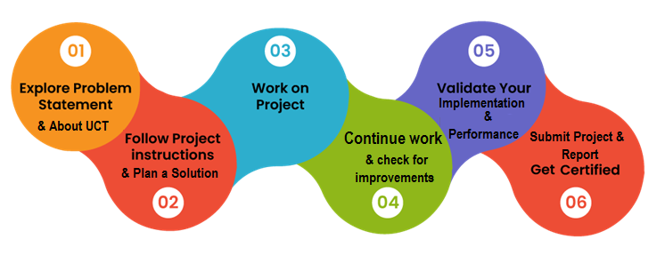

Your Learnings and overall experience.

Thanks to all (with names), who have helped you directly or indirectly.

# Introduction

## About UniConverge Technologies Pvt Ltd

A company established in 2013 and working in Digital Transformation domain and providing Industrial solutions with prime focus on sustainability and RoI.

For developing its products and solutions it is leveraging various**Cutting Edge Technologies e.g. Internet of Things (IoT), Cyber Security, Cloud computing (AWS, Azure), Machine Learning, Communication Technologies (4G/5G/LoRaWAN), Java Full Stack, Python, Front end**etc.

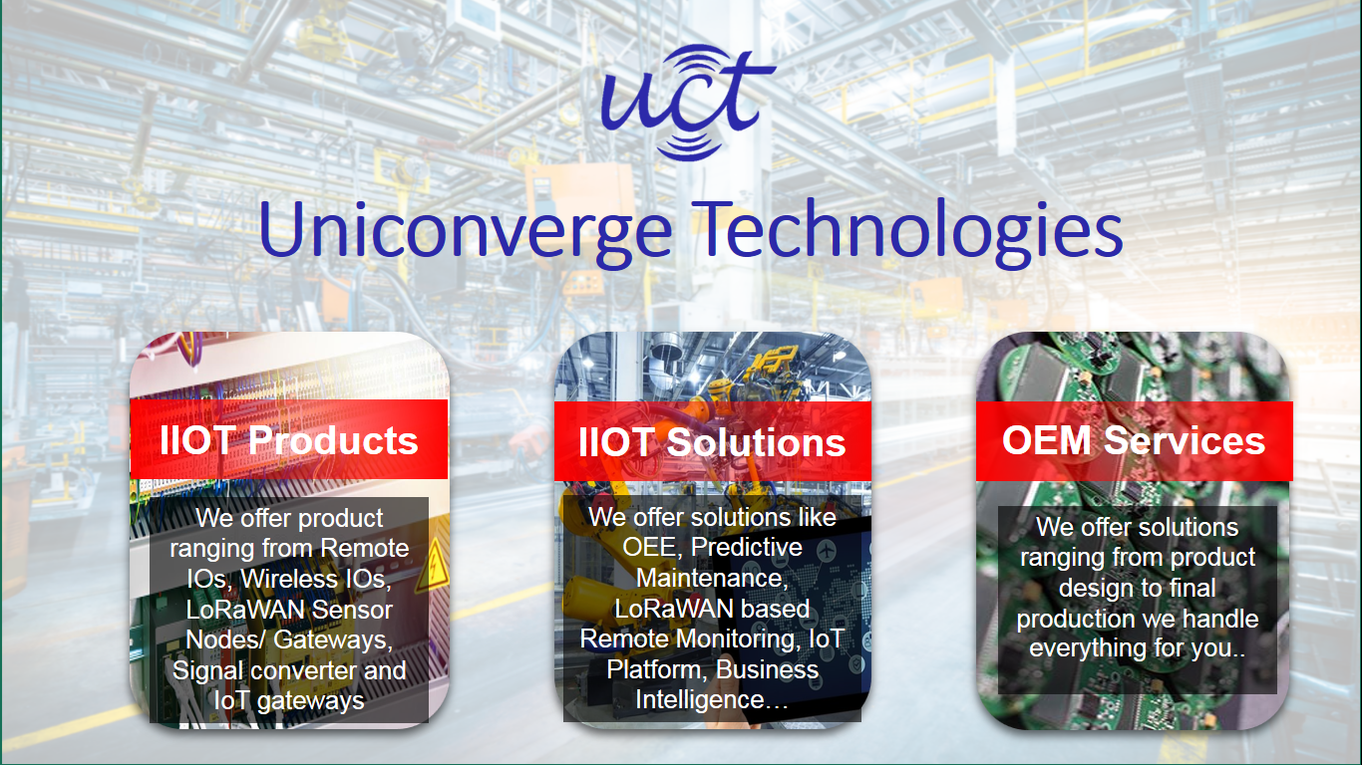

1. UCT IoT Platform **(****)**

**UCT Insight** is an IOT platform designed for quick deployment of IOT applications on the same time providing valuable “insight” for your process/business. It has been built in Java for backend and ReactJS for Front end. It has support for MySQL and various NoSql Databases.

* It enables device connectivity via industry standard IoT protocols - MQTT, CoAP, HTTP, Modbus TCP, OPC UA
* It supports both cloud and on-premises deployments.

It has features to  
• Build Your own dashboard  
• Analytics and Reporting  
• Alert and Notification  
• Integration with third party application (Power BI, SAP, ERP)  
• Rule Engine





1. **Smart Factory Platform (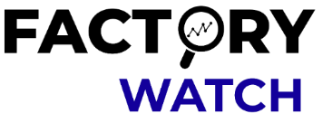)**

Factory watch is a platform for smart factory needs.

It provides Users/ Factory

* with a scalable solution for their Production and asset monitoring
* OEE and predictive maintenance solution scaling up to digital twin for your assets.
* to unleased the true potential of the data that their machines are generating and helps to identify the KPIs and also improve them.
* A modular architecture that allows users to choose the service that they what to start and then can scale to more complex solutions as per their demands.

Its unique SaaS model helps users to save time, cost and money.



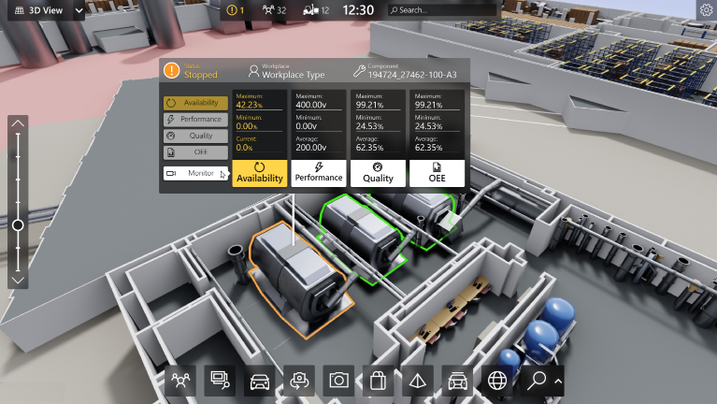

1. 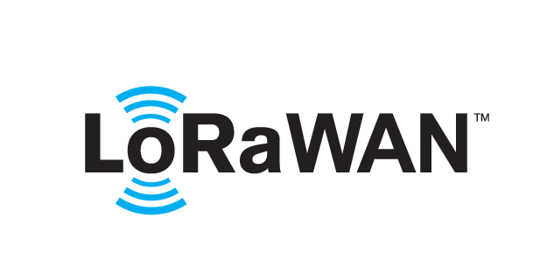 based Solution

UCT is one of the early adopters of LoRAWAN technology and providing solution in Agritech, Smart cities, Industrial Monitoring, Smart Street Light, Smart Water/ Gas/ Electricity metering solutions etc.

1. Predictive Maintenance

UCT is providing Industrial Machine health monitoring and Predictive maintenance solution leveraging Embedded system, Industrial IoT and Machine Learning Technologies by finding Remaining useful life time of various Machines used in production process.



## About upskill Campus (USC)

upskill Campus along with The IoT Academy and in association with Uniconverge technologies has facilitated the smooth execution of the complete internship process.

USC is a career development platform that delivers **personalized executive coaching** in a more affordable, scalable and measurable way.

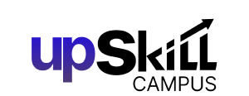

Seeing need of upskilling in self- paced manner along-with additional support services e.g. Internship, projects, interaction with Industry experts, Career growth Services

<https://www.upskillcampus.com/>

upSkill Campus aiming to upskill 1 million learners in next 5 year

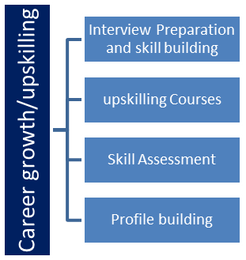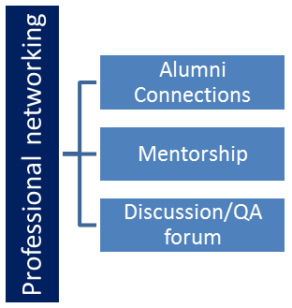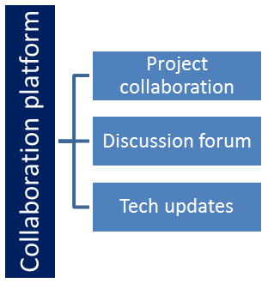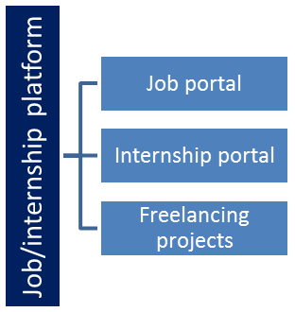

## The IoT Academy

The IoT academy is EdTech Division of UCT that is running long executive certification programs in collaboration with EICT Academy, IITK, IITR and IITG in multiple domains.

## Objectives of this Internship program

The objective for this internship program was to

 ☛ get practical experience of working in the industry.

 ☛ to solve real world problems.

 ☛ to have improved job prospects.

 ☛ to have Improved understanding of our field and its applications.

 ☛ to have Personal growth like better communication and problem solving.

## Reference

[1] YouTube

[2] Django tutorials

# Problem Statement

HEALTHCARE DATA MANAGEMENT

A Healthcare Data Management System is essential for modernizing healthcare delivery, improving patient outcomes, and ensuring efficient operation of healthcare facilities. Healthcare Data Management System provides a robust framework for managing healthcare data securely and effectively. Despite the challenges, the benefits of implementing a Healthcare Data Management System make it a valuable investment for healthcare organizations aiming to enhance the quality of care and operational efficiency.

A Healthcare Data Management System (HDMS) is a comprehensive platform designed to collect, store, manage, and analyze patient data and other healthcare-related information. The primary goal of an HDMS is to improve the quality of care, enhance patient outcomes, streamline operations, and ensure compliance with regulatory standards.

# Existing and Proposed solution

Provide summary of existing solutions provided by others, what are their limitations?

Healthcare Data Management Systems (HDMS) have evolved significantly, incorporating a range of technologies and functionalities. Here are some prominent existing solutions and their key features:

1)Practice Management Systems (PMS)

Examples: Athenahealth, NextGen, Kareo

Features: Appointment scheduling, billing and insurance claims management, patient communication, administrative task automation.

2)Clinical Data Repositories (CDR)

Examples: IBM Health Insights, Philips HealthSuite, SAP Health

Features: Centralized storage of clinical data, data integration from various sources, support for big data analytics, real-time data access for clinical and research purposes.

Its limitations are:

1) Data Security and Privacy Concerns

Cybersecurity Threats: Healthcare data is a prime target for cyberattacks, and existing systems often struggle to keep up with evolving threats.

Compliance Burden: Ensuring compliance with regulations like HIPAA, GDPR, and other local laws can be complex and resource-intensive.

2) Data Quality and Accuracy

Data Entry Errors: Manual data entry can lead to errors, inaccuracies, and inconsistencies in patient records.

Incomplete Data: Incomplete or missing data can affect clinical decision-making and patient care quality.

The future of Healthcare Data Management Systems (HDMS) is poised to transform the healthcare industry significantly, driven by technological advancements and the increasing demand for efficient and effective healthcare solutions. Here are key areas where HDMS is expected to evolve and have a substantial impact:

1. Artificial Intelligence and Machine Learning Integration

Predictive Analytics: AI and machine learning will enhance predictive analytics capabilities, allowing for early detection of diseases, prediction of patient outcomes, and personalized treatment plans.

Automated Diagnosis: AI-powered tools can assist in diagnosing diseases more accurately and quickly, reducing the burden on healthcare professionals and improving patient care.

2. Enhanced Interoperability

Standardized Data Formats: Development of standardized data formats and protocols (such as FHIR - Fast Healthcare Interoperability Resources) will facilitate seamless data exchange between different healthcare systems.

Global Health Information Exchange: Enhanced interoperability will enable global health information exchanges, allowing for better coordination of care, especially for patients traveling or moving between different healthcare providers.

3. Advanced Data Security and Privacy Measures

Blockchain Technology: Implementing blockchain can provide a secure and immutable way to manage healthcare data, ensuring transparency and security while allowing patients to control their data.

Enhanced Encryption: Continued advancements in encryption technologies will protect patient data from breaches and unauthorized access, ensuring compliance with stringent regulatory requirements.

4. Personalized Medicine

Genomic Data Integration: HDMS will integrate genomic data, enabling personalized medicine where treatments and medications can be tailored to individual genetic profiles.

Precision Healthcare: Leveraging big data and analytics, healthcare providers can develop precision healthcare strategies that address individual patient needs and conditions.

5. Telemedicine and Remote Monitoring

Integration with Wearables: HDMS will increasingly integrate data from wearable devices and remote monitoring tools, providing real-time health data to healthcare providers and enabling proactive management of chronic conditions.

Telehealth Expansion: Enhanced data management capabilities will support the expansion of telehealth services, making healthcare more accessible, especially in remote and underserved areas.

6. Enhanced Patient Engagement and Empowerment

Improved Patient Portals: Future HDMS will feature more sophisticated patient portals, offering comprehensive health records, personalized health advice, and interactive tools for managing health and wellness.

Patient-Centric Care: Empowering patients with better access to their health data will promote a more patient-centric approach to care, encouraging active participation in health management.

7. Data-Driven Decision Making

Clinical Decision Support Systems: Advanced data analytics will power clinical decision support systems, helping healthcare providers make evidence-based decisions and improve clinical outcomes.

Operational Efficiency: Data-driven insights will optimize hospital operations, resource allocation, and supply chain management, leading to cost reductions and improved efficiency.

**Code submission (Github link)**

<https://github.com/janhavilall/upskillCampus.git>

**Report submission (Github link):**

<https://github.com/janhavilall/upskillCampus.git>

# Proposed Design/ Model

For our system we had decided to use Waterfall Model. The Waterfall model is a sequential software development methodology that progresses through distinct phases: Requirements, Design, Implementation, Verification, and Maintenance. It is often used for projects with well-defined requirements and is suitable for systems where changes are costly or complex.

**1. Requirements Analysis**

Objectives:

Gathered and documented all requirements (e.g., patients).

Define the system's functionality, including data entry, storage, retrieval, and reporting capabilities.

**2. System Design**

Objectives:

Developed a comprehensive system architecture that meets the specified requirements.

Design the database schema, user interfaces.

**3. Implementation**

Objectives:

Developed the system based on the design specifications.

Ensure that the code adheres to best practices and regulatory requirements.

**4. Verification (Testing**)

Objectives:

Ensure the system meets all requirements and functions correctly.

Verify that the system is secure and compliant with regulations.

**5. Maintenance**

Objectives:

Address issues identified during the system's operational phase.

Implement updates and enhancements as needed.

# Performance Test

Performance testing is a crucial aspect of software development, particularly for systems like healthcare data management where reliability, speed, and scalability are critical.

We could not test them, but we have mentioned how constraints can impact our design, and what are recommendations to handle them.

Constraints significantly impact the design process in various ways. They can shape the overall architecture, influence technology choices, and dictate the usability and functionality of the system.

## Test Plan/ Test Cases

**Test Case 1: User Login**

Objective: Verify that users can log in with valid credentials.

Preconditions: User accounts are set up.

Test Steps:

Navigate to the login page.

Enter valid username and password.

Click the login button.

Expected Results: User is successfully logged in and redirected to the dashboard.

**Test Case 2: Add Patient Record**

Objective: Ensure new patient records can be added.

Preconditions: User is logged in with appropriate permissions.

Test Steps:

Navigate to the patient records section.

Click on "Add New Patient."

Fill in the required fields (e.g., name, DOB, medical history).

Click "Save."

Expected Results: New patient record is saved and appears in the patient list.

**Test Case 3: Search Patient Record**

Objective: Verify that patient records can be searched.

Preconditions: Patient records exist.

Test Steps:

Navigate to the patient records section.

Enter a search term (e.g., patient name or ID).

Click "Search."

Expected Results: Relevant patient records are displayed.

## Test Procedure

Test procedures are detailed instructions on how to execute each test case within the test plan. These procedures ensure that testing is consistent, repeatable, and thorough.

**1. Functional Testing**

**Test Case 1: User Login**

Objective: Verify that users can log in with valid credentials.

Preconditions: User accounts must be set up and active.

Test Steps:

Open the healthcare data management system application.

Navigate to the login page.

Enter a valid username in the "Username" field.

Enter the corresponding password in the "Password" field.

Click the "Login" button.

Verify that the system redirects to the user dashboard.

Log out to complete the test.

Expected Results: User is successfully logged in and redirected to the dashboard.

**2. Performance Testing**

**Test Case 2: System Response Time Under Load**

Objective: Measure response time with 100 concurrent users.

Preconditions: Load testing tool configured and system accessible for load testing.

Test Steps:

Configure the load testing tool to simulate 100 concurrent users.

Define user actions (e.g., login, navigate to patient records, search for a patient).

Start the load test.

Monitor and record response times for each user action.

Analyse the collected data to ensure response times are within acceptable limits.

Expected Results: Response times remain under 2 seconds for all actions.

**3. Security Testing**

**Test Case 3: User Access Control**

Objective: Ensure users have appropriate access based on their roles.

Preconditions: User accounts with different roles (admin, doctor, nurse) set up.

Test Steps:

Log in as a user with restricted access (e.g., nurse).

Attempt to access administrative features (e.g., user management, system settings).

Verify that access is denied with an appropriate message.

Log out and repeat steps for other roles (e.g., doctor, admin) as necessary.

Expected Results: Users can only access features allowed by their roles.

## Performance Outcome

Performance outcomes in a healthcare data management system are critical for ensuring the system's reliability, efficiency, and user satisfaction. Here are key performance outcomes that should be evaluated, along with the methods to measure them and their implications:

1. System Response Time
2. Throughput
3. Scalability
4. Data Integrity and Consistency
5. Resource Utilization
6. System Availability and Uptime
7. User Satisfaction

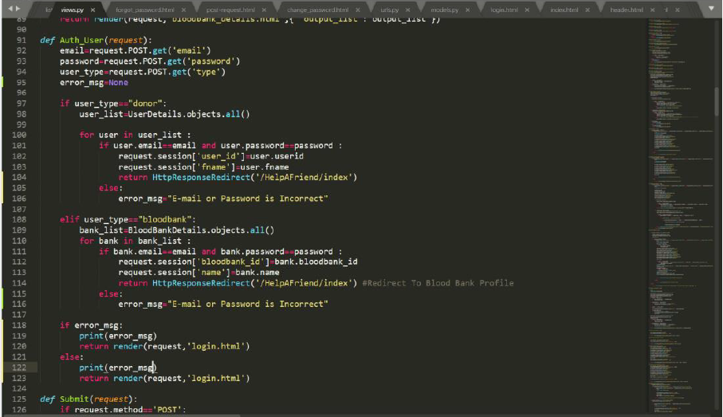

# My learnings

Embarking on a cloud computing internship offers a rich and diverse learning experience, providing valuable insights into the dynamic world of cloud technologies. Here’s an overview of what I learnt and experience during such an internship:

1. **Cloud Platforms**

AWS, Azure, Google Cloud: Hands-on experience with one or more of the major cloud service providers.

1. **Cloud Security**

Best Practices: Implementing security best practices for cloud resources.

Tools: Using security tools and services like AWS IAM, Azure Security Center, and Google Cloud IAM.

1. **Real-world Projects**

Project Involvement: Participating in or leading real-world projects that leverage cloud technologies.

Problem-Solving: Applying cloud solutions to solve business problems.

1. **Teamwork**

Working with cross-functional teams, including developers, operations, and security professionals.

# Future work scope

The future scope of healthcare management systems is vast and promising, driven by technological advancements, evolving patient needs, and the increasing emphasis on efficiency, data security, and personalized care. Here are some key areas:

**1. Integration of Advanced Technologies**

a. Artificial Intelligence (AI) and Machine Learning (ML)

Predictive Analytics: AI and ML can predict patient outcomes, disease outbreaks, and treatment responses by analyzing vast amounts of data.

Personalized Medicine: Tailoring treatment plans based on individual patient data and genetic information.

Administrative Automation: Automating administrative tasks such as appointment scheduling, billing, and claims processing.

**2. Enhanced Data Security and Privacy**

Blockchain Technology: Implementing blockchain for secure and immutable patient records, ensuring data integrity and privacy.

Advanced Encryption Methods: Using more robust encryption techniques to protect sensitive health data.