Homework 2B: Practice exercises on class project (100 points)

No. | First Name | Last Name | Cornell NetID | GithubID
1 | Janhavi | Gaikwad | jg2569 | janhaviprof-bot
2 | Anurag | Yadav | ay468 | anuragyadav21
3 | Kris | Singh | as4499 | realAryavardhanSingh

Project Topic-A Family Of Next-Generation General Aviation
Aircraft

Exercise 1: Functional and operational architecture (50 points)

1. Complete list and succinctly of the primary functions of the system and hierarchical decomposition of functions and representation in SysML Bdd.

Level-1 Primary Functions (Top-Level BDD)
Function-ID | Function Name | Description | Primary Goals Addressed
F1 | Generate & Manage Propulsion | Produce and regulate thrust via the hybrid-electric powertrain (turbine/piston generator + battery + electric motors). Manage energy flow, redundancy switching, and fuel burn. | G1, G6, G9, G19
F2 | Control Flight Path | Translate pilot inputs and autopilot commands into control surface deflections and flight management actions. Enforce flight envelope limits. | G3, G13, G17, G18
F3 | Monitor & Ensure Safety | Continuously monitor all critical systems, detect faults, trigger redundant pathways, and provide crew/passenger emergency protection (ballistic parachute, automated recovery). | G1, G2, G4, G14, G18
F4 | Manage Avionics & Communications | Process navigation, communication, and surveillance data. Display situational awareness to the crew and transmit telemetry to ATC and ground systems. | G2, G13, G17, G20
F5 | Support Cabin & Payload | Maintain cabin environmental conditions (pressure, temperature, noise), manage passenger comfort, and accommodate mission-specific payload modules. | G11, G16, G19
F6 | Enable Maintenance & Health Management | Collect health/usage monitoring data from all subsystems, support diagnostics and prognostics, generate maintenance action recommendations, and enable modular replacement. | G4, G7, G8, G20
Level-2 Sub-Functions ( Decomposition Table)
Sub Function-ID | Sub-Function Name | Description | Primary Function
F1.1 | Generate Hybrid Thrust | Operate the turbine/piston engine in series or parallel hybrid mode to produce shaft power and/or direct thrust. Manage fuel metering. | F1
F1.2 | Store & Distribute Electrical Energy | Manage battery state-of-charge, balance cells, protect from over/under-voltage, and distribute power to electric motors and avionics buses. | F1
F1.3 | Drive Electric Propulsors | Command and regulate distributed electric motor/propeller units; switch among primary, secondary, and emergency propulsor sets. | F1
F1.4 | Manage Propulsion Redundancy | Monitor propulsion health, detect failures, and execute automatic failover (e.g., single-engine-out procedure, motor rebalancing). | F1
F2.1 | Process Pilot Control Inputs | Receive and interpret sidestick/rudder pedal inputs; apply control laws and trim logic; send commands to actuators. | F2
F2.2 | Actuate Primary Flight Controls | Deflect ailerons, elevator, and rudder via fly-by-wire actuators. Provide redundant actuator lanes and position feedback. | F2
F2.3 | Manage High-Lift & Landing Systems | Operate flaps, slats, landing gear extension/retraction, and brakes; integrate with energy management for landing approach. | F2
F2.4 | Enforce Flight Envelope Protection | Monitor alpha, G-load, bank angle and airspeed; prevent exceedances through autonomous limit-protection inputs to actuators. | F2
F3.1 | Monitor System Health in Real-Time | Continuously sample sensor data from all LRUs; detect anomalies against defined thresholds; alert crew via cockpit warnings. | F3
F3.2 | Execute Fault Isolation & Reconfiguration | Identify failed components through FMEA-based logic; isolate faults; reconfigure remaining healthy systems to maintain operability. | F3
F3.3 | Trigger Emergency Recovery Systems | Deploy ballistic whole-aircraft parachute, auto-feather propellers, and emergency power when catastrophic failure is confirmed. | F3
F3.4 | Manage Fire & Structural Protection | Monitor engine bay/battery for thermal runaway; activate fire suppression; monitor airframe structural health sensors. | F3
F4.1 | Navigate & Position the Aircraft | Fuse GPS, inertial, and radio-nav data to compute accurate aircraft position, velocity, and attitude for flight management. | F4
F4.2 | Display Situational Awareness | Present flight data (PFD/MFD), traffic, terrain, weather, and system status on glass cockpit displays with clear human-factors design. | F4
F4.3 | Communicate & Transmit Data | Manage VHF/HF voice radio, ADS-B In/Out, datalink (ACARS), and satellite uplink for ATC clearances and telemetry. | F4
F4.4 | Manage Flight Plan & Autopilot | Store, sequence, and execute flight plans; couple autopilot/autothrottle; provide missed-approach and go-around guidance. | F4
F5.1 | Condition Cabin Environment | Regulate cabin temperature, ventilation, and acoustic damping (exploiting electric propulsion's low noise); alert on pressurization anomaly. | F5
F5.2 | Accommodate Modular Payload | Mechanically and electrically interface standardized mission-module bays; verify module mass/CG compliance before flight. | F5
F5.3 | Ensure Passenger Restraint & Egress | Manage door-locking logic, occupant restraint sensing, and emergency egress paths; integrate with parachute deployment sequence. | F5
F6.1 | Collect & Log Health/Usage Data | Record time-series data from all sensors to on-board HUMS memory and transmit compressed snapshots over datalink after flight. | F6
F6.2 | Diagnose & Predict Maintenance Needs | Run on-board and ground-based analytics to detect degradation trends and predict component life; generate maintenance work-orders. | F6
F6.3 | Support Modular Line Replaceable Units | Provide standardized electrical/data connectors and mechanical interfaces for LRU swap; automate BIT (Built-In Test) on reconnection. | F6

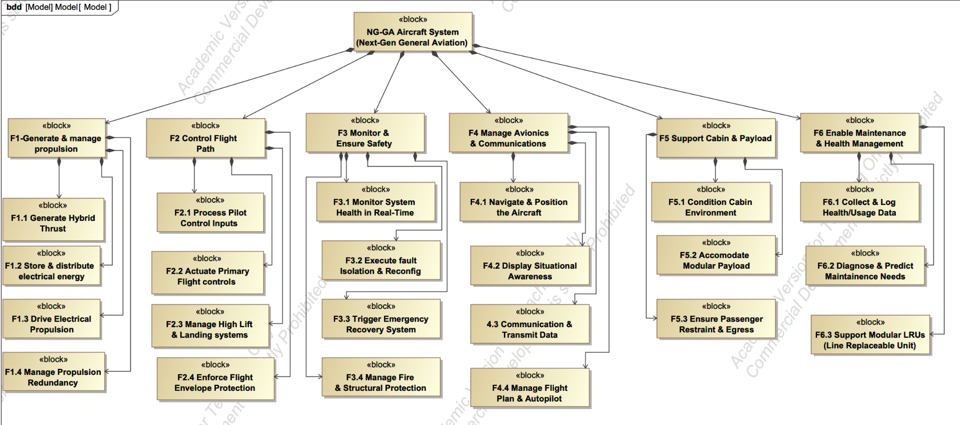
Figure 1 : Sysml Bdd & hierarchical decomposition of
functions

2. Flow of operands between functions and their representation in SysML Activity Diagrams (act).

1: Activity Diagram for F1-Generate & Manage Propulsion
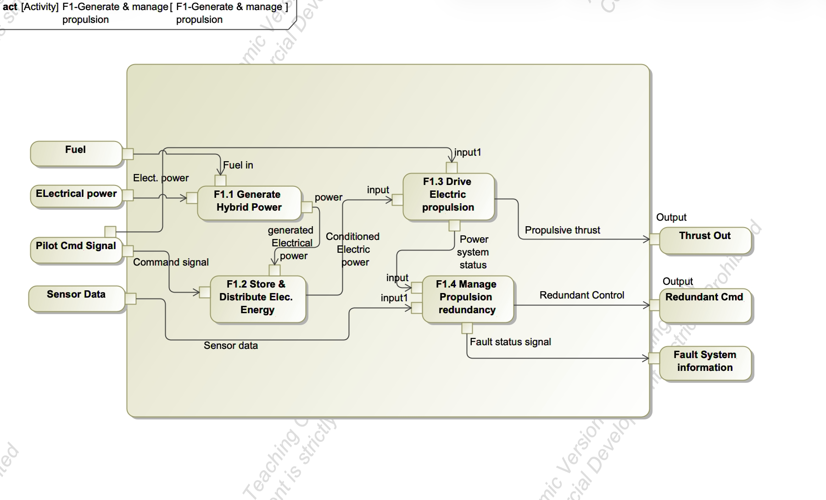
Figure 2 : Activity Diagram Generate & Manage Propulsion

In F1, fuel and electrical power enter the boundary and are first converted into usable hybrid power in F1.1. That generated electrical power is then conditioned and distributed through F1.2, where it becomes usable for propulsion. The conditioned power flows into F1.3, which actually drives the electric propulsion and produces thrust. At the same time, pilot command signals and sensor data influence both F1.2 and F1.3, shaping how energy is allocated. Propulsion status is then passed to F1.4, which manages redundancy and generates fault information and backup control commands. So energy is progressively transformed, while control and health operands supervise the process in parallel.

2: Activity Diagram for F2-Control Flight

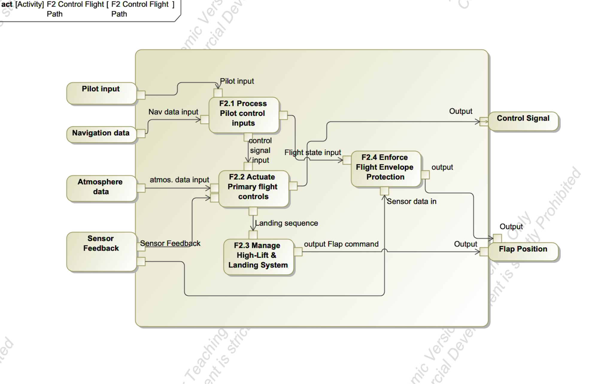
Figure 3 : Activity Diagram Control Flight

Pilot input and navigation data are first processed in F2.1, where the primary control signal is generated. That signal flows into F2.2, which actuates the primary flight controls and adjusts response based on atmospheric data. From there, the landing sequence branches into F2.3 for high-lift and flap management. Meanwhile, flight state information from F2.1, along with sensor feedback, feeds into F2.4, where flight envelope protection ensures operational limits are respected. The final output control signals and flap position are therefore shaped by both actuation and constraint logic.

3: Activity Diagram for F3-Monitor & Ensure Safety

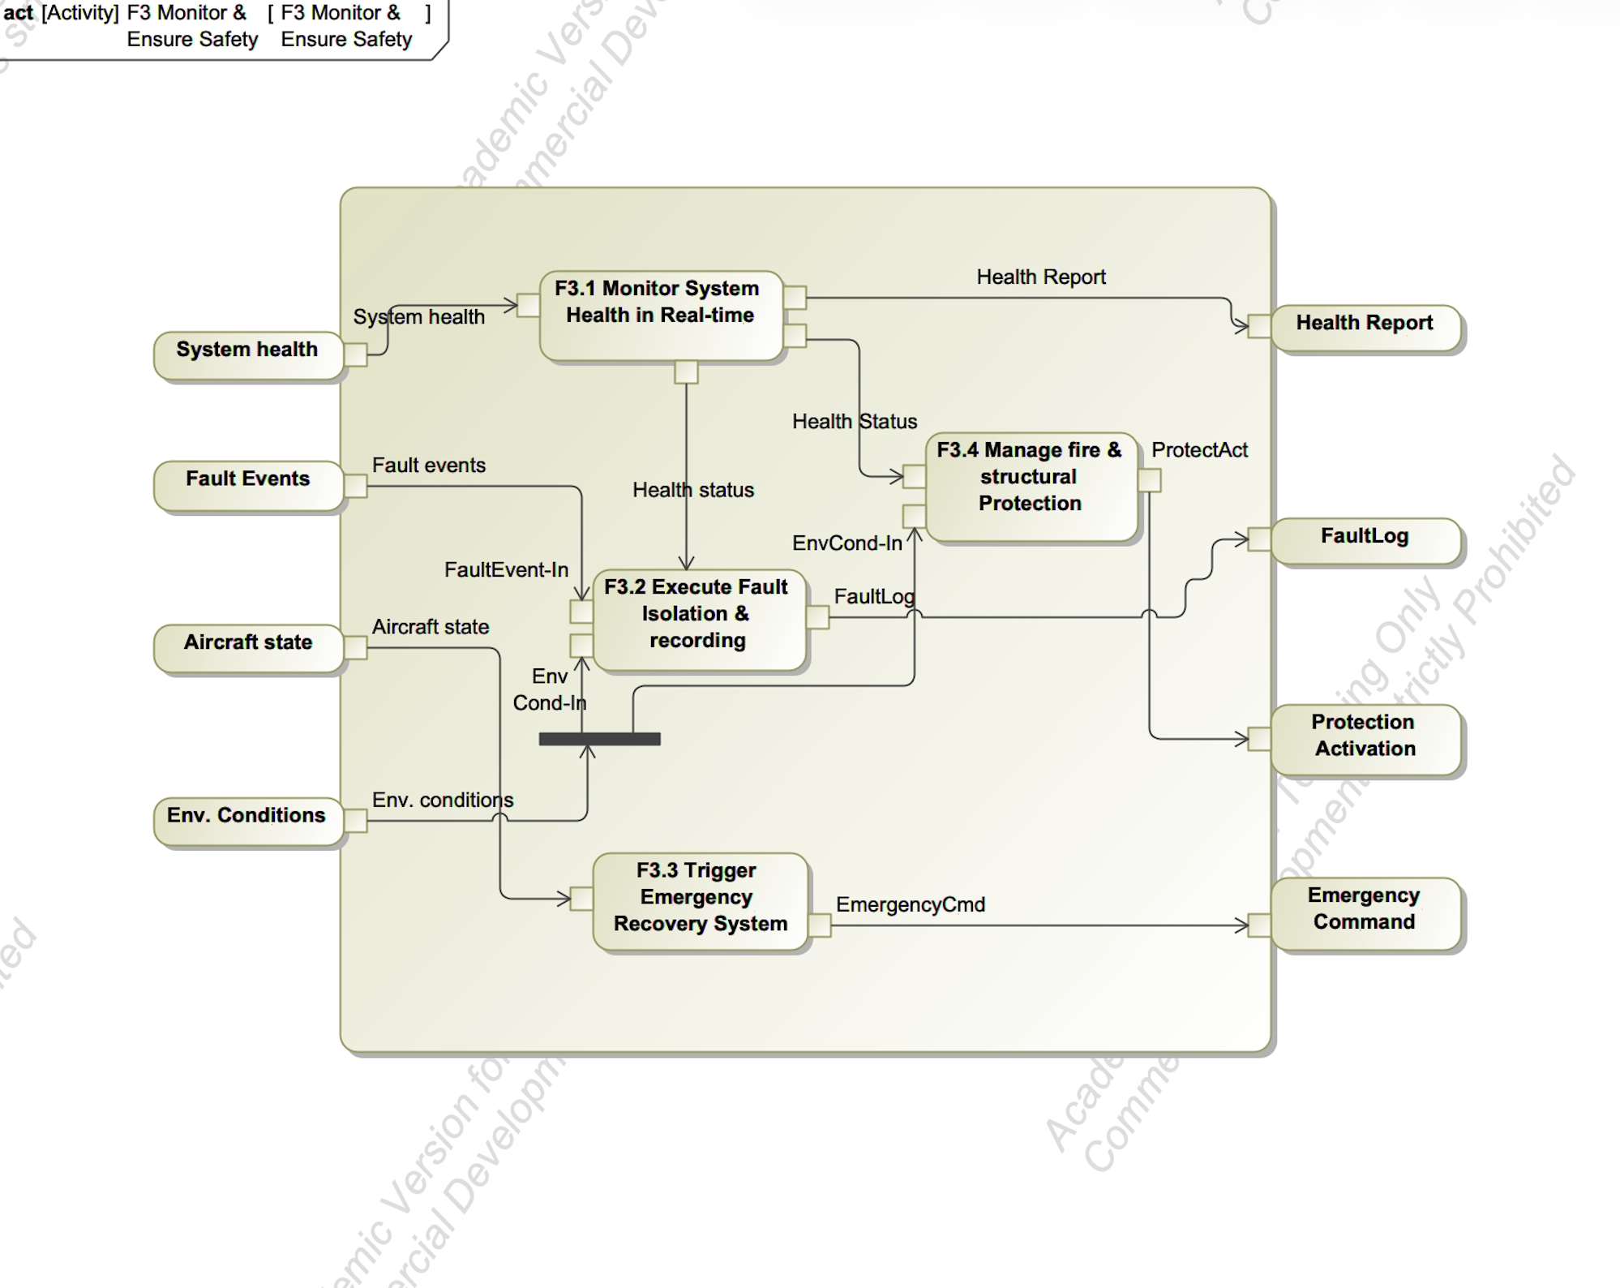
Figure 4 : Activity Diagram for Monitor & Ensure Safety

System health data is continuously monitored in F3.1, where it is converted into a health status. That status feeds into F3.2 for fault isolation and logging, and also into F3.4 for protection management. Fault events and aircraft state further influence F3.2, which can trigger responses in F3.3 if emergency recovery is needed. Environmental conditions are evaluated across the safety logic before protection activation is issued. So this function shows how data is assessed, filtered, and escalated through F3.1–F3.4 depending on severity.

4: Activity Diagram for F4-Manage Avionics & Communications
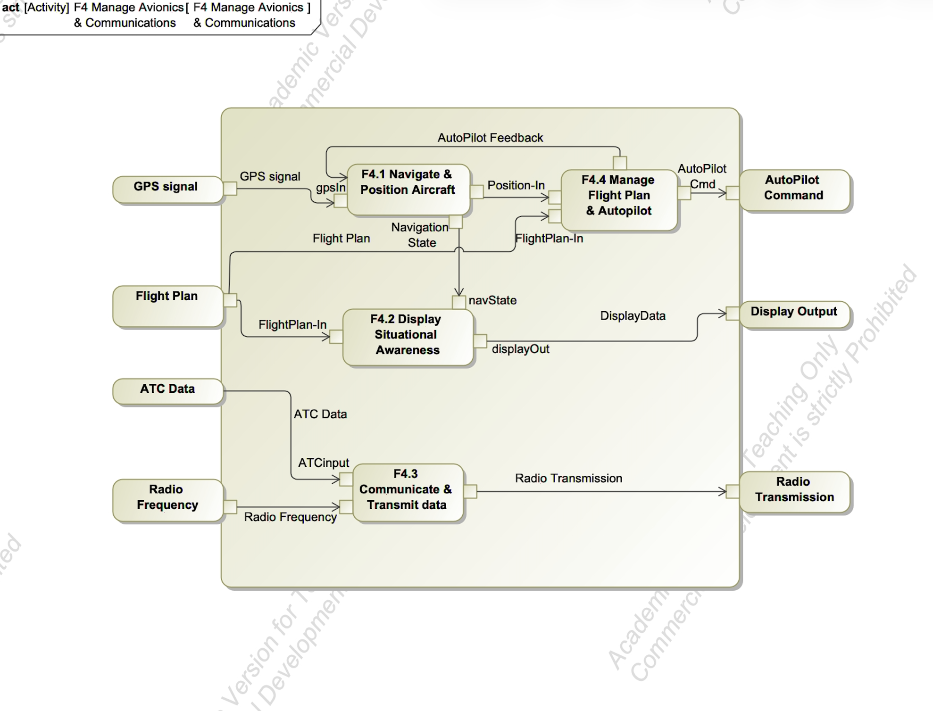
Figure 5 : Activity Diagram for Manage avionics & Communications

GPS input is processed in F4.1 to establish the navigation state and aircraft position. That state feeds into F4.2 for situational awareness display and into F4.4, where flight plan management and autopilot control occur. There is a feedback loop from F4.4 back to F4.1, showing continuous refinement of navigation. Separately, ATC data and radio frequency inputs are handled in F4.3, which produces outbound radio transmissions. So F4.1–F4.4 collectively transform navigation and communication inputs into both display outputs and autopilot commands.

5: Activity Diagram for F5-Support Cabin & Payload

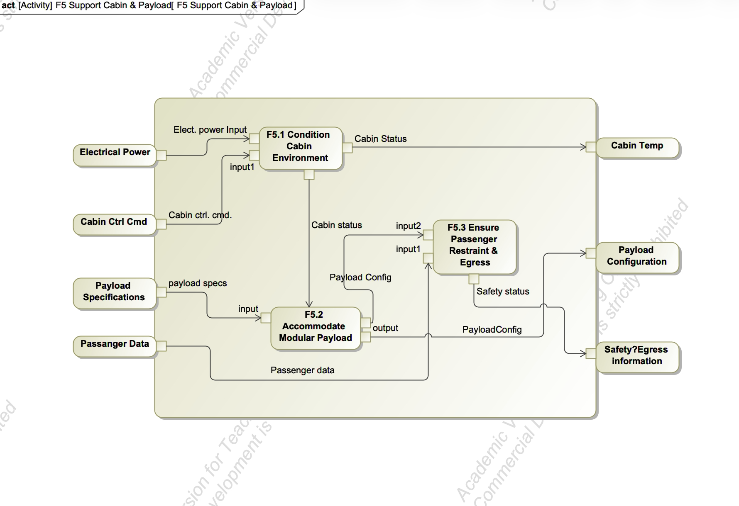
Figure 6 : Activity Diagram for Support Cabin & Payload

Electrical power and cabin control commands are processed in F5.1 to condition the cabin environment and generate cabin status outputs. That cabin status flows into F5.2, where payload specifications are used to configure the modular payload appropriately. The resulting payload configuration then moves into F5.3, where passenger restraint and egress conditions are verified using passenger data. The outputs, cabin temperature, payload configuration confirmation, and safety/egress status reflect how environmental control and payload management interact across F5.1–F5.3.

6: Activity Diagram for F6-Enable Maintenance & Health Management

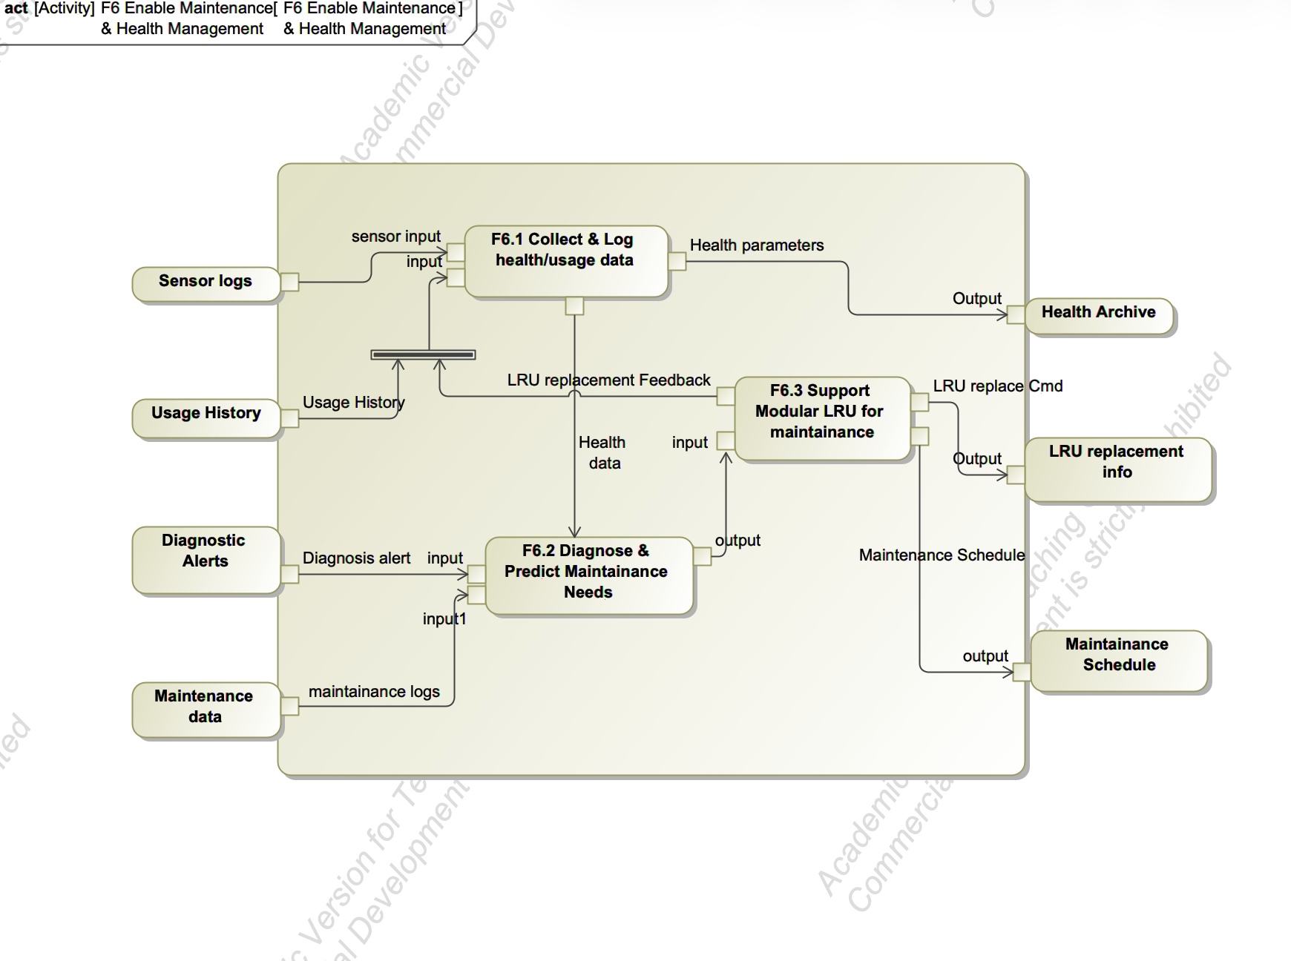
Figure 7: Activity Diagram for Enable Maintenance & Health Management

Sensor logs and usage history are collected in F6.1, where they are consolidated into a health record. Diagnostic alerts combine with that record in F6.2 to evaluate and predict maintenance needs. The diagnostic results are then passed to F6.3, which supports modular LRU replacement decisions and generates maintenance schedules. There is also a feedback loop from F6.3 back to F6.1, ensuring that replacement actions update the long-term health archive. Overall, F6.1–F6.3 form a data-driven loop focused on lifecycle tracking and corrective planning rather than real-time control.

3. Domain Mapping Matrix between goals and functions

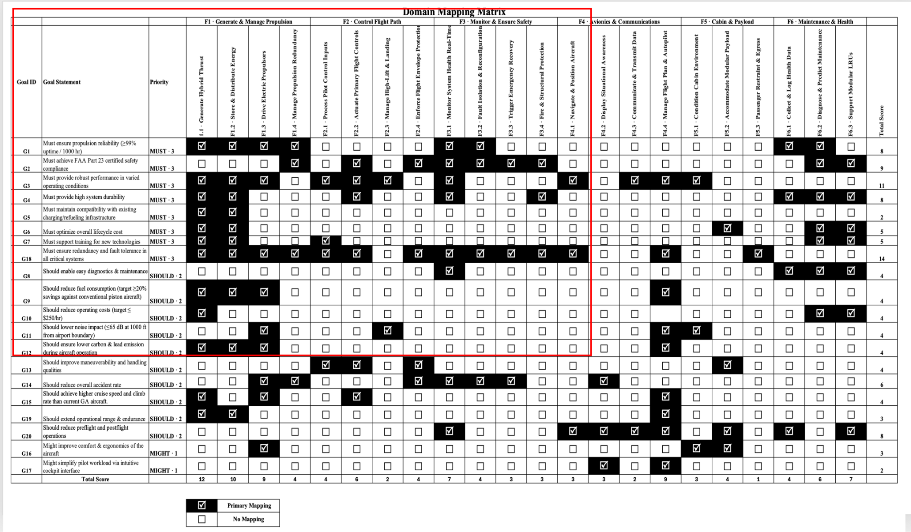
Figure 8 : Domain Mapping Matrix (DMM)

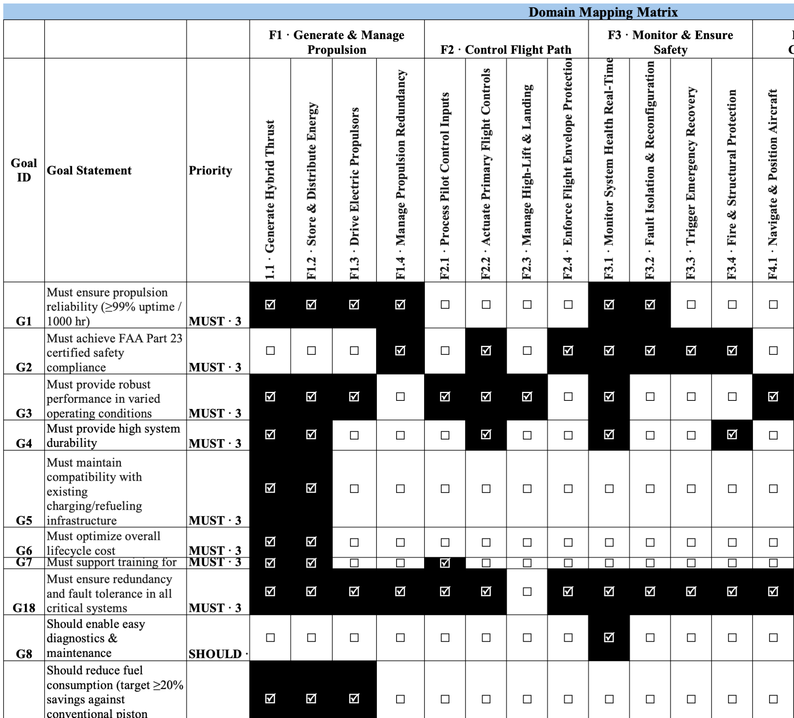Figure 9 : Excerpt from DMM (for illustrative purposes)

Examples & Justification for Goals to Functions from DMM

G18 → F1.4Propulsion Redundancy MUST · Primary
G18 requires fault tolerance in all critical systems. F1.4 is the dedicated redundancy
management function for the propulsion domain, it monitors health across all motor lanes, detects any single-lane failure within say 200 ms, and executes automatic thrust rebalancing among the remaining healthy motors. Without F1.4, the hybrid architecture's redundancy exists only in hardware, F1.4 is the software mechanism that activates that redundancy. This is the most direct single mapping in the entire matrix.

G9 → F4.4 Flight Plan & Autopilot SHOULD · Primary
F1.1 and F1.3 create the potential for fuel savings. F4.4 realizes that potential by computing and flying the optimal power split at every point in the flight. A pilot manually managing a hybrid powertrain will consume more fuel than an FMS that continuously optimizes turbine operating point, battery state-of-charge slope, and step-climb altitudes. Analysis of hybrid car data shows that automated energy management recovers 12–18% more efficiency than manual management of the same hardware. F4.4 is therefore not just a convenience feature, it is essential to achieving G9's ≥20% fuel-savings target.

G10 → F6.2 Diagnose & Predict Maintenance SHOULD · Primary
In commercial aviation, unscheduled maintenance events cost 3–5X more than the same work done on schedule. G10's $250/hr. target includes maintenance cost amortization over annual hours flown. F6.2 reduces unscheduled maintenance frequency by detecting component degradation before failure, converting unscheduled events (which cause AOG situations and lost revenue) into planned events. For a flight school operating 600 hr./year, reducing unscheduled maintenance from 3 events to 1 event per year could save $8,000–$15,000 annually, making the difference between meeting and missing the $250/hr. Target.

G16 → F5.1 & F5.2 Cabin Environment & Modular Payload MIGHT · Primary
Comfort goals are the lowest priority ("Might"), but they are commercially important for aircraft owners and passengers who choose this aircraft over a legacy Cirrus. F5.1 addresses the physical environment (noise, temperature, vibration) the largest driver of passenger perceived quality. F5.2 addresses ergonomic configuration: different seat pitches, layouts, and cabin widths can be implemented as different cabin modules. Together, these two functions enable the aircraft to offer competing comfort levels at different price points without redesigning the airframe, a market differentiation strategy that directly supports the investor ROI goal

4. Represent the primary use case of your system (operation) using an activity diagram.
Example: Resident Commute to Work
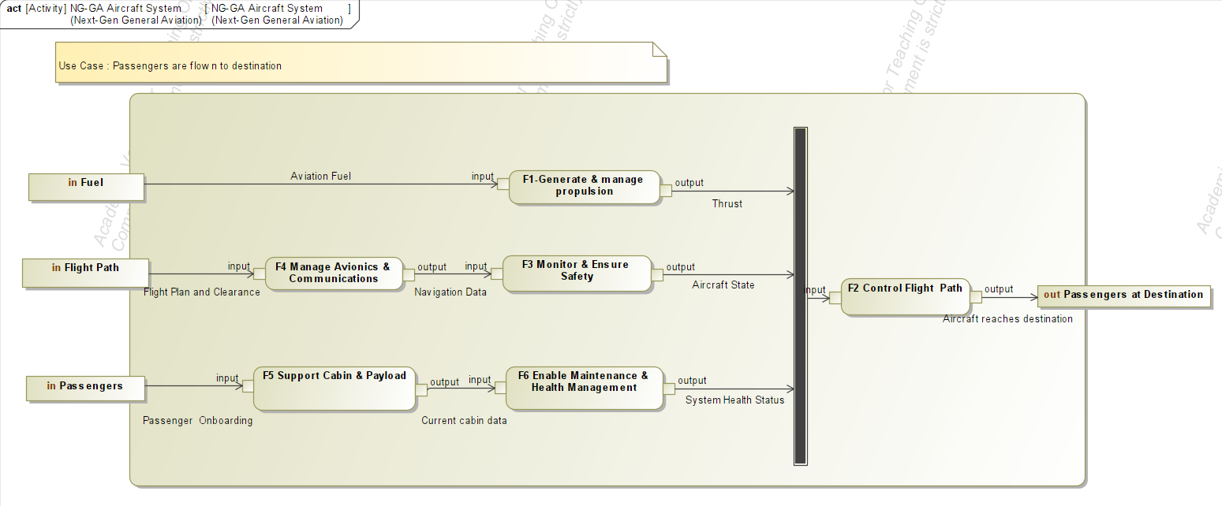
Figure 10 : Activity Diagram : Primary Use Case

The activity diagram represents the primary use case where passengers are transported safely to their destination. Fuel enables Generate Propulsion, producing thrust for Control Flight Path, which governs aircraft movement. The flight plan is processed by Manage Avionics and monitored by Monitor Safety to ensure safe navigation. In parallel, passengers are supported through Support Cabin and supervised by Health Management to maintain acceptable cabin and system conditions. All functions collectively enable controlled flight, resulting in passengers arriving safely at the destination.

5. State Machine Diagram
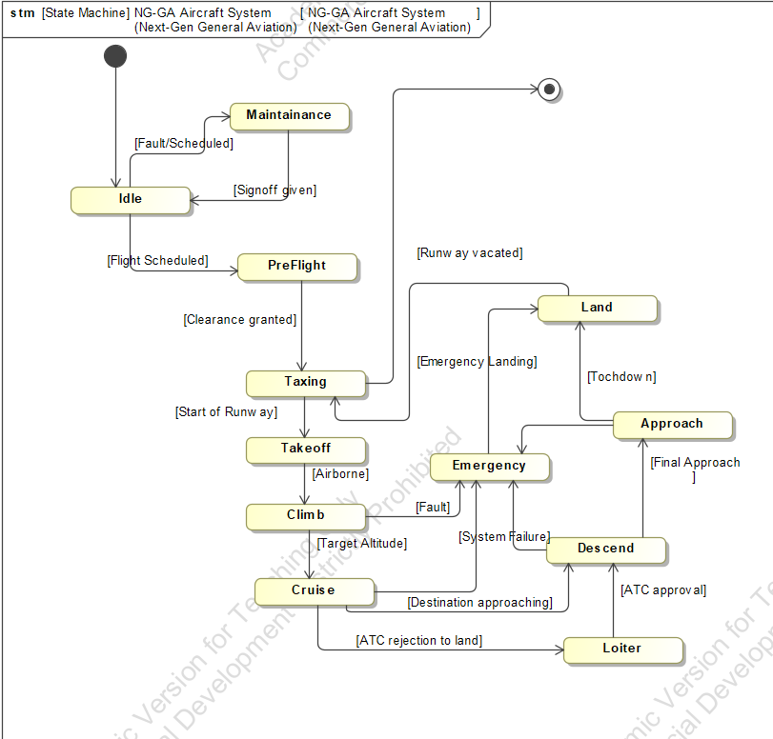
Figure 11 : State Diagram

This SysML state diagram models the complete operational lifecycle of a general aircraft, covering all phases from ground to air and back.
The aircraft begins at Idle, where it either enters Pre-Flight checks or is routed to Maintenance for scheduled or fault-driven servicing. Whenever a flight is scheduled, pre-flight runs are checked. Once pre-flight is cleared, it taxis to the runway, performs Takeoff, and enters the ascending Climbing phase until reaching Cruising altitude.
When it comes closer to destination, the aircraft may enter a Loiter if runway is not free, orbiting a fixed area on ATC instruction or for surveillance before beginning descent. The descent flows into Approaching and finally Landing, after which the aircraft taxis back to the gate and returns to Idle.
At any point during flight, a system fault can trigger the Emergency state, which routes the aircraft to either an emergency landing or a ground resolution.

Exercise 2: Physical and allocated architecture (50 points)

1. Physical Architecture : block definition diagram

Level | Block | Description
0 | Hybrid General Aviation Aircraft | Small passenger aircraft designed for safety, efficiency, and hybrid-electric propulsion.
1 | Airframe | Structural body of the aircraft: fuselage, wings, tail, landing gear. Provides support for all subsystems.
1 | Propulsion System | Provides thrust using parallel hybrid configuration. Traditional engine provides main power; electric motors provide redundancy and efficiency; gearbox combines them mechanically.
1 | Electrical And Energy System | Stores and distributes electrical energy to all subsystems. Supports hybrid propulsion and powers electronics.
1 | Flight And Control System | Brain of the aircraft: interprets pilot input, processes sensor data, moves control surfaces (hidden at Level 1).
1 | Safety and Support System | Monitors system health, detects failures or fires, provides backup power for critical operations.
2 | Thermal Engine | Traditional engine providing main thrust for the aircraft.
2 | Electric Motors | Provides supplementary or redundant thrust; used in hybrid mode.
2 | Gearbox | Combines thermal engine and electric motor output to propeller efficiently.
2 | Propeller | Converts engine/motor rotation into thrust; essential for hybrid operation.
2 | Battery Packs | Redundant energy storage for hybrid operation and electronics.
2 | Power Distribution Unit | Delivers electrical power to other subsystems safely.
2 | Power Electronics | Manages charging, discharging, and power flow between batteries, motors, and computers.
2 | Flight Control Computers | Processes pilot commands and sensor data; decides how to move actuators.
2 | Actuators | Move ailerons, elevators, rudder, and flaps to control aircraft
2 | Control Surfaces | Moves to control the airframe orientation of aircraft
2 | Health Monitoring System | Continuously monitors propulsion, electrical, and flight systems for faults.
2 | Environmental Control system | Maintains cabin pressure and temperature.
2 | Emergency Power Unit | Provides and stores backup power for emergency scenarios
2 | Avionics | Navigation, communication, and monitoring systems

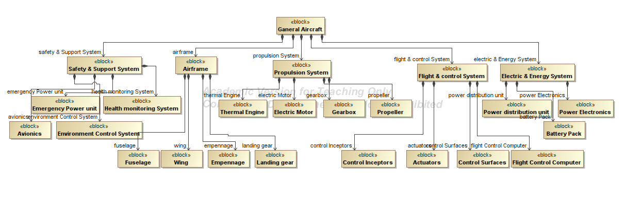
Figure 12 : Physical Architecture : Block Definition Diagram

To develop the hierarchical decomposition of the hybrid general aviation aircraft, I first defined the system boundary, identifying the entire 8–10 seater aircraft as the top-level system. I then divided it into five major functional subsystems: Airframe, Propulsion System, Electrical And Energy System, Flight And Control System, and Safety And Support System, based on their primary roles in structure, thrust, power management, control, and safety. Within each subsystem, I identified key components, such as engines, electric motors, propeller, batteries, actuators, avionics, and monitoring units, ensuring that the decomposition reflected the hybrid-electric architecture, redundancy, and extreme safety features. The process focused on maintaining clarity for non-experts, using descriptive terms, and keeping Level 1 blocks manageable (3–5 per system). Finally, I cross-checked functional roles and interfaces to ensure consistency between physical energy flows and informational signals.

2. Physical Architecture : Internal block Diagram
The following interfaces are identified in level 1 of the system
Physical interfaces:
Sender | Receiver | Interface | Port Type
Propulsion System | Airframe | Torque transmission | Flow Port (Mechanical)
Propulsion System | Electrical and Energy System | Charging / electrical feedback | Flow Port (Electrical)
Electrical and Energy System | Flight and Control System | Power supply | Flow Port (Electrical)
Electrical and Energy System | Safety and Support System | Power supply | Flow Port (Electrical)
Informational interfaces:
Sender | Receiver | Interface | Port Type
Flight and Control System | Propulsion System | Control signals | Proxy Port / Full Port
Flight and Control System | Safety and Support System | Status / requests | Standard Port
Propulsion System | Flight and Control System | Sensor feedback | Flow Port / Signal
Airframe | Flight and Control System | Sensor feedback | Flow Port / Signal
Safety and Support System | Flight and Control System | Fault alerts | Standard Port
Safety and Support System | Propulsion System | Fault alerts | Standard Port

Based on identified interfaces the corresponding Internal Block Diagram of systems is as follows:
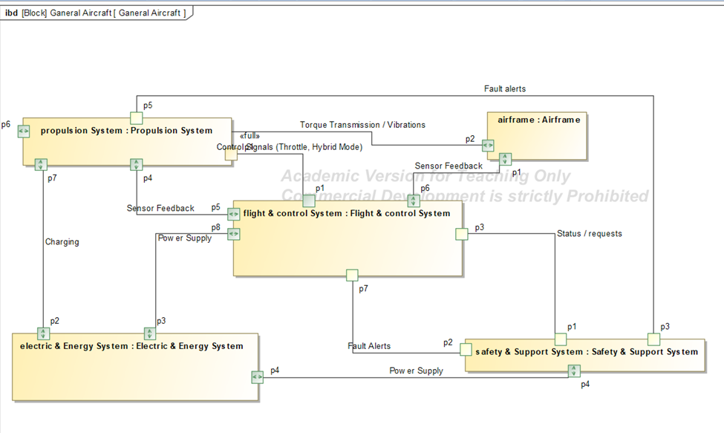
Figure 13 : Physical Architecture : Internal Block Diagram

The Level 1 Internal Block Diagram (IBD) represents both physical and informational interfaces between the aircraft’s main subsystems. Physical interfaces include mechanical torque transfer from the Propulsion System to the Airframe and electrical power exchange between the Electrical & Energy System and other subsystems to support hybrid operation and redundancy. Informational interfaces include control signals from the Flight And Control System to the PropulsionSystem, sensor feedback from the Propulsion System and Airframe back to the Flight & Control System, and fault or health-monitoring alerts exchanged with the Safety & Support System. Flow ports were used for energy and measurable signal transfers, proxy ports for exposing control behavior without internal detail, full ports where functionality is implemented, and standard ports for discrete status and fault messages, ensuring clear separation between physical and informational interactions.

2. Physical Architecture : Sequence Diagram

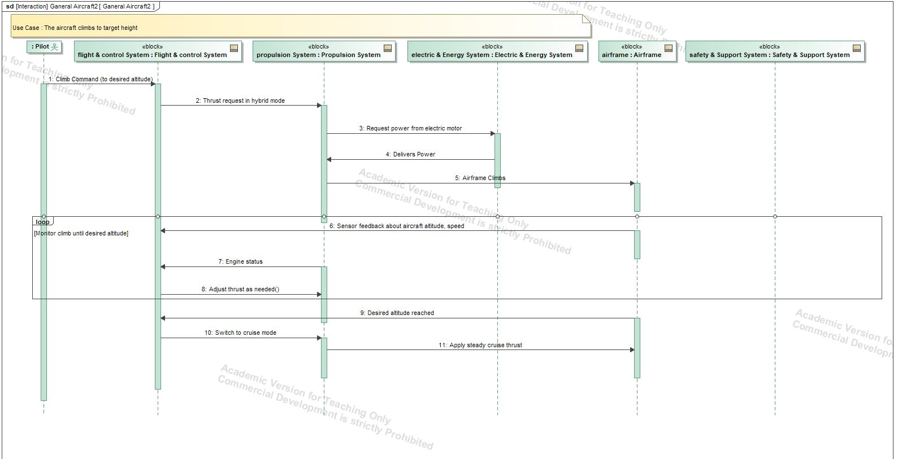
Figure 14 : Physical Architecture : Sequence Diagram

The sequence diagram for the aircraft climbing to a desired altitude illustrates the dynamic interactions between the pilot, Flight & Control System (FCS), Propulsion System, Electrical & Energy System (EES), and Airframe. The pilot initiates the climb by sending a target altitude command to FCS, which computes the required thrust and hybrid allocation between engine and electric motor, sending a thrust request to the Propulsion System. The Propulsion System requests electrical power from EES, applies combined torque to the propeller, and the Airframe Sensors continuously provide feedback on altitude, climb rate, and acceleration. FCS uses this feedback to adjust thrust allocation and hybrid mode in real time, ensuring efficient and stable climb. Once the AirframeSensors indicate the target altitude is reached, FCS commands the Propulsion System to switch from climb mode to cruise mode, completing the climb scenario while maintaining coordinated control and energy management throughout.

3. Represent the level-2 (components) structural connectivity of the system components as
a colored DSM. Show your decomposition at level-1 (subsystems) with black rectangles
and use colors to represent different types of connections (electrical, mechanical, fluid,
informational). Discuss the distribution of connectivity within and across subsystems. No
need to optimize the system decomposition as seen in class. Hint: You may want to use
Excel to do this.

Distribution of Connectivity Within and Across Subsystems: The colored Design Structure Matrix (DSM) illustrates the structural and functional connectivity among the 19 Level-2 components of the Next-Generation General Aviation Aircraft, mapped across the five primary Level-1 subsystems. The distribution reveals several key architectural characteristics:
- High Intra-Subsystem Density: Interactions within individual subsystems are tightly clustered along the diagonal. The Airframe and Propulsion systems exhibit dense mechanical (red) couplings, as components like the Thermal Engine, Electric Motors, and Gearbox must physically integrate to transfer torque to the Propeller.
- The Airframe as a Physical Hub: The Fuselage acts as the central mechanical foundation. It shows widespread mechanical connections (red) across almost all other subsystems, physically supporting the wings, empennage, landing gear, thermal engine, and gearbox.
- Power Distribution as a Centralized Electrical Bus: The Power Distribution Unit serves as the electrical heart of the aircraft. It creates an extensive vertical/horizontal band of electrical connections (blue) across the matrix, supplying power to the Electric Motors, Flight Control Computers, Actuators, and various Safety/Support systems.
- Widespread Information & Control Networks: The Flight Control Computer and Health Monitoring System act as the primary informational (green) hubs. Their connectivity spans across the entire matrix, pulling sensor data from the propulsion/airframe elements and pushing control signals to actuators and avionics.
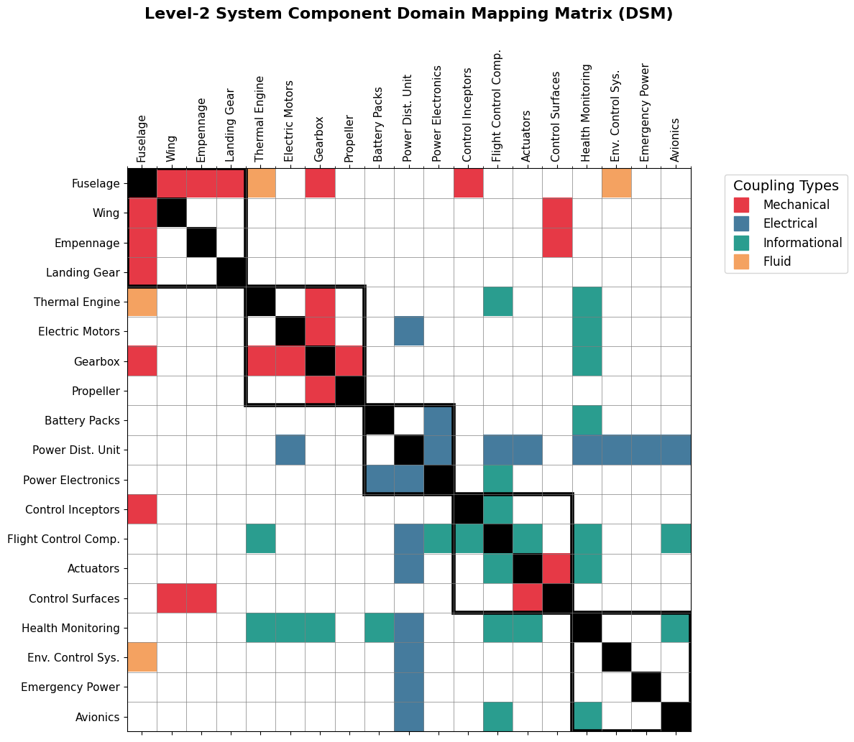
Figure 15 : Level-2 System Component Design Structure Matrix (DSM)

4. Represent the allocated architecture at Level 1 (mapping of Level1 functions to
subsystems) in SysML/Mermaid (e.g., adding swimlanes or partitions to your activity
diagram).

Level-1 Allocated Architecture: The diagram below represents the Level-1 Allocated Architecture, mapping the 6 primary system functions to the 5 Level-1 physical subsystems. Using a partitioned activity diagram format with horizontal swimlanes, we can visualize the strict distribution of functional responsibilities across the hardware domains.
Mapping Breakdown:
- Electric & Energy System & Propulsion System: Both share the allocation for F1: Generate & Manage Propulsion. The Energy system handles energy storage and distribution (F1.2), while the Propulsion system handles thrust generation (F1.1, F1.3).
- Safety & Support System: This subsystem acts as the primary operational and environmental hub. It physically houses the components allocated to F4: Manage Avionics & Communications, F3: Monitor & Ensure Safety, and F6: Enable Maintenance & Health Management.
- Flight & Control System: Strictly allocated to F2: Control Flight Path. It utilizes navigation data and distributed power to physically actuate the control surfaces.
- Airframe: Allocated to F5: Support Cabin & Payload (specifically F5.2 and F5.3). It acts as the physical structure responsible for accommodating the passengers while serving as the recipient of the aerodynamic and propulsive forces.
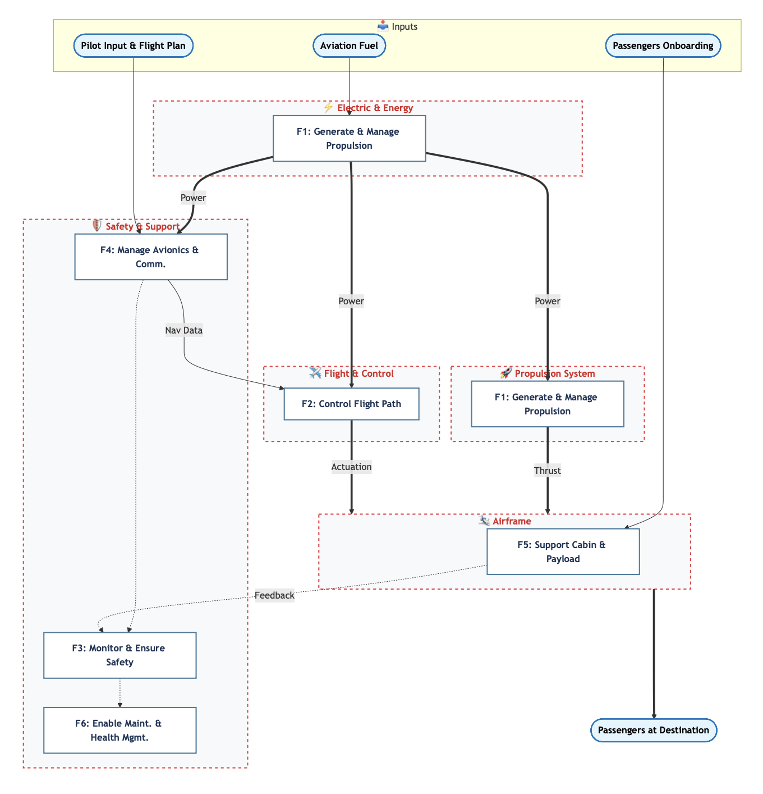
Figure 16 : Level-1 Allocated Architecture Activity Diagram

5. Represent the allocated architecture at Level 2 (mapping of Level 2 functions to
components) using a domain mapping matrix. Please comment on the structure of the
resulting DMM (e.g. one-to-one).

Allocated Architecture at Level 2 (DMM): The Domain Mapping Matrix (DMM) below formalizes the "Allocated Architecture" by strictly mapping the 22 Level-2 operational and software functions (rows) to the complete list of 19 Level-2 physical hardware components (columns).
Commentary on the Structure:
- Functional Clustering (Many Functions-to-One Component): The matrix reveals a highly centralized architecture for system diagnostics. The Health Monitoring component appears as a dense vertical block, acting as the primary hardware for almost all safety monitoring (F3.1, F3.2, F3.3, F3.4) and health management (F6.1, F6.2, F6.3) functions.
- Distributed Physical Execution (One Function-to-Many Components): Conversely, primary mechanical functions display a horizontal "one-to-many" spread. F1.1 Generate Hybrid Thrust requires the coordinated operation of the Thermal Engine, Electric Motors, Gearbox, and Propeller. Similarly, F2.2 Actuate Primary Flight Controls relies on Actuators, Control Surfaces, Wings, and the Empennage functioning seamlessly together.
- Integrated Control Logic: In F4.4 Manage Flight Plan & Autopilot, the mapping splits between Avionics(providing the navigation data) and the Flight Control Comp. (executing the control laws).
- Sparse vs. Dense Component Columns: Passive structural components have very sparse, targeted allocations; the Fuselage is tied to payload and passenger accommodation (F5.2, F5.3), the Landing Gear activates for F2.3, and the Wing/Empennage are linked to flight control actuation (F2.2). In contrast, electrical components like the Power Electronics have scattered mappings across multiple functional groups (Energy and Propulsion), confirming their role as a highly integrated bridge between power storage and thrust generation.

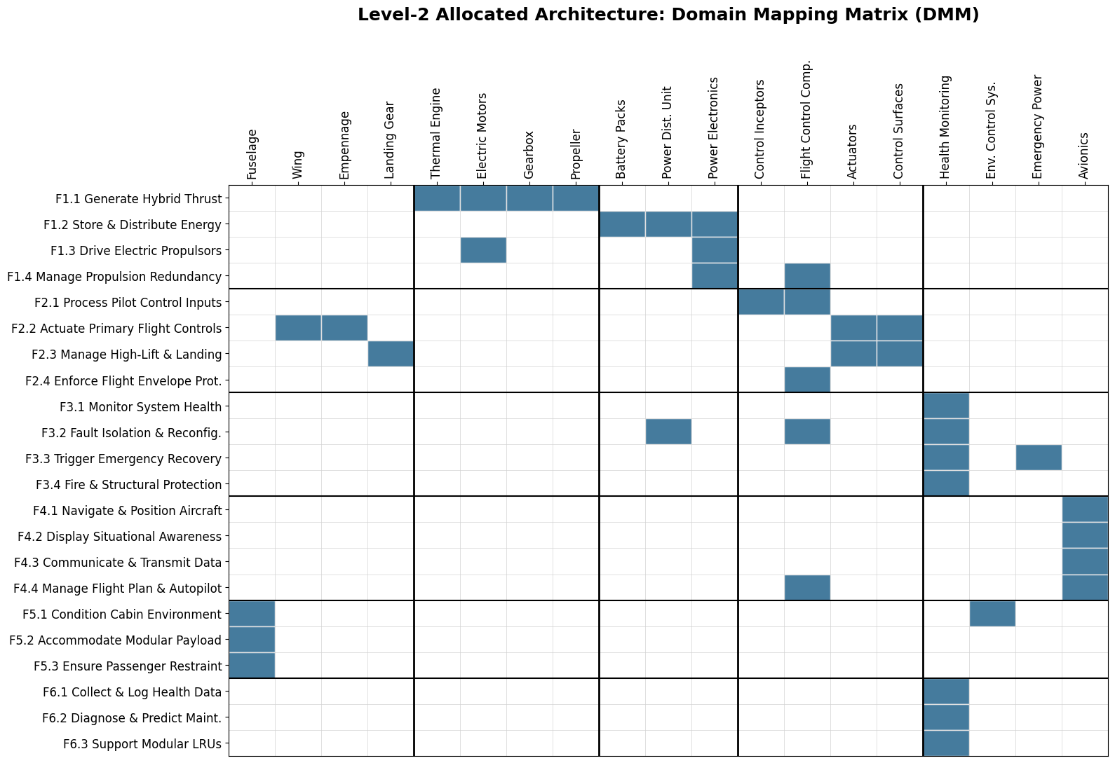
Figure 17 : Level-2 Allocated Architecture Domain Mapping Matrix (DMM)

