Homework 3B: Practice exercises on class project (100 points)
Please do the exercises below for your system of choice (the one for which you are doing the class project). Please include your code and results files (e.g. .mat files) along with your submission in a single zip file. We will check that the code runs and works.

No. | First Name | Last Name | Cornell NetID | GithubID
1 | Janhavi | Gaikwad | jg2569 | janhaviprof-bot
2 | Anurag | Yadav | ay468 | anuragyadav21
3 | Kris | Singh | as4499 | realAryavardhanSingh

Exercise 1: Full factorial enumeration

1. Architectural decisions for the system and their importance with alternatives, canonical types & metric connections.
Decision ID | Decision Name | Description & connection to metrics | Alternative | Canonical Type & Justification
D1 | Propulsion topology | How the thermal engine and electric motors are mechanically and electrically coupled to produce shaft thrust. This single architectural choice defines the entire powertrain layout. | A. Series hybrid- ICE charges battery only, electric motor(s) drive propeller exclusively; decouples thermal and propulsive systems | This is Standard form (SF) decision type with 3 \alternatives, because exactly one power-train topology is selected, alternatives are architecturally mutually exclusive. Each implies a completely different mechanical and electrical layout (function-to-form mapping, Task is Specializing or Characterizing). SF is the correct pattern for this: one choice, finite discrete set, space size = 3.
 |  |  | B.Parallel hybrid- ICE and electric motor(s) both mechanically drive the propeller shaft simultaneously; highest efficiency at cruise
 |  | Metrics related to goals-  G9 fuel savings ≥20%  G10 op. cost ≤$250/hr  G1 reliability ≥99%  G6 redundancy | C.Turboelectric- gas turbine drives a generator, electrical power distributed to wing-mounted motor-propulsors; best for distributed propulsion
D2 | Battery pack chemistry | Electrochemical cell type adopted across the main energy storage pack. Determines gravimetric energy density, thermal risk, cycle life, and LRU replacement cost across the aircraft's operational lifetime. | A. Li-Ion NMC (Nickel Manganese Cobalt) ~250 Wh/kg; high energy density; elevated thermal risk; mature aviation supply chain | This is a Standard Form decision (SF) with 3 alternatives. One chemistry adopted across the entire pack, no valid mixed-chemistry architecture exists at system level. Discrete, mutually exclusive options (Characterizing Form). Independent of all other decisions at the enumeration level: D2 feeds directly to the completed architecture without constraining any downstream decision.
 |  |  | B. Li-Ion LFP (Lithium Iron Phosphate)~180 Wh/kg; superior thermal stability and cycle life; preferred for safety-critical aviation
 |  | Metrics related to goals-  G9 energy density to range  G10 unit replacement cost  G4 thermal safety  G14 fault tolerance | C. Solid-state ~400 Wh/kg projected; eliminates liquid electrolyte; TRL( technology readiness level) 4–5, near-term adoption risk
D3 | Number of electric motors | Count of independent electric propulsor units installed on the airframe. Sets propulsion redundancy level and its critical to determine the size of the motor-to-position | A. 1 motor- centralised; minimum weight; no propulsion redundancy; single-point failure risk | This is a Standard Form (SF) type decision. A single integer count chosen from a finite discrete set (Specializing Form). D3 is not independent of D4: the motor count directly sets the number of rows in the AS assignment matrix for D4, making D3 to D4 a mandatory ADG edge. This is an enumeration-level dependency.
 |  |  | B. 2 motors- twin configuration; standard redundancy for GA category aircraft; enables differential thrust
 |  | Metrics related to goals-  G1 reliability  G6 propulsion redundancy  G9 distributed propulsion efficiency  G10 weight & maintenance cost | C. 4 motors- quad-distributed propulsion; highest fault tolerance; differential yaw/roll control without control surfaces
D4 | Motor-to-airframe position assignment | Ordered mapping of each electric motor unit to a structural mounting position on the airframe. Both the candidate position set (constrained by D1 topology) and the matrix size (set by D3 motor count) are determined by upstream decisions. | A. Possible Candidate positions of motors (up to 6): Wing-root-Left, Wing-root-Right, Wing-tip-Left, Wing-tip-Right, Nose, Tail | This is an Downselecting type (DS) decision, which depends on D1, D3. This is selecting the available option for the position of engines from the set of available option (n=6). It is constraint by number of motors we are going to choose in D1 and Type of motors we are going to choose in D4
 |  |  | B. D1 topology removes 1–2 positions (e.g. Series: Nose occupied by ICE)
 |  | Metrics related to goals-  G3 flight control authority  G13 lateral/directional stability  G17 handling qualities  G18 fault tolerance | C. Each motor maps to exactly one position; space = P(valid_n, D3_count) ordered permutations
D5 | Flight control computer (FCC) redundancy level | Redundancy architecture of the flight control computers, how many independent FCC units are installed and whether voting logic (2-of-3) is implemented to mask individual failures automatically. | A. Simplex- 1 FCC; lowest cost and weight; limits certification to Normal category; single-point failure | This is the standard Form (SF) decision type. If one redundancy level is selected, architectures are mutually exclusive(Characterizing Form). Choosing Triple-redundant imposes an enumeration-level constraint on D7: the three FCC units must each reside in a separate LRU package to preserve physical fault isolation, creating the ADG edge D5 → D7.
 |  |  | B. Dual-redundant- 2 FCCs with cross-monitoring and failover; standard for Part 23 Enhanced category
 |  | Metrics related to goals-  G2 FAA Part 23 certification  G4 high durability  G14 fault tolerance  G18 critical system redundancy | C. Triple-redundant- 3 FCCs with 2-of-3 majority voting; required for Design Assurance Level (DAL)-A flight-critical systems
D6 | Avionics integration | Whether avionics subsystems use dedicated hardware per function (federated) or a shared certifiable computing platform Integrated Modular Avionics (IMA). Determines which sub-function co-packaging rules are physically feasible in D7. | A. Federated-each avionics function has its own dedicated LRU box; high fault isolation; higher weight and part count | Standard Form (SF) decision, with 2 alternatives. Binary, mutually exclusive pick-one (Specializing Form).
 |  | Metrics related to goals-  G2 FAA certification path  G7 accommodate new technologies  G17 situational awareness  G20 Ease in operations | B. Integrated Modular Avionics (IMA)- shared certifiable computing platform, lower SWaP (Size, Weight & Power), incremental certification harder
D7 | Subsystem LRU decomposition | How the 6 Level-1 functions from functional architecture (F1–F6) are grouped into physical Line-Replaceable Unit (LRU) packages. Determines maintenance access granularity and replacement cost over the aircraft lifecycle. | A. Elements: all 6 Level-1 sub-functions F1–F6 from functional BDD | Partitioning (PA) decision type. Sub-functions are partitioned into mutually exclusive, collectively exhaustive LRU packages- this is the Partitioning (PA) pattern by definition (System Decomposition task). Every sub-function belongs to exactly one LRU, all 6 must be assigned. Space size depends on D5.
B. Groups: only k=2 or 3 LRU packages
Minimum possible LRU packages maintains redundancy without compromising cost
 |  | Metrics related to goals-  G7 accommodate new technologies  G8 health monitoring  G10 LRU replacement cost  G20 modularity | C. If D5=Triple: FCC units must be in separate packages (k=3 groups required)
D8 | Ballistic whole-aircraft parachute (Cirrus Airframe Parachute System (CAPS)) | Whether a ballistic whole-aircraft parachute recovery system is installed as a last-resort mechanism for loss-of-control events beyond FCC recovery capability. Direct tradeoff between safety and weight/cost. | A. CAPS installed, adds ~25–30 kg, substantially improves survivability in LOC events; earns FAA safety credit toward certification | Standard Form (SF) decision type with binary go/no-go selection (Specializing Form) with direct, measurable effects on safety and cost metrics. Fully independent of all other decisions at the enumeration level, no upstream decision changes this decision's option set. D8 feeds directly to the completed architecture without constraining any downstream decision.
 |  |  | B. No CAPS, lower weight and acquisition cost; relies entirely on avionics, structural, and flight control safety systems
Metrics related to goals-
G2 FAA safety requirements
G4 durability & passenger safety
G10 +25–30 kg weight penalty
G14 maneuverability & high safety

2. Identification of constraints that exist at the enumeration level and architectural decision graph (ADG) and showing the dependencies between the decisions from the standpoint of enumeration.
Enumeration-level constraints & Architectural Decision Graph (ADG)
The ADG only captures dependencies that actually change the number or set of valid alternatives for a downstream decision, rather than general performance interactions. In this case, four enumeration-level constraints were identified. Decisions D2 and D8 act as independent roots since they have no upstream constraints.

1.Propulsion topology constrains valid motor mounting positions (D1 leads to D4)
If D1 = Series hybrid, the ICE/generator occupies the nose structural bay, physically removing "Nose" from D4's candidate set. If D1 = Parallel hybrid, the mechanical gearbox shaft exits at the nose station, also removing "Nose." If D1 = Turboelectric, the turbine intake at the nose removes the "Nose." All three topologies remove at least one position and the specific set removed differs by alternative, changing D4's option space.

- If D1 = Series then D4 valid positions = {Wing-root-L, Wing-root-R, Wing-tip-L, Wing-tip-R, Tail} = 5 positions (Nose removed)
- If D1 = Parallel then D4 valid positions = {Wing-root-L, Wing-root-R, Wing-tip-L, Wing-tip-R, Tail} = 5 positions (Nose blocked by shaft)
- If D1 = Turboelectric then D4 valid positions = {Wing-root-L, Wing-root-R, Wing-tip-L, Wing-tip-R} = 4 positions (Nose + Tail blocked by turbine/exhaust)

2. Motor count sets the size of the assigning matrix (D3 leads to D4)
The number of motors to be assigned (rows in the AS matrix) equals the value of D3. A different motor count produces a fundamentally different assignment space size, not just fewer choices within the same space. This is a direct enumeration-level dependency. The AS pattern will need knowing M (number of items to assign) before the space can be enumerated.

- If D3 = 1 motor, D1 = Series (5 valid positions) → D4 space = P(5,1) = 5 assignments
- If D3 = 2 motors, D1 = Series (5 valid positions) → D4 space = P(5,2) = 20 assignments
- If D3 = 4 motors, D1 = Turboelectric (4 valid positions) → D4 space = P(4,4) = 24 assignments

3. Triple-redundant FCCs must occupy separate LRU packages (D5 leads to D7)
If D5 = Triple-redundant, the three FCC instances (sub-function F2.4, triplicated for voting) must each reside in physically distinct LRU packages to preserve fault isolation. Any D7 partition that places two or more FCCs in the same subset is infeasible, this eliminates a large fraction of the unconstrained Set partitions and forces the minimum group count to 3.

- If D5 = Triple then the D7 partition must have ≥3 groups, with FCC-A, FCC-B, FCC-C each in a separate subset. Partitions like {FCC-A, FCC-B, others} | {FCC-C, others} are infeasible and prevented from enumeration.
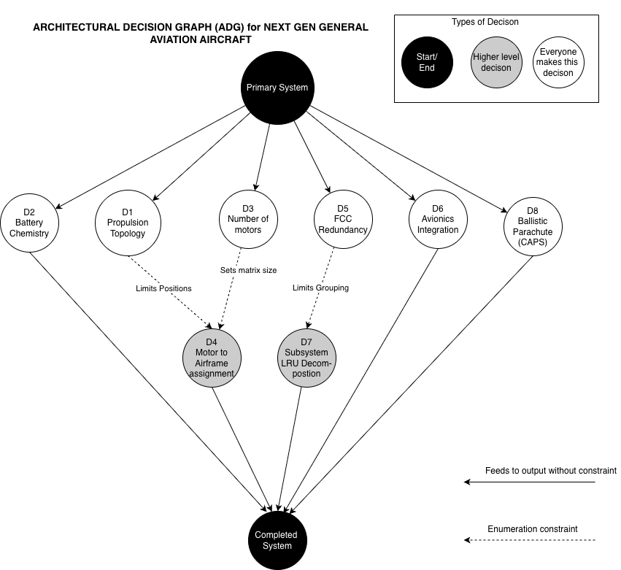

Figure- 1 Architectural Decision Graph (ADG) for Next Gen General Aviation Aircraft System

3. What is the size of the global architecture space for your problem? Show your math.
Decision | Type | k | n | Alternatives | Enumeration
D1 | Standard Form | 1 | 3 | {0,1,2} = {Series, Parallel, Turboelectric} | N_d1=n*k  N_d1=3*1=3
D2 | Standard Form | 1 | 3 | {0,1,2} = {Li-Ion NMC, Li-Ion LFP, Solid-state} | N_d2=n*k  N_d2=3*1=3
D3 | Standard Form | 1 | 3 | {0,1,2} = {1 motor, 2 motors, 4 motors} | N_d3=n*k  N_d3=3*1=3
D4 | Downselecting |  |  | set m: {motor units} set n: {Wing-root-L, Wing-root-R, Wing-tip-L, Wing-tip-R, Nose, Tail}  Constraint from D1:  If D1=Series or Parallel → Nose removed → n=5  If D1=Turboelectric → Nose+Tail removed → n=4  Constraint from D3: k = number of motors | Without constraints:  N_d4 = C(n,k) = n!/k!(n-k)! =64  With D1 and D3 constraints:  If D1=Series/Parallel, D3=1: C(5,1) = 5!/1!×4! = 5  If D1=Series/Parallel, D3=2: C(5,2) = 5!/2!×3! = 10  If D1=Series/Parallel, D3=4: C(5,4) = 5!/4!×1! = 5  If D1=Turboelectric, D3=1: C(4,1) = 4!/1!×3! = 4  If D1=Turboelectric, D3=2: C(4,2) = 4!/2!×2! = 6  If D1=Turboelectric, D3=4: C(4,4) = 4!/4!×0! = 1  N(D1×D3×D4) = (5+10+5)+(5+10+5)+(4+6+1) = 20+20+11 = 51
D5 | Standard Form | 1 | 3 | {0,1,2} = {Simplex, Dual-redundant, Triple-redundant} | N_d5=n*k  N_d5=3*1=3
D6 | Standard Form | 1 | 2 | {0,1} = {Federated, IMA} | N_d6=n*k  N_d6=2*1=2
D7 | Partitioning | 2 or 3 | 6 | Elements: {F1, F2, F3, F4, F5, F6} blocks into k=2 or k=3 parts  Constraint from D5:  If D5=Dual or Triple → k=2 infeasible (cannot separate 2 or 3 FCCs into packages when k=2) → only k=3 valid  If D5=Simplex → both k=2 and k=3 valid | If D5=Simplex:  N_d7 = S(6,2) + S(6,3) = (2^5-1) + (1/6)×(729-192+3) = 31 + 90 = 121  If D5=Dual or Triple:  N_d7 = S(6,3) = (1/6)×(729-192+3) = (1/6)×540 = 90 N(D5×D7) = 121 + 90 + 90 = 301
D8 | Standard Form | 1 | 2 | {0,1} = {CAPS installed, No CAPS} | N_d8=n*k  N_d8=2*1=2

Total size of architecture space with constraint is
N_total = N(D1×D3×D4) × N_d2 × N(D5×D7) × N_d6 × N_d8
= 51*3*301*2*2
=184212

4. Write an algorithm to enumerate all architectures in the architecture space using the tools we learned in class (e.g. R).
HW3B_EX1_Q4.R
Hybrid Electric Aircraft - Architecture Enumeration
getwd()

# Load required packages
library(dplyr) # For filter, mutate, select
library(tidyr) # For expand_grid
library(readr) # For write_csv
library(archr) # For enumerate functions

# ============================================================
# SECTION 1: ENUMERATE EACH DECISION INDIVIDUALLY
# ============================================================
# ------------------------------------------------------------
# D1 - Propulsion Topology (Standard Form)
# ------------------------------------------------------------
d1 = enumerate_sf(n = c(3), .did = 1)

# ------------------------------------------------------------
# D2 - Battery Pack Chemistry (Standard Form)
# ------------------------------------------------------------
d2 = enumerate_sf(n = c(3), .did = 2)

# ------------------------------------------------------------
# D3 - Number of Electric Motors (Standard Form)
# ------------------------------------------------------------
d3 = enumerate_sf(n = c(3), .did = 3)

# ------------------------------------------------------------
# D4 - Motor-to-Airframe Position (Down-selecting)

# 6 candidate positions (binary — selected=1 or not=0):
# ADG constraints from D1 and D3 applied during combination
# ------------------------------------------------------------
d4 = enumerate_ds(n = 6, k = 6, .did = 4) %>%
# Add count column — total positions selected
# Used to enforce D3 motor count constraint
mutate(count = d4_1 + d4_2 + d4_3 + d4_4 + d4_5 + d4_6)

# ------------------------------------------------------------
# D5 - FCC Redundancy Level (Standard Form)
# ------------------------------------------------------------
d5 = enumerate_sf(n = c(3), .did = 5)
# ------------------------------------------------------------
# D6 - Avionics Integration (Standard Form)
# ------------------------------------------------------------
d6 = enumerate_sf(n = c(2), .did = 6)

# ------------------------------------------------------------
# D7 - Subsystem LRU Decomposition (Partitioning)
# 6 functional blocks to partition into LRU packages:
# ADG NOTE: D5 constrains valid k:
# ------------------------------------------------------------
# Enumerate k=2 partitions
# min_times=c(1,1): each group must have at least 1 block
# max_times=c(5,5): each group can have at most 5 blocks
d7_k2 = enumerate_partition(n = 6, k = 2, .did = 7,
min_times = c(1, 1),
max_times = c(5, 5)) %>%
mutate(k_val = 2) %>%
# This removes all duplicates
filter(d7_1 == 0)

# Enumerate k=3 partitions
# min_times=c(1,1,1): each group must have at least 1 block
# max_times=c(4,4,4): each group can have at most 4 blocks
d7_k3 = enumerate_partition(n = 6, k = 3, .did = 7,
min_times = c(1, 1, 1),
max_times = c(4, 4, 4)) %>%
mutate(k_val = 3) %>%
# This removes all duplicates
filter(d7_1 == 0) %>%
filter(d7_2 != 2) %>%
filter(!(d7_2 == 0 & d7_3 == 2)) %>%
filter(!(d7_2 == 0 & d7_3 == 0 & d7_4 == 2)) %>%
filter(!(d7_2 == 0 & d7_3 == 0 & d7_4 == 0 & d7_5 == 2)) %>%
filter(!(d7_2 == 0 & d7_3 == 0 & d7_4 == 0 & d7_5 == 0 & d7_6 == 2))

# Combine k=2 and k=3 partitions
d7 = bind_rows(d7_k2, d7_k3)
cat("D7 total before D5 constraint:", nrow(d7), "\n") # Expected 121

# ------------------------------------------------------------
# D8 - CAPS Installation (Standard Form)
# ------------------------------------------------------------
d8 = enumerate_sf(n = c(2), .did = 8)

# ============================================================
# SECTION 2: COMBINE DECISIONS AND APPLY ADG CONSTRAINTS
# ============================================================
# Order of operations matches
# D1 → D4 (position availability)
# D3 → D4 (motor count)
# D5 → D7 (LRU group count)
#Resulting columns : d1 d2 d3 d4_1 d4_2 d4_3 d4_4 d4_5 d4_6 d5 d6 d7_1 d7_2 d7_3 d7_4 d7_5 d7_6 d8
# ============================================================
arch = expand_grid(d1, d2, d3) %>%

# --------------------------------------------------------
# Add D4 — apply D1→D4 and D3→D4 ADG constraints
# --------------------------------------------------------
expand_grid(., d4) %>%
filter(
# --- ADG CONSTRAINT: D1 → D4 ---
# Series hybrid (d1=0):
# Nose position unavailable — ICE/generator
# physically occupies the nose structural bay
!(d1 == 0 & d4_5 == 1),

# Parallel hybrid (d1=1):
# Nose position unavailable — mechanical gearbox
# shaft exits at nose station
!(d1 == 1 & d4_5 == 1),

# Turboelectric (d1=2):
# Nose unavailable — turbine intake at nose
# Tail unavailable — turbine exhaust at tail
!(d1 == 2 & d4_5 == 1),
!(d1 == 2 & d4_6 == 1),

# --- ADG CONSTRAINT: D3 → D4 ---
# D3 determines exact number of motors to place
# D3=0 (1 motor): exactly 1 position selected
!(d3 == 0 & count != 1),

# D3=1 (2 motors): exactly 2 positions selected
!(d3 == 1 & count != 2),

# D3=2 (4 motors): exactly 4 positions selected
!(d3 == 2 & count != 4)
) %>%

# Remove helper count column — no longer needed
select(-count) %>%

# --------------------------------------------------------
# Add D5 &D6— no constraints applied yet
# D5→D7 constraint applied when D7 is added below
# --------------------------------------------------------
expand_grid(., d5) %>%
expand_grid(., d6) %>%

# --------------------------------------------------------
# Add D7 — apply D5→D7 ADG constraint
# --------------------------------------------------------
expand_grid(., d7) %>%

filter(
# --- ADG CONSTRAINT: D5 → D7 ---
# D5=Simplex(0): both k=2 and k=3 valid
# No filtering needed for Simplex

# D5=Dual(1): only k=3 valid
# 2 FCCs must be in separate LRU packages
# k=2 cannot accommodate FCC separation requirement
!(d5 == 1 & k_val == 2),

# D5=Triple(2): only k=3 valid
# 3 FCCs must each be in separate LRU packages
# k=2 cannot accommodate 3 separate FCC packages
!(d5 == 2 & k_val == 2)
) %>%
# Remove helper k_val column — no longer needed
select(-k_val) %>%

# Add D8 — independent, no ADG constraints
expand_grid(., d8)
# ============================================================
# SECTION 3: OUTPUT AND VERIFICATION
# ============================================================
# Print total — should match manual calculation of 184,212
cat("Total number of valid architectures:", nrow(arch), "\n")
# View first few architectures
head(arch)
# Save to CSV file
write_csv(arch, "output_ex1_Q4.csv")
# Cleanup
rm(list = ls())

Output :
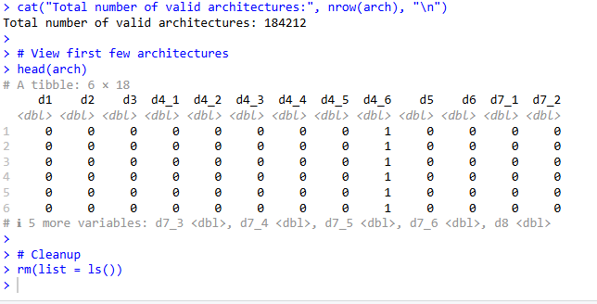

Exercise 2: Well-balanced Fractional population

1. List a few reference architectures (3-5). For each architecture…
● (1) Describe each architecture briefly,
● (2) show its encoding as a vector of symbols
● (3) explain why you chose it as a reference architecture.

Reference Architectures
Before outlining the reference architectures, the encoding mapping for the vector of symbols is defined based on the decision space from Exercise 1. The vector is formatted as [D1] - [D2] - [D3] - [D4] - [D5] - [D6] - [D7] - [D8].
Encoding Schema:
- D1 (Propulsion Topology): 0=Series, 1=Parallel, 2=Turboelectric
- D2 (Battery Chemistry): 0=NMC, 1=LFP, 2=Solid-state
- D3 (Motor Count): 0=1 motor, 1=2 motors, 2=4 motors
- D4 (Motor Positions): 6-bit string representing {Wing-root-L, Wing-root-R, Wing-tip-L, Wing-tip-R, Nose, Tail}. (1=Occupied, 0=Empty).
- D5 (FCC Redundancy): 0=Simplex, 1=Dual-redundant, 2=Triple-redundant
- D6 (Avionics Integration): 0=Federated, 1=IMA
- D7 (LRU Decomposition): 6-digit string representing the partition block assignments (Subsets 0, 1, or 2) for sub-functions F1 through F6.
- D8 (CAPS): 0=CAPS Installed, 1=No CAPS

Reference Architecture | Description | Vector of Symbols | Why Chosen as Reference
1. The Advanced Single-Engine Commuter(e.g., Cirrus SR22 Hybrid Concept) | A centralized series-hybrid architecture. The ICE occupies the nose, while a single electric motor is mounted in the tail. It utilizes futuristic solid-state batteries and Integrated Modular Avionics (IMA) to save weight. Designed for Part 23 Normal category, it relies on a Simplex FCC but compensates with a ballistic parachute (CAPS). | 0 - 2 - 0 - 000001 - 0 - 1 - 000111 - 0 | Serves as the lower-bound complexity baseline. It validates the minimal redundancy paths (Simplex FCC, minimal $k=2$ LRU partitioning constraint) and tests the mutually exclusive spatial constraints of the Series topology (Nose is blocked by the generator, forcing the single motor to the Tail station).
2. The Conventional Part 23 Twin Retrofit (e.g., Diamond DA62 Hybrid / Ampaire EEL) | A parallel-hybrid twin-engine configuration. The ICE and electric motors mechanically drive two wing-root propellers simultaneously. Employs mature Li-Ion NMC batteries and dual-redundant, federated avionics typical of present-day commercial commuter platforms without whole-airframe parachutes. | 1 - 0 - 1 - 110000 - 1 - 0 - 001122 - 1 | Represents the industry-standard evolutionary step (TRL 8-9). It anchors the design space in present-day feasibility. Utilizing dual-redundancy forces the $k=3$ LRU partitioning constraint, while the parallel topology accurately limits the Nose position, demonstrating standard architectural constraint propagation.
3. The Distributed Electric e-STOL (e.g., NASA X-57 Maxwell Paradigm) | A high-redundancy, turboelectric quad-motor distributed propulsion system. Utilizes thermally stable LFP batteries and triple-redundant FCCs for fly-by-wire reliability. Uses IMA to efficiently manage the complex distributed thrust logic safely across 4 wing-mounted motors. | 2 - 1 - 2 - 111100 - 2 - 1 - 012012 - 0 | Pushes the upper bounds of the architectural space for performance and fault tolerance. It heavily activates the most restrictive ADG constraints: Turboelectric blocks both the Nose and Tail from D4, while the Triple-redundant FCCs strictly enforce fault-isolation rules in D7, requiring exactly $k=3$ LRU packages.

2. Generate some deterministic architectures (<100), uniformly sampled with techniques.
Deterministic Fractional Population

a. Vector representation of architectures
Below is the deterministically sampled fractional population of 90 architectures, formatted as D1 - D2 - D3 - D4 - D5 - D6 - D7 - D8.
Note: The Python code utilized to generate this sample can be found here:
HW3B-EX2-2.ipynb
As per the assignment requirements, the complete matrix of the 90 deterministically sampled architectures has been exported and is attached to this submission in electronic format as the file deterministic_sample.csv.
First 10 rows:
Total valid architectures loaded: 184212
--- Generated 90 Deterministic Architectures ---
Arch 01: 0 - 0 - 0 - 000001 - 0 - 0 - 000001 - 0
Arch 02: 0 - 0 - 0 - 000100 - 1 - 1 - 012222 - 0
Arch 03: 0 - 0 - 0 - 010000 - 0 - 1 - 012221 - 0
Arch 04: 0 - 0 - 1 - 000101 - 0 - 0 - 010201 - 0
Arch 05: 0 - 0 - 1 - 001001 - 2 - 0 - 011211 - 0
Arch 06: 0 - 0 - 1 - 010001 - 1 - 0 - 011210 - 0
Arch 07: 0 - 0 - 1 - 011000 - 0 - 0 - 012220 - 0
Arch 08: 0 - 0 - 1 - 100001 - 2 - 1 - 010020 - 0
Arch 09: 0 - 0 - 1 - 101000 - 1 - 1 - 010012 - 0
Arch 10: 0 - 0 - 2 - 011101 - 0 - 1 - 010121 - 0
. . .

b. Process for Adapting the Full-Factorial Grid
Standard deterministic grid techniques, such as unconstrained Orthogonal Arrays (OA), assume that all decision variables are strictly mathematically independent. In this system's Architectural Decision Graph (ADG), applying an unconstrained OA would yield a matrix heavily saturated with invalid architectures because Decisions D4 (Motor Position) and D7 (LRU Decomposition) are deeply constrained by upstream choices in D1, D3, and D5. Generating a standard OA and subsequently deleting the infeasible rows breaks the array's orthogonality and results in an uneven, flawed sample distribution.
To "whittle down" the space while maintaining deterministic rigor, Lexicographical Systematic Sampling was applied directly to the pre-constrained population.
- The full-factorial matrix was first completely enumerated and filtered through the ADG rules, yielding the true valid architectural space (N=184,212 total valid architectures).
- This fully validated matrix was then sorted lexicographically from D1 through D8. This action groups similar architectural branches together to form a structured, multi-dimensional grid of the entire feasible space.
- To achieve a uniform sample size of exactly 90 (satisfying the <100 requirement), a deterministic geometric stride was calculated by dividing the total population by the target sample size: k=⌊184,212/90⌋=2046.
- The algorithm systematically extracted every 2046th architecture. This approach casts a perfectly uniform, deterministic net across the entirety of the viable design space without ever violating downstream constraints.

c. Feasibility Verification
Because the deterministic sampling methodology fundamentally extracts row indices directly from the pre-validated population matrix (where all ADG rules were strictly applied during the Exercise 1 enumeration), 100% feasibility is inherently guaranteed. There is zero probability of generating an unfeasible architecture because unfeasible combinations literally do not exist in the source grid.
This absolute feasibility can be verified by cross-checking the generated vectors against the core enumeration rules:
- Proof of Topology and Motor Constraint (D1 & D3 to D4): Examine Arch 84 (2 - 1 - 2 - 111100...). D1 is 2 (Turboelectric), meaning both Nose and Tail positions must be completely avoided. D3 is 2 (4 motors), meaning exactly four positions must be selected. The D4 substring is 111100, which correctly places the 4 motors exclusively on the wings, completely avoiding the blocked 5th and 6th positions.
- Proof of Partition Constraint (D5 to D7): Examine Arch 05 (0 - 0 - 1 - 001001 - 2 - 0 - 011211 - 0). D5 is 2 (Triple-redundant). The ADG mandates this must isolate into 3 physically separate LRU packages (k=3) to prevent a single point of failure. The D7 substring is 011211, which successfully utilizes packages 0, 1, and 2, proving the fault-isolation constraint was perfectly respected.

3. Generate N=100 random architectures.

Stratified Random Population

a. Vector representation of architectures
Below is the stratified random sample of N=100 architectures, formatted as D1 - D2 - D3 - D4 - D5 - D6 - D7 - D8.
Note: The Python code utilized to generate this sample and the corresponding frequency comparison charts can be found here:
HW3b-EX2-3.ipynb
As per the assignment requirements, the complete matrix of the 100 stratified random architectures has been exported and is attached to this submission in electronic format as the file stratified_random_sample.csv.
First 10 rows:
--- Generated 100 Stratified Random Architectures ---
Arch 001: 2 - 2 - 0 - 010000 - 0 - 1 - 010201 - 1
Arch 002: 1 - 2 - 1 - 100001 - 2 - 1 - 010220 - 0
Arch 003: 1 - 0 - 2 - 110101 - 2 - 0 - 012011 - 1
Arch 004: 1 - 0 - 0 - 000001 - 1 - 0 - 010211 - 1
Arch 005: 1 - 1 - 0 - 001000 - 2 - 1 - 011221 - 0
Arch 006: 1 - 1 - 0 - 010000 - 0 - 0 - 012120 - 1
Arch 007: 0 - 0 - 1 - 010100 - 1 - 0 - 010221 - 0
Arch 008: 2 - 0 - 0 - 010000 - 0 - 1 - 011112 - 1
Arch 009: 0 - 2 - 1 - 000101 - 0 - 0 - 001202 - 0
Arch 010: 0 - 1 - 0 - 010000 - 0 - 0 - 012120 - 1
. . .

b. Feasibility Verification
To ensure that all generated architectures are physically feasible and logically sound, the random sampling algorithm was strictly restricted to draw only from the fully enumerated and Architectural Decision Graph (ADG) constrained global population matrix.
Because the sample is a direct subset of a mathematically verified population, 100% feasibility is inherently guaranteed. There is zero risk of combinatorial constraint violations (such as allocating motors to blocked structural positions in D4, or failing to properly isolate redundant systems in D7) because those invalid configurations were structurally prevented from existing in the source grid during Exercise 1.

c. Quantitative Justification of Randomness
To quantitatively justify that the sample is truly representative of the global design space without bias, a stratified random sampling methodology was utilized. A simple random sample risks underrepresenting heavily constrained edge-case configurations (such as the Turboelectric topology). By stratifying the population across primary driving decisions (D1: Propulsion Topology and D3: Motor Count), we force the random extraction to perfectly mirror the categorical density of the full space.
As demonstrated in the generated frequency comparison charts, the probability mass function of the N=100 random sample robustly aligns with the entire architectural space ("Population"):
- Decision 1 (Propulsion Topology): The fundamental architectures are preserved. Series (0) and Parallel (1) configurations each comprise 39.2% of the population, and the random sample captures this nearly perfectly at 39.0% for both. The more constrained Turboelectric (2) topology represents 21.6% of the population, which is accurately reflected in the sample at 22.0%.
- Decision 3 (Number of Motors): The frequency of 1, 2, and 4 motor configurations is maintained. The 2-motor configuration (Alternative 1) is naturally the most dominant in the total population (51.0%) due to possessing the highest number of valid permutations in the D4 assignment matrix. The random sample successfully mirrors this heavy weighting at 50.0%, while preserving the 1-motor (28.0% vs 27.5%) and 4-motor (22.0% vs 21.6%) minority distributions.
- Decision 6 (Avionics Integration): Even for decisions not explicitly used as sampling strata, randomness is proven. The global population is perfectly split 50.0% / 50.0% between Federated (0) and IMA (1) avionics. The random sample resulted in a 48.0% / 52.0% split. This 2% delta falls well within the expected statistical variance for an N=100 sample size, proving the un-stratified variables were selected randomly and without systemic bias.
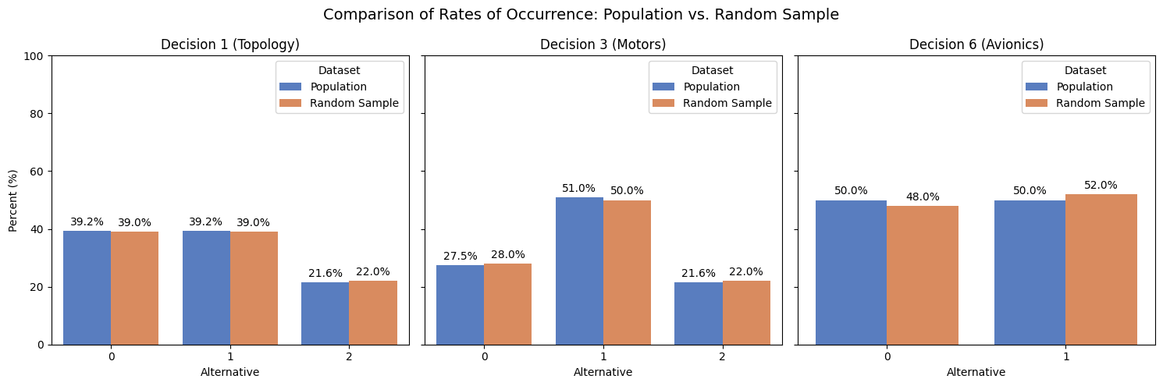
Figure: Comparison of the rates of occurrence for architectural alternatives across Decision 1 (Propulsion Topology), Decision 3 (Number of Motors), and Decision 6 (Avionics Integration). The distributions demonstrate that the stratified random sample (N=100) successfully mirrors the true statistical probability mass of the fully enumerated global architectural space (N=184,212), quantitatively validating that the sample is both rigorously random and free of systemic bias.

